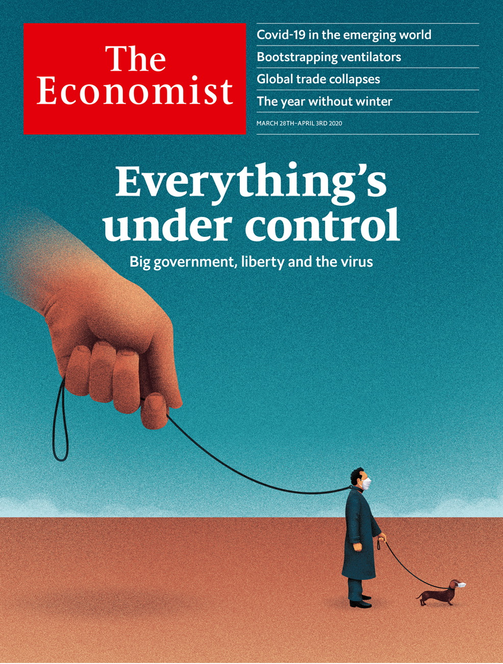

# Table of Contents

The world this week

Politics this week

Business this week

KAL’s cartoon

Leaders

The state and covid-19: Everything’s under control

The pandemic: The next calamity

America’s rescue package: Mixed medicine

Iran and covid-19: Get serious

Videoconferencing etiquette: Through the keyhole

Letters

Letters to the editor: On Taiwan, Myanmar, primaries, elephants, Freeman Dyson, congenital diseases, house names

Briefing

The pandemic and the state: Creating the coronopticon

Economic policy and the virus: Building up the pillars of state

United States

Congress responds: A $2 trillion bazooka

Viral exceptionalism: The bills you have to pay

Dating: Love under lockdown

Covid-19 and the locked-up: Pushing on an open door

Teenage sexting: Sharing and not caring

The Green Party: Zowie Howie

Lexington: Sore and feverish

The Americas

Covid-19 in Brazil: BolsoNero

Mexican-American relations: Distancing neighbours

Bello: The Latin American patient

Asia

Covid-19 in Japan: Blowing out the flame

Politics in Bangladesh: Ee begum!

Sexual abuse in South Korea: Naming and shaming

Banyan: An island at the ready

Covid-19 in South Asia: Hand-to-mouth to lockdown

China

The post-virus economy: Back to work

Chaguan: No shining city on a hill

Middle East and Africa

Coronavirus in Africa: Not immune

The virus in the Arab world: An even tighter grip

Covid-19 reaches Gaza: Quarantine while under siege

Europe

Spain: The emergency room

Italy, Germany and the virus: A numbers game

Coronanomics: Money for all

Swearing: Dutch disease

Russia’s economy: Isolationomics

Charlemagne: Aesop’s euro zone

Britain

Covid-19 and inequality: The great divider

Politics: Slow starter

Drugs: Stay in, drop out

Health care: National Covid Service

Village England: The Swan takes flight

Community life in London: Alone, together

Saving jobs: Furlough maintenance

Scottish politics: Leaping Salmond

Bagehot: The new politics

International

The pandemic: Stop, collaborate and listen

Hospital ventilators: Wind rush

Special report

Africa: The African century

Demography: Sex and education

Migration: Young, bright and on the move

Fighting the jihadists: The forever wars

Food and climate: Feeding another billion

Economy: Take-off speed

The future: Perchance to dream

Business

Business and the virus: Best in show

Confinement shopping: Still open

Human resources: The importance of people people

Bartleby: Diary of a home worker

Distributed companies: The nowhere firm

Schumpeter: A dispatch from the home front

Finance and economics

World trade: Trucks, queues and blues

On shaky ground: America’s mortgage market sickens

The dollar: The Zoom accord

The euro zone: Ripping up the rules

Commodities: Buyer beware

Buttonwood: Bridges to somewhere

Free exchange: How to pay for the pandemic

Science and technology

Covid-19 and climate change: Clear thinking required

Covid-19 and pollution: Heat and dust

Detecting elevated body temperatures: And now here is the fever forecast

Books and arts

Disease and democracy: How to survive a plague

Art on the internet: The online of beauty

Italian history: Civilisation and barbarism

Disappearing acts: Woman overboard

Disaster fiction: The yolk of fate

Economic and financial indicators

Economic data, commodities and markets

Graphic detail

Climate change: Winter is not coming

Obituary

Michel Roux: Cooking with Albert



### Friday, March 27, 2020

|  |  |
| --- | --- |
| The world this week | 3 |
| Leaders | 5 |
| Letters | 1 |
| Briefing | 2 |
| United States | 7 |
| The Americas | 3 |
| Asia | 5 |
| China | 2 |
| Middle East and Africa | 3 |
| Europe | 6 |
| Britain | 9 |
| International | 3 |
| Special report | 7 |
| Business | 6 |
| Finance and economics | 7 |
| Science and technology | 3 |
| Books and arts | 5 |
| Economic and financial indicators | 1 |
| Graphic detail | 1 |
| Obituary | 1 |

|  |  |  |
| --- | --- | --- |
|  | Sections | Leaders |

The world this week

Politics this week

.

Business this week

.

KAL’s cartoon

.

|  |  |  |
| --- | --- | --- |
|  | Sections | Leaders |

|  |  |  |  |
| --- | --- | --- | --- |
|  | Articles | Sections | Next |

# Politics this week

Mar 26th 2020 |

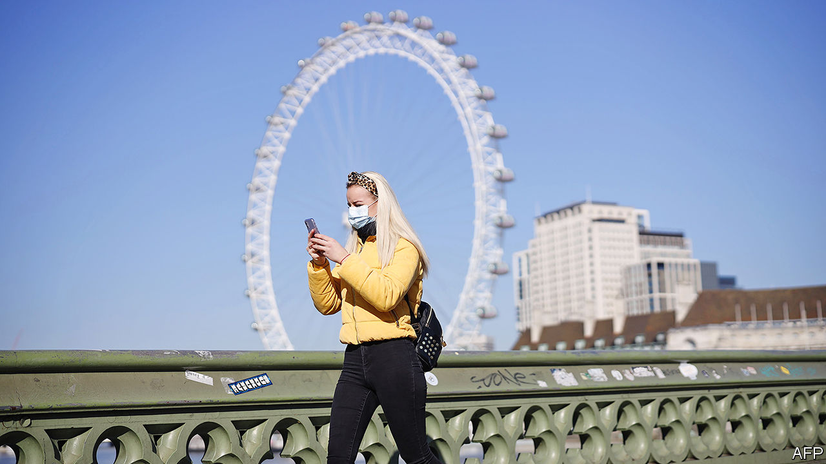

More countries rolled out wartime-like emergency measures to fight covid-19. In Britain people were told to leave home only in limited circumstances; gatherings of more than two people were banned. All non-essential businesses, pubs and restaurants were ordered to shut. The government announced an unprecedented aid package, including paying up to 80% of workers’ wages. The American Congress prepared a $2trn economic-rescue bill, the biggest in modern history, which provides relief to business and direct payments to workers. Germany tore up its strict fiscal rules and launched a raft of emergency measures totalling €750bn ($810bn). See article.

In America more states went into lockdown, but the message to stay indoors was somewhat undermined by Donald Trump’s insistence that some restrictions should be relaxed so that the economy can get working again by Easter.

India’s prime minister, Narendra Modi, sparked panic-buying when he said the entire country would be placed on lockdown within hours for a duration of three weeks to slow the spread of the new coronavirus. He later clarified that food shops and other essential services would remain open. See article.

Abe Shinzo, Japan’s prime minister, announced that the summer Olympics would be delayed by a year because of the pandemic. Athletes have been complaining that restrictions on movement related to the outbreak made it impossible to train. Tokyo’s governor warned of an “explosive spike” in cases in the city. See article.

The government of Bangladesh released on bail Khaleda Zia, the leader of the Bangladesh Nationalist Party, the main opposition, to allow her to seek medical treatment. See article.

The supreme leader of Iran, which is fighting one of the world’s worst outbreaks of covid-19, rejected an offer of aid from America. “Possibly your medicine is a way to spread the virus more,” said Ayatollah Ali Khamenei, revealing an odd worldview. China’s ambassador to America said it was “harmful” to speculate about the origin of covid-19. His remarks appeared aimed at a baseless conspiracy theory, promoted by some Chinese diplomats, that the American army may have brought the virus to China.See article.

## Could it be?

Hubei, the province in China worst-hit by covid-19, allowed most of its people to move freely again, as long as they have no symptoms. Officials said the lockdown of the province’s capital, Wuhan, where the disease was first discovered, would end on April 8th, 11 weeks after it was imposed. China continued to report few if any newly confirmed domestic cases of infection. See article.

The Speaker of Israel’s parliament, Yuli Edelstein, resigned instead of complying with a Supreme Court order to hold a vote on his replacement. The opposition bloc, which won a majority in the last election, hopes to appoint a new Speaker and may seek to bar Binyamin Netanyahu from leading a new government. Mr Edelstein, an ally of the prime minister, had been accused of obstructing those moves.

Prosecutors in Turkey charged 20 Saudi citizens for the murder of Jamal Khashoggi, a Saudi dissident writer, in Istanbul in 2018. A former adviser to the royal family and a former deputy head of intelligence were accused of instigating the killing, the rest with carrying it out.

Risking legal action, Lebanon said it would stop paying its maturing Eurobonds in foreign currencies, as the heavily indebted country deals with an economic and financial crisis.

Boko Haram, a jihadist group operating mainly in north-eastern Nigeria, killed 92 soldiers in an attack on an army base in Chad. In a separate incident the group killed 50 soldiers in Nigeria.

The World Bank and the IMF said that Somalia will qualify for debt relief under the Heavily Indebted Poor Countries Initiative. Outstanding debt of more than $5bn will decline to $557m over three years.

At least 23 prisoners died in a riot at one of Colombia’s largest jails. Prisoners fearful of contracting covid-19 attempted to break out of La Modelo jail in Bogotá.

Political parties in Chile agreed to postpone a plebiscite due to be held on April 26th on whether to set up an assembly to write a new constitution. Bolivia delayed a general election that had been planned for May 3rd. Both are in response to covid-19.

As the covid-19 pandemic deepened in Europe, both Italy and Spain overtook China to become the countries where the largest and second-largest numbers of people have died from the disease. See article.

In Russia, Vladimir Putin put on hold his plans for a popular vote on constitutional changes that could allow him to stay in office for another 16 years. The vote had been scheduled for April 22nd, Lenin’s birthday. He blamed covid-19. The mayor of Moscow criticised his slow response to the crisis.

Alex Salmond, a former leader of the Scottish Parliament, was cleared of sexual assault charges by the high court. The Scottish government has conceded that its own investigation into the matter breached its guidelines. See article.

## Coronavirus briefs

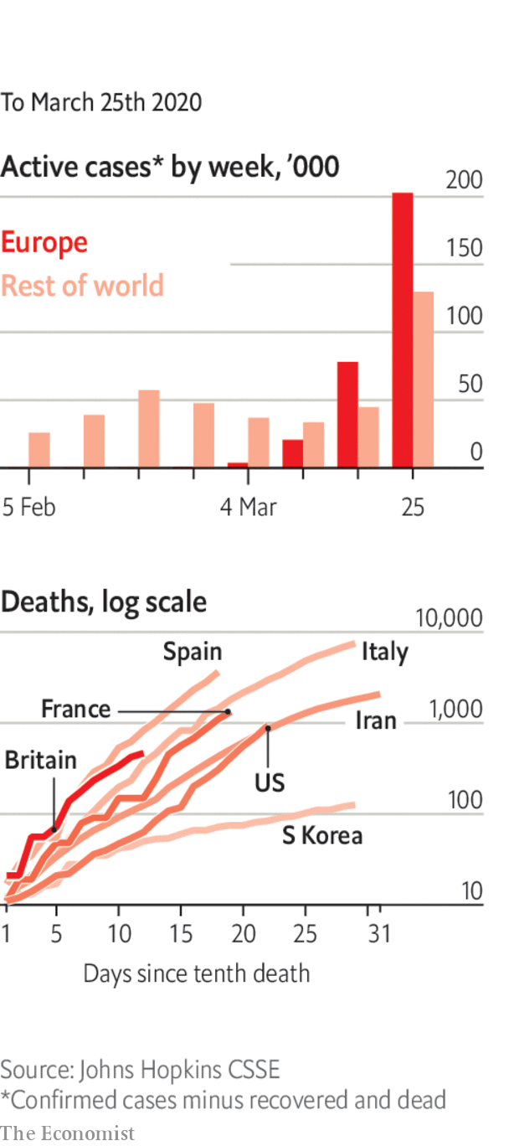

In America, some senators and congressmen were accused of having used intelligence information on the covid-19 outbreak to sell stock before markets crashed.

New York’s governor warned about the “astronomical numbers” of infections in the state, but also said that social distancing seemed to be working.

Amid a wave of panic-buying, the British government urged shoppers to behave responsibly. Hoarders are thought to have £1bn-worth ($1.2bn) of extra food in their kitchens that they have not eaten.

Mississippi followed Texas and Ohio in classifying abortions as non-essential medical procedures during the crisis.

Among those testing positive for covid-19 were Prince Charles and Rand Paul, a Republican senator. Angela Merkel went into self isolation after her doctor tested positive.

This article was downloaded by calibre from <https://www.economist.com/the-world-this-week/2020/03/26/politics-this-week>

|  |  |  |  |
| --- | --- | --- | --- |
|  | Articles | Sections | Next |

|  |  |  |  |
| --- | --- | --- | --- |
| Previous | Articles | Sections | Next |

# Business this week

Mar 26th 2020 |

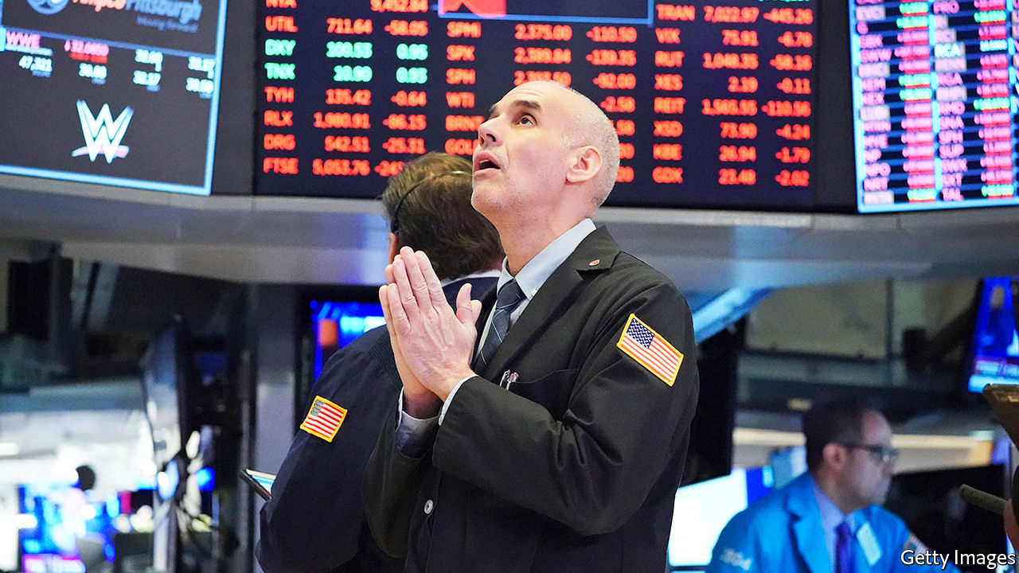

In an unprecedented move the Federal Reserve said it would buy corporate bonds, including new issues and the riskiest investment-grade debt, action that it shied away from during the financial crisis a decade ago. The central bank is using a subsidiary of BlackRock to manage the investments. It is also buying government debt (unlimited quantitative easing), reviving a facility that enables it to absorb securities backed by student, car and credit-card loans, and has pledged to help small businesses. See article.

## Animal spirits

Markets had another manic week, as investors swung between despondency and optimism. On March 24th the S&P 500 rose by 9.4%, its biggest one-day gain since October 2008. The NASDAQ was up by 8% and the Dow Jones Industrial Average by 11.4%. The FTSE 100 and German DAX recorded similar leaps.

Easing the pressure on big banks, the Bank of England cancelled its annual stress tests. This came after the central bank cut its benchmark interest rate to 0.1%, the lowest in its 326-year history.

Responding to plummeting oil prices, Saudi Arabia unveiled a package of aid for the kingdom’s businesses worth $32bn and raised its debt ceiling from 30% of GDP to 50%.

A measure of business activity compiled by IHS Markit fell to record lows for America, Britain and the euro zone. Worse is yet to come. The survey was taken before many of the more stringent lockdowns on companies and personal movement were introduced. See [article.](https://www.economist.com/graphic-detail/2020/03/24/march-pmis-presage-a-precipitous-recession-in-america-and-europe)

With passenger numbers down by 70% on Britain’s railways the government suspended for at least six months the franchise system through which train companies operate on routes. The Department for Transport is doing this so that it can take on all the revenue and cost risk, in effect nationalising any losses. Train companies will continue to run services for a small fee.

The International Air Transport Association increased its estimate of revenue losses for the airline industry this year to $250bn. Global carriers have asked governments to bail them out, but environmentalists want this linked to swifter action on carbon emissions.

Virgin Australia reportedly asked Australia’s antitrust authority to investigate public comments made by Alan Joyce, the chief executive of Qantas, Virgin’s arch-rival. Mr Joyce has suggested that Virgin should not receive state aid during the crisis, implying that it is “badly managed”, and has said he wants his airline to be the “last man standing”. Reports suggest Virgin is worried that Qantas is using the crisis to reduce competition. Meanwhile, and despite stretched credit markets, Qantas was able to raise A$1.1bn ($635m) in bank loans.

Norwegian Air, which was already struggling before covid-19 grounded flights, received its first cash injection from Norway’s government after securing a rescue package for the country’s airlines. Under the deal, commercial lenders provide 10% of loan guarantees and the government the remaining 90%.

Boeing suspended production at its factory near Seattle for two weeks. Washington state has been hit particularly hard by covid-19 and dozens of Boeing’s workers have contracted the disease; one man has died. Airbus reopened its plants in France and Spain after a four-day hiatus, but reduced their output.

Workers at several Amazon warehouses in America tested positive for covid-19, forcing some of them to close while they were cleaned. Amazon is hiring 100,000 more people to cope with a surge in online shopping, but hundreds of employees have signed a petition urging the company to do more to protect them.

A sales update from Target provided a glimpse into the impact of coronavirus on large retailers. Total sales were up by more than 20% in March so far compared with the same month last year, and by 50% for food and household essentials. Clothing sales were down by a fifth, however.

Nike revealed that 80% of the stores that sell its products in China have reopened, after closing in February soon after the start of the virus outbreak.

SoftBank announced a sale of up to ¥4.5trn ($41bn) of assets to fund a share buy-back plan and reduce its debt. The troubled Japanese conglomerate’s share price soared after the announcement. That was not enough to stop Moody’s from cutting its rating for SoftBank’s bonds by two notches.

## Frozen

Just in time for the family lockdown, Disney+ launched in Britain, Germany, Italy, Spain and several other European countries. Being stuck indoors has led to a surge in streaming, which has caused Netflix, Amazon Prime and others to reduce their playback quality in Europe to ensure films don’t stutter.

This article was downloaded by calibre from <https://www.economist.com/the-world-this-week/2020/03/26/business-this-week>

|  |  |  |  |
| --- | --- | --- | --- |
| Previous | Articles | Sections | Next |

|  |  |  |  |
| --- | --- | --- | --- |
| Previous | Articles | Sections | Next |

# KAL’s cartoon

Mar 26th 2020 |

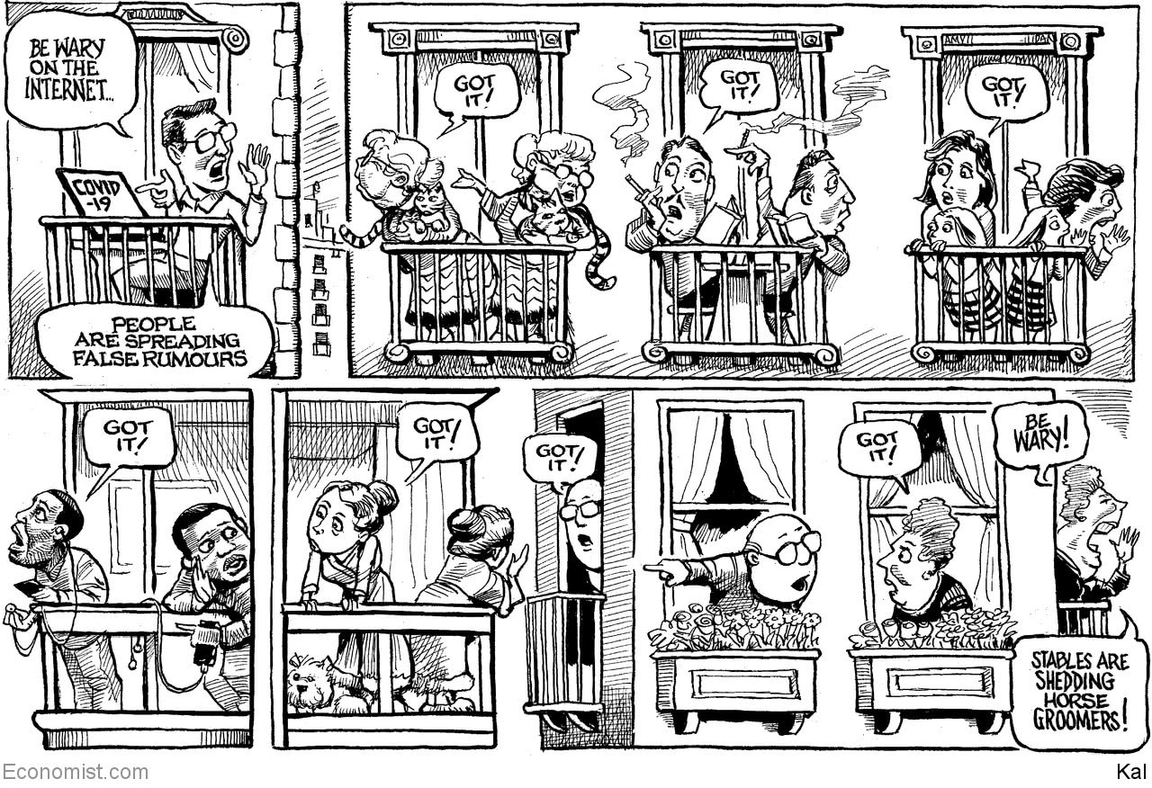

This article was downloaded by calibre from <https://www.economist.com/the-world-this-week/2020/03/26/kals-cartoon>

|  |  |  |  |
| --- | --- | --- | --- |
| Previous | Articles | Sections | Next |

|  |  |  |
| --- | --- | --- |
| The world this week | Sections | Letters |

Leaders

The state and covid-19: Everything’s under control

.

The pandemic: The next calamity

.

America’s rescue package: Mixed medicine

.

Iran and covid-19: Get serious

.

Videoconferencing etiquette: Through the keyhole

.

|  |  |  |
| --- | --- | --- |
| The world this week | Sections | Letters |

|  |  |  |  |
| --- | --- | --- | --- |
|  | Articles | Sections | Next |

#### Everything’s under control

# The state in the time of covid-19

Big government is needed to fight the pandemic. What matters is how it shrinks back again afterwards

Mar 26th 2020 |

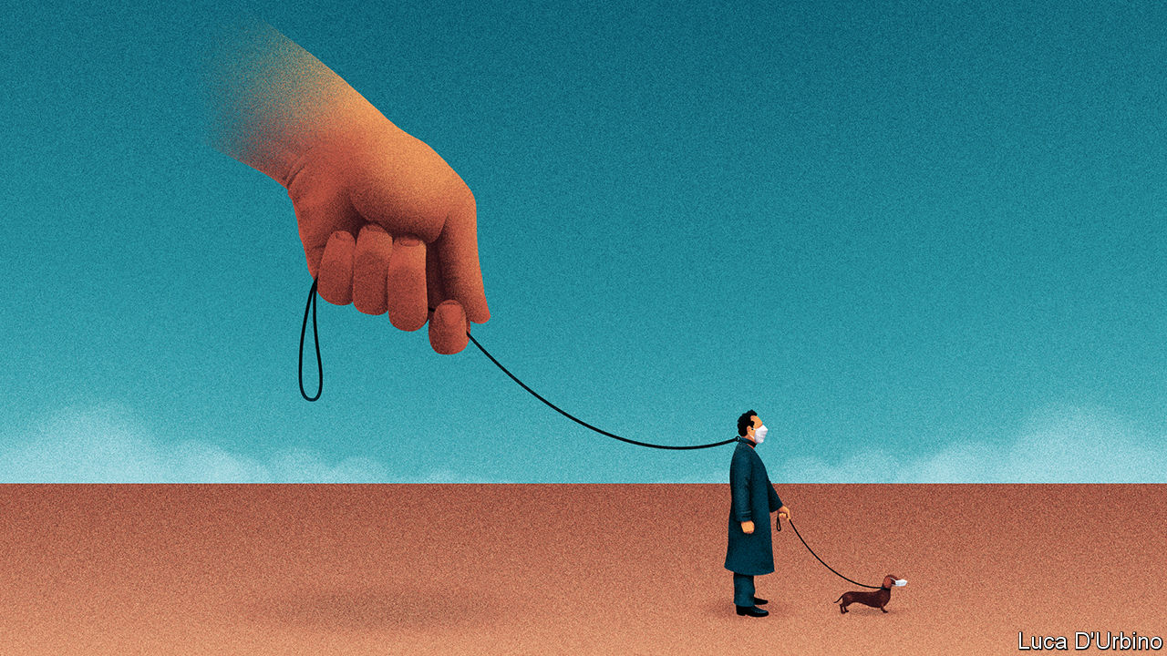

Editor’s note: The Economist is making some of its most important coverage of the covid-19 pandemic freely available to readers of The Economist Today, our daily newsletter. To receive it, register [here](https://www.economist.com/newslettersignup). For more coverage, see our coronavirus [hub](https://www.economist.com/coronavirus)

IN JUST A few weeks a virus a ten-thousandth of a millimetre in diameter has transformed Western democracies. States have shut down businesses and sealed people indoors. They have promised trillions of dollars to keep the economy on life support. If South Korea and Singapore are a guide, medical and electronic privacy are about to be cast aside. It is the most dramatic extension of state power since the second world war.

One taboo after another has been broken. Not just in the threat of fines or prison for ordinary people doing ordinary things, but also in the size and scope of the government’s role in the economy. In America Congress is poised to pass a package worth almost $2trn, 10% of GDP, twice what was promised in 2007-09. Credit guarantees by Britain, France and other countries are worth 15% of GDP. Central banks are printing money and using it to buy assets they used to spurn. For a while, at least, governments are seeking to ban bankruptcy.

For believers in limited government and open markets, covid-19 poses a problem. The state must act decisively. But history suggests that after crises the state does not give up all the ground it has taken. Today that has implications not just for the economy, but also for the surveillance of individuals.

It is no accident that the state grows during crises. Governments might have stumbled in the pandemic, but they alone can coerce and mobilise vast resources rapidly. Today they are needed to enforce business closures and isolation to stop the virus. Only they can help offset the resulting economic collapse. In America and the euro area GDP could drop by 5-10% year-on-year, perhaps more.

One reason the state’s role has changed so rapidly is that covid-19 spreads like wildfire. In less than four months it has gone from a market in Wuhan to almost every country in the world. The past week logged 253,000 new cases. People are scared of the example of Italy, where almost 74,000 recorded cases have overwhelmed a world-class health system, leading to over 7,500 deaths.

That fear is the other reason for rapid change. When Britain’s government tried to hang back so as to minimise state interference, it was accused of doing too little, too late. France, by contrast, passed a law this week giving the government the power not just to control people’s movements, but also to manage prices and requisition goods. During the crisis its president, Emmanuel Macron, has seen his approval ratings soar.

In most of the world the state has so far responded to covid-19 with a mix of coercion and economic heft. As the pandemic proceeds, it is also likely to exploit its unique power to monitor people using their data (see article). Hong Kong uses apps on phones that show where you are in order to enforce quarantines. China has a passporting system to record who is safe to be out. Phone data help modellers predict the spread of the disease. And if a government suppresses covid-19, as China has, it will need to prevent a second wave among the many who are still susceptible, by pouncing on every new cluster. South Korea says that automatically tracing the contacts of fresh infections, using mobile technology, gets results in ten minutes instead of 24 hours.

This vast increase in state power has taken place with almost no time for debate. Some will reassure themselves that it is just temporary and that it will leave almost no mark, as with Spanish flu a century ago. However, the scale of the response makes covid-19 more like a war or the Depression. And here the record suggests that crises lead to a permanently bigger state with many more powers and responsibilities and the taxes to pay for them. The welfare state, income tax, nationalisation, all grew out of conflict and crisis (see article).

As that list suggests, some of today’s changes will be desirable. It would be good if governments were better prepared for the next pandemic; so, too, if they invested in public health, including in America, where reform is badly needed. Some countries need decent sick pay.

Other changes may be less clear-cut, but will be hard to undo because they were backed by powerful constituencies even before the pandemic. One example is the further unpicking of the euro-zone pact that is supposed to impose discipline on the member-states’ borrowing. Likewise, Britain has taken its railways under state control—a step that is supposed to be temporary but which may never be retracted.

More worrying is the spread of bad habits. Governments may retreat into autarky. Some fear running out of the ingredients for medicines, many of which are made in China. Russia has imposed a temporary ban on exporting grain. Industrialists and politicians have lost trust in supply chains. It is but a small step from there to long-term state support for the national champions that will have just been bailed out by taxpayers. Trade’s prospects are already dim (see article); all this would further cloud them—and the recovery. And in the long term, a vast and lasting expansion of the state together with dramatically higher public debt (see article) is likely to lead to a lumbering, less dynamic kind of capitalism.

But that is not the biggest problem. The greater worries lie elsewhere, in the abuse of office and the threats to freedom. Some politicians are already making power grabs, as in Hungary, where the government is seeking an indefinite state of emergency. Israel’s prime minister, Binyamin Netanyahu, appears to see the crisis as a chance to evade a trial for corruption.

The most worrying is the dissemination of intrusive surveillance. Invasive data collection and processing will spread because it offers a real edge in managing the disease. But they also require the state to have routine access to citizens’ medical and electronic records. The temptation will be to use surveillance after the pandemic, much as anti-terror legislation was extended after 9/11. This might start with tracing TB cases or drug dealers. Nobody knows where it would end, especially if, having dealt with covid-19, surveillance-mad China is seen as a model.

Surveillance may well be needed to cope with covid-19. Rules with sunset clauses and scrutiny built in can help stop it at that. But the main defence against the overmighty state, in tech and the economy, will be citizens themselves. They must remember that a pandemic government is not fit for everyday life. ■

Dig deeper:  
For our latest coverage of the covid-19 pandemic, register for The Economist Today, our daily [newsletter](https://www.economist.com/newslettersignup), or visit our [coronavirus hub](https://www.economist.com/coronavirus)

This article was downloaded by calibre from <https://www.economist.com/leaders/2020/03/26/the-state-in-the-time-of-covid-19>

|  |  |  |  |
| --- | --- | --- | --- |
|  | Articles | Sections | Next |

|  |  |  |  |
| --- | --- | --- | --- |
| Previous | Articles | Sections | Next |

#### The next calamity

# Covid-19 could devastate poor countries

It is in the rich world’s self-interest to help

Mar 26th 2020 |

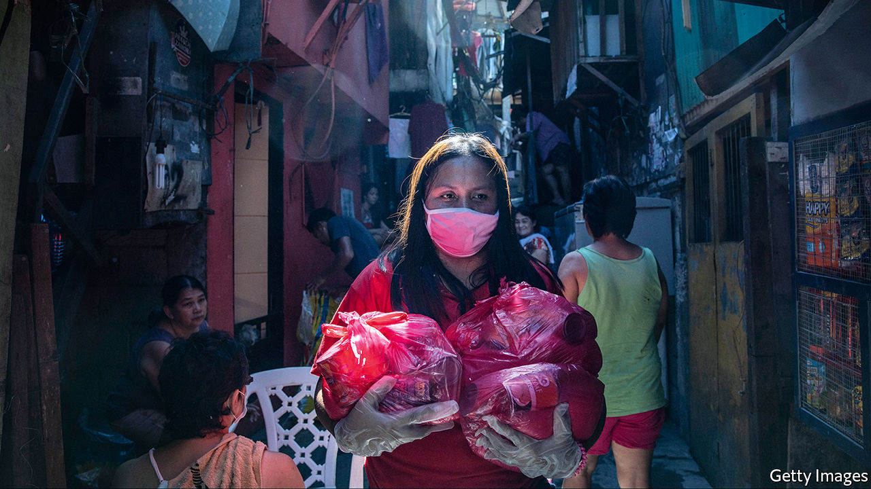

Editor’s note: The Economist is making some of its most important coverage of the covid-19 pandemic freely available to readers of The Economist Today, our daily newsletter. To receive it, register [here](https://www.economist.com/newslettersignup). For more coverage, see our coronavirus [hub](https://www.economist.com/coronavirus)

THE NEW coronavirus is causing havoc in rich countries. Often overlooked is the damage it will cause in poor ones, which could be even worse. Official data do not begin to tell the story. As of March 25th Africa had reported only 2,800 infections so far; India, only 650. But the virus is in nearly every country and will surely spread. There is no vaccine. There is no cure. A very rough guess is that, without a campaign of social distancing, between 25% and 80% of a typical population will be infected. Of these, perhaps 4.4% will be seriously sick and a third of those will need intensive care. For poor places, this implies calamity.

Social distancing is practically impossible if you live in a crowded slum. Hand-washing is hard if you have no running water (see article). Governments may tell people not to go out to work, but if that means their families will not eat, they will go out anyway. If prevented, they may riot.

So covid-19 could soon be all over poor countries. And their health-care systems are in no position to cope. Many cannot deal with the infectious diseases they already know, let alone a new and highly contagious one. Health spending per head in Pakistan is one two-hundredth the level in America. Uganda has more government ministers than intensive-care beds. Throughout history, the poor have been hardest-hit by pandemics. Most people who die of AIDS are African. The Spanish flu wiped out 6% of India’s entire population.

Dozens of developing countries have ordered lockdowns. India has announced a “total ban” on leaving home for 21 days (see article). South Africa has deployed the army to help enforce one. They may slow the disease, but they are unlikely to stop it.

Many places are still in denial. Street markets in Myanmar are packed. Brazil’s populist president, Jair Bolsonaro, dismisses covid-19 as just “a sniffle” (see article). Some leaders are clueless. Tanzania’s president, John Magufuli, said churches should stay open because the coronavirus is “satanic” and “cannot survive in the body of Christ”. Many autocrats see covid-19 as a handy excuse to tighten their grip. Expect some to ban political rallies, postpone elections and extend surveillance over citizens’ daily lives—all to protect public health, of course.

Granted, there are some reasons for hope. Poor countries are young—the median age in Africa is under 20—and the young appear less likely to die from an infection. The poorest are very rural: two-thirds of people in countries with incomes per head below $1,000 a year live in the countryside, compared with less than a fifth in rich countries. Farmers can grow yams without breathing viral droplets on each other. The climate may help. It is possible, though far from certain, that hot weather slows the spread of covid-19. Some places have useful experience. Countries that endured Ebola learned a lot about hand-washing, contact-tracing and securing public trust.

Alas, even the good news comes with caveats. People in poor countries may be young, but they often have weak lungs or immune systems, because of malnutrition, tuberculosis or HIV. Rural folk may get the virus later, but they will probably still get it. Lockdowns will be hard to sustain unless governments can provide a generous safety-net. Firms need credit to avoid laying off staff. Informal workers need cash to tide them over. Unfortunately, poor countries do not have the financial muscle to provide these things, and covid-19 has just made it much harder.

Demand has collapsed for the commodities on which many emerging markets depend, from crude oil to fresh flowers. Tourism has tanked. No one wants to visit the Masai Mara or Machu Picchu just now. Foreign investors have pulled $83bn from emerging markets since the start of the crisis, the largest capital outflow ever recorded, says the Institute of International Finance, a trade group. Remittances, usually a safety-net in hard times, may tumble as migrants in rich countries lose their jobs.

Many poor and middle-income countries face a balance-of-payments crisis and a collapse in government revenues as they need to raise health-related spending and imports (to reduce the death toll) and welfare (so that workers can isolate themselves without running out of money). Whereas governments in rich countries can borrow cheaply in a crisis as investors flock to safety, poor countries see their borrowing costs soar. The trade-off between saving lives and saving livelihoods is excruciating. The worry, as Imran Khan, Pakistan’s prime minister says, is that “if we shut down the cities...we will save [people] from corona at one end, but they will die from hunger.”

Far from helping, many better-off countries have taken a nationalist turn. Some places, such as the EU, are restricting the export of medical kit. That goes against the values they profess to hold. Other countries, such as Kazakhstan, are curbing exports of food, which is not in short supply. If global trade is gummed up, the economic damage will be far greater. For poor countries that rely on imported food, it could be deadly.

Since so much remains unknown about covid-19, any response must be based on imperfect information. But some things are both urgent and obvious. Governments in poor countries, as elsewhere, should supply people with timely, accurate information, by any means practical. No cover-ups, no internet shut-downs, no arresting of those who share unwelcome news.

## Time to be generous

The rich world, meanwhile, should help the poor world swiftly and copiously. The IMF says it is ready to deploy its $1trn lending capacity. Much more may be needed. As The Economist went to press, the G20 was about to set out a plan. It should be generous. Some of those vast rich-world bail-out pots should be used to cushion the suffering of the global south. China is winning influence with high-profile deliveries of medical equipment. Poor countries will remember who helped them.

As past campaigns against malaria and HIV showed, it takes a co-ordinated global effort to roll back a global scourge. It is too late to avoid a large number of deaths, but not too late to avert catastrophe. And it is in rich countries’ interests to think globally as well as locally. If covid-19 is left to ravage the emerging world, it will soon spread back to the rich one. ■

Dig deeper:  
For our latest coverage of the covid-19 pandemic, register for The Economist Today, our daily [newsletter](https://www.economist.com/newslettersignup), or visit our [coronavirus hub](https://www.economist.com/coronavirus)

This article was downloaded by calibre from <https://www.economist.com/leaders/2020/03/26/covid-19-could-devastate-poor-countries>

|  |  |  |  |
| --- | --- | --- | --- |
| Previous | Articles | Sections | Next |

|  |  |  |  |
| --- | --- | --- | --- |
| Previous | Articles | Sections | Next |

#### The medicine tastes bad

# America’s emergency stimulus is imperfect but necessary

Like past rescue packages, this one could leave a lingering sense of unfairness

Mar 26th 2020 |

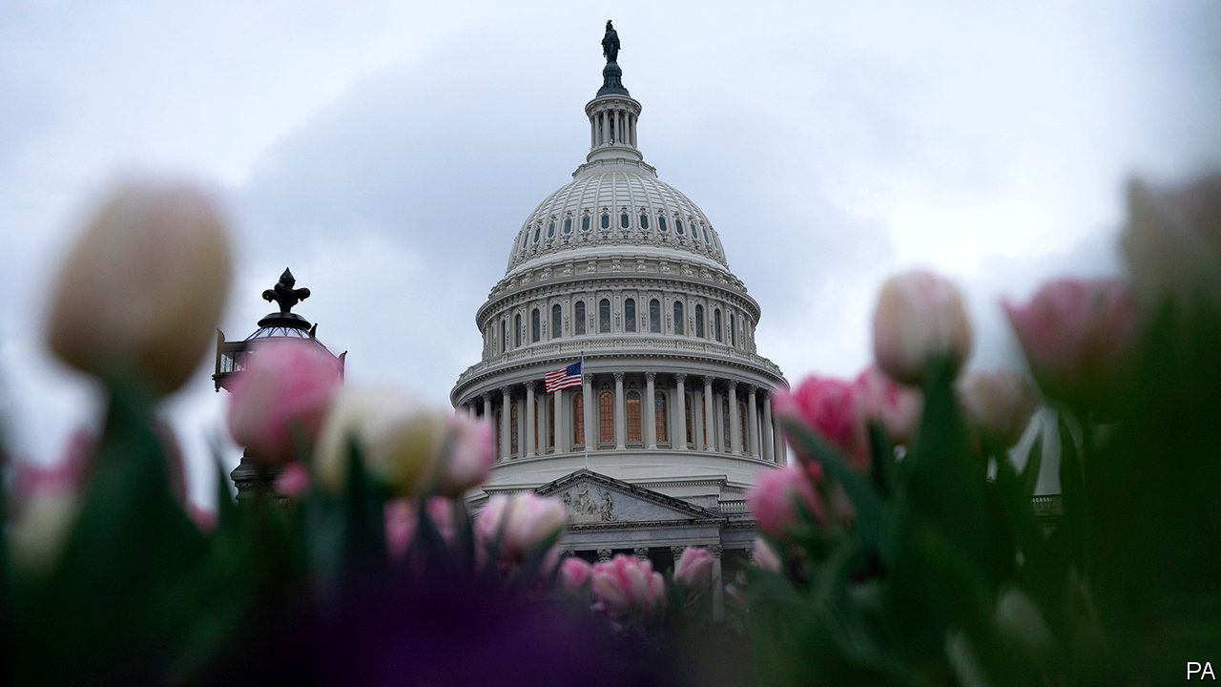

Editor’s note: The Economist is making some of its most important coverage of the covid-19 pandemic freely available to readers of The Economist Today, our daily newsletter. To receive it, register [here](https://www.economist.com/newslettersignup). For more coverage, see our coronavirus [hub](https://www.economist.com/coronavirus)

NO TEXTBOOK WAS ever written to tell economists what to do in the face of the extraordinary economic hiatus caused by covid-19. Yet as they consider the deserted malls, abandoned offices and billions of lives on hold, the overarching responsibilities of economic policymakers are clear. First, they must protect the incomes of those who cannot work during lockdowns through no fault of their own. Second, they must make sure that growth bounces back fast when daily life resumes.

The enormous emergency spending bill due to be passed by America’s Congress—which will cost the taxpayer about $2trn (10% of GDP) up front and support much more in new lending—goes some way to discharging both duties. It beefs up unemployment benefits, provides emergency loans and grants to small businesses, and gives $1,200 unconditionally to most Americans. When combined with the ultra-loose monetary policy of the Federal Reserve, which this week announced that it would buy government and mortgage debt in unlimited quantities, the fiscal boost will underpin growth once lockdowns are lifted. America now stands in contrast to some other parts of the world, such as the euro area, where markets expect a prolonged disinflationary slump (see article).

But the bill also brings dangers. Markets cheered it not just because of its likely effect on growth, but also because it directly benefits investors. Large firms will have access to cheap taxpayer-financed loans on an unprecedented scale. The Fed had already announced, on March 23rd, that it would buy companies’ short-term debt. Congress is now giving the central bank a capital infusion to support vast direct lending to corporate America. Emergency interventions like these shift the costs of the crisis away from investors and towards taxpayers (see article).

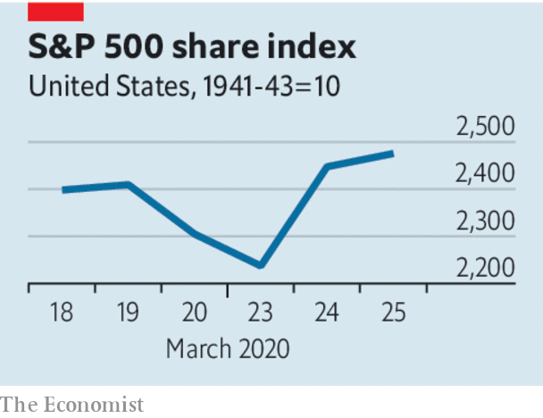

That is partly necessary, because letting a large number of big firms go bankrupt could prove so disruptive that it would worsen the crisis. And investors are not completely undeserving beneficiaries. No firm could have been expected to stockpile cash to pay workers to do nothing in the event of a government-enforced lockdown. The real potential unfairness in the stimulus is that aid to large firms is the part of the rescue package that is most likely to work without a hitch. Sophisticated corporations will have no trouble borrowing from the Fed or from backstopped capital markets, even as they lay off some workers (prohibited only “to the extent practicable”). But aid to small firms, and directly to the jobless, may turn out to be less than comprehensive.

Small businesses employ 52% of private-sector workers. Half have a cash buffer of less than one month, by one estimate. The bill starts a new programme to lend to them directly. The part of any government loan used to pay wages, utility costs, rent or mortgages will be forgiven—except if firms lay off workers, in which case the subsidy will be reduced in proportion to the number of jobs lost. This scheme is more complex than those in some European countries, under which governments are paying most of the wages of suspended workers. It is hard to imagine that its administration will be quick and efficient. And some analysts think the pot of money on offer is too small (see article). Those most adept at navigating the bureaucracy may get most of the benefit.

Cash handouts to the public are simple enough. But $1,200 is not much help for a laid-off worker. The jobless will rely on the bill’s temporary expansion of unemployment insurance benefits by $600 per week. Yet America cannot construct an adequate social safety-net overnight. For example, 8.5% of Americans lack health insurance. Some workers who are laid off will join their ranks just as they face a heightened risk of falling ill.

Make no mistake: we would vote for the bill, most of which is urgent and necessary. But it is far from perfect. And just like past emergency stimulus, it could work better for big firms than for anyone else, leaving a lingering sense of injustice. ■

Dig deeper:  
For our latest coverage of the covid-19 pandemic, register for The Economist Today, our daily [newsletter](https://www.economist.com/newslettersignup), or visit our [coronavirus hub](https://www.economist.com/coronavirus)

This article was downloaded by calibre from <https://www.economist.com/leaders/2020/03/26/americas-emergency-stimulus-is-imperfect-but-necessary>

|  |  |  |  |
| --- | --- | --- | --- |
| Previous | Articles | Sections | Next |

|  |  |  |  |
| --- | --- | --- | --- |
| Previous | Articles | Sections | Next |

#### Get serious

# Iran cannot fight covid-19 with conspiracy theories

Try public-health policies instead

Mar 26th 2020 |

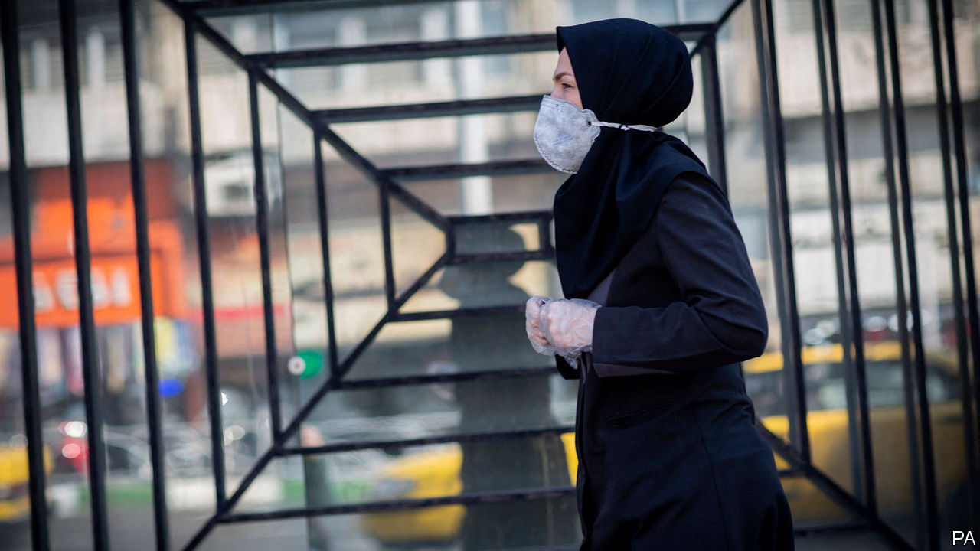

Editor’s note: The Economist is making some of its most important coverage of the covid-19 pandemic freely available to readers of The Economist Today, our daily newsletter. To receive it, register [here](https://www.economist.com/newslettersignup). For more coverage, see our coronavirus [hub](https://www.economist.com/coronavirus)

AS COVID-19 BEGAN spreading across Iran in February, the regime held a rigged election. Weeks later, when nearly 10% of Iranian MPs were infected and it was clear the country had a problem, the ruling clerics refused to close crowded holy spots. Even as it dug mass graves, the government hushed up the scale of the epidemic. Now its leaders are propounding conspiracy theories, such as that covid-19 is an American bioweapon. Rejecting an offer of American aid, Iran’s supreme leader said: “Possibly your medicine is a way to spread the virus more.”

Officially, Iran has suffered over 27,000 cases and 2,000 deaths. All countries undercount, but Iran wilfully minimised the numbers at the outset. Hundreds of thousands have been infected and many will die. That is partly because American sanctions have made it harder to cope. But Iran’s leaders have also mismanaged the crisis. Like officials elsewhere, they have been refusing to quarantine cities or ban large gatherings. Worse, they are placing their confrontational worldview above public health.

The clerics claim they are doing a fine job. Iran has produced more face masks than Italy and tested more people than Britain. Military factories are now making personal protective equipment, oxygen canisters and hospital beds. The government has turned stadiums into isolation centres and increased the number of laboratories testing for the virus from two to almost 60. It has referred 62,000 people to health facilities. Volunteers are distributing hundreds of thousands of food parcels to those who cannot leave their homes. The effort is “unparalleled” in the Middle East—and even much of Europe—says an official at the WHO.

However, the government is doing little to stop the spread of the virus. Malls are still open. Parks are packed. Popular shrines have at last been closed. Nevertheless, many converged on the holy city of Mashhad for Nowruz, the Persian new-year festival, on March 20th. Hundreds jammed the streets of Tehran three days later to touch the coffin of a prominent soldier. On March 25th President Hassan Rouhani at last promised travel bans between cities, but he has dismissed calls to lock down the country. Other officials deflect blame. “A huge part of the danger Iranians face is due to the United States,” says Muhammad Javad Zarif, the foreign minister.

America could certainly do more to help Iran. Its offer of aid means little as long as its sanctions remain rigid. American officials claim that the sanctions allow for the import of medical supplies. But most trade is impossible because banks will not handle transactions with Iran, for fear of America’s wrath. Workarounds set up by European countries, and even one by America, have failed to increase the flow of covid-fighting kit.

Iran is reluctant to enforce a complete nationwide lockdown because it does not have the money to pay people to stay at home. If millions do not show up for work, their families will go hungry. Yet despite pleas to relax sanctions, at least temporarily, America has recently announced new ones.

That bolsters Mr Zarif’s argument that sanctions are keeping Iran from getting the help it needs. But the foreign minister is being disingenuous: his government is also rejecting aid from Médecins Sans Frontières (MSF). Two planeloads of equipment sent by the international NGO have been left on the tarmac at Imam Khomeini airport. A team of MSF doctors was also turned away.

Perhaps they were not needed, as some officials claimed. But state media absurdly portrayed MSF’s efforts as part of an American spying operation. “Iran does not need hospitals established by foreigners,” said a health official. Iran’s leaders, it seems, prefer to confront the outside world rather than engage with it. Their prejudice will cost Iranian lives. ■

Dig deeper:  
For our latest coverage of the covid-19 pandemic, register for The Economist Today, our daily [newsletter](https://www.economist.com/newslettersignup), or visit our [coronavirus hub](https://www.economist.com/coronavirus)

This article was downloaded by calibre from <https://www.economist.com/leaders/2020/03/26/iran-cannot-fight-covid-19-with-conspiracy-theories>

|  |  |  |  |
| --- | --- | --- | --- |
| Previous | Articles | Sections | Next |

|  |  |  |  |
| --- | --- | --- | --- |
| Previous | Articles | Sections | Next |

#### Through the keyhole

# Videoconferencing etiquette

Working and entertaining online pose new challenges—and require new thinking

Mar 26th 2020 |



Editor’s note: The Economist is making some of its most important coverage of the covid-19 pandemic freely available to readers of The Economist Today, our daily newsletter. To receive it, register [here](https://www.economist.com/newslettersignup). For more coverage, see our coronavirus [hub](https://www.economist.com/coronavirus)

AROUND THE world, coronavirus lockdowns have driven professional and social life out of the physical world and into the virtual realm. Though self-isolation means no longer seeing friends and colleagues in person, it has opened a sudden and alarming window on their private, domestic selves. Many readers, videoconferencing for hours every day, will find themselves unexpectedly familiar with other people’s kitchen layouts, wall decorations and interior design—depending, that is, on how they position their devices. (Never have so many ceilings been broadcast to so many for so long.)

For those unused to working from home, the sudden disappearance of boundaries between domestic and professional life can be trying (see article). But what about the lack of boundaries between other people’s homes and your own? Letting crowds of colleagues and acquaintances peer into your life can be unsettling, but it has one advantage: it opens up new opportunities for oneupmanship.

Even cramped living quarters can be subtly altered to create an impression of space. Simply move the desk to one side of the room, the sofa to another and the bed to a third. A lick of different-coloured paint on all those walls, and a couple of trompe-l’oeil posters of windows, looking out onto rolling countryside on one side and a secluded beach on the other, and—voilà!—over the course of a few meetings your studio flat is transformed into a mansion on an extensive beachside estate. If you have the necessary equipment and technical skills, of course, you can opt for a virtual background instead, and appear to be hovering over the city in your personal airship, or relaxing on your yacht.

Props can also help. If your bookshelves are visible, rearrange the books so the titles behind your head suit the occasion. For the intellectual soirée, the obscure Scandinavian novelist and the existential philosopher you never quite got around to reading will do nicely; for the professional backdrop, reach for Sun Tzu and Nassim Nicholas Taleb; for the high-net-worth cocktail gathering, bring out the hand-tooled leather-bound classics. Remember that high-definition cameras have sharp eyes: well-thumbed copies of “The Joy of Sex” are best left out of sight.

Electronics should, by and large, be invisible, as there is an inverse relationship between social status and size of televisions. High-end audio gear or home-cinema equipment, however, is acceptable in the background, suggesting as it does a superior, artsy approach to entertainment; steering the conversation towards the merits of valve amplifiers or the “texture” of a director’s oeuvre will let you advertise its presence in your house. Ostentatious sports equipment—golf clubs, skis, a Purdey shotgun—can be borrowed from friends and left just visible in a corner, implying a vast hinterland of expensive entertainments that are awaiting you once the lockdown is over.

What of the risk that the sudden appearance of screaming, chocolate-smeared children will undermine the impression of domestic perfection? Best if you can to hide them away in another room—“Minecraft” might keep them occupied—or dress them smartly and persuade them to serve you with trays of tea and biscuits or canapés, as appropriate. Either approach will convey the desired impression of domestic order and deference, to contrast pleasingly with the yells and curses to be heard in the background of your friends’ and colleagues’ homes.

Humanity is now coming together to fight a common enemy. In these dark times, it is essential to maintain some of the pillars of normal life—such as showing that you’re doing better than everybody else. ■

Dig deeper:  
For our latest coverage of the covid-19 pandemic, register for The Economist Today, our daily [newsletter](https://www.economist.com/newslettersignup), or visit our [coronavirus hub](https://www.economist.com/coronavirus)

This article was downloaded by calibre from <https://www.economist.com/leaders/2020/03/26/videoconferencing-etiquette>

|  |  |  |  |
| --- | --- | --- | --- |
| Previous | Articles | Sections | Next |

|  |  |  |
| --- | --- | --- |
| Leaders | Sections | Briefing |

Letters

Letters to the editor: On Taiwan, Myanmar, primaries, elephants, Freeman Dyson, congenital diseases, house names

.

|  |  |  |
| --- | --- | --- |
| Leaders | Sections | Briefing |

|  |  |  |  |
| --- | --- | --- | --- |
|  | Articles | Sections | Next |

#### On Taiwan, Myanmar, primaries, elephants, Freeman Dyson, congenital diseases, house names

# Letters to the editor

A selection of correspondence

Mar 26th 2020 |

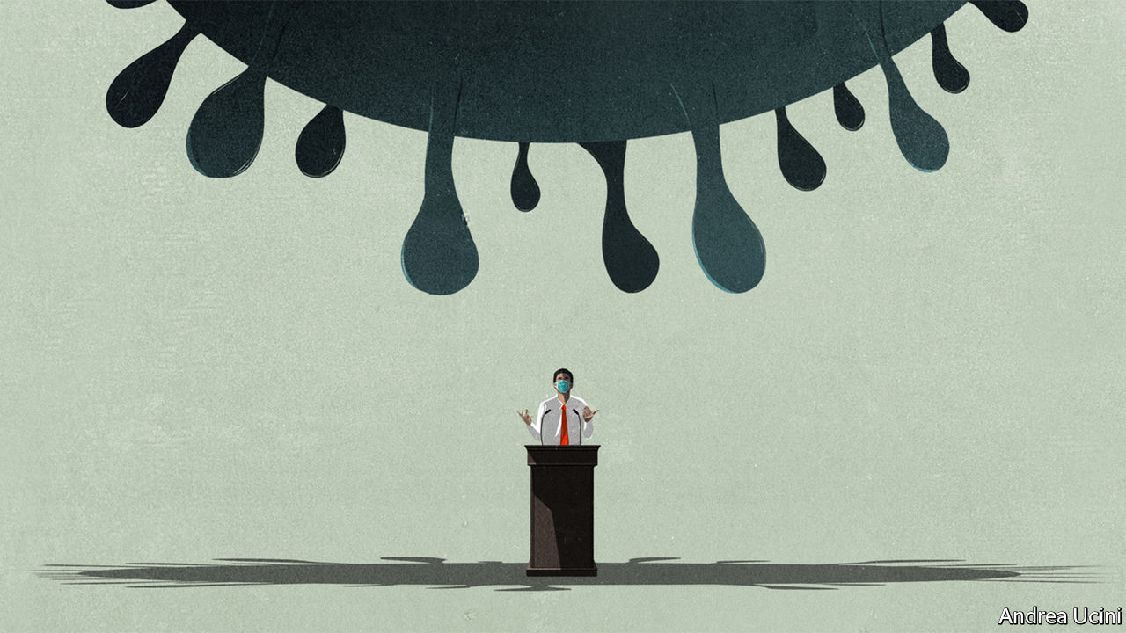

## Taiwan’s response to covid-19

Countries are indeed struggling to cope with covid-19 (“[The politics of pandemics](https://www.economist.com/leaders/2020/03/12/the-politics-of-pandemics)”, March 14th). But China’s approach is not the only way to suppress its spread. Taiwan has relatively few cases of the disease. Learning harsh lessons from the SARS crisis in 2003, the government of Taiwan acted swiftly and established a central command centre in order to respond to the outbreak. Taiwan’s health minister held press conferences almost every day to provide updates and information. Tests on travellers from Wuhan, the Chinese city where the outbreak started, began in December, one month ahead of China. Technology using big-data analysis was applied for intensive health monitoring.

Despite being excluded from participating in the World Health Organisation because of pressure from China, Taiwan sent an early warning to the international health body about the risk of transmission of the coronavirus between humans at the end of December. However, the warning was not shared with other countries by the WHO because of its relationship with China. That error ultimately delayed the global response to the pandemic. The politics of pandemics, which exists inside the WHO as well as between states, should be unacceptable to any country that cares about public health.

The Chinese propaganda machine is trying to convince the world that its draconian response to the coronavirus is the only way to combat its spread; other countries are following its lead. Taiwan proves that democracies can successfully fight the virus without an authoritarian response. Given the nature of China’s autocratic system, Taiwan should serve as a better democratic model for managing pandemics.

DAVID LIN  
Taipei Representative Office in the United Kingdom  
London

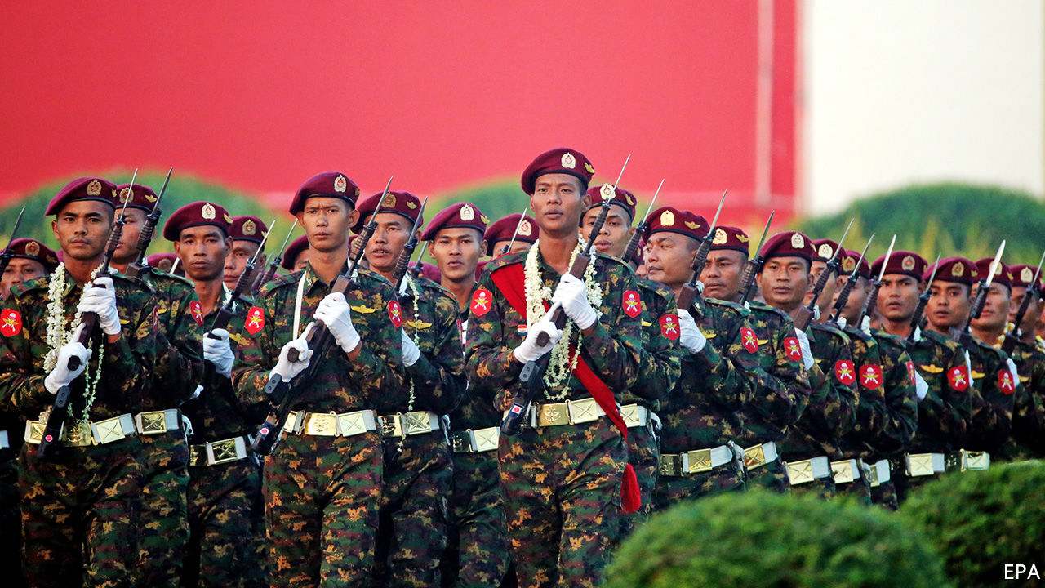

## Politics in Myanmar

You provided good context for the recent failure by civilian lawmakers to limit the generals’ power in Myanmar (“[Making war and law](https://www.economist.com/asia/2020/03/12/myanmars-army-blocks-constitutional-reforms)”, March 14th). Since 1962 the armed forces have determined to control power in perpetuity, which they have accomplished through rule by decree (1962-74, 1988-2011), a single-party socialist system controlled by the army (1974-88), and, since the manipulated elections in 2010, through a constitution which the generals dictate and cannot be altered without their approval. Yet this continuous military control was not only based on command of all forces of coercion, but, until recently, all avenues of social mobility (a contrast with all other armies in Asia with no such pervasive power). That has now gradually broken down through political, economic, educational and civil advances. Military control will probably ebb, though slowly and in relation to assurances of the unity of the state and the army’s autonomy from civilian political restraints. But the local elections of 2020 will not change that trajectory.

DAVID STEINBERG  
Professor emeritus of Asian studies at Georgetown University  
Bethesda, Maryland

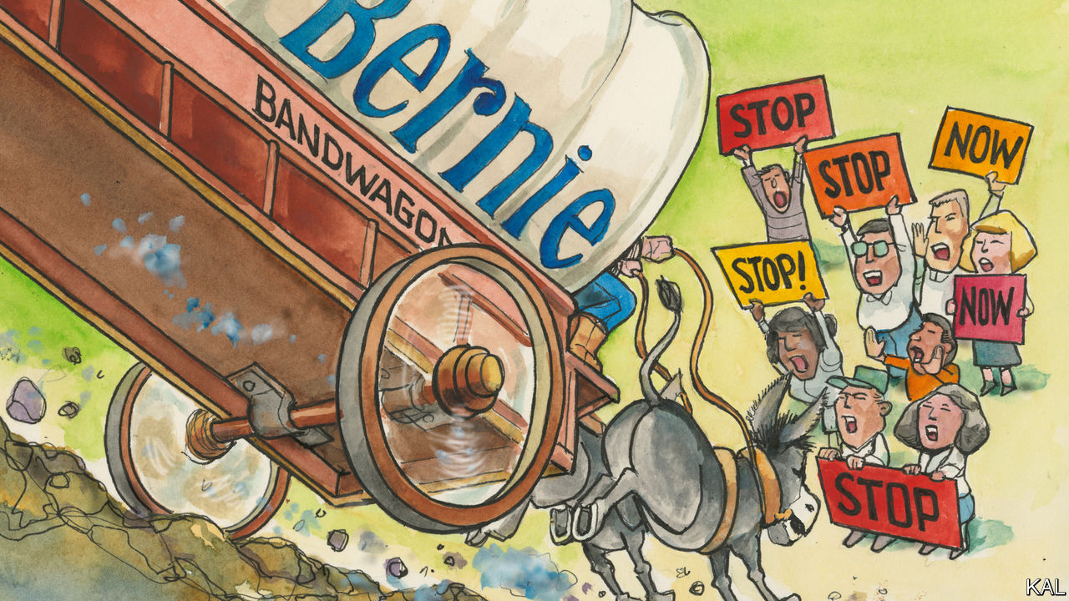

## The primary problem

[Lexington](https://www.economist.com/united-states/2020/02/29/the-primary-problem) was right to point out that our primary system poorly reflects the public interest (February 29th). The column referred to a paper by the Brookings Institution, which says that “party organisations need to find ways to reassert more control over their candidate selection processes before candidates reach the primary ballot.”

The error is in the way we vote. When only a single vote is allowed, moderates split their votes and radicals win. There are several better options, such as “approval voting”, which was recently implemented in Fargo, North Dakota, and will soon be on the ballot in St Louis. It favours consensus and increases the quality of candidates by not being vulnerable to vote splitting. Americans should try several different local methods, so that we can ultimately replace the current silly national system.

FELIX SARGENT  
Chair  
Board of directors  
Centre for Election Science  
Oakland, California

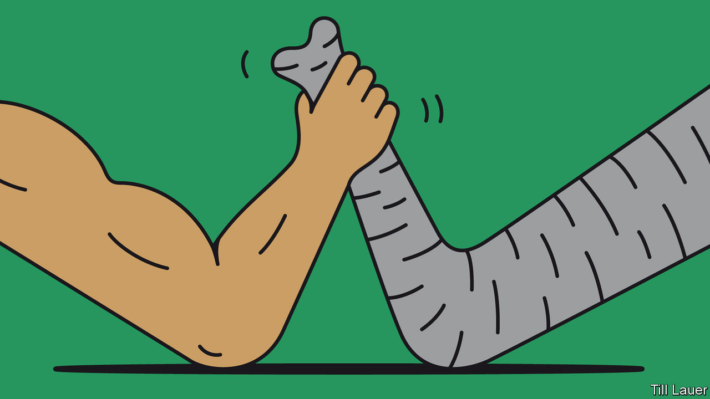

## Getting elephants to bee-have

Conflict between humans and elephants remains a problem in many parts of the world, including Sri Lanka ([Banyan](https://www.economist.com/asia/2020/02/27/of-all-sri-lankas-conflicts-the-one-with-elephants-is-the-oldest), February 29th). There is a very simple and cost-effective natural solution: beehive fences. Elephants are terrified of bees and will flee at even the sound of them. Beehive fences involve wires strung between hives; if elephants walk through the wires they irritate the bees, which swarm out and chase them away. Lucy King developed the concept and it is now used widely in east Africa (see her recent TED talk). Not only is it an effective deterrent, farmers can also make money from selling honey.

RICHARD MILBURN  
King’s College London



## Vital writing on viruses

In this particular moment of crisis, Freeman Dyson’s ideas on the origin of life are of particular interest ([Obituary](https://www.economist.com/obituary/2020/03/12/freeman-dyson-died-on-february-28th), March 14th). In a humble “not scientific theory”, Dyson proposed that RNA, the information engine of viruses, was at the origin of cells’ DNA. With time, the RNA and the cells learned how to collaborate and “grew gradually into a harmonious unity”. Dyson was a supporter of the idea that symbiosis, or collaboration, is among the driving forces behind evolution in cells as much as in societies. He answered an unsolicited email I sent him last January with kind words: “At age 96, I am lucky to be still smart enough to know that I am not as smart as I used to be.” Kindness and humbleness often go together. He was still one of the smartest people on the planet when he wrote those words.

MARIO ALEMIMilan



## The meaning of congenital

Your piece on curing rare genetic diseases with targeted therapies showed what can be done with analysis of our DNA (“[Broken](https://www.economist.com/technology-quarterly/2020/03/12/congenital-diseases-reveal-a-lot-about-human-biology)”, March 14th). Unfortunately its subheading was “Congenital disease”. Congenital means originating from the time of birth and covers genetic and non-genetic defects, like my own congenital anosmia. I don’t intend to have my gene analysed in order to be able to smell.

PETER TOMPKINS  
London

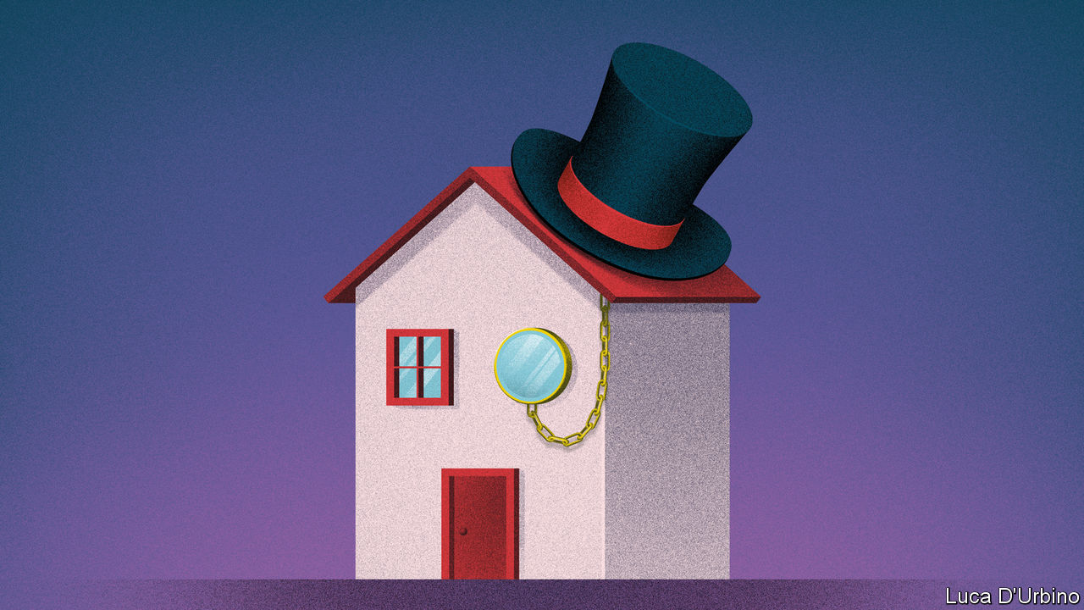

## Living in Arcadia

I was amused to read your piece on British house names (“[Dun Namin](https://www.economist.com/britain/2020/03/12/why-britons-house-names-reflect-their-class-anxieties)’”, March 14th). Some of us did not have a choice. When we moved to our house 16 years ago there were numbers on the opposite side of the road but not ours, so we had to choose a name. Haslemere incidentally is a postman’s hell for two reasons: a very high number of named houses and many steep hills.

JOCK GARDNER  
Haslemere, Surrey

There is a sixth category of house names: the professions. My uncle, a pharmacist, called his house Nux Vomica.

KEITH HUNTERLondon

When I dealt with retired personnel in the Royal Air Force an inordinate number of them named their home Llamedos. Eventually, I realised the connection to Dylan Thomas’s Llareggub, “bugger all”.

CLIVE RAINBOW  
Speen, Berkshire

This article was downloaded by calibre from <https://www.economist.com/letters/2020/03/26/letters-to-the-editor>

|  |  |  |  |
| --- | --- | --- | --- |
|  | Articles | Sections | Next |

|  |  |  |
| --- | --- | --- |
| Letters | Sections | United States |

Briefing

The pandemic and the state: Creating the coronopticon

.

Economic policy and the virus: Building up the pillars of state

.

|  |  |  |
| --- | --- | --- |
| Letters | Sections | United States |

|  |  |  |  |
| --- | --- | --- | --- |
|  | Articles | Sections | Next |

#### Creating the coronopticon

# Countries are using apps and data networks to keep tabs on the pandemic

And also, in the process, their citizens

Mar 26th 2020 | HONG KONG, SINGAPORE, SAN FRANCISCO, SEOUL AND TAIPEI

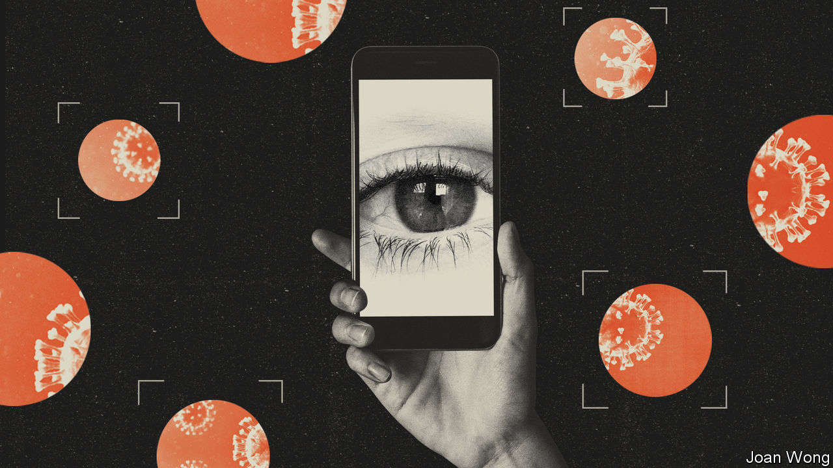

Editor’s note: The Economist is making some of its most important coverage of the covid-19 pandemic freely available to readers of The Economist Today, our daily newsletter. To receive it, register [here](https://www.economist.com/newslettersignup). For more coverage, see our coronavirus [hub](https://www.economist.com/coronavirus)

HAVING BEEN quarantined at his parents’ house in the Hebei province in northern China for a month, Elvis Liu arrived back home in Hong Kong on February 23rd. Border officials told him to add their office’s number to his WhatsApp contacts and to fix the app’s location-sharing setting to “always on”, which would let them see where his phone was at all times. They then told him to get home within two hours, close the door and stay there for two weeks.

His next fortnight was punctuated, every eight hours, with the need to reactivate that always-on location sharing; Facebook, which owns WhatsApp, requires such affirmation so people do not just default to being tracked. Compared with his first lockdown—in a spacious apartment, with family and dogs for company—the ten-square-metre flat with two tiny courtyard-facing windows was grim. When he emerged, on March 8th, he immediately donned mask, goggles and gloves and took a ferry to the island of Lamma where he galloped down lush forest trails for 30km, high on freedom, injuring his knees in the process. He still has trouble sleeping. But he is fit to work, and Hong Kong is content that he poses no risk to the health of his fellow citizens.

Mainland China and South Korea have reduced the number of reported new covid-19 cases down to around 100 a day or less; Hong Kong, Singapore and Taiwan never saw steep rises in the first place (see chart 1). Now they all face the same challenge: how to limit the all-but-inevitable rise in cases that will follow when they relax current controls, a rise which can already be seen in some places. To meet that challenge they are all turning to information technology.

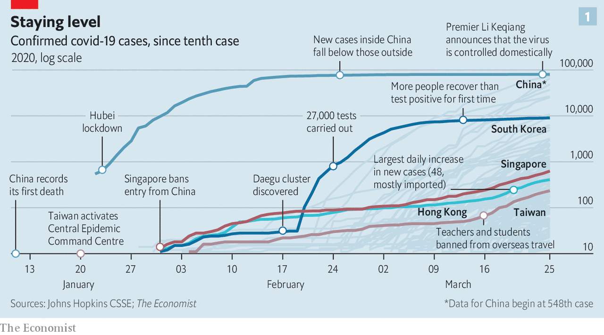

Their efforts, like others elsewhere, are experimental. They risk failure; they also risk adverse side-effects, most obviously on civil liberties. But around 2.5bn people have now been put on some sort of lockdown during the pandemic (see chart 2). Only a fraction of them have been or will be infected, and thus become immune. The rest, when they emerge, will need watching—for their own sakes, and for the sakes of those around them.

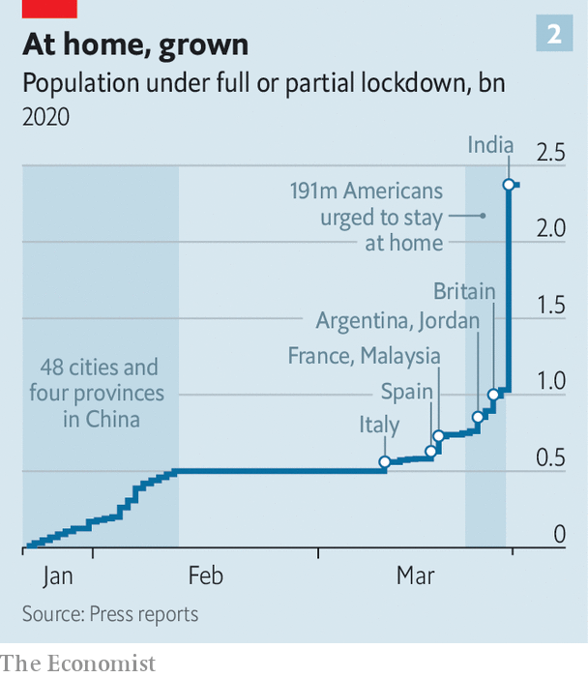

The tools in use fall into three categories. The first is documentation: using technology to say where people are, where they have been or what their disease status is. The second is modelling: gathering data which help explain how the disease spreads. The third is contact tracing: identifying people who have had contact with others known to be infected.

When it comes to documentation, most of the action is in quarantine: replacing phone calls and home visits with virtual checking-up. While Hong Kong uses WhatsApp, South Korea has a customised app that sounds an alarm and alerts officials if people stray; as of March 21st 42% of the 10,600 people under quarantine there were using the app. Taiwan uses a different approach, tracking quarantined people’s phones using data from cell-phone masts. If it detects someone out of bounds, it texts them and alerts the authorities. Leaving quarantine without your phone can incur a fine; in South Korea fines for breaking quarantine are hefty, and will soon be accompanied by the threat of prison.

Phones need not just send data back to the government; they can also pass data on to third parties. China’s Health Check app, developed by provincial governments and run through portals in the ubiquitous payment apps Alipay and WeChat, takes self-reported data about places visited and symptoms to generate an identifying QR code that is displayed in green, orange or red, corresponding to free movement, seven-day and 14-day quarantines. It is not clear how accurate the system is, but Alipay says people in more than 200 cities are now using their Health Check status to move more freely.

## Cellular biology

A group of academics, developers and public-health officials from the World Health Organisation (WHO) and elsewhere are building a similar WHO MyHealth app. When reliable tests for immunity—whether gained through infection or, one day, vaccination—become available, such documentation apps may be used to communicate their results in some places, too.

When it comes to helping with modelling and situational awareness, there is a wealth of data. Phone companies know roughly where all their mobile customers are from what cell their phones are using. And because advertisers will pay to tailor ads, internet companies such as Bytedance, Facebook, Google and Tencent gather scads of data about what their billions of users are doing where. Modellers can use data from both kinds of company to fine-tune predictions of the spread of disease.

Governments can use the same data to check how their policies are performing at a district or city level. In Germany Deutsche Telekom has provided data to the Robert Koch Institute, the government’s public-health agency, in an aggregated form which does not identify individuals. The British government is in talks with cell-phone carriers about similar data access. It could simply require it: the Investigatory Powers Act of 2016 gives it the power to take whatever data it wishes from any company within its jurisdiction in order to fight the virus, and to do so in secret. In practice, negotiation and openness make more sense. The belief that personal data are being passed to the government in secret could erode exactly the sort of trust on which an “all in it together” fight, as called for by Boris Johnson, the prime minister, depends.

Google, which may well have more information about where people are than any other company around, says that it is exploring ways in which it could help modellers and governments with aggregated data. One example could be helping health authorities determine the impact of social distancing using the sort of data that allow Google Maps to tell users about how congested streets or museums are.

Computational social scientists, who use data from digital systems to study human behaviour, are mulling over other ways that this kind of data might inform and improve epidemiological models. One problem with current models, says Sune Lehmann of the University of Copenhagen, is that they assume that people mix and interact in a uniform manner; that passing a friend and a stranger in the street is exactly the same sort of interaction. His research group has written machine-learning software which can sift through historical records from mobile-phone providers to diagnose and explore how relationships modulate such interactions. Applied to current data this understanding might show that interactions between friends in coffee shops are not that important for the spread of disease, but that the delivery of packages is—or vice versa. During an extended pandemic, such information could, if reliable, be a great help to policymakers trying to keep bits of the economy running.

The use of data becomes most fraught when it moves beyond modelling and informing policy to the direct tracking of individuals in order to see from whom they got the disease. Such contact-tracing can be an important public-health tool. It also has a resemblance to modern counter-terrorism tactics. “The technology to track and trace already exists and is being used by governments all around the world,” says Mike Bracken, a partner at Public Digital, a consultancy, and former boss of the British government’s digital services. To what extent those capabilities are now part of the fight against covid-19, no one will say.

One reason governments keep secret the procedures and powers by which they seize and make use of data is a concern that informed enemies would thus evade them. When it comes to public health, this is unconvincing. Complex as it is by the standards of RNA-based viruses, SARS-CoV-2 is not going to change its behaviour because of what the spooks are doing. But their adversaries are not the only people that spooks like to keep in the dark. Citizens concerned with civil liberties fit the bill, too. This is why Mr Bracken expects governments not to be forthcoming about any use they are making of such capabilities in the fight against covid-19: to be frank would, he says, “expose the power that governments have very quickly”.

Apparently unworried about doing so, on March 16th Israel’s government authorised Shin Bet, the internal security service, and the police to use their technical know-how to track and access the mobile phones of those who have been infected. Israel’s High Court initially limited the powers; after parliamentary oversight was established, though, they were good to go.

South Korea, too, is using digital systems to ease the load on its human contact tracers. At the beginning of the outbreak the Korea Centers for Disease Control and Prevention ran their requests for location histories through the police, who used their channels to data controllers to retrieve the required information. But the KCDC says that system was too slow, and it has now automated the request process, allowing contract tracers to pull data in automatically through a “smart city” dashboard. This data-request system was put into operation on March 16th. Korean news reports say that the automation has reduced contact-tracing time from 24 hours to ten minutes.

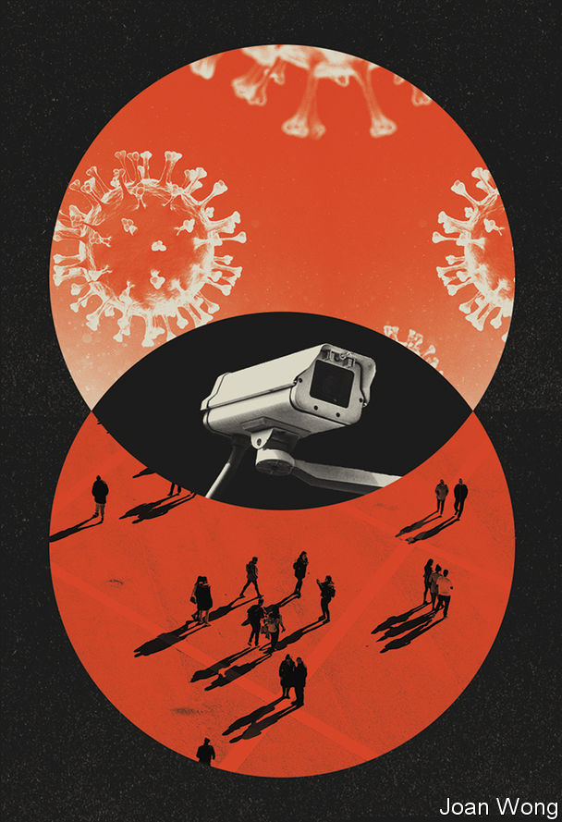

It might also be possible to do something similar from the bottom up, thus limiting government snooping. Start with an app that sends coherent health and travel data to a central registry, as China’s Health Check purports to. Then add sufficiently smart and powerful number-crunching for the system to be able to find all the places where two people’s histories cross. When someone gets sick, the system can then alert all the other users whose paths that user crossed. Because the infrastructure would be separate from that of the spooks, it could be much more open, scrutable and trustworthy.

Such approaches, though, face serious problems. The number of people an infectious person actually infects will almost always be much smaller than the number they encounter. Sean McDonald, an expert on public health and digital governance, says a system which alerted all the people that an infected person had been near over the past week could lead to a demand for tests that would entirely overwhelm the capacity available in most countries. If the relative risk of, say, walking past someone on the street and drinking from the same water fountain an hour apart were known, and if the data picked up such niceties, things might be different. But they are not.

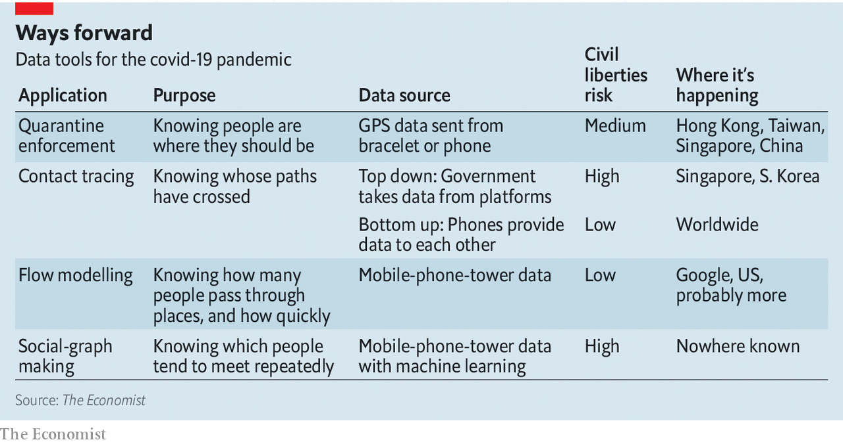

An alternative to too much testing would be not enough. Annie Sparrow, an epidemiologist who advises Tedros Adhanom Ghebreyesus, director-general of the WHO, points out that modellers without field experience tend to misunderstand the psychology of testing. The stigma associated with a disease, she says, is likely to outweigh the rational pull of keeping oneself and one’s family safe. And both Dr Sparrow and Mr McDonald point out that any solution which relies on smartphones and internet access inherently ignores the half of the planet which does not have internet access. Mr McDonald says he would prefer to see the data wizards apply themselves to easier problems such as optimising the supply chains for medical goods like masks and ventilators.

## Big brother is contact-tracing you

Google says that, having heard epidemiologists make such points, it is not planning to use the location data it collects to do contact tracing. The data-collection mechanisms built into products like Android or Google Maps are “not designed to provide robust or high-confidence records for medical purposes and the data cannot be adapted to this goal”, the company says. Facebook says something similar. Both companies can be assumed to think that talking explicitly about how well they might be able to do such things would raise concerns about privacy.

What Google and Facebook will not do, though, the government of Singapore is quite up for. Its Government Technology Agency and health ministry have designed an app which can retrospectively identify close-ish contacts of people who come down with covid-19.

When two users of this new app, called TraceTogether, are within two metres of each other their phones get in touch via Bluetooth. If the propinquity lasts for 30 minutes both phones record the encounter in an encrypted memory cache. When someone with the app is diagnosed with the virus, or identified as part of a cluster, the health ministry instructs them to empty their cache to the contact-tracers, who decrypt it and inform the other party. It is especially useful for contacts between people who do not know each other, such as fellow travellers on a bus, or theatre-goers.

The app’s developers have tried to assuage concerns about privacy and security. Downloading it is not compulsory. Phone numbers are stored on a secure server, and are not revealed to other users. Geolocation data are not collected (though Google’s rules governing apps that use Bluetooth mean that they will be stored on Android phones running the app). They are planning to publish the app’s source code and make it free to reuse, so that others may capitalise on their work.

Singaporeans trust their government. Since TraceTogether was released on March 20th it has been downloaded by 735,000 people, or 13% of the population, according to government data. Several Singaporeans your correspondent spoke to one overcast day in the business district were unaware that they could be prosecuted for refusing to hand over their data to the health ministry. But they had no intention of frustrating the authorities. “I’d rather be responsible than irresponsible,” said one trader.

In an attempt to get past the uproar about the security services tracking the infected, Israel’s Health Ministry has launched a similar app that allows people choosing to use it to see if they have come into contact with other users who subsequently took ill. The government says that the app, which uses open-source software, does not share data with the authorities. The WHO MyHealth app, also open-source, might in time take on a similar contact-tracing function.

This patchwork of global systems presents its own challenge: how to make them talk to each other so that they can stimulate a global response to the disease, not just one that operates at a national or city level. Yves-Alexandre de Montjoye, who studies computational privacy at Imperial College, in London, says that governments should come together to agree on common protocols for handling covid-19 data, making it easier to pool their resources. Compared with finding ventilators and protecting health-care workers, though, this is pretty low down the list of anyone’s must-dos.

And there’s the rub. Covid-19 demands an array of drastic, immediate responses. It also requires thinking that looks beyond the next two weeks. The network of computers built for entertainment, convenience, connection and security is helping in all sorts of quotidian ways, from video-conferencing to team-working to gaming for rest and recuperation. But it also provides a network of sensors that can co-ordinate the responses of both individuals and whole populations to a degree unimaginable in any previous pandemic. Countries are learning how to make use of that panopticon’s power in a pell-mell, piecemeal way. The systems that they lash together may last a long time. It would be best to keep an eye on them.■

Dig deeper:  
For our latest coverage of the covid-19 pandemic, register for The Economist Today, our daily [newsletter](https://www.economist.com/newslettersignup), or visit our [coronavirus hub](https://www.economist.com/coronavirus)

This article was downloaded by calibre from <https://www.economist.com/briefing/2020/03/26/countries-are-using-apps-and-data-networks-to-keep-tabs-on-the-pandemic>

|  |  |  |  |
| --- | --- | --- | --- |
|  | Articles | Sections | Next |

|  |  |  |  |
| --- | --- | --- | --- |
| Previous | Articles | Sections | Next |

#### Building up the pillars of state

# Rich countries try radical economic policies to counter covid-19

History suggests that the effects will be permanent

Mar 26th 2020 |

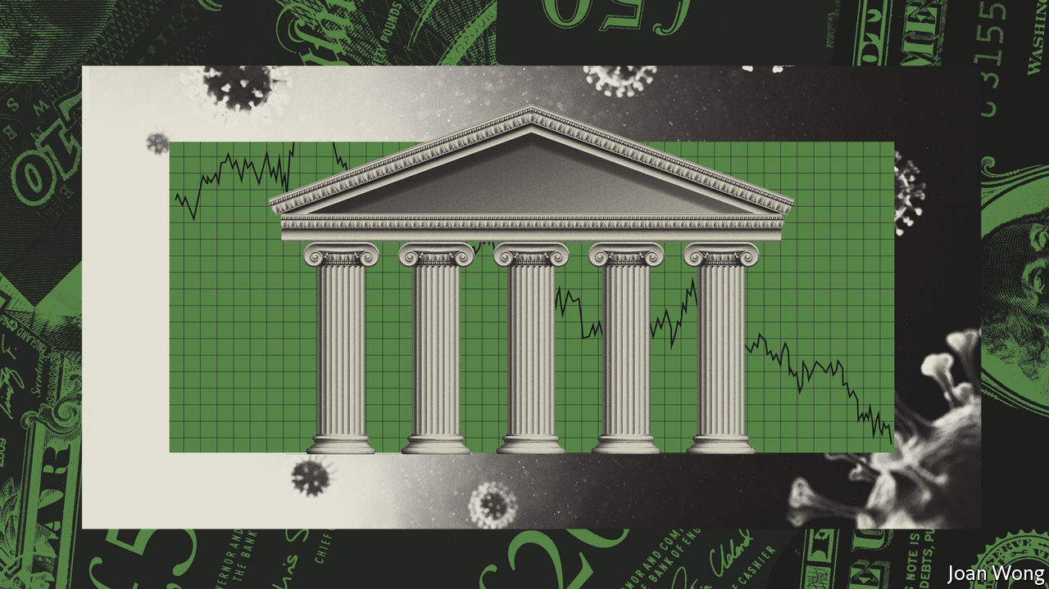

Editor’s note: The Economist is making some of its most important coverage of the covid-19 pandemic freely available to readers of The Economist Today, our daily newsletter. To receive it, register [here](https://www.economist.com/newslettersignup). For more coverage, see our coronavirus [hub](https://www.economist.com/coronavirus)

“THE GOVERNMENT intervention is not a government takeover,” the American president argued. “Its purpose is not to weaken the free market. It is to preserve the free market.” The IMF pointed to the “unprecedented policy actions undertaken by central banks and governments worldwide”. The economic response to the financial meltdown of 2007-09 was big enough. But in answer to the covid-19 pandemic policymakers are launching even bigger, more radical interventions. Putting the economy on a wartime footing is supposed to be temporary. A look at 500 years of governmental power, however, suggests another outcome: the state is likely to play a very different role in the economy—not just during the crisis, but long after.

The policy response has been swift and decisive. Globally central banks have cut interest rates by more than 0.5 percentage points since January and have launched huge new quantitative-easing schemes (creating money to buy bonds). Politicians are throwing open the fiscal spigots to support the economy. As The Economist went to press, America’s Congress was set to pass a bill that boosts spending by twice as much as President Barack Obama’s package in 2009 (see article). On top of that, Britain, France and other countries have made credit guarantees worth as much as 15% of GDP, seeking to prevent a cascade of defaults. On the most conservative measure, the global stimulus from government spending this year will exceed 2% of global GDP, a much bigger push than was seen in 2007-09 (see chart 1). Even Germany, whose fiscal rectitude is the punchline of economists’ jokes, is spending more (see article).

The upshot is that the state is swelling. Last year overall government spending accounted for 38% of GDP across the rich world. The stimulus effort, combined with a fall in nominal GDP in the next few months, will push that ratio well above 40%, perhaps to its highest-ever level.

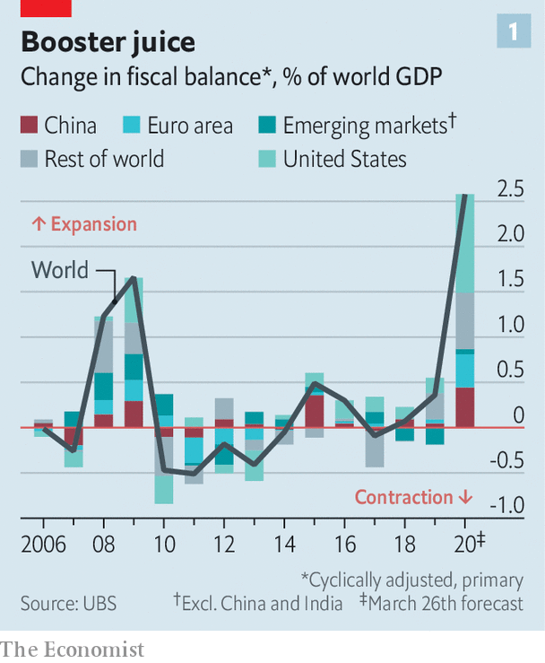

To focus just on the numbers misses something crucial, though. There are important qualitative changes under way in how policymakers manage the economy—the responsibilities they have seized for themselves, what is seen as a legitimate action and what is not, and the criteria used to judge policy success or failure. On these measures, the world is in the early stages of a revolution in economic policymaking.

Central banks have in effect pledged to print as much money as necessary to keep down government-borrowing costs. The European Central Bank is promising more or less to buy everything that governments might issue; this should reduce the gap in borrowing costs between weaker and stronger euro-zone members, which widened in the early days of the pandemic. On March 23rd America’s Federal Reserve promised to buy unlimited quantities of Treasury bonds and agency mortgage-backed securities, if necessary. The rise in borrowing caused by America’s stimulus may be matched, at least initially, by bond purchases by the Fed, which smells a lot like money-printing to finance deficits. The central bank also announced new programmes to support the flow of credit to companies and consumers. The Fed is now the direct lender of last resort to the real economy, not just the financial system.

Politicians, too, are ripping up the rulebook. In a standard recession firms are allowed to go bust and people to become unemployed. Even in normal economic times, roughly 8% of businesses in OECD countries go under each year, while 10% or so of the workforce lose a job. Now governments hope to stop this from happening entirely. President Emmanuel Macron does not speak only for France when he vows that no firm will “face the risk of bankruptcy” as a result of the pandemic. Boris Johnson, Britain’s prime minister, contrasts his government’s response with the one during the last financial crisis: “everybody said we bailed out the banks and we didn’t look after the people who really suffered”. Larry Kudlow, the director of America’s National Economic Council, calls America’s fiscal stimulus “the single largest Main Street assistance programme in the history of the United States”, comparing it favourably with Wall Street bail-outs a decade ago.

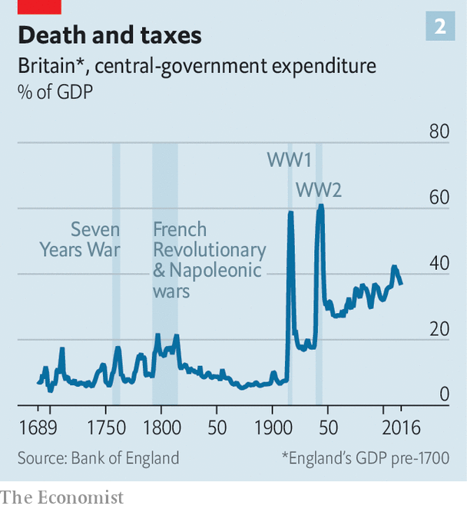

To that end, governments across the rich world are channelling vast sums to firms, providing them with grants and cheap loans in an attempt to preserve jobs and prevent them from going bust. In some cases the government is paying the wages of people who cannot work safely: the EU in particular has embraced this policy, while the British state will pay up to 80% of the wages of furloughed workers. The American package includes loans to small businesses that will be forgiven if workers are not laid off. Households across the rich world are being given temporary relief on mortgages, other debts, rent and utility bills. In America people will also be sent cheques worth up to $1,200.

The vast majority of economists support these measures. Nominally they are temporary, designed to hold the economy in an induced coma until the pandemic passes, at which point the world is supposed to revert to the status quo ante. But history suggests that a return to pre-covid days is unlikely. Two lessons stand out. The first is that governmental control over the economy takes a large step up during periods of crisis—and in particular war. The second is that the forces encouraging governments to retain and expand economic control are stronger than the forces encouraging them to relinquish it, meaning that a “temporary” expansion of state power tends to become permanent.

## The sinews of power

In recent centuries government spending across the capitalist world has leapt. In the 1600s the outlays of the entire English state accounted for about 5% of GDP, with practically no spending on public health or education, nor much regulation of economic life, save for crude contract enforcement (see chart 2). That began to change in the 18th century, and from the end of the 19th century Britain and other capitalist countries saw increased state intervention, with more government resources being devoted to public goods such as welfare and education and commensurate increases in taxes (see chart 3).

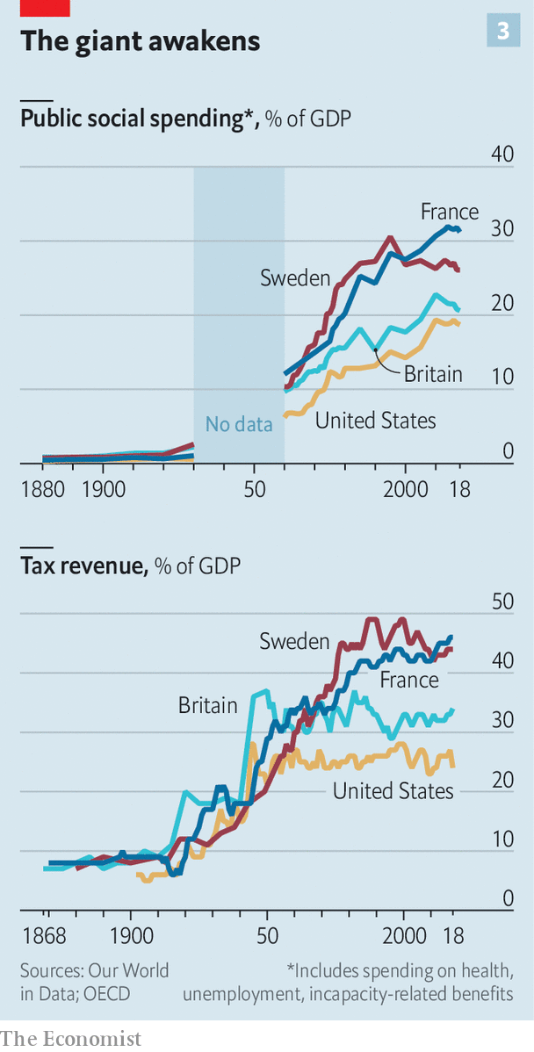

Governments have had some lean periods. In Victorian Britain state spending fell as a share of GDP—though that was largely because economic growth was so rapid, and the measure in chart 2 excludes spending by local governments, which became exceptionally powerful over the period. In the 1980s Ronald Reagan succeeded in stabilising America’s day-to-day federal spending. His reforms, as well as those of Margaret Thatcher in Britain, reduced the role of government in fixing prices; privatisations encouraged profit-making firms to provide formerly state-run services such as power and transport. Yet even during Reagan’s presidency the number of pages of federal regulations rose by 14%.

A back-of-the-envelope calculation finds that, of the more than 50 countries for which there are long-run fiscal data, two-thirds saw their government-spending-to-GDP ratio increase between 1988 and 2018. America’s ratio of day-to-day public spending to GDP is eight percentage points higher than it was in 1962, when Milton Friedman wrote “Capitalism and Freedom”, a book which warned of the dangers of socialism.

Historians argue over why the public sector has a tendency to expand. In the 19th century Adolph Wagner, a German economist, suggested that as places got richer, demands on government grew. An increasingly complex production process needed more regulation and contractual enforcement. Wealthier people would also demand more public welfare provision, the theory goes, perhaps because they worried less about their own material situation and could thus turn their attention to others.

Wagner’s theories also pointed to what economists call “hysteresis” in fiscal policy. Governments may intend to boost spending only for a short while. But then expectations change, making such expansionism hard to undo. It is now common sense that the state should provide education to children at no cost to parents, or support people who are out of work. American governments have in recent decades cut the share of public spending devoted to welfare. However, it remains politically impossible to bring it down to anywhere near its level in the mid-1960s, before President Lyndon Johnson’s “war on poverty” was launched. The upshot is that while it is easy to ratchet state spending up, it is much harder to push it down.

Perhaps the most important lesson of 500 years of history, however, is that nothing has helped boost state power in Europe and America more than crises. Historians broadly agree that the growing fiscal capacity of capitalist countries from the 1700s onwards was linked to the need to fight increasingly sprawling and expensive wars, especially those using navies and where the field of battle was far from home. (The Seven Years War of 1756-63 is widely considered to be the first global war because it involved a large number of countries, often fighting in foreign theatres.)

To win, countries required increasingly complex, well-resourced administrations which could supply fighters with weapons that worked and food that had not rotted. They also needed the money to pay for it, whether by levying more taxes or by becoming a reliable borrower in markets—which called for yet more bureaucracy. Growing state capacity, in turn, allowed for the emergence of the capitalism we know today, with properly regulated markets, efficient telecoms and transport, and healthy and educated citizens.

The winners of those wars also seized control of resources, from sugar and spices to linens, which proved integral to industrialisation. So it is no surprise that historians contend that wars and other crises have been an engine of economic development. It is no coincidence that the Netherlands, the first country to embrace capitalism, in the 17th century, was also at the time the world’s pre-eminent naval power, fighting and winning numerous wars over the period; or that Britain, which came to dominate the seas in the 18th century, then became the world’s largest economy. According to Larry Neal of the University of Illinois at Urbana-Champaign, the Industrial Revolution “occurred precisely during and because of the Napoleonic wars” of the late 18th and early 19th centuries.

The responses to crises since then have further consolidated the power of the state. France’s top rate of income tax was zero in 1914; a year after the end of the first world war it was 50%. Canada introduced income tax in 1917 as a “temporary” measure to finance the war. During the second world war income tax in America turned from a “class tax” to a “mass tax”, with the number of payers rising from 7m in 1940 to 42m in 1945 (today more than twice as many Americans are caught in the net). The second world war also led to calls for the introduction of cradle-to-grave welfare systems. So did the dynamics of the cold war: governments across the capitalist world wanted to forestall a communist rebellion. The state-led model pursued in Europe from the 1950s to the 1970s, in which bureaucrats controlled services from power networks to transport systems, would have been unimaginable without wartime experience, where the state managed practically everything and ordinary people made tremendous sacrifices, whether on the battlefield or at home.

## The new ideology

What will be the lasting effects of the covid-19 pandemic? Start with the size of the state. Over the next year government debt will rise sharply, as spending jumps and tax revenues collapse. When the economy recovers, attention will turn to paying it down. “Capital and Ideology”, a new book by Thomas Piketty, a French economist, shows that after the first and second world wars many governments in the West turned to heavier taxation of the incomes and wealth of the richest to achieve that goal. Another option is “financial repression”, where governments force citizens to lend to them at below-market rates (see article).

Central banks’ innovations will also have lasting consequences. Few economists believe that the explicit co-operation between the fiscal and monetary authorities risks creating runaway inflation, as it has done in Venezuela and Zimbabwe, any time soon. (If anything, the bigger worry right now is deflation, not least because of a collapse in oil prices.) However, just as the use of quantitative easing in 2008-09 opened the door to more of the same down the road, it will become harder to make the argument that the “magic money tree” does not exist. Politicians in the future may lean on central banks to peg interest rates at zero to support government borrowing, even during times of economic growth and low unemployment. If central banks promised to fund the government during the coronavirus pandemic, they might ask, then why shouldn’t they also fund it to launch an expensive war against a foreign enemy or to invest in a Green New Deal?

The final impact of the current interventions relates to policymakers’ tolerance for risk. No one cheers when a firm goes bust, but often the process helps shift resources from less efficient to more efficient uses, thus raising productivity and average living standards over time. The novel notion that the government needs to preserve firms, jobs and workers’ incomes at practically any cost may endure, especially if the intervention proves successful in narrow terms. The policy will formally end once the pandemic has passed, but political pressure for similar support schemes—from the nationalisation of tottering firms to the provision of a universal basic income—may well be higher the next time a sharp downturn comes along. If politicians are able to preserve jobs and incomes during this crisis, many people will see little reason why they should not try again in the next one.

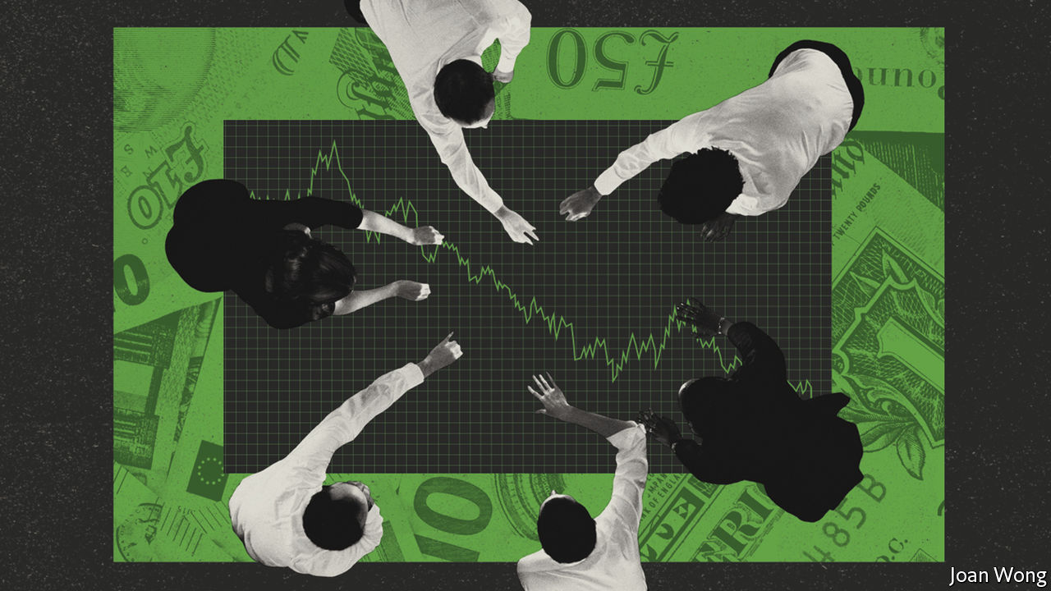

Calls for a more activist fiscal-monetary government will come against a backdrop of structurally higher demand for state spending. The public sector tends to provide labour-intensive services in which productivity improvements are difficult, such as health care and education. It must match the salaries of workers in other sectors in order to retain its own, even as they become less productive relative to the overall economy—a phenomenon which raises the cost of provision. Long before the coronavirus pandemic, fiscal wonks argued that government spending would soar during the 2020s, even in the absence of a crisis. That was not only or even primarily because an ageing population would raise demand for health care, but because health systems would be able to treat a wider range of illnesses more effectively, which would push up costs.

The likely economic effects of the pandemic reach far beyond the role of the state. Countries could become even less welcoming to immigrants—the better, they may believe, to reduce the likelihood of infection from foreign arrivals. On the same logic, resistance to the development of dense urban centres could mount, thereby limiting construction of new housing and raising costs. More countries may seek to become self-sufficient in the production of “strategic” commodities such as medicines, medical equipment and even toilet roll, contributing to a further rollback of globalisation. But the redefined role of the state could prove to be the most significant shift. The rules of the game have been moving in one direction for centuries. Another radical change is looming.■

Dig deeper:  
For our latest coverage of the covid-19 pandemic, register for The Economist Today, our daily [newsletter](https://www.economist.com/newslettersignup), or visit our [coronavirus hub](https://www.economist.com/coronavirus)

This article was downloaded by calibre from <https://www.economist.com/briefing/2020/03/26/rich-countries-try-radical-economic-policies-to-counter-covid-19>

|  |  |  |  |
| --- | --- | --- | --- |
| Previous | Articles | Sections | Next |

|  |  |  |
| --- | --- | --- |
| Briefing | Sections | The Americas |

United States

Congress responds: A $2 trillion bazooka

.

Viral exceptionalism: The bills you have to pay

.

Dating: Love under lockdown

.

Covid-19 and the locked-up: Pushing on an open door

.

Teenage sexting: Sharing and not caring

.

The Green Party: Zowie Howie

.

Lexington: Sore and feverish

.

|  |  |  |
| --- | --- | --- |
| Briefing | Sections | The Americas |

|  |  |  |  |
| --- | --- | --- | --- |
|  | Articles | Sections | Next |

#### A $2trn bazooka

# Congress puts aside its habitual dysfunction and responds to covid-19

The fiscal stimulus is impressive, but America may need another one before too long

Mar 26th 2020 | WASHINGTON, DC

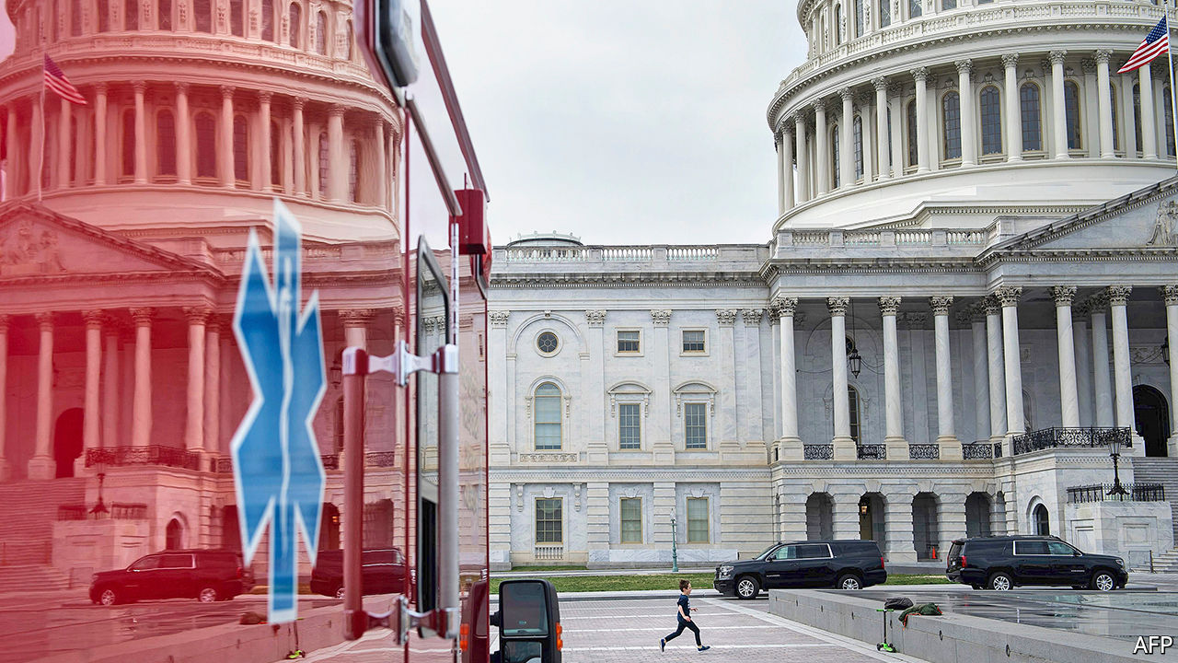

Editor’s note: The Economist is making some of its most important coverage of the covid-19 pandemic freely available to readers of The Economist Today, our daily newsletter. To receive it, register [here](https://www.economist.com/newslettersignup). For more coverage, see our coronavirus [hub](https://www.economist.com/coronavirus)

EVEN TO THE housebound and socially distanced, the signs of a contraction are apparent. The 18th Street corridor of Adams Morgan, a typically bustling stretch of restaurants and shops in Washington, DC, is shuttered—closed as part of the nationwide effort to contain the epidemic of covid-19 that had, as of March 25th, infected 65,778 Americans and killed 942, according to Johns Hopkins University. One fledgling business—a new bar called Death Punch—never managed to open its doors. Down the road, an established whiskey bar called Jack Rose has been selling off its gargantuan collection at discount to support its staff. The queue for it snaked several blocks—a long dotted line of aficionados standing a careful six feet apart.

These are just the premonitions of the pain to come. Unemployment will rocket as much of the economy is put into a sort of medically induced coma. So many unemployment claims are being filed in Ohio that the state website has crashed. The national weekly unemployment numbers that will be released on March 26th are widely expected to be the worst in history. Goldman Sachs has predicted that there could be 2.25m new claims over the week—triple the previous record. And just as the covid-19 epidemic has not yet reached its apex, neither has the economic crisis. Morgan Stanley predicts that GDP will fall by 8% year-on-year in the second quarter and unemployment will rise to 12.8%, compared with just 3.5% in February.

To head off the damage, Congress has prepared the largest fiscal stimulus in modern history. Its provisions—including bail-outs for firms both big and small, expanded unemployment-insurance benefits and a straight cash transfer to Americans—are expected to cost close to $2trn, roughly one-tenth of GDP. This is the third substantial piece of legislation to deal with covid-19. Even this may not be enough.

Whole industries rely on congregating people. So too, unfortunately, does the virus. Twelve states have ordered all non-essential businesses closed. Seventeen states, covering half the country’s population, have urged residents to stay at home. Many white-collar tasks can just about be performed remotely. But cruelly, those likeliest to lose income or their jobs are in more precarious, less well-paid industries—restaurant staff (of which there are 9.6m), retailers (8.8m) or hotel workers (2m). If they lose their livelihoods, the effects will ripple through the economy.

One corrective for this problem is unemployment insurance. Yet this is not as robust as in other parts of the rich world. The American version replaces a smaller share of previous income than the average in the OECD, a club of mostly rich countries, and declines faster with time. Individual states, which administer the programme jointly with the federal government, differ in their generosity: Mississippi caps its maximum benefits at a paltry $235 a week.

At the insistence of Democrats, Congress would make this part of the safety-net decidedly more European, at least temporarily. The federal government would pay to top up unemployment-benefit levels by $600 a week—an enormous increase, given that the current weekly average is $385. The set of people eligible for benefits would also be expanded to include independent contractors, such as gig-economy workers. Those who have been laid off but not fired could receive compensation for lost hours. And the length of the benefit period would be extended from the usual 26 weeks to 39 weeks. The cost of all of this is thought to be $260bn: a serious expansion of a targeted programme.

A similarly gargantuan wad of cash—$250bn—will be spent on a less targeted scheme, sending cheques to Americans direct from Uncle Sam. Below some generous income thresholds ($75,000 a year for a single person and $150,000 for a married couple) every family can expect $1,200 per adult and $500 per child. This is the best version of a cash transfer that was proposed. Previously the White House had pushed the idea of a payroll-tax holiday; an early version of the stimulus bill ignored people who did not file taxes. Both would have excluded those with the lowest incomes from an ostensibly universal programme. Reaching everyone eligible now will require ingenuity, such as using administrative data from states, says Sam Hammond of the Niskanen Centre, a think-tank. But even if sent quickly, the cheques could be both too small for those who need them and too big for those who do not.

The government is also expected to set aside $500bn to stabilise firms and states. The capital could facilitate lending several times larger than that. Democrats in Congress and the White House got stuck on a (relatively) small portion of the programme, the $75bn set aside to bail out embattled big firms like airlines and those deemed critical to national security—because of the latitude the treasury secretary would have to set and disclose the terms of loans. A compromise struck in the dead of night bulked up independent oversight.

A more intriguing scheme is the $350bn set aside to save small and medium-size firms (those with fewer than 500 employees). The programme would give loans of up to $10m without interest or fees to pay for employees, rental costs and sundry other expenses. These would then be forgiven in proportion to the share of staff spared the sack: a firm that kept all employees would owe nothing; one that dispensed with half would owe half, and so on.

This is a more complicated idea than those devised by European finance ministers facing down the pandemic. Rishi Sunak, the British chancellor, pledged to pay up to 80% of wages for furloughed workers; the Danish government could pay up to 90% of the costs. The added hurdle in America may mean that the most sophisticated operations get the grant-loans (or “groans” in bureaucratic argot), while mom-and-pop operations languish. It may also mean that even more money will be needed. Research from Glenn Hubbard, an economist at Columbia Business School, and Michael Strain of the American Enterprise Institute, a think-tank, estimates that total needs could amount to $1.2trn—roughly triple the sum allocated. With the ink not yet dry on the phase-three bill, bigger bail-outs may be needed in future.

The extraordinary legislation is not intended to avoid the recession that already seems to have arrived, but to spur the fastest possible rebound. This of course requires that the cause—the covid-19 pandemic—is effectively dealt with first.

But after a brief period of taking the virus seriously, President Donald Trump seems eager to lift restrictions as soon as possible. He has taken to saying that “the cure cannot be worse than the problem itself”, and that he wants the country “opened up and just raring to go by Easter”, which epidemiological projections suggest is unwise. The collapse of the stockmarket, which used to be Mr Trump’s barometer of success, may be spooking the president. Markets jumped in anticipation of the coming stimulus. But pre-emptively relaxing the restrictions would harm both public health and the economy.

Because health authority is devolved to the states, it is unlikely that Mr Trump would pre-empt local declarations of emergency. But some states could follow suit, and the president’s supporters might not adhere to the recommended course of social distancing. Already, the lieutenant-governor of Texas has suggested that the elderly might risk death for the sake of the economy. Liberty University, an evangelical Christian institution led by a devotee of the president’s, is proudly inviting thousands of students back to campus in defiance of public-health advice.

Mr Trump appears to be defaulting into an old playbook—vacillating wildly in the hope of winning concessions. What may work with Democrats or North Korean dictators has no chance against a virus, however. And as things worsen, as seems likely, such irresolution may look like political malpractice. Already, New York appears to be a new disease hotspot. “The apex is higher than we thought and the apex is sooner than we thought,” said Andrew Cuomo, the governor of New York, in his address to citizens. He is warning that the city’s health system could be overwhelmed by lack of ventilators and protective equipment for staff. The medicine—a controlled, national shutdown of the economy—may be strong stuff. But a premature reopening, leading to rampant transmission of the virus, could produce something far worse.■

Correction (March 26th 2020): An earlier version of this article mistook Morgan Stanley’s annualised quarter-on-quarter growth forecast for its year-on-year growth forecast. Sorry.

Dig deeper:  
For our latest coverage of the covid-19 pandemic, register for The Economist Today, our daily [newsletter](https://www.economist.com/newslettersignup), or visit our [coronavirus hub](https://www.economist.com/coronavirus)

This article was downloaded by calibre from <https://www.economist.com/united-states/2020/03/26/congress-puts-aside-its-habitual-dysfunction-and-responds-to-covid-19>

|  |  |  |  |
| --- | --- | --- | --- |
|  | Articles | Sections | Next |

|  |  |  |  |
| --- | --- | --- | --- |
| Previous | Articles | Sections | Next |

#### The bills you have to pay

# Young Americans have been surprisingly vulnerable to the virus

This may not last

Mar 26th 2020 |

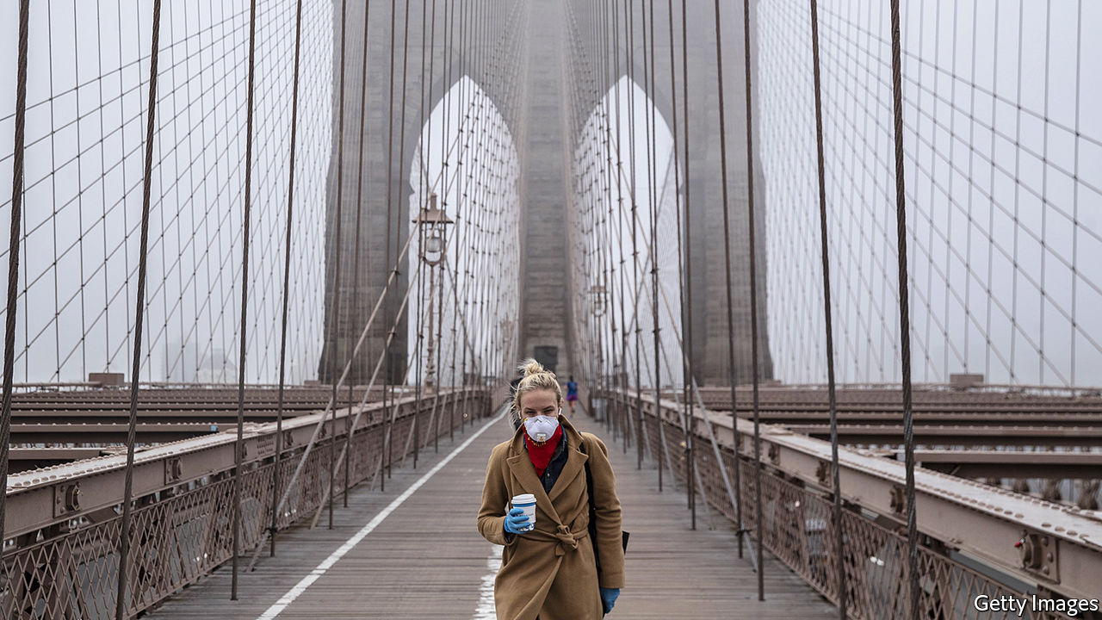

Editor’s note: The Economist is making some of its most important coverage of the covid-19 pandemic freely available to readers of The Economist Today, our daily newsletter. To receive it, register [here](https://www.economist.com/newslettersignup). For more coverage, see our coronavirus [hub](https://www.economist.com/coronavirus)

AMONG MANY worrying data points from the coronavirus crisis, one in particular has struck Americans. In a report published on March 18th the Centres for Disease Control and Prevention (CDC) showed that of the 508 known patients to have been hospitalised in the United States by March 16th, two-fifths were younger than 55. Of those, half were between 20 and 44. For a virus that is meant mostly to affect elderly people, those figures were extremely worrying. In the overall population adults aged 19 to 55 make up 47% of the population.

The report set off a storm. On March 22nd Anthony Fauci, a leading member of the White House’s task-force on the disease, noted that young people are certainly not immune. “All bets are off, no matter how young you are, if you have an underlying, serious medical condition,” said the doctor. Alexandria Ocasio-Cortez, a 30-year-old Democratic congresswoman, told young people they should be concerned not only for their elderly relatives but also for themselves: “Let me tell you something, in the state of New York, about 55% of our cases are with folks 18 to 49.”

It remains to be seen whether young people will continue to make up such large proportions of those hospitalised. But it seems unlikely. Since the CDC’s research was published, the number of confirmed cases in America has leapt from 4,226 to over 65,000. The CDC has not updated its figures on hospitalisation. There are some reasons why, at least in the early stages of the epidemic, young people might have been particularly affected. The spread in America has been concentrated in big cities like New York, which tend to be younger than the rest of the country. Before lockdowns were implemented, young people were more likely to crowd into bars, restaurants and subway carriages where the disease can spread easily. As it spreads further, it is likely that older people will make up a larger share of those in hospitals.

But there are some reasons to remain concerned about younger Americans. Research on the virus in China suggests that obese people, those with high blood pressure and those with pre-existing conditions such as diabetes may be more vulnerable. All those factors are especially prevalent in America. In Italy around 20% of people are obese; in America the figure is 36%. Over a tenth of Americans suffer from diabetes. Not all are old. On March 18th Donald Trump said he worried that many young people “don’t realise” the danger “and they’re feeling invincible.” His other statements have probably not helped with that, but his words ring true.■

Dig deeper:  
For our latest coverage of the covid-19 pandemic, register for The Economist Today, our daily [newsletter](https://www.economist.com/newslettersignup), or visit our [coronavirus hub](https://www.economist.com/coronavirus)

This article was downloaded by calibre from <https://www.economist.com/united-states/2020/03/26/young-americans-have-been-surprisingly-vulnerable-to-the-virus>

|  |  |  |  |
| --- | --- | --- | --- |
| Previous | Articles | Sections | Next |

|  |  |  |  |
| --- | --- | --- | --- |
| Previous | Articles | Sections | Next |

#### Love under lockdown

# The return of slow courtship to American dating

Under quarantine, video courtship replaces hookup culture

Mar 26th 2020 |

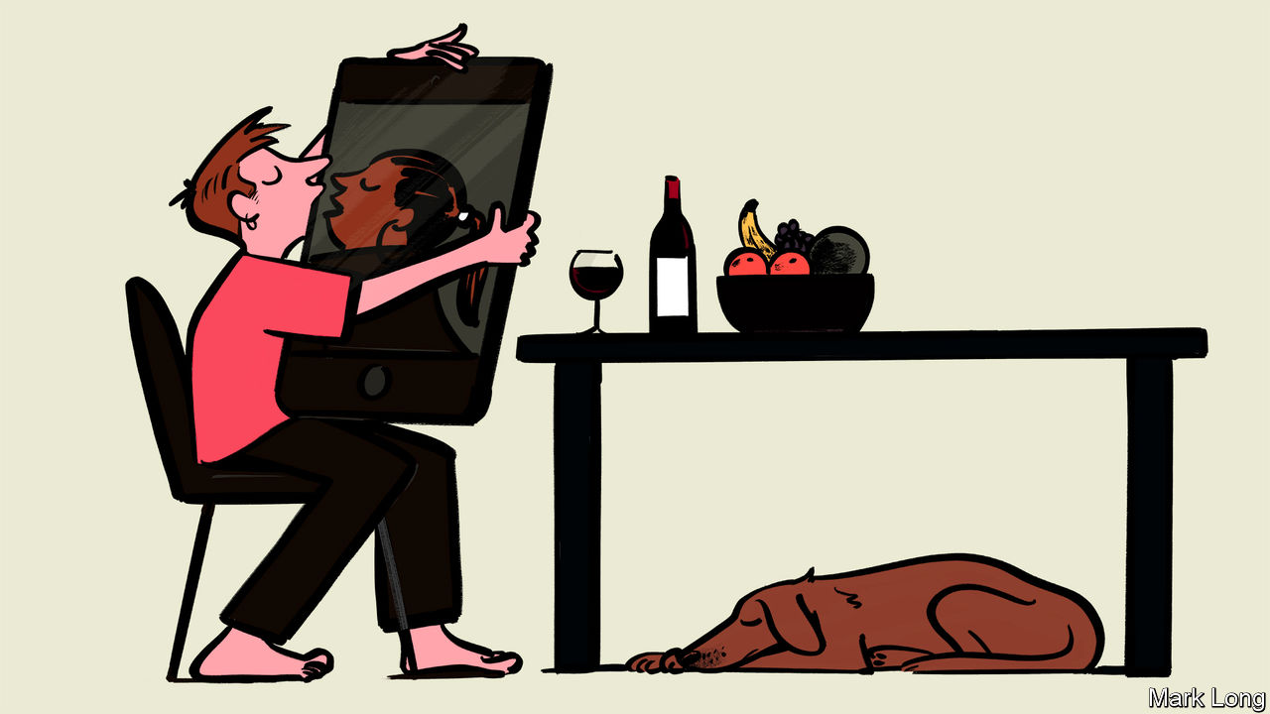

Editor’s note: The Economist is making some of its most important coverage of the covid-19 pandemic freely available to readers of The Economist Today, our daily newsletter. To receive it, register [here](https://www.economist.com/newslettersignup). For more coverage, see our coronavirus [hub](https://www.economist.com/coronavirus)

FOR TREVOR BARNES, a 27-year-old teacher from Hershey, Pennsylvania, quarantine could be terrible. He lives on his own in an apartment attached to the boarding school he works at, and he is fully locked down. For ten days he has not been able to go outside even to buy groceries. Yet Mr Barnes has discovered that being cooped up inside at least does not mean he has to give up his romantic dreams. Over the past week he has met several women, all by phone call and video conference. “I go on a lot of dates normally, from Tinder, Hinge, Bumble, all that stuff,” he says, but has never found somebody he really hit it off with. “This has been a good way to figure out a more serious approach,” he says.

Though older people will suffer the brunt of the coronavirus, it is the footloose young who will see their lives turned upside down. But a generation that is tied to its phones anyway is perhaps also well-equipped to innovate around some of the problems social isolation imposes. And a lot of young people are proving that just because you cannot actually meet somebody in person does not mean you cannot date.

One popular app, Hinge, says that 70% of its users have expressed an interest in going on digital dates. Match Group, the owners of Tinder, are giving away some features of the app that usually cost money to reflect the fact that people have more time to kill by swiping left and right. All dating apps are encouraging users to try video dating. One Instagram feed, called Love is Quarantine, has taken off by parodying a popular Netflix show called Love is Blind. Its creators, Thi Lam and Rance Nix, who share a flat in Brooklyn, New York, joke that their invention has “gone viral”.

It is not all easy, dating in a lockdown. Kevin, a 26-year-old tech worker, says he met somebody online recently. “After work I set up a hammock in my tiny back yard, grabbed a beer from my fridge and we chatted for an hour,” he says. It went well—he and his date are going to have a walk around a local park next. But he wonders what comes after that. “I am comfortable adding one more person to my isolation group if it comes to that,” he says. Whether his three flatmates will be equally comfortable is less clear.

Still, it could be worse. “It has brought us back to an older way of connecting with people, which is just talking, not all these visual branding cues on profiles,” says Katie Nelson, a journalist confined to her parents’ home in Minneapolis. She used to despair of men rushing to meet up before she knew anything about them. When lockdowns end, it may be too much to hope that the return of slow courtship will last. But by then some people might have become experts at it.

Dig deeper:  
For our latest coverage of the covid-19 pandemic, register for The Economist Today, our daily [newsletter](https://www.economist.com/newslettersignup), or visit our [coronavirus hub](https://www.economist.com/coronavirus)

This article was downloaded by calibre from <https://www.economist.com/united-states/2020/03/26/the-return-of-slow-courtship-to-american-dating>

|  |  |  |  |
| --- | --- | --- | --- |
| Previous | Articles | Sections | Next |

|  |  |  |  |
| --- | --- | --- | --- |
| Previous | Articles | Sections | Next |

#### Pushing on an open door

# The virus should speed efforts to shrink America’s prison population

Two million Americans are behind bars. Covid-19 may bring some long-overdue change

Mar 26th 2020 | CHICAGO

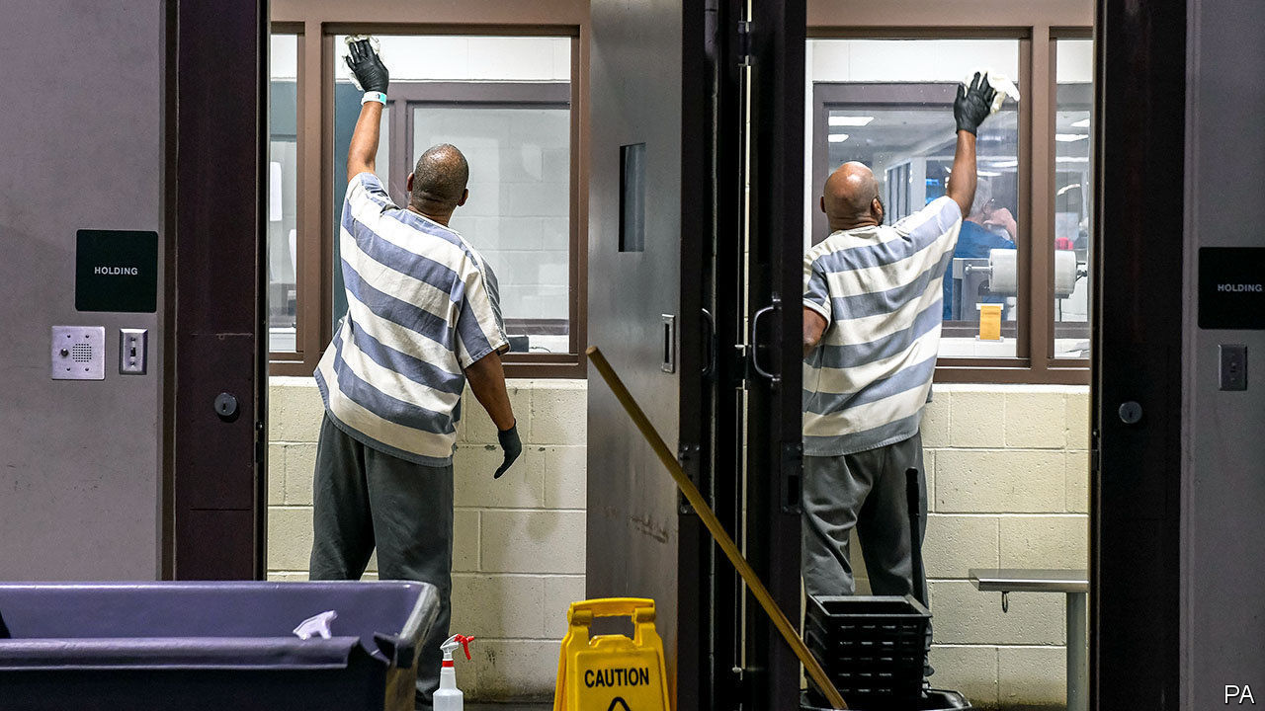

Editor’s note: The Economist is making some of its most important coverage of the covid-19 pandemic freely available to readers of The Economist Today, our daily newsletter. To receive it, register [here](https://www.economist.com/newslettersignup). For more coverage, see our coronavirus [hub](https://www.economist.com/coronavirus)

FACED WITH a pandemic, officials rush to close any place that threatens to become a centre of transmission. If fewer people mingle inside cruise ships, schools, churches or retirement homes then the risk of mass infections falls. Yet for more than 2m Americans squeezed into jails and prisons, along with many staff, a shutdown is not an option. Instead, such places risk becoming hotspots for disease. In 1918 the Spanish flu raged through San Quentin prison in California, infecting 500 of its 1,900 inmates in just two months.

Anxiety is rising by the day. The sheriff of Harris County, Texas, has likened his huge jail to “a perfect incubator” for covid-19, saying an outbreak would spread like “wildfire”. Inmates at an immigrant-detention centre in New Jersey have launched a hunger strike to demand soap. At Rikers Island, in New York, prisoners this week refused to leave their dormitories, worrying about infections. Tom Dart, sheriff of Cook County, who runs a large jail in Chicago, warns he is “juggling with impending disaster”. Some prisoners have the virus, but he lacks tests for checking others or even protective gear for staff.

“Universities and hotels you can close. I’m left with people I can’t send home,”, says Sheriff Dart. Instead he improvises. He clumps new arrivals in cohorts by the day they come in, hoping to isolate potentially sick ones for at least a week to prevent any infection spreading. Tents for quarantine are now going up in place of a mental-health centre. Staff take inmates’ temperatures, quiz them about sickness in the family and spray food trays with bleach water more often than before.

Such efforts are well-meant but inadequate. The virus is already spreading behind bars. Prisons in every state now ban regular visitors. In 15 states even lawyers are blocked. As staff and volunteers who provide education, therapy and other services also stay away, another risk is that morale will fall, to be replaced by mounting fear and frustration. That bodes ill for good order. In Italy similar efforts to contain the virus this month provoked at least 25 prison riots and several deaths.

Inmates are often packed close and obliged to buy their own soap—seen as a luxury, not a basic need—from meagre earnings. They will struggle to fend off infection. Pam Oliver, a sociologist who studies prisons in Wisconsin, calls the lack of hygiene “extremely dangerous”. The current crisis at least is raising public awareness of “severe overcrowding and unsanitary conditions” for those locked up, says Inimai Chettiar, of Justice Action Network, which campaigns for reform.

In Harris County some pregnant inmates have been released. Those protesting in Rikers want detainees aged 50 or older sent home. Ohio’s chief justice has said that people at highest risk of infection must be isolated outside jails. Ms Oliver notes that older inmates are both at risk and pose little threat, as they are unlikely to reoffend. A bill, HR4018, which was unanimously passed by the House last year and is waiting to go before the Senate, would make it easier for elderly prisoners to serve the final third of their sentences at home.

Another effort in many states aims to prevent people entering jails in the first place. Sheriff Dart in Chicago says daily arrivals have recently fallen by nearly half, from 100, as police issue more citations and arrest fewer offenders. That is becoming common in dozens of counties and cities. In Baltimore the state attorney, Marilyn Mosby, has told prosecutors to stop charging non-violent offenders such as those caught dealing drugs, trespassing or illegally selling sex. In Los Angeles, where 17,000 are in jail on an average day, officials are aiming to get the population down by 2,000. Daily arrests there have dropped from 300 to 60, says the sheriff.

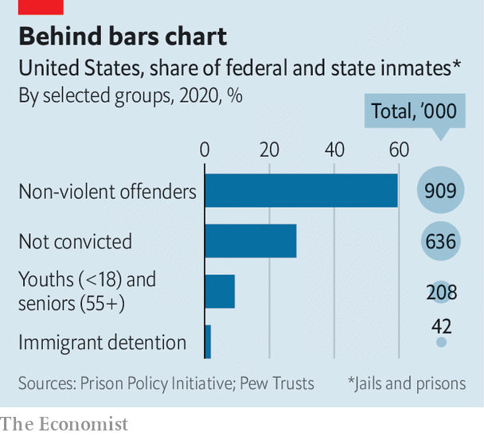

Amid all this, there is an opportunity to release those whose detention does little for public safety. Of the 1.29m in state prisons, according to the Prison Policy Initiative, a think-tank, nearly half are held for non-violent crimes. Three-quarters of the 631,000 in jails are awaiting trial, mostly on non-violent charges. Those held for breaking parole conditions or not posting bail, and those nearing the end of their sentences, may all be let out early. Montana’s chief justice has called for judges to free “as many prisoners as you are able” in such categories. One county jail in Kentucky released 120 of its 697 detainees this month.

The remaining population will be harder to reduce, but some individuals who are classed as “violent offenders” probably also pose little threat to public safety, says Julian Adler at the Centre for Court Innovation in New York. He points out that some defendants strike plea bargains and get a record as violent, though they have never inflicted or threatened physical harm on any victim. “Statistics can mislead,” he says. A getaway driver, convicted as an accessory to a robber, may count as a violent felon. So may someone who brawled in a bar. Mr Adler hopes the current push to rethink who should be kept inside will change public attitudes in the longer term.

This wish may not be forlorn. Efforts are under way in several states to change laws so as to shrink the incarcerated population: by doing away with cash bail, for example, or by getting police to carry out fewer arrests for misdemeanours. Such existing programmes are routinely backed by both political parties and have made it easier to respond quickly in the face of covid-19, according to Laurie Garduque of the MacArthur Foundation, which funds research on jail reform. The speedy action of many courts, sheriffs and other officials in the past week or so she describes as admirable. The pandemic brings a reminder that society’s most vulnerable—the poor, homeless and mentally ill—commonly end up in jails. Efforts to help them now are “not radical”, says Ms Garduque, “but are pushing in the same direction that we knew from before.” After the pandemic, she predicts, “we can go even further.” ■

Dig deeper:  
For our latest coverage of the covid-19 pandemic, register for The Economist Today, our daily [newsletter](https://www.economist.com/newslettersignup), or visit our [coronavirus hub](https://www.economist.com/coronavirus)

This article was downloaded by calibre from <https://www.economist.com/united-states/2020/03/26/the-virus-should-speed-efforts-to-shrink-americas-prison-population>

|  |  |  |  |
| --- | --- | --- | --- |
| Previous | Articles | Sections | Next |

|  |  |  |  |
| --- | --- | --- | --- |
| Previous | Articles | Sections | Next |

#### Sharing and not caring

# American teens are sexting more and sexing less

How to adapt sex-ed to a different kind of peril

Mar 26th 2020 | WASHINGTON, DC

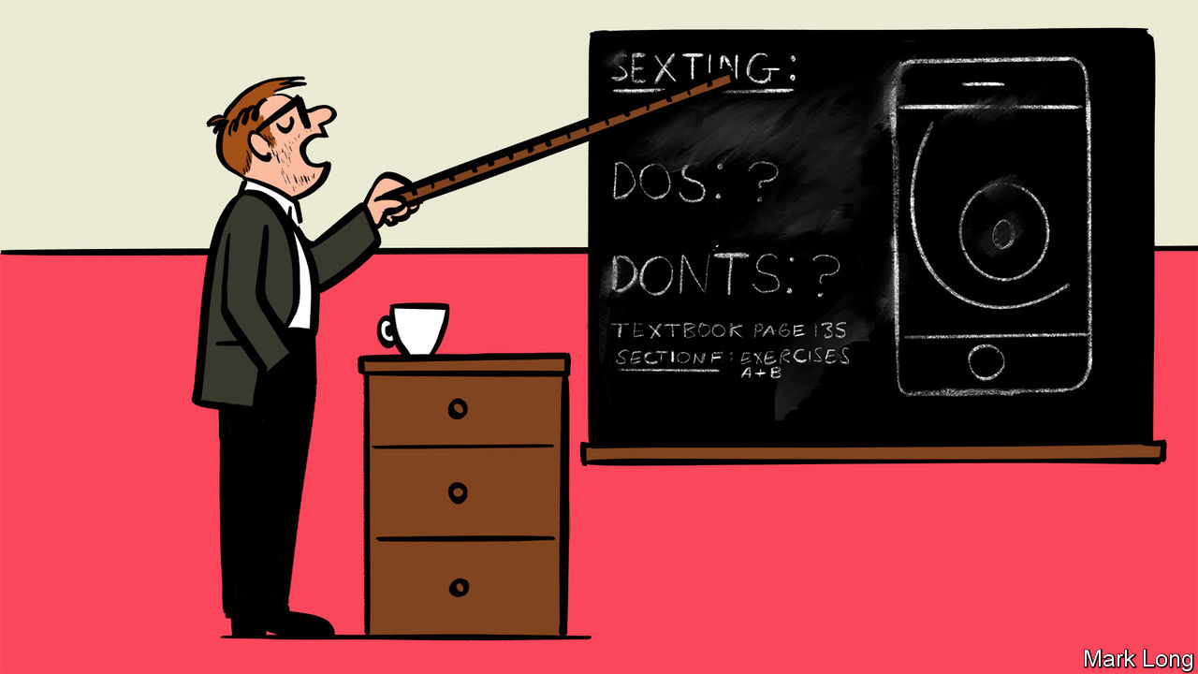

BY CONVENTIONAL measures, American teenagers have become prudish. Less than half of high-school students are having sex, with fewer partners and more contraception than the generation before them. Teen-pregnancy rates have never been lower. But those indicators no longer offer a complete picture: online, teens are bucking the trend. In 2019, among 12- to 17-year-olds, 14% reported sending nude images, compared with 12% three years earlier; 23% received them, up from 19%. The steady climb may reflect rising smartphone use and changing social norms. What it certainly reflects, says Justin Patchin, of the University of Wisconsin-Eau Claire, is that “the current approach to stop this isn’t working.”

For a decade, the prevailing advice to teens about sexting has been straightforward: don’t. In about half of states it is illegal for under-18s to sext, on child-pornography grounds. Legal punishments for minors are rare, but widely publicised in hard-line sex-education literature. One sexting-prevention programme in Connecticut, sponsored by the state’s criminal-justice division, warns would-be sexters that “your family members are eventually very likely to see any images you send electronically,” and friends may be “ashamed to be associated with you.” Public-school lesson plans from one county in Florida are bluntly entitled “Sexting Over the Net! STOP IT NOW” and “Safe Sexting: No Such Thing.”

Those reactions are understandable. But they are based on misconceptions of the problem. “We wasted so much time trying to figure out why kids were sexting,” laments Joris Van Ouytsel of the University of Antwerp, who began studying the topic in 2013. More important, researchers now broadly agree, is the context in which children are doing it. Just as it is offline, consent is vital. Things go wrong when teenagers pressure and coerce others, most often girls and younger teenagers, to send nude photos; or forward them to someone else, as happens in 4% of cases.

Conflation of abusive and non-abusive sexting has led to an oversimplified response. The onus of most interventions has been on the sender. But Jeff Temple, of the University of Texas Medical Branch at Galveston, notes that such thinking ignores the fact that sext-senders are often the victims of harassment. It also lets off teenagers who demand sexts or share them without permission, and leaves out the recipients of unsolicited ones who have been “cyber-flashed”. In some places sexting laws lump together teenagers who take nude photos of themselves, technically creating child pornography, with adult predators. Some states, including New Mexico and Washington, have begun decriminalising sexting between minors—a good first step.

“We have to stop being distracted by the fact that sexting involves digital technology,” says Elizabeth Englander, director of the Massachusetts Aggression Reduction Centre. Instead, she argues, it is “part and parcel of sexual development”. The internet has spawned novel abuses with wider-than-ever reach, but they tend to mirror those in the real world. For instance, more than a quarter of teenagers in relationships suffer “digital-dating abuse”, where one partner uses technology to snoop on, threaten or stalk the other; 35.9% of teenage victims have also suffered that offline.

Yet most sex education is stuck in analogue. New Jersey is rare in covering sexting problems in its curriculum; in December a bill was introduced to incorporate it in Illinois, too. The question that remains is what they should be teaching. To find out, researchers discussed some anti-sexting messages with older teenagers in Massachusetts and Colorado. Girls reported being affected by danger-fuelled warnings they had heard in the past (“You can’t control a picture once it’s been sent”); boys, on the whole, didn’t. Even among female students who had found such messages convincing, 40% had sexted nonetheless. Ms Englander concludes that just-say-no messages “may work for some, but not many, kids.” Worse, they risk scaring those who need help from coming forward.

Some researchers are proposing an alternative: a tech-savvy version of “abstinence-plus” education, which discourages sexting but offers strategies to keep teenagers safe if it does happen. The goal is to ensure that “any backlash is not irreparable”, explains Sameer Hinduja, co-director of the Cyberbullying Research Centre. It would stress that all sexting carries risk, but certain strands elevate it: taking a photo with your face in it, with a birthmark, in a recognisable place; sending it to a stranger, storing it on a cloud server, using an unsecured app. And it would incorporate sexting into broader conversations about respect in relationships generally. Most experts endorse this approach.

Laypeople, though, will probably “cringe”, “even recoil” at it, Mr Hinduja admits, “because it counters everything they have been taught” about sexting. Some concerns are age-old, such as that children will as a result have more sex, online or off. Others are new. Encryption meant to protect minors’ identity could complicate child-pornography investigations. Without a formal curriculum, parents can still talk to their children about how to be good “digital citizens”. But some translation may be required. “When we say ‘sexting’, kids know we’re boomers,” says Darren Laur, a 55-year-old former law-enforcement official who now runs a digital-literacy company. “They say ‘send nudes’.”■

This article was downloaded by calibre from <https://www.economist.com/united-states/2020/03/26/american-teens-are-sexting-more-and-sexing-less>

|  |  |  |  |
| --- | --- | --- | --- |
| Previous | Articles | Sections | Next |

|  |  |  |  |
| --- | --- | --- | --- |
| Previous | Articles | Sections | Next |

#### Zowie Howie

# Howie Hawkins will probably be the Green Party’s 2020 nominee

He looks unlikely to play spoiler, as Jill Stein did in 2016

Mar 26th 2020 | CHICAGO

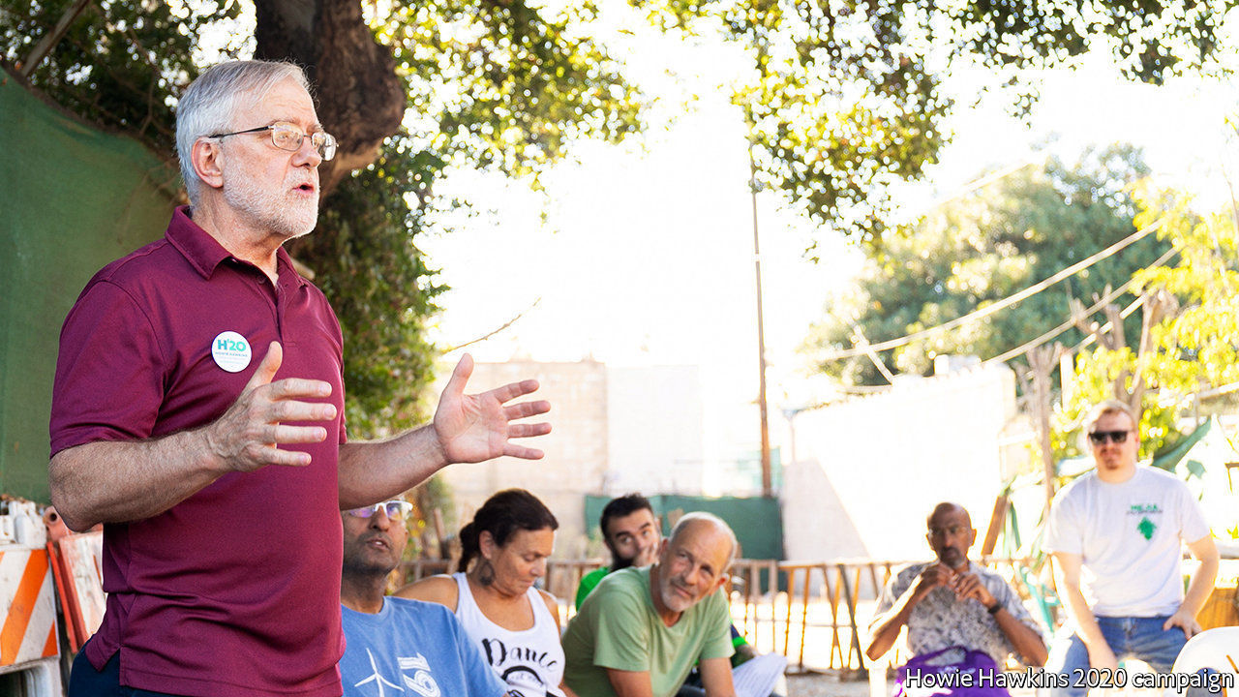

HOWIE HAWKINS, the front-runner for the Green Party’s presidential nomination, is inclined to look on the bright side. Munching on oatmeal during a recent campaign visit to Chicago, the genial, white-bearded 67-year-old lists reasons for his optimism. First comes his record of pursuing seemingly lost causes. The ex-Marine, construction worker, lorry-unloader and member of the Teamsters says, “I’ve been on the unpopular side that proved right in the end several times.”

As a teenager in 1960s San Francisco he joined the Peace and Freedom Party, demanding an end to the war in Vietnam. As a student at Dartmouth College he helped the Clam Shell Alliance stir opposition to nuclear power in New Hampshire. He marched for civil rights in America and opposed apartheid in South Africa. As a long-standing democratic socialist, he first dropped leaflets for Bernie Sanders in Vermont in the 1970s. Today he sees more Americans than ever welcoming ideas of “eco-socialism”. Triumphs don’t come easy, but “it’s a matter of time until we win people over”, he says.

For Greens the purpose of the election is twofold. One is to use the campaign to build the party, win volunteers and find recruits who can later run for local office, beginning with county boards. Without this, he says, the party will never gain national appeal. The second purpose is to press other parties to adopt green policies. He cites his own record of running to be governor of New York. In the 2014 race he won nearly 5% of the vote, enough to spook Andrew Cuomo, a Democrat, into taking up greener, leftier policies, such as a ban on fracking and plans for paid family leave and cheaper college.

He also cites the Green New Deal, which he says he has pushed since 2010. A version of it was adopted by Alexandria Ocasio-Cortez and other Democrats in the House. He sniffs that they have watered it down—“They took the brand and eliminated the content”—since their ambition is zero carbon emissions for America by 2050, and he says it must be 2030. He is pleased, nonetheless, that the plan is spreading.

His other policy ideas are equally bold, amounting to a $23trn plan to reshape the economy, impose a carbon tax, bring in a national health service, electrify all railways, put light-rail and other public transport in all cities and build up a machine-tools industry to make new environmental equipment, such as electric furnaces for steelmakers. He would also prevent the plastics industry from using petrochemicals and encourage the use of carbon-free cement for construction.

What of the party he helped to found? Mr Hawkins, who has won almost all the state primaries so far and expects to be picked in July at a convention in Detroit, wants the Greens to weave together their various strands of peace activists, social-justice campaigners and ecologists. They are still too “atomised” and prone to ideological squabbles, he says. Until they get over that, mass appeal will not follow.

Other countries show what might be possible. Greens in many rich democracies have sprouted vigorously in recent years. In Germany, for example, they could help form the next government. America’s system squeezes third parties, but elsewhere, even where first-past-the-post electoral politics hurts small ones, as in Britain and Canada, the odd Green MP gets elected. American voters say they want to tackle climate change. Disaffection with traditional parties is rising. And if there ever were electoral reform—such as a switch to ranked-choice voting—smaller parties could gain.

As for the 2020 election, Mr Hawkins hopes to appeal to young, fervent and disgruntled supporters of Mr Sanders, upset that their candidate has been pushed aside by Democratic primary voters. If the Democratic convention were to prove a bitterly contested one, some “Bernie bros” could give Howie a look. This raises a spectre for the Democratic Party. Ralph Nader, running as an independent in 2000, picked up 2.8m ballots (nearly 3%) in a tight presidential race, a tally that helped to keep Al Gore out of the White House. In 2016 Jill Stein, the Green Party’s candidate, helped by Russian meddlers, received 1.5m votes (1%), many of them in crucial midwestern states that Donald Trump narrowly won.

A repeat performance is unlikely. Polling by YouGov for The Economist shows support for third-party candidates at 3%, half of what they won in 2016. More probably, then, Mr Hawkins is in a fight to avoid humiliation. Even getting on the ballot in many states, which Greens usually manage, is proving difficult. The problem is getting signatures (and the tightening of some requirements). The party’s presidential candidate is eligible to stand in just 21 states so far. Mr Hawkins guesses 1.6m more signatures are needed to qualify in the remaining ones. The arrival of covid-19 makes that look almost impossible. On March 19th he suspended his effort to gather those signatures. As for disruption to campaigning because of the virus, Mr Hawkins seems relaxed. He says he has 10,000 books at home and an appetite to read as many of them as possible. ■

This article was downloaded by calibre from <https://www.economist.com/united-states/2020/03/26/howie-hawkins-will-probably-be-the-green-partys-2020-nominee>

|  |  |  |  |
| --- | --- | --- | --- |
| Previous | Articles | Sections | Next |

|  |  |  |  |
| --- | --- | --- | --- |
| Previous | Articles | Sections | Next |

#### Lexington

# Relations between China and America are infected with coronavirus

China-bashing has become a bipartisan passion

Mar 26th 2020 |

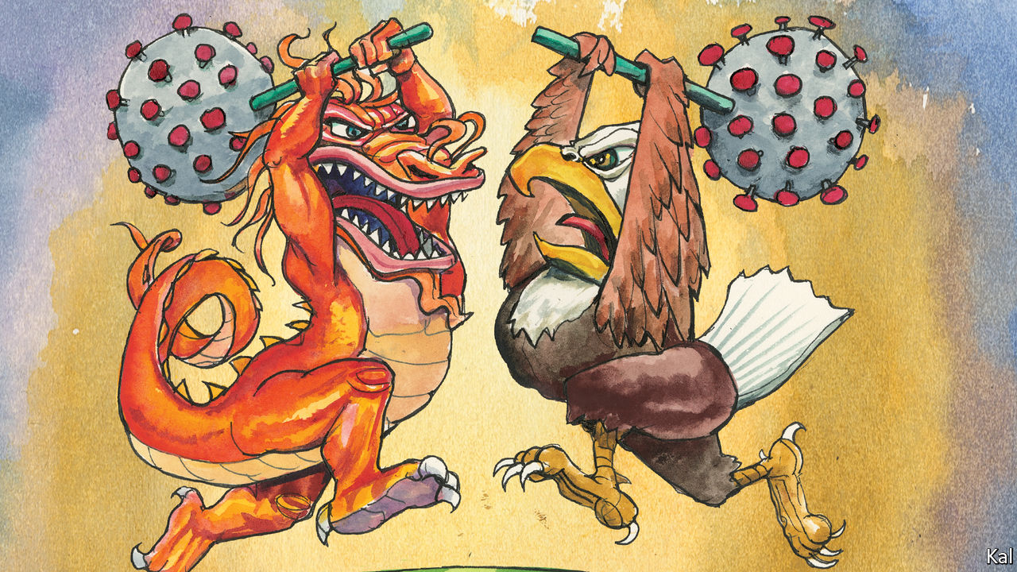

Editor’s note: The Economist is making some of its most important coverage of the covid-19 pandemic freely available to readers of The Economist Today, our daily newsletter. To receive it, register [here](https://www.economist.com/newslettersignup). For more coverage, see our coronavirus [hub](https://www.economist.com/coronavirus)

FACED WITH the first great crisis of his presidency, Donald Trump fell back on his go-to tactic: blame China. His decision in January to bar non-American visitors from the country appears to have been his only prompt action against the coronavirus. After that failed to prevent it penetrating America’s borders, he has been insisting on China’s responsibility for the pathogen.

While the disease was concentrated in China, Mr Trump called it by its approved name, coronavirus. Since its arrival in America he has referred to it, in daily tweets and briefings, as the “China virus”. Others in his administration use “Wuhan virus”, including Mike Pompeo, the secretary of state. He is reported to have demanded the G7 group of industrial countries call it by that name. A White House staffer is said to prefer the phrase “kung flu”.

It is easy to see what Mr Trump is about. He wants to distract from his administration’s failure to contain the disease—such that America, despite having had months to prepare for it, will soon have more covid-19 cases than China. He also sees in the issue an opportunity to own the libs. A note circulated by Mr Trump’s re-election campaign last week suggests that it plans to make the president’s fearlessness in uttering the phrase “China virus” a defining difference between him and his presumed Democratic opponent, Joe Biden. In 2016 Mr Trump portrayed Hillary Clinton’s aversion to the unhelpful phrase “radical Islamic terrorism” as weak; he has updated the tactic.

Yet what candidate Mr Trump said in 2016 and what America’s president says are different matters. China has responded angrily to his administration’s slurs. Where recent pandemics—including the 2014 west African Ebola outbreak—saw productive Sino-American co-operation, this one has taken the already-poor relations between Mr Trump and Xi Jinping to new lows.

And they are liable to worsen, despite efforts on both sides to rein in the rhetoric this week. Mr Trump appears set on a campaign of China-baiting which America’s looming recession and death toll will make more feverish, especially as the virus spreads to Republican-voting states. China-watchers warn of a rising risk of a “low probability, high consequence” upset. In the best case, one opines, the relationship with China will be “utterly broken”.

The best way to lower the tension would be if Mr Trump’s diversionary tactic failed. But this would require his supporters to denounce his handling of the virus, of which there is currently no sign. Republicans admire it. And even if their faith wobbled, Mr Trump’s China-bashing would be likelier to sustain his popularity on the right than to endanger it.

This reflects more than Republicans’ traditional hawkishness. Bashing China unites two of the Republicans’ main factions: national-security sorts, who dislike Mr Trump’s protectionism but like his belligerence, and economic populists, who are wary of militarism but love the tariffs. By extension, it is also one of the ways the Republican establishment, which dominates the former group, has made peace with Mr Trump. No wonder ambitious Republicans, who try to keep a foot in both camps, sound especially hawkish. They include Mr Pompeo, who calls China’s ruling party “the central threat of our times”.

Discernible, too, amid the Republican mistrust of China is a fear of national decline that looks like an accompaniment to white conservatives’ dread of the socio-demographic currents that threaten the party. In a tweet this week, Newt Gingrich, a Trump loyalist and former presidential candidate, lamented that Huawei, a Chinese telecoms firm emblematic of state capitalism, was dispensing medical supplies while “our once great telecommunications companies have lost their entrepreneurial drive.”

This helps explain why Republicans find it easy to ignore the obvious expediency of Mr Trump’s latest China-bashing. It also explains why few appear to have registered that his antagonistic China policy has not achieved much. His tariffs have been ruinous to American farmers and consumers and won no big concessions from China on any of the issues, such as intellectual-property theft, they were supposed to address. The need to confront China has been embraced by many Republicans as an ideological imperative, requiring no supporting evidence of its wisdom.

And yet the pandemic also points to other ways in which Mr Trump’s policy has backfired. In line with its general disregard for science and civilian expertise, the administration slashed the Centres for Disease Control’s China-based staff—the potential focal point for Sino-American pandemic co-operation—ahead of the outbreak. Instead of rallying its allies in a global response to the pandemic, it has continued to alienate them. Mr Trump gave the Europeans no forewarning of his plan to bar non-American visitors from their countries this month. Instead of rising above China’s propagandists, he got into the mud with them.

## Sino’ the times

Earlier this month Mr Trump was lambasted for having allegedly tried to buy a promising German coronavirus vaccine for America’s exclusive use. He would do better to reignite the liberal values and openness to talent upon which America’s economic dynamism is based. Last week Propublica, a news website, described how a Chinese scientist, Weihong Tan, was hounded from the University of Florida last year by federal restrictions on scientists with ties to China. Now at Hunan University, he switched from cancer research and created a faster test for covid-19. And Mr Trump’s recent rhetoric, which has helped inspire a surge in hate crimes against Asian-Americans, cannot have tempted him to return.

Mr Trump’s effort to redefine relations with China as fundamentally competitive may prove to be his most enduring legacy. Contrary to his politicking, even Democrats now see the relationship in those terms. His management of it, as the pandemic highlights, is a different story: it shows how America can lose.■

Dig deeper:  
For our latest coverage of the covid-19 pandemic, register for The Economist Today, our daily [newsletter](https://www.economist.com/newslettersignup), or visit our [coronavirus hub](https://www.economist.com/coronavirus)

This article was downloaded by calibre from <https://www.economist.com/united-states/2020/03/26/relations-between-china-and-america-are-infected-with-coronavirus>

|  |  |  |  |
| --- | --- | --- | --- |
| Previous | Articles | Sections | Next |

|  |  |  |
| --- | --- | --- |
| United States | Sections | Asia |

The Americas

Covid-19 in Brazil: BolsoNero

.

Mexican-American relations: Distancing neighbours

.

Bello: The Latin American patient

.

|  |  |  |
| --- | --- | --- |
| United States | Sections | Asia |

|  |  |  |  |
| --- | --- | --- | --- |
|  | Articles | Sections | Next |

#### BolsoNero

# Brazil’s president fiddles as a pandemic looms

It’s just a sniffle, he claims

Mar 26th 2020 | SÃO PAULO



Editor’s note: The Economist is making some of its most important coverage of the covid-19 pandemic freely available to readers of The Economist Today, our daily newsletter. To receive it, register [here](https://www.economist.com/newslettersignup). For more coverage, see our coronavirus [hub](https://www.economist.com/coronavirus)

THE FIRST person to die from covid-19 in the state of Rio de Janeiro was a 63-year-old maid who commuted each week to a beachside apartment in Leblon, the priciest neighbourhood in Brazil. Her employer had recently returned from Italy. The maid, who had diabetes and high blood pressure, died on March 17th in a city 100km (60 miles) away, where she and five relatives shared a cinder-block house. Several hospital workers there have since fallen ill.

If the virus in Italy jumps between generations living together, in Brazil it started by hopping between classes, which are socially distant but physically close. One vector may be the populist president, Jair Bolsonaro. On March 15th, after his communications secretary tested positive for the virus, he ignored quarantine orders and took selfies with fans. When the first Brazilian died of covid-19 on the next day, he denounced “hysteria” about the virus.

Other leaders are less complacent. Voting remotely for the first time, congressmen proclaimed a “state of calamity”, which lets the government breach constitutional spending limits. Rodrigo Maia, the president of the lower house, wants to spend at least 400bn reais ($80bn, or 4% of GDP) to help the health system and the economy. The health minister, Luiz Henrique Mandetta, is not an ideologue, unlike many of his cabinet colleagues. City and state governments are imposing isolation measures—São Paulo and Rio de Janeiro have full lockdowns—and turning football stadiums into hospitals. Universities and private labs are developing covid-19 tests. Companies are donating materials for their production. Brazil’s biggest brewery is making hand sanitiser.

But workers against the disease must block out signals from a president who continues to disparage their efforts. On March 25th he told Mr Mandetta to stop calling for large-scale social distancing. In a televised speech on March 24th, he urged local governments to abandon “scorched-earth” strategies of closing schools and shops, and blasted the media for spreading “the sensation of fear”.

As The Economist went to press, Brazil had 59 covid-19 deaths and 2,554 confirmed cases. But testing has mostly been limited to patients in hospital. The true number is probably much higher. Piecemeal responses by governments and the private sector will not fend off disaster. Warm climates like Brazil’s may slow transmission of the virus, says a new study from the Massachusetts Institute of Technology. Otherwise “there are no mitigating factors,” says Paulo Chapchap of the Sírio-Libanês hospital in São Paulo. Private hospitals like his are strained, because current patients tend to be rich folk who caught the disease abroad, or their intimates. As it migrates to the masses it could quickly overwhelm the public health system, which serves four-fifths of the population.

Brazil’s universal health-care system serves more people than any other totally free system in the world, but the country spends just 3.8% of GDP on it. Italy spends 6.7% of GDP; Germany, 9.4%. Brazil’s public system has just seven acute-care hospital beds per 100,000 people, nearly all of which are occupied by non-covid patients. Demand for acute-care beds in some cities abroad has approached 25 per 100,000 during the pandemic. Mr Mandetta warns that the system could “collapse” in April.

The Institute for Health Policy Studies in Rio calculates that the government would need to spend 1bn reais for every 1% of the population infected in order to treat all severe cases. The government has approved around 10bn reais of extra spending, a rise of a tenth but probably too little. “The forecast is catastrophic,” says Miguel Lago, the institute’s director.

Until the government reaches its goal of testing 30,000-50,000 people a day, which may take months, lockdowns are the only way to slow transmission. This is especially hard in favelas. These informal settlements are home to 13m of Brazil’s 211m people, including a fifth of those in Rio. They are densely packed and many lack running water. For now, grassroots groups, not the government, are running public-health campaigns. Organisers in the Maré, in Rio, suggest quarantining patients with mild symptoms in empty schools. Paraisópolis, in São Paulo, plans to move older residents to rented mansions in a leafy district nearby. Activists are driving around favelas with loudspeakers, telling residents to stay home. In some, drug-traffickers have shut open-air drug markets, cancelled bailes funk (all-night parties) and imposed curfews. “If the government isn’t capable of making it happen, organised crime will,” vows one gang on WhatsApp.

In many favelas commerce continues because people have to work. Just a fifth of residents have formal jobs. Most are day-labourers, vendors or domestic employees. They can afford to stay home only if the government pays them, says Eliana Sousa Silva of Redes da Maré, an NGO.

The government plans to give informal workers 300 reais a month for three months. That may not be enough. Brazil’s fiscal deficit and weak credit rating will prevent the government from offering a massive stimulus (see article). Paulo Guedes, the economy minister, has proposed almost no new economic support.

As suffering spreads, the political cost to Mr Bolsonaro will become clearer. Twenty-three people who travelled with him to see Donald Trump in Florida this month have tested positive for covid-19. On March 13th Fox News reported that the president’s son, Eduardo, said that his father had the virus. Both then denied it. A judge ordered the military hospital in Brasília, the capital, to publish the names of confirmed cases from the delegation. It held back two.

People in swanky neighbourhoods that voted for Mr Bolsonaro in 2018 are now banging pots and pans in nightly protests. In one poll, his approval rating dropped to its lowest point since he took office last year. Fiddling while a pandemic looms may cost him re-election in 2022. ■

Dig deeper:  
For our latest coverage of the covid-19 pandemic, register for The Economist Today, our daily [newsletter](https://www.economist.com/newslettersignup), or visit our [coronavirus hub](https://www.economist.com/coronavirus)

This article was downloaded by calibre from <https://www.economist.com/the-americas/2020/03/26/brazils-president-fiddles-as-a-pandemic-looms>

|  |  |  |  |
| --- | --- | --- | --- |
|  | Articles | Sections | Next |

|  |  |  |  |
| --- | --- | --- | --- |
| Previous | Articles | Sections | Next |

#### Distancing neighbours

# Mexico and the United States shut their border, sort of

A carefully calibrated closure

Mar 26th 2020 | TIJUANA

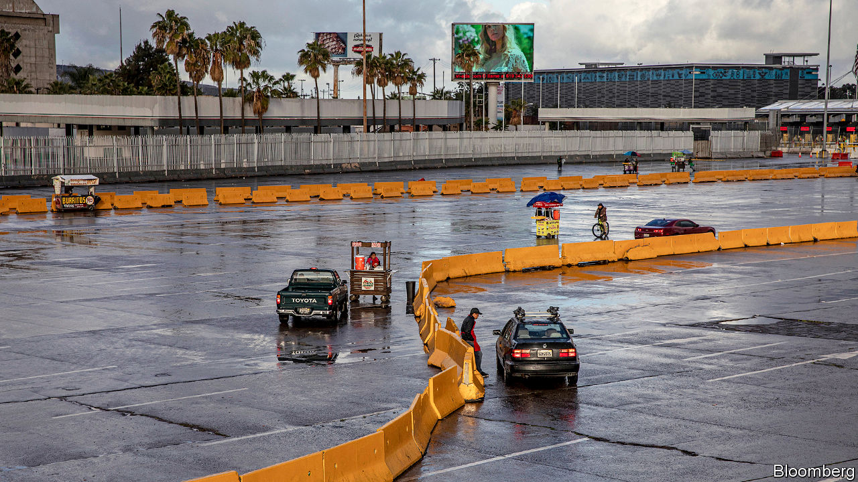

Editor’s note: The Economist is making some of its most important coverage of the covid-19 pandemic freely available to readers of The Economist Today, our daily newsletter. To receive it, register [here](https://www.economist.com/newslettersignup). For more coverage, see our coronavirus [hub](https://www.economist.com/coronavirus)

TIJUANA AND San Diego are rumbustious siblings. The San Ysidro border crossing, which links them, is the world’s busiest. Some 5m people a month make the northward journey between the cities. But covid-19 has brought about an abrupt change in their relationship. On March 19th California’s government ordered the state’s 42m residents to stay home to slow the spread of the new coronavirus. The next day Donald Trump, the American president, announced that the United States-Mexico border would be closed to all but “essential” traffic.

San Diego immediately became a ghost town, its streets bare but for a few dog walkers and homeless people. At each stop on an empty tram, a gloved attendant wiped clean the buttons that operate its doors. Traffic at San Ysidro slowed to a trickle. But at Tijuana beach, a few hundred metres across the border, couples strolled, vendors sold hot dogs and party-goers congregated around fires. Despite the notable absence of Americans, the pandemic seemed far away. “If we die, we’ll die among friends,” said one Mexican.

If covid-19 was a golden opportunity for Mr Trump to erect the wall that he has long sworn to build, he did not seize it. Although a dozen Latin American countries have shut their borders completely, Mexico and the United States have kept theirs porous. Mr Trump’s definition of “essential” travel is wide enough to let through lorries full of electronics. Both governments seem wary of disrupting commerce; some $1.4bn-worth of goods crosses the border daily. The annual flow is the equivalent of nearly half of Mexico’s GDP. Besides, border closures do little good once an epidemic has taken hold on both sides.

The decision to block partially the 3,200km (2,000-mile) border was mutual, announced by joint press release. Talks with the White House were “quite different from the take it or leave it” approach of past discussions, says a Mexican diplomat. Mr Trump forced Mexico (and Canada) to renegotiate the North American Free Trade Agreement, but the process helped build relationships. The manner of the border tightening shows that bridges built in those talks are still standing, says Agustín Barrios Gómez of the Mexican Council on Foreign Relations.

In theory, the restrictions keep out border-crossers who want to shop or visit people. Mexicans with work permits are exempt from the restrictions, as are Americans heading south for cheap dentistry. A supermarket attendant in Tijuana grumbles that despite California’s quarantine San Diegans raid the shelves for toilet paper, pasta and rice. But in a pandemic an open border can be an asset as well as a threat. Nearly 200,000 Mexican recipients of seasonal H2-A visas will harvest American crops. Mexican-made sensors of blood-oxygen levels and virus-blocking N95 masks will be used in American hospitals. Drugs and medical equipment will head south.

Even so, traffic has slowed sharply, which will hurt output and employment. “We are gonna have to close,” says a sales manager for a small firm in Tijuana that resells industrial materials. His workers cross into San Diego with tourist visas every other day to pick up supplies, which they deliver to factories on the Mexican side of the border. That is no longer possible. American citizens could do the job but will not accept the firm’s low wages, the manager says. Besides, half of the factories he serves are shut, he adds.

The future is more uncertain still for the thousands of Central Americans and others on the border who await word on their applications for asylum in the United States. Their faint hopes of refuge have dimmed further: the Trump administration has stopped receiving applications and suspended hearings. Migrant camps are potential virus hotspots.

The numbers suggest that it is Mexico that should fear contagion more. They indicate that the outbreak in Mexico lags two weeks behind that of the United States. On March 25th California had 2,998 confirmed cases of covid-19. The neighbouring state of Baja California had 16. That is surely an under-count. By that date Mexico had tested about 4,500 people, compared with 422,000 in the United States.

Mexico’s populist president, Andrés Manuel López Obrador, is doing little to prepare Mexicans for what is coming. He continued to travel and hug supporters and encouraged families to visit restaurants, as “this strengthens the economy”. Other officials are taking the virus more seriously. On March 22nd the mayor of Mexico City shut bars and banned large gatherings. Two days later the federal health ministry ramped up testing and advocacy of social distancing. That would have happened earlier if the government had collected better evidence by testing more, say experts. The financial markets are predicting massive economic harm, from an American recession, low oil prices and a domestic outbreak of covid-19. The Mexican peso has dropped to its lowest-ever level against the dollar (see article).

Openness on the border was tested before Mr Trump and covid-19 came along. After the terrorist attacks of September 11th 2001, the United States enacted stringent inspections. The delays they caused threatened such economic damage that they “would [have] deliver[ed] to al-Qaeda the victory that it sought” had they been kept, says Alan Bersin, a former boss of United States Customs and Border Protection. The two countries fixed that by waving through “low-risk” workers with registered fingerprints, which freed border agents to watch for terrorists. That will not avert panic during a pandemic. If the disease becomes rampant in Mexico, Mr Trump could slam shut today’s semi-open border.■

Dig deeper:  
For our latest coverage of the covid-19 pandemic, register for The Economist Today, our daily [newsletter](https://www.economist.com/newslettersignup), or visit our [coronavirus hub](https://www.economist.com/coronavirus)

This article was downloaded by calibre from <https://www.economist.com/the-americas/2020/03/26/mexico-and-the-united-states-shut-their-border-sort-of>

|  |  |  |  |
| --- | --- | --- | --- |
| Previous | Articles | Sections | Next |

|  |  |  |  |
| --- | --- | --- | --- |
| Previous | Articles | Sections | Next |

#### Bello

# Covid-19 will sicken Latin America’s weak economies

Governments scramble to mitigate the shock

Mar 26th 2020 |

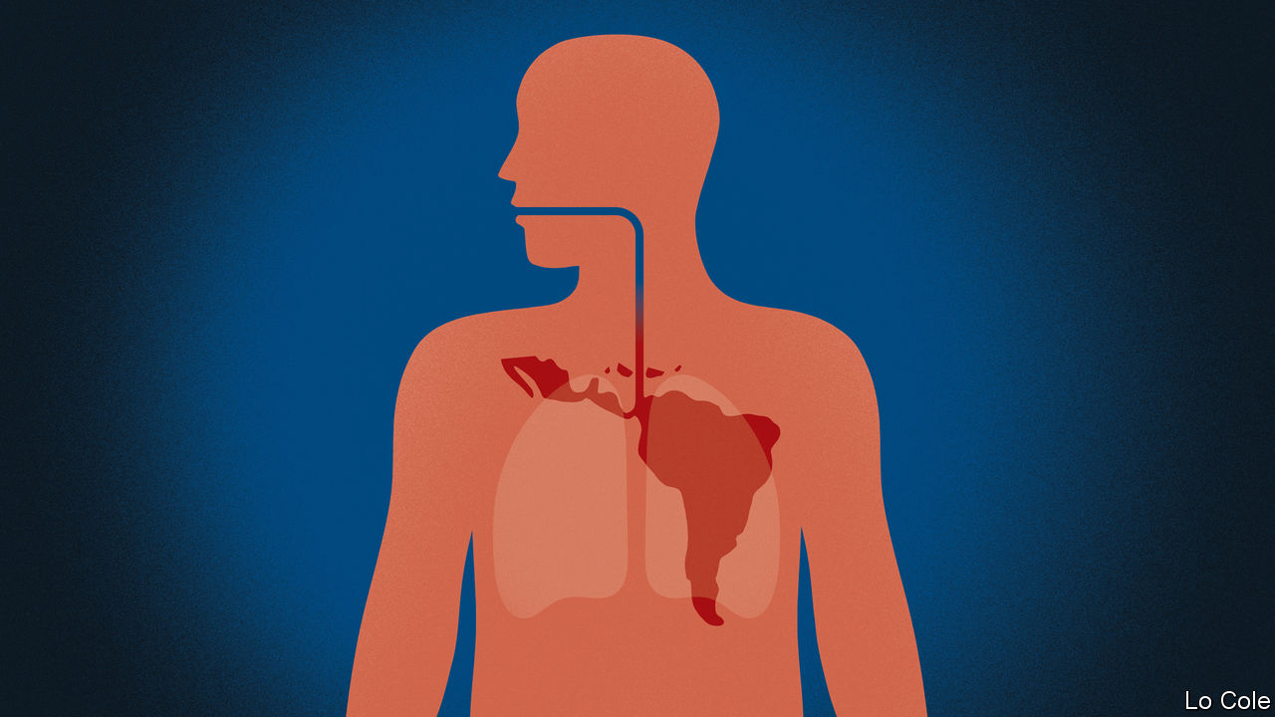

Editor’s note: The Economist is making some of its most important coverage of the covid-19 pandemic freely available to readers of The Economist Today, our daily newsletter. To receive it, register [here](https://www.economist.com/newslettersignup). For more coverage, see our coronavirus [hub](https://www.economist.com/coronavirus)

IN BRAZIL, COPACABANA beach is deserted and football stadiums are being turned into field hospitals. Colombia has shut its border with Venezuela. Seabirds have taken possession of Peruvian beaches and a puma was spotted ambling through the suburbs of Santiago, Chile’s capital. Covid-19 has now arrived in strength in Latin America. With it have come lockdowns in many countries, though some leaders remain in denial, storing up trouble. Everywhere, it is threatening and testing both public health and livelihoods.

The virus has struck a patient that in economic terms has a serious pre-existing condition. Since 2014 the region’s economy has grown at an annual average rate of less than 1% a year and income per person has dropped. Now it faces a contraction even more severe than that induced by the financial crisis in 2009, when Latin America’s GDP fell by 1.7%. Back then, thanks to prudent economic management, many countries were able to soften the blow by relaxing monetary and fiscal policy. Now they have less scope to do so. Many central banks had already cut interest rates last year because of economic weakness. On average, public debt was 57% of GDP in 2019, compared with below 40% in 2008, according to the Inter-American Development Bank (IDB).

As in 2009, Latin American countries face less demand for their exports and lower prices for them. Unlike then, they will also be hit by quarantines and the concomitant temporary shutdown of many service businesses. Mexico, Central America and the Caribbean, with close ties to the economy of the United States, will be especially badly hit. Tourism, which directly accounts for 15.5% of GDP and 14% of total employment in the Caribbean islands, has stopped dead. Some South American economies have been badly hit by the contraction in China, their biggest export market.

Nobody knows how long quarantines will last, so forecasts involve more guesswork than usual. Early this year Ben Ramsey of J.P. Morgan Chase, a bank, had reckoned on growth of 1.2% in Latin America. Now he thinks the region will contract by 2.2%, assuming a recovery in the second half of the year. Santiago Levy, a former chief economist of the IDB, reckons that the region will be lucky if the contraction is no worse than 4% or 5%. The UN Economic Commission for Latin America and the Caribbean, which predicts a fall of 1.8%, thinks the number of poor people will rise from 185m to 220m (in a total population of 650m).

Policymakers are scrambling to react. “They are using their tool-kits and throwing caution to the winds,” says Mr Ramsey. Central banks in Chile, Brazil, Mexico and Peru have made emergency cuts in interest rates. Several are readying credit lines for firms (Brazil’s central bank has announced that it will inject $230bn into the financial system, about 11% of GDP) and help for health services and workers.

But here they face a difficulty: most Latin Americans work in small businesses and are in the informal (unregistered) economy. Emergency payments can reach formal workers and, through conditional cash-transfer programmes, the poorest. That leaves out a large segment of the lower-middle and working classes.

Peru’s government has ordered a payment of 380 soles ($108) per family, but is finding it hard to distribute. Governments might consider resorting to mototaxi (tuk-tuk) money, in which, with suitable security and social distancing, they courier cash to households.

How will they pay for all this? Some may face a “sudden stop” in private capital inflows, similar to that suffered by Argentina in 2001 and 2018. Ecuador, an oil exporter which was all but bankrupted by Rafael Correa, its populist president from 2007 to 2017, looks close to default. Other countries have seen investors demand higher premiums to hold their bonds. Currencies have suffered, too. Since February, against the dollar the Mexican peso has depreciated by a quarter and the Brazilian real by 16%.

Countries that can still tap financial markets should make it clear that their spending measures are temporary and that they don’t imply losing control over public finances, urges Mr Levy. Others may turn to the IMF, which is preparing emergency finance. Some governments may print money, something that has been rightly frowned upon by serious policymakers in Latin America since the 1980s, when it was associated with hyperinflation. But today deflation looks a bigger risk than inflation. Desperate times call for desperate measures.

Dig deeper:  
For our latest coverage of the covid-19 pandemic, register for The Economist Today, our daily [newsletter](https://www.economist.com/newslettersignup), or visit our [coronavirus hub](https://www.economist.com/coronavirus)

This article was downloaded by calibre from <https://www.economist.com/the-americas/2020/03/26/covid-19-will-sicken-latin-americas-weak-economies>

|  |  |  |  |
| --- | --- | --- | --- |
| Previous | Articles | Sections | Next |

|  |  |  |
| --- | --- | --- |
| The Americas | Sections | China |

Asia

Covid-19 in Japan: Blowing out the flame

.

Politics in Bangladesh: Ee begum!

.

Sexual abuse in South Korea: Naming and shaming

.

Banyan: An island at the ready

.

Covid-19 in South Asia: Hand-to-mouth to lockdown

.

|  |  |  |
| --- | --- | --- |
| The Americas | Sections | China |

|  |  |  |  |
| --- | --- | --- | --- |
|  | Articles | Sections | Next |

#### Blowing out the flame

# Covid-19 forces Japan to delay the Olympics

Experts fear Japan is too nonchalant about the virus

Mar 26th 2020 | TOKYO

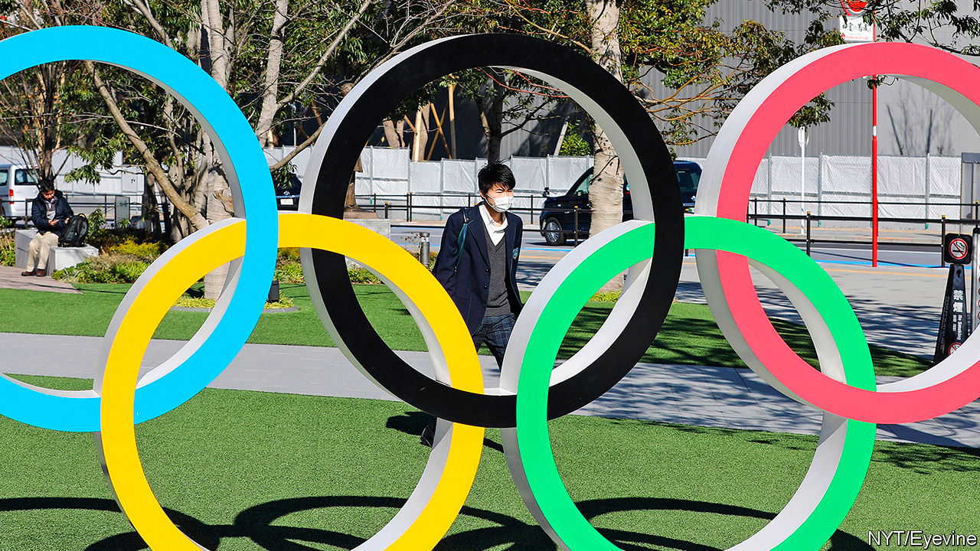

Editor’s note: The Economist is making some of its most important coverage of the covid-19 pandemic freely available to readers of The Economist Today, our daily newsletter. To receive it, register [here](https://www.economist.com/newslettersignup). For more coverage, see our coronavirus [hub](https://www.economist.com/coronavirus)

WHEN THE annals of the new coronavirus are written, a chapter will surely be devoted to the dogged insistence by Japan’s prime minister, Abe Shinzo, that despite a galloping global pandemic the Tokyo Olympic Games would go ahead as planned in July. Mr Abe—the most assertive prime minister since his beloved grandfather, Kishi Nobusuke, who secured the 1964 Olympics for Tokyo—is not used to being gainsaid. But on March 24th he at last conceded, declaring that the games would be postponed by a year. The announcement left the Olympic flame stranded in, of all places, Fukushima, the site of a nuclear meltdown in 2011.

Only 12 days earlier Mr Abe had convened a press conference on a Saturday to insist that postponement or cancellation was unthinkable. Japan itself had the coronavirus under control, he said. The games would provide a welcome tonic as the world emerged from the pandemic’s shadow. Yet the shadow was only lengthening as he spoke, shutting down travel and upending training schedules across Asia, Europe and America. At the start of this week Australia and Canada said they would not send their athletes if the games went ahead. An opinion poll found nearly two-thirds of Japanese wanted a delay.

Japan had much riding on the games, as did Mr Abe himself. Officially, they were to be the “recovery Olympics”, marking the country’s bounce-back from the Fukushima disaster. But the government also wanted to show off Japan’s corporate genius, organisational verve and innovative design, just as the Olympics did in 1964. Toto wanted to show off all-singing, all-dancing toilets and Toyota had plans for a flying car. Since the bursting of the stockmarket and property bubbles in the late 1980s, Japan Inc has suffered a collective loss of confidence. “Japan,” Mr Abe had declared when he came to power in 2012, “is back.” Here was the chance to prove it.

Pressed into national service by Dentsu, Japan’s advertising giant, big firms including Bridgestone, Canon, Nomura, Toto and Toyota provided a record $3.1bn to sponsor the games. Even before the postponement, executives wondered what the outlay of as much as $100m a firm would get them. The answer will have to wait a year. Meanwhile, the spanking new stadium, the hotels built to put up hordes of spectators, Toyota’s new fleet of London-style cabs, the Olympic banners lining the empty roads and even the commemorative manhole covers all give parts of Tokyo the air of an abandoned stage set.

The absence of visitors spending gaily this summer will be keenly felt. Even before the advent of covid-19, the economy was slowing. It is almost certainly in recession now. The Bank of Japan has been busy buying shares to prop up the stockmarket. Starting next week the Diet will rush through an emergency stimulus package worth perhaps ¥30trn ($271bn)—on a par with its response to the global financial crisis. But one senior politician worries that cautious beneficiaries will promptly stash the proceeds under the futon.

Much depends on the course of the coronavirus in Japan. Mr Abe was criticised for the early handling of the crisis—the government welcomed Chinese visitors for the lunar new year even after the Wuhan eruption was known, and fumbled the handling of a cruise ship with infected passengers. The prime minister’s poll numbers took a dive, improving only after he closed schools and even banned audiences at the spring sumo tournament.

Japan has to date been a virus outlier: the epidemic has proceeded more slowly than in other big economies. It had its first infection in mid-January, two weeks before Italy. Since then Italy has recorded more than 74,000 cases and 7,500 deaths. In Japan just over 1,300 have been reported as infected and only 45 have died.

Like other East Asian countries, Japan has learned from previous epidemics, such as SARS and bird flu, about the importance of containment: pains are taken to identify infection clusters and then to track down transmission routes, says Shindo Nahoko of the WHO. A compliant population heeds government health advice about frequent hand-washing and accepts unpopular measures such as the closure of schools.

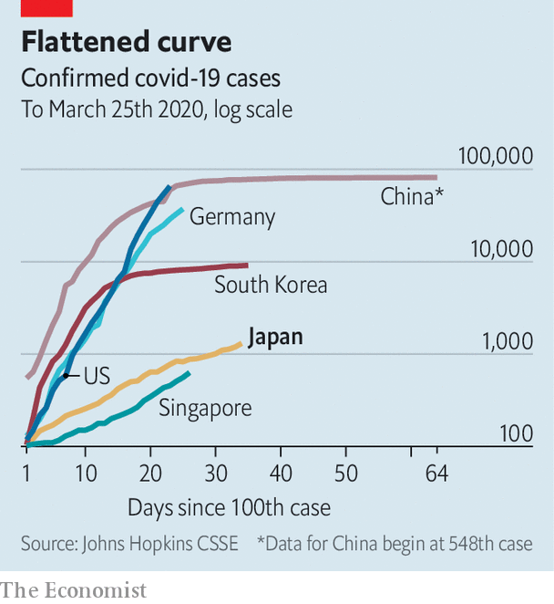

Yet the government has to date communicated little sense of crisis—in part, the suspicion goes, to make everything appear normal so that the games could go ahead. Instead of adopting the stringent suppression measures being pursued across Asia, Europe and America, Japan is relaxing its restrictions. Hokkaido, with a big cluster of infections, has lifted the state of emergency declared in late February. Mr Abe says that schools can reopen next month.

Meanwhile fewer than a sixth of workers are working from home. Over the weekend, Tokyoites ignored official guidance and turned out in throngs to admire the cherry blossoms. A kick-boxing event in Saitama prefecture attracted 6,500 fans. Late-night revellers slurp shoulder-to-shoulder at ramen joints before heading home on crowded trains. In the land of bows, senior officials greet foreign visitors with hearty handshakes, to show that everything is fine.

Given that infections continue to rise, some are finding the general nonchalance unnerving. Reports are growing of corohara (short for “coronavirus harassment”): the bullying of people who have recently returned from abroad, or who cough in public places. Experts in public health are alarmed. Some say the government’s testing only of those who have clear symptoms or who have been in contact with a carrier risks missing the spread of infection through the wider population. Mr Abe has set up a task force and an expert panel but, says Iwata Kentaro of Kobe University, no one appears to be in charge. Kami Masahiro, who heads the non-profit Medical Governance Research Institute, fears that in a climate of complacency and restricted testing, coronavirus cases could “explode”.

For now, raising such fears is taboo among national politicians and at the public broadcaster, NHK—just as suggesting that the games should be postponed was, only a week ago. But that may soon change. Faced with a new clutch of infections in her city, the governor of Tokyo, Koike Yuriko, this week warned that the city of 13m might face a lockdown if cases could not be contained. Transmission routes were becoming increasingly hard to identify, she said; the coming three weeks would be critical. She urged Tokyoites to stay at home this weekend, although she stopped short of ordering it.

Her comments ought to shake the city’s residents out of their complacency. Nor can the prime minister afford to be complacent. If the pandemic is mishandled, even next year may prove too early to hold the games. Party rules dictate that Mr Abe retire by the autumn of 2021—which means he could miss the games he did so much to bring about, just like his grandfather did. ■

Dig deeper:  
For our latest coverage of the covid-19 pandemic, register for The Economist Today, our daily [newsletter](https://www.economist.com/newslettersignup), or visit our [coronavirus hub](https://www.economist.com/coronavirus)

This article was downloaded by calibre from <https://www.economist.com/asia/2020/03/26/covid-19-forces-japan-to-delay-the-olympics>

|  |  |  |  |
| --- | --- | --- | --- |
|  | Articles | Sections | Next |

|  |  |  |  |
| --- | --- | --- | --- |
| Previous | Articles | Sections | Next |

#### Ee begum!

# Bangladesh releases a jailed opposition figure

Some see a link to the coronavirus epidemic

Mar 26th 2020 |

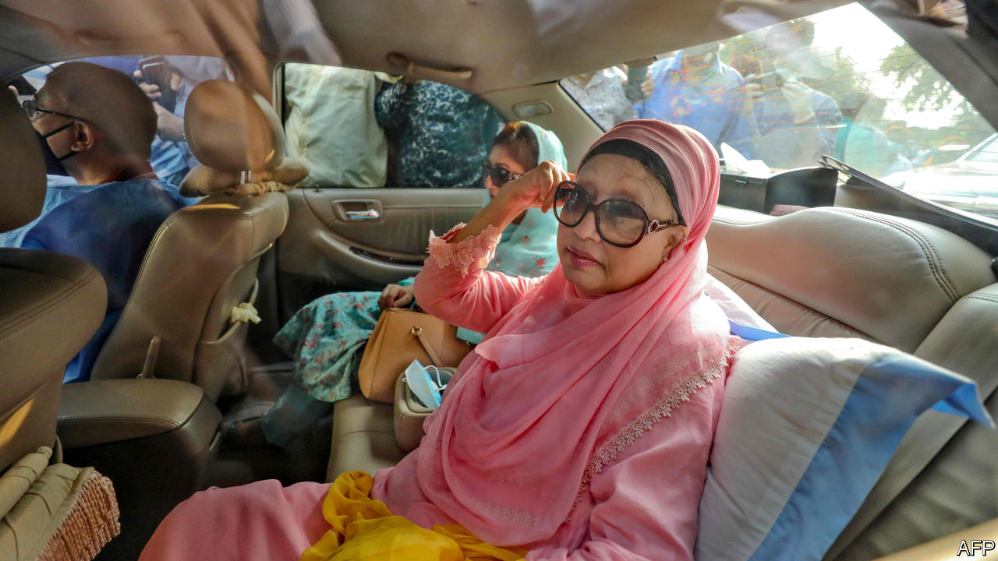

LIKE MANY others, the government of Bangladesh has issued a ban on public gatherings to curb the spread of covid-19. Yet not even the threat of a pandemic could deter supporters of Khaleda Zia, a jailed opposition leader, from turning out en masse to witness her release on bail. The 74-year-old, who leads the Bangladesh Nationalist Party (BNP), was granted a six-month reprieve from prison on March 25th in order to seek medical treatment.

Mrs Zia, who served as Bangladesh’s prime minister from 1991 to 1996 and from 2001 to 2006, was handed a five-year prison sentence in 2018 for misusing funds intended for a charity for children. The BNP claims that case and others against Mrs Zia—there are 34 in all—are politically motivated. For a time the leadership of Bangladesh seesawed between the two begums, Mrs Zia and Sheikh Hasina Wajed, the incumbent prime minister. But since her re-election in 2008 Sheikh Hasina has governed in an increasingly authoritarian vein.

“I hope this will bury the old animosity and pave the way for a new future,” says Badiul Majumdar of SHUJAN, an anti-corruption group. But most explanations of the decision are more cynical. Tasvirul Islam, a BNP district leader, says it is designed to “divert the attention of the people” from the covid outbreak. Others speculate that the government is worried that Mrs Zia might die behind bars. “There would be riots,” says one Bangladeshi journalist. Whatever the government’s motivation, Mr Islam sighs, “The current health crisis will mean the government is even less tolerant of opposition.”

This article was downloaded by calibre from <https://www.economist.com/asia/2020/03/26/bangladesh-releases-a-jailed-opposition-figure>

|  |  |  |  |
| --- | --- | --- | --- |
| Previous | Articles | Sections | Next |

|  |  |  |  |
| --- | --- | --- | --- |
| Previous | Articles | Sections | Next |

#### Naming and shaming

# A sex-abuse scandal incenses millions of South Koreans

Thousands subscribed to pornographic social-media channels featuring under-age girls

Mar 26th 2020 | SEOUL

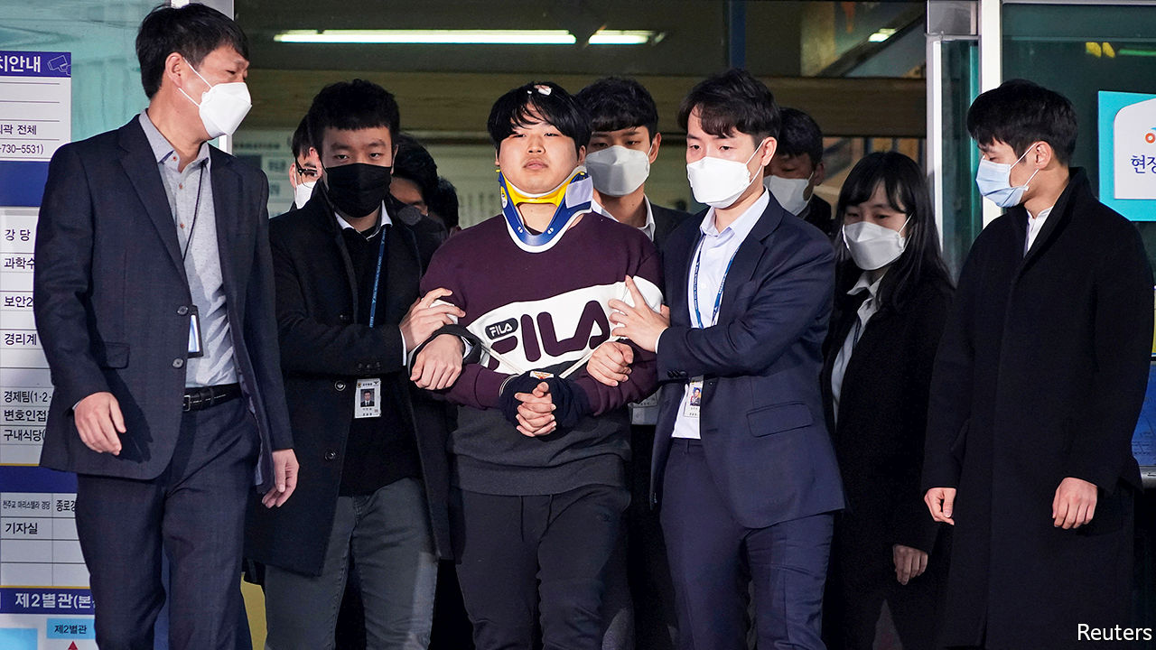

“FIRST HE JUST asked for a picture of my body, but then he asked if I could send one that showed my face...and then he asked me to play with myself...to use school supplies,” the girl told a local radio show on the morning of March 24th. She went on to describe a weeks-long ordeal during which she sent more than 40 graphic videos to a man she feared would publicly humiliate her if she stopped complying. “He had all my personal information...I was afraid he would threaten me with that if I quit.”

The girl was a middle-school student at the time of the alleged incident two years ago. She is only one of dozens of apparent victims in the latest sexual-abuse scandal to rock South Korea.

On the same day that she described her plight, police revealed the identity of the man who stands accused of running a range of porn channels, known as “nth rooms” on the Telegram chat app, charging up to 30,000 subscribers between $200 and $1,200 (most of that, it seems, collected in bitcoin to avoid detection) for access to graphic sexual content extorted from young women and under-age girls. Cho Ju-bin (pictured), a 24-year-old graduate and former college-newspaper editor who called himself baksa, or “doctor”, was named after 2.5m South Koreans signed a petition clamouring for his identity to be made public. Almost 2m people signed a separate petition demanding that the police also identify all the subscribers to the channels. Authorities say they have counted more than a quarter of a million subscribers across chat rooms featuring extorted videos, footage from spy-cams and deepfake pornography.

The case has caused particular outrage owing to the youth of many of the victims. Subscribers knew this only too well: descriptions of some channels featured personal details of the girls, including where they went to school. Public anger has eclipsed even the reaction to the “Burning Sun” scandal, which rocked the glamorous K-pop scene last year when it emerged that several stars had been complicit in producing abusive content and sharing it in online chatrooms.

The authorities are keen to be seen to be cracking down hard. So far they have detained 19 men, including Mr Cho. Dozens more are under investigation. Even South Korea’s president, despite being busy with covid-19, has become involved to reassure people that justice will prevail. Moon Jae-in vowed to take a stern approach to digital sexual-abuse crimes, calling the offenders “cruel” and public fury “justified”.

But it remains to be seen whether all the public hand-wringing will result in justice for the victims, many of them vulnerable girls with troubled family histories or financial difficulties. Activists have long complained of South Korea’s sketchy record on prosecuting sexual abuse and the misogyny entrenched in the law, which still regards being drunk as a valid defence for those accused of rape. Anger ran high last week when prosecutors recommended a sentence of only three and a half years for a chat-room host in a similar case. And even with the best of intentions, attempting to stamp out the distribution of abusive material online can be a wild-goose chase, as perpetrators shift from one anonymous platform to the next. ■

This article was downloaded by calibre from <https://www.economist.com/asia/2020/03/26/a-sex-abuse-scandal-incenses-millions-of-south-koreans>

|  |  |  |  |
| --- | --- | --- | --- |
| Previous | Articles | Sections | Next |

|  |  |  |  |
| --- | --- | --- | --- |
| Previous | Articles | Sections | Next |

#### Banyan

# Let Taiwan into the World Health Organisation

A champion against covid-19 is shut out of the body that fights the pandemic

Mar 26th 2020 |

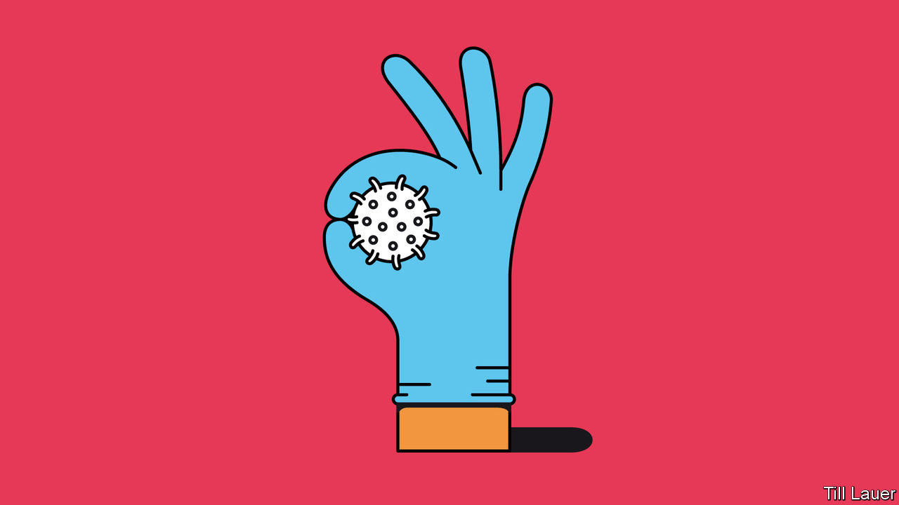

Editor’s note: The Economist is making some of its most important coverage of the covid-19 pandemic freely available to readers of The Economist Today, our daily newsletter. To receive it, register [here](https://www.economist.com/newslettersignup). For more coverage, see our coronavirus [hub](https://www.economist.com/coronavirus)

SPARE A MOMENT and admire Taiwan. Its handling of the new coronavirus pandemic has so far saved many, many lives. The figures tell the story. A country of 24m, it has far fewer infections than its neighbours: just 235 as of March 25th, with only two deaths.

Taiwanese officials seem to know what they are doing. The vice-president, Chen Chien-jen, is a noted epidemiologist and former health minister. It helps that the country has had a system in place to handle such crises, since the SARS epidemic of 2003, which led to 73 deaths. Back then, it was not clear who was in charge. So in 2004 the government set up the Central Epidemic Command Centre (CECC). Usually dormant, in an emergency its mandate is to work across government departments and commandeer the resources it needs. On January 20th President Tsai Ing-wen triggered the CECC and put the minister of health, Chen Shih-chung, in charge.

Its response was swift, and ranged from screening inbound air passengers to energetic testing and rationing face masks. A curious legacy of dictatorship under the Kuomintang, or Nationalist Party, organised along Leninist lines, is Taiwan’s system of neighbourhood wardens. These have helped enforce quarantines and deliver food to those who cannot go out to get it.

If Taiwan shines at anything, it is IT. National databases and big data have been put to use identifying those most at risk of infection. If that sounds like Big Brother, freedom-loving Taiwanese have widely accepted it for the common good. Meanwhile, the government is open and upfront about the progress of the outbreak. The media take the dissemination of information seriously. And a stiff fake-news law has helped shut down disinformation campaigns on social media originating from China, which are intended to sow mistrust of the government’s handling of the pandemic. If ordinary Taiwanese are broadly reassured, so is the economy. Business confidence has held up remarkably well. This is in striking contrast to the panic and uncertainty in Europe and America.

Strong economic and personal connections with China might be expected to complicate Taiwan’s response to covid-19. After all, even America got it in the neck when it banned flights from China. Yet Ms Tsai and her administration have been in the doghouse with the Chinese authorities for years. China, which claims the island as its own, dislikes her Democratic Progressive Party for its espousal of formal independence from China. Yet the chill made for crisper decision-making once the threat became clear. And those strong connections alerted the Taiwanese authorities to a worrying outbreak in Wuhan before the Chinese government had come clean about it. China’s initial cover-up eroded people’s trust in its response. In contrast, vigorous and timely action in Taiwan set a reassuring tone. As early as late December Taiwanese health officials were boarding flights from Wuhan to check passengers for symptoms.

Not all is rosy. It is harder to track infections among some 50,000 illicit migrants from South-East Asia, many of them care-workers. Taiwanese returning from other parts of the world risk setting off a new wave of infections. A Taiwanese press used to Chinese hostility has adopted a war footing against the coronavirus, including vigorous support for the government; if officials do fall short, or invade citizens’ privacy, it is not clear the press would call them out.

For all that, Taiwan’s performance is remarkable. Even more remarkable is that the country is not a member of the World Health Organisation. The simple reason is that a bullying China refuses it entry. It may not even attend the World Health Assembly, the WHO’s decision-making forum, as an observer. When Taiwan wrote to the WHO in late December asking whether there was human-to-human transmission in the virus outbreak in Wuhan, the WHO, the body now admits, did not reply.

Taiwan’s fight against covid-19 has shown that it can cope outside the WHO, even if there is a cost. But its exclusion causes wider damage. Taiwan’s early understanding of the threat of the coronavirus could have given others advance warning. Taiwan’s inability to disseminate its findings cost lives.

The WHO has praised China for “perhaps the most ambitious, agile and aggressive disease containment effort in history”, which is true. But the WHO could spare a word of praise for Taiwan, too. Better yet, it should insist that China end its unconscionable boycott.

Dig deeper:  
For our latest coverage of the covid-19 pandemic, register for The Economist Today, our daily [newsletter](https://www.economist.com/newslettersignup), or visit our [coronavirus hub](https://www.economist.com/coronavirus)

This article was downloaded by calibre from <https://www.economist.com/asia/2020/03/26/let-taiwan-into-the-world-health-organisation>

|  |  |  |  |
| --- | --- | --- | --- |
| Previous | Articles | Sections | Next |

|  |  |  |  |
| --- | --- | --- | --- |
| Previous | Articles | Sections | Next |

#### Hand-to-mouth to lockdown

# India and Pakistan try to keep a fifth of humanity at home

But for many in the subcontinent, the restrictions mean instant ruin

Mar 26th 2020 | DELHI

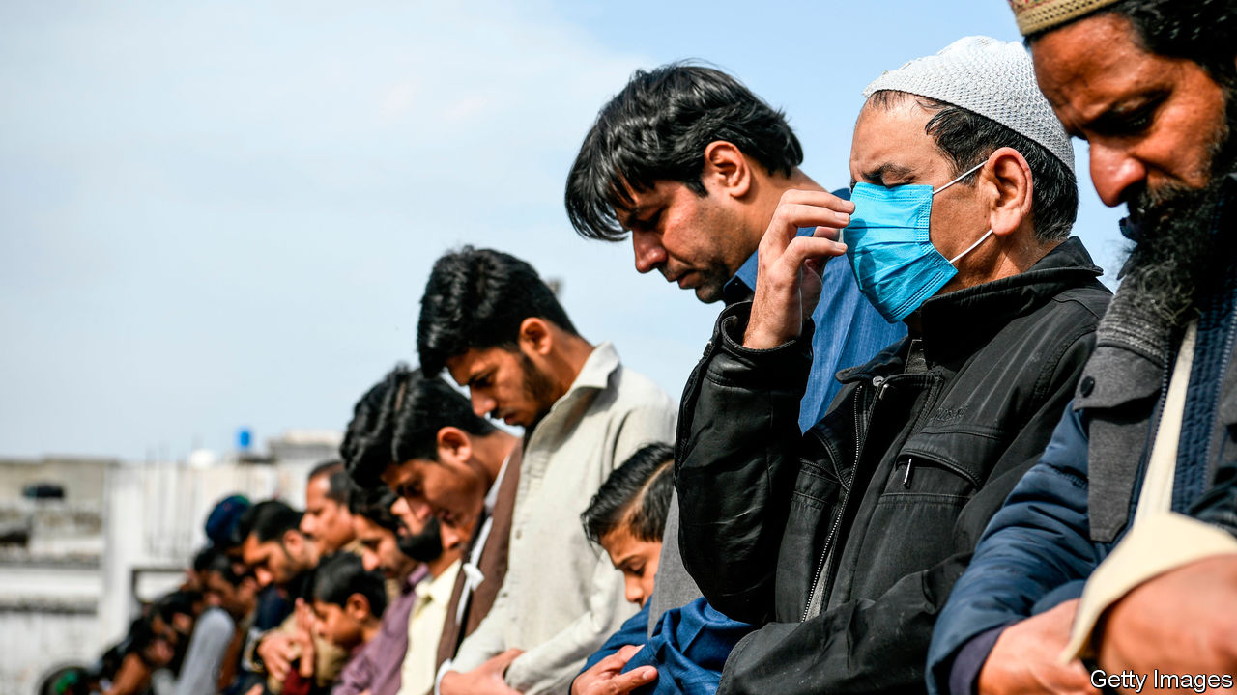

Editor’s note: The Economist is making some of its most important coverage of the covid-19 pandemic freely available to readers of The Economist Today, our daily newsletter. To receive it, register [here](https://www.economist.com/newslettersignup). For more coverage, see our coronavirus [hub](https://www.economist.com/coronavirus)

ON MARCH 17TH Imran Khan, the prime minister of Pakistan, declared that there would be no national lockdown to block the spread of covid-19. “If we shut down the cities,” he said, “we will save them from corona at one end, but they will die from hunger on the other side.” Barely a week later, not only have 210m Pakistanis been confined to their homes; on March 24th next-door India shut in all 1.3bn of its citizens, too.

The unhappy neighbours did not co-ordinate these moves. Indeed, the two scarcely communicate. Earlier this month, arguments over Kashmir nearly wrecked a top-level virtual meeting to plan a regional response to covid-19. Their approaches to the epidemic itself have been different, too. Whereas India’s order for a strict 21-day lockdown came directly from Prime Minister Narendra Modi in an 8pm speech, Pakistan’s de facto ban was enacted haphazardly at the provincial level, and then grudgingly acknowledged by Mr Khan.

The details of the restrictions differ, too. India’s are strict and no-nonsense. Multiple videos have captured police thwacking anyone they catch on the roads, including doctors trying to reach hospitals, delivery men and people looking for food. The ban includes all religious services, of any faith. Pakistan is wary of going so far. Although it has nearly twice as many covid-19 cases as India, and despite glaring evidence that the return of Shia pilgrims from Iran, as well as a jamboree that brought tens of thousands of Sunni missionaries to Lahore, were big sources of infection, the government has merely urged imams to discourage communal services and to suggest that the faithful pray at home instead.

Yet for all the differences, the reasoning behind the unco-ordinated drive to lock down a fifth of humanity is shared. In mid-March, as the number of cases in both India and Pakistan began to rise into the hundreds, the inadequacy of both countries’ medical infrastructure stood alarmingly exposed. China, for instance, can muster 18 doctors and 42 hospital beds per 10,000 people, according to the World Health Organisation. India has just eight doctors and seven hospital beds for the same number of people, and Pakistan ten doctors and six hospital beds. India has at most 40,000 or so working ventilators, equipment that has proved life-saving for the most severely affected covid-19 patients. In contrast America, with a quarter as many people, has four times as many functioning ones. Pakistan has only 2,200 ventilators and these are poorly distributed: the 12m people of Balochistan make do with 49 machines, fewer than a single hospital in Lahore.

Simply put, both countries needed to put a stop to the spread of the disease by any means possible, or risk being swamped by dying patients. Curfews and lockdowns, backed by police muscle and softened by government handouts, as well as by calls to patriotism, are the cheaper option. The Indian Council of Medical Research, the government body that has led India’s effort, estimates that strict social distancing may reduce the total number of expected cases by 62%. More crucially for India’s health system, it would reduce the peak number of sick people by nearly 90%.

## Rewarding idleness

This will not come cheap. Mr Khan on March 24th announced a 1trn rupee ($7bn) support package, cutting fuel prices and earmarking money for the poor. Mr Modi is spending $23bn to provide free food and cash transfers to India’s poorest. He is also boosting funding for health care and support for farmers. State governments in India have been more generous still, with some paying pensions in advance and others paying a month’s wage to all migrant construction workers. Such fillips are vital, say economists. The lockdown has brought most factories to a standstill, including the entire car industry.

But the pain is felt hardest in the informal sector, which accounts for over 70% of the workforce in both countries. For the middle class in both India and Pakistan, the lockdowns have meant nothing worse than claustrophobia and doing without servants. For the poor they are devastating: within hours of the closure thousands of homeless had collected outside free kitchens in Delhi, India’s capital, not knowing where else to go.

Mr Khan has expressed anguish for the poor and Mr Modi has repeatedly asked employers to be kind to workers, as well as suggesting that each wealthy family take care of nine less fortunate ones during the 21-day lockdown. He even asked citizens to look after stray animals that are no longer being fed. Yet many Indians question why, despite such shows of sympathy, the prime minister neglected to say that groceries and pharmacies would remain open. The predictable result was a mad rush to stock up on food. Although understandable as a means to curb the epidemic, the prime minister’s decision not to give migrant workers time to return to their home villages sowed further chaos and misery as hundreds of thousands of poor labourers with nowhere else to go struggled to cross the country despite the closure of air, rail and bus services. Thousands have ended up walking long distances. Pakistan has seen a similar flight to villages, with impoverished workers caught riding in ambulances and in the cargo holds of buses to escape the travel ban. In India as many as 500,000 truck drivers were also stranded with their vehicles, blocked from crossing state boundaries, says a research group. Ironically, the stalled deliveries have included vital medical supplies, such as parts for ventilators. ■

Dig deeper:  
For our latest coverage of the covid-19 pandemic, register for The Economist Today, our daily [newsletter](https://www.economist.com/newslettersignup), or visit our [coronavirus hub](https://www.economist.com/coronavirus)

This article was downloaded by calibre from <https://www.economist.com/asia/2020/03/26/india-and-pakistan-try-to-keep-a-fifth-of-humanity-at-home>

|  |  |  |  |
| --- | --- | --- | --- |
| Previous | Articles | Sections | Next |

|  |  |  |
| --- | --- | --- |
| Asia | Sections | Middle East and ... |

China

The post-virus economy: Back to work

.

Chaguan: No shining city on a hill

.

|  |  |  |
| --- | --- | --- |
| Asia | Sections | Middle East and ... |

|  |  |  |  |
| --- | --- | --- | --- |
|  | Articles | Sections | Next |

#### The post-virus economy

# China goes back to work

But not back to normal

Mar 26th 2020 | SHANGHAI

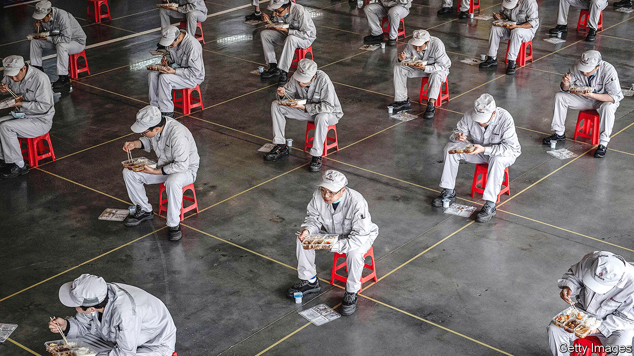

Editor’s note: The Economist is making some of its most important coverage of the covid-19 pandemic freely available to readers of The Economist Today, our daily newsletter. To receive it, register [here](https://www.economist.com/newslettersignup). For more coverage, see our coronavirus [hub](https://www.economist.com/coronavirus)

IN GOOD TIMES Gu Changshi’s job is to persuade companies to invest in Lingang, a wind-swept free-trade zone on the edge of Shanghai, abutting the Pacific Ocean. But over the past two months, as China has battled covid-19, his job has been to ensure basic survival, both physical and corporate. First his agency requisitioned two hotels to quarantine anyone coming to Lingang from virus-hit regions. Then it started offering conditional cash grants to beleaguered companies located there. “There is no fixed limit to the subsidies,” he says, his hands spreading wide.

When China went into lockdown in late January, economists thought that its growth trajectory would be V-shaped. There would be a sharp slowdown, followed by a swift rebound as soon as the virus was under control, as happened with China’s outbreak of SARS in 2003. They were right about the slowdown. Hundreds of millions of people stayed inside for weeks on end. Factories, offices, restaurants and shops closed, in scenes now being replayed around the world. Most analysts think that China’s economy shrank in the first three months of 2020, perhaps by as much as 10%. The last time it contracted was more than four decades ago, at the end of the Cultural Revolution, according to official data.

The prediction of a quick, strong recovery is more debatable. With barely any new cases of covid-19 now being detected, the government is trying to restore normal life. At four separate meetings of the ruling Politburo since late February, leaders have declared that they want to restart the economy. But doing so is far from simple when the pandemic is still raging elsewhere.

Reviving growth involves boosting both supply and demand. Officials schooled in Marxist theory, which emphasises production rather than consumption, have naturally turned first to the former, ie, to ensuring that goods are made. The main problem has been a dearth of blue-collar workers, many of whom went to their hometowns for the spring festival just before the lockdown and have not yet returned. Production hubs along the coast have chartered trains and buses to bring them back.

Officials boast that things are almost normal again. Fully 98% of all listed companies have resumed work, says the securities regulator. Around the country 89% of big investment projects, from airport expansions to the laying of gas pipelines, are also under way, according to a planning commission. “Roaring Chinese factories in full swing”, Xinhua, a state news agency, proclaimed on March 21st.

The reality is less exuberant. When any measure becomes an official target, it is susceptible to distortion—a phenomenon known as Goodhart’s law. It has been amply demonstrated in China over the years. In this case an obsession with the “work resumption rate” has invited fiddling. Some low-level officials have told firms to embellish their recoveries, reports Caixin, a magazine. To prevent such trickery, the central authorities started checking electricity data. The logical next step? Some companies were told to consume more power by turning on idle equipment.

Measures aimed at preventing another surge of covid-19 have added to the complexities of manufacturing in China. The German manager of an optical-wire factory in Jiangsu province has divided his workers into ten separate units to minimise the risk of cross-infections. The units are kept apart from each other in the factory, the canteen and their dormitories. Such measures are necessary but cumbersome, he says. Firms are also wary of sending staff around the country because some places still impose 14-day quarantines on outsiders. Travel between cities, whether by plane, train or car, is at less than half its normal level (see lower chart). Video calls only help so much when a creaking furnace needs fixing.

Nevertheless, on the supply side, the overall picture is encouraging. Large companies report that they are fully operational. Foxconn, which makes most of Apple’s iPhones in China, has said that it will resume normal production by the end of March. Even many smaller companies are in good shape. Sean Xie, the general manager in China of Lenze, a German automation company, says that all 260 of its employees had returned to its factory in Shanghai as of March 20th, apart from a couple still stuck in Wuhan, the centre of the outbreak of covid-19 (Wuhan plans to lift its lockdown on April 8th).

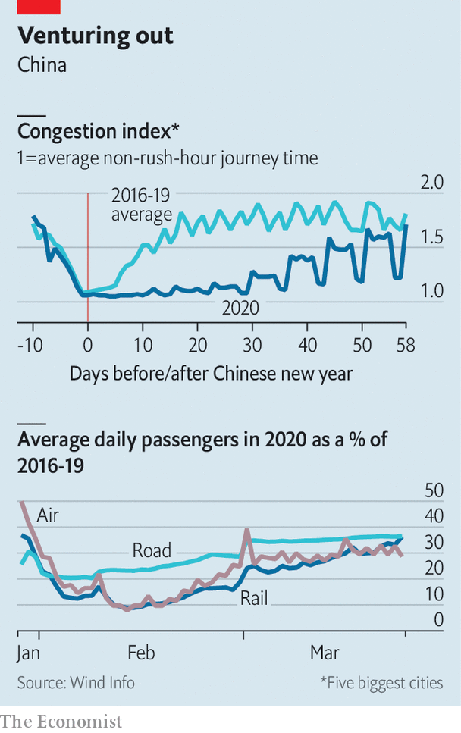

Resuscitating demand is proving more difficult. It involves two things that are harder for the government to manage: global growth and public anxiety about the disease. Officials had hoped that factories, once up and running, would be able to tap into strong demand abroad. The relentless march of the virus around the world has put paid to that. “All the wheels started spinning very quickly here, but the orders aren’t there,” says a chemicals executive who oversees a factory in the city of Wuxi.

China can take some solace in the fact that it relies less on exports than it did during the global financial crisis of 2007-09. But domestic consumption is now far more central to the economy than exports ever were, and it is much curtailed. Retail sales plunged, unsurprisingly, when just about everyone was cooped up at home. People now can move more freely, but many still avoid large crowds. Shops and restaurants are quiet. Covid-19 has cut people’s incomes, so few seem willing to splurge yet on big-ticket items. Queues outside Apple stores—open in China but closed everywhere else—are deceptive. Apple strictly limits the number of customers to ensure a safe distance between them.

A good proxy for the state of consumption in China is urban traffic. Some thus welcome the return of traffic jams: congestion has reached about 90% of its normal level (see chart). But a closer look is less comforting. Some people who used to take subways to work are using cars instead, to limit contact with others. Passenger numbers on subways are down by roughly two-thirds in big cities. Unusually, there is no road congestion at the weekend. The occupancy rate of a posh international hotel chain is in the single digits, says the company’s boss in China. Bao Wenjun, who owns a restaurant in Shanghai selling cheap and tasty noodles, says that his revenues are down by nearly three-quarters.

## Hey small spender

For consumption to recover, people must feel confident. They do not. Most provinces have reduced their emergency-alert levels. Even Hubei, the worst-hit, has started to let people (other than residents of Wuhan, the capital) travel elsewhere. But anxiety abounds. Except in a few remote regions, schools are into their second month of closure. Only about 500 of the country’s 11,000 cinemas have re-opened. The government has tightened border controls because many travellers—541 at last count—have tested positive for the virus after arriving from abroad.

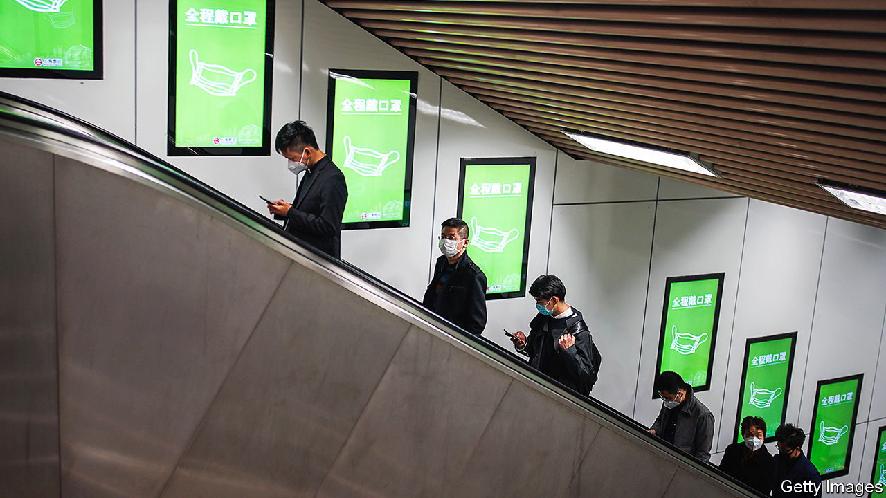

In the past China has often been quick to unleash stimulus measures to counteract economic slowdowns. Its spending splurge in response to the global financial crisis was crucial to the world’s recovery. This time China has been uncharacteristically restrained. Britain has pledged to make loans to firms worth 15% of GDP and America is working on a support package worth nearly 10% of its output. But China’s fiscal measures—mainly tax and fee cuts—so far add up to little more than 1% of its GDP. Whereas America has slashed its interest rates to zero, China has barely trimmed its own.

What explains the frugality? One reason is that China has no need to replicate some of the other countries’ actions. Take the struggling airline industry. The American programme includes $58bn in aid for it. Britain may take direct stakes in its airlines. The Chinese government already owns the country’s biggest airlines. State-owned firms account for about three-quarters of corporate debt in China. The government need not spell out that it stands behind them. Investors know that. Whereas corporate-bond prices have fallen sharply in the West—reflecting concerns about firms’ solvency—they have only inched down in China. In the Lingang free-trade zone, Mr Gu goes out of his way to note that the official subsidies are mainly aimed at private businesses, which have a harder time obtaining loans than state firms do.

For officials the most worrying trend is a sharp rise in joblessness. The unemployment rate in urban areas jumped nearly a full percentage point to 6.2% in February, the highest on record. And this rate fails to capture the tens of millions of migrants who are still in their hometowns, waiting for the economy to perk up before returning to cities for work. So the government is cautiously rolling out some stimulus. On March 20th it pledged to increase financial support for the unemployed.

More help may be on the way. The government has given provinces more leeway to raise funds for such things as infrastructure and buildings. Spending of this kind has been a cornerstone of China’s past stimulus packages. But now it is proceeding gingerly. It fears that unleashing more of it could push up debt levels, which are already dangerously high. Most crucially, for all their talk about restarting the economy, China’s leaders are wary of letting growth rip until they are certain that a boom in business will not also bring a resurgence of covid-19. “We want to reduce risk to the absolute minimum and will not count the cost of that,” says Mr Gu. The economic rebound can wait. ■

Dig deeper:  
For our latest coverage of the covid-19 pandemic, register for The Economist Today, our daily [newsletter](https://www.economist.com/newslettersignup), or visit our [coronavirus hub](https://www.economist.com/coronavirus)

This article was downloaded by calibre from <https://www.economist.com/china/2020/03/26/china-goes-back-to-work>

|  |  |  |  |
| --- | --- | --- | --- |
|  | Articles | Sections | Next |

|  |  |  |  |
| --- | --- | --- | --- |
| Previous | Articles | Sections | Next |

#### Chaguan

# The pandemic will boost China’s standing, its propagandists claim

But beware simple predictions

Mar 26th 2020 |

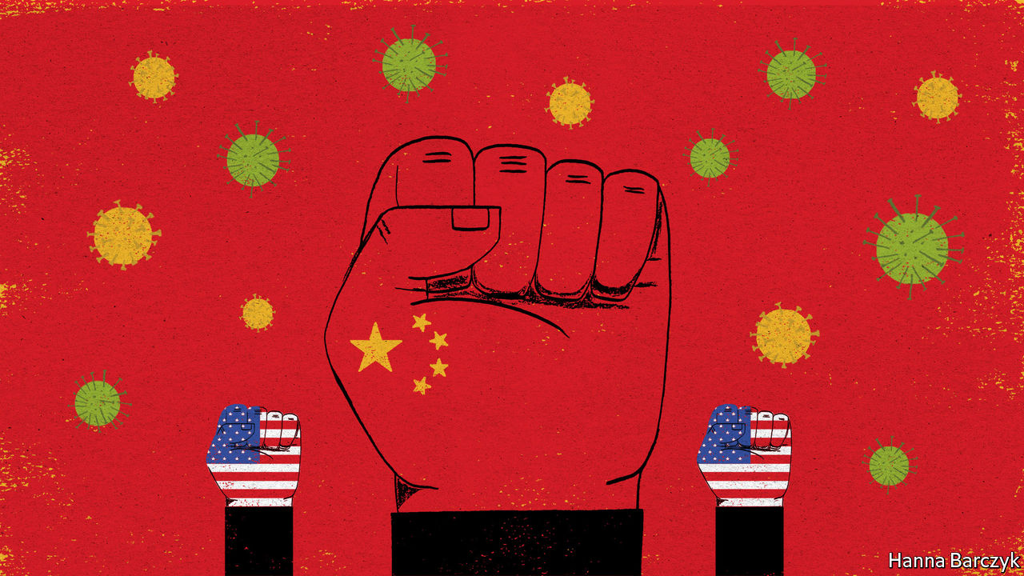

Editor’s note: The Economist is making some of its most important coverage of the covid-19 pandemic freely available to readers of The Economist Today, our daily newsletter. To receive it, register [here](https://www.economist.com/newslettersignup). For more coverage, see our coronavirus [hub](https://www.economist.com/coronavirus)

VICTORY IS A perilous moment for a guerrilla army. Over years of civil war, revolutionaries become experts at raids, ambushes and subversion behind enemy lines. Then one day a foe melts away, giving up a great city or miles of precious terrain and setting insurgents a different challenge: how will you govern, now this is yours? In 1949 the peaceful fall of ancient, palace-filled Peiping, as Beijing was then officially known, daunted even Mao Zedong. Comparing his troops to scholars summoned to sit entrance tests for the imperial civil service, he mused: “Today we’re heading into the capital to take the big test... All of us have to make the grade.”

Today, a new victory is in sight. For decades when a pandemic or other worldwide scourge has struck, the response has been co-ordinated by rich Western countries led by America, occupying the high ground of global leadership in a mixture of altruism and bossy self-interest. Now, under President Donald Trump, America is abandoning that terrain. Take Chinese propaganda outlets at face value, and China is ready to advance and take the ground.

Some may object that Communist Party chiefs have a nerve to seek praise for their response to covid-19. After all, Chinese officials spent several disastrous weeks silencing doctors and concealing test results, and letting millions leave Wuhan, the city where the illness was first seen. That cover-up will forever colour judgments of what came next: a mass mobilisation of hundreds of millions of Chinese to tame a first wave of infections. Yet bungling by foreign leaders, and above all by Mr Trump, has handed the Chinese government a chance to recover. Plenty of ordinary citizens remain angry about early missteps in Wuhan. But many of the same citizens cheer reports of China’s delivery of medical supplies and advice to more than 80 countries, and gasp at news of rising death tolls in Italy, Britain and America.

Small wonder that a cottage industry has sprung up in the West, churning out essays arguing that Mr Trump is creating a vacuum that China is poised to fill, as the covid-19 pandemic reshapes the world order. There is something to this. China’s best scientists are sprinting to create a covid-19 vaccine. If they win that race (and good luck to them), brace for a torrent of global commentary comparing this to the Soviet launch of Sputnik, the first satellite. It is sobering to watch foreign leaders, from Serbia’s president to Hungary’s prime minister and Italy’s foreign minister, loudly thanking China for medical supplies and teams of doctors while chiding European neighbours for abandoning them (never mind that some of those supplies were sold by China, not donated).

For all that, it remains unclear whether China wants to occupy newly vacant positions of global leadership—if that involves accepting multilateral rules and norms that might constrain its actions in the future. China seeks thanks and respect for its virus response. It is happy to see covid-19 weaken rivals like America. But it is worth noting what it has and has not achieved during this pandemic. China has long had a genius for befriending countries and leaders who are shunned by mainstream peers. The pro-Chinese leaders of Serbia and Hungary are also autocratic admirers of Russia, whose ties with the European Union are fractious. Recruiting foreign leaders to be “friends of China” is not the same as having an appealing model—a Chinese Way—to offer the world.

During this crisis China has made several moves that pay domestic dividends but make no sense for a country that hopes to win hearts and minds abroad. In particular, official media, backed by Chinese diplomats with Twitter accounts and a taste for nationalist provocation, have promoted offensive, often contradictory conspiracy theories about the origins of the virus. State media have publicised a quote from an Italian scientist, recalling cases of a strange pneumonia circulating before covid-19 was identified in China, and insinuating that this reveals that the virus began in Italy, not China. The scientist has since clarified that he believes that the virus is “without a doubt” from China, fuming about Chinese “propaganda”. Too late. A Chinese internet hashtag about covid-19’s history in Italy has been viewed almost half a billion times. At the same time Chinese netizens have seized on a rival theory pushed by foreign-ministry provocateurs—though it is unsupported by any evidence—that covid-19 somehow escaped from an American military laboratory and was carried to China by American athletes competing in a military sports tournament in Wuhan. Depressingly, lots of Chinese netizens are unfazed by the flimsiness of these theories, some of which have been obliquely disowned by China’s ambassador to America. Convinced that America is a dirty fighter intent on keeping China down, online nationalists have a bleaker goal: get some low blows in first.

## When in doubt, blame foreigners

Sowing distrust and division abroad is a risky game for China. Another master of disinformation, Russia, can sell its oil and gas even amid global chaos. As a would-be tech superpower that has profited mightily from globalisation, China has much to lose from a world which cannot agree on basic facts. The nasty side of China’s virus diplomacy has political costs, too. European governments may often be appalled by Mr Trump. But in a commentary published on March 23rd the EU’s foreign-policy chief, Josep Borrell, described China’s aggressive messaging in a global battle of narratives over covid-19, and pointedly chided powers that seek geopolitical advantage by spinning the “politics of generosity”.

China may emerge from this crisis stronger in relative terms, and less willing than ever to be criticised or thwarted. But beware simple predictions about vacuums being filled. The West may lose ground that China prefers not to fill. As Mao understood, an enemy’s retreat is a test as well as an opportunity. True global leadership may require China to ditch its love of ambiguity and cynical opportunism, and spell out what it really believes and wants. If that is the test, the hard men who run China may prefer to skip it. ■

Dig deeper:  
For our latest coverage of the covid-19 pandemic, register for The Economist Today, our daily [newsletter](https://www.economist.com/newslettersignup), or visit our [coronavirus hub](https://www.economist.com/coronavirus)

This article was downloaded by calibre from <https://www.economist.com/china/2020/03/26/the-pandemic-will-boost-chinas-standing-its-propagandists-claim>

|  |  |  |  |
| --- | --- | --- | --- |
| Previous | Articles | Sections | Next |

|  |  |  |
| --- | --- | --- |
| China | Sections | Europe |

Middle East and Africa

Coronavirus in Africa: Not immune

.

The virus in the Arab world: An even tighter grip

.

Covid-19 reaches Gaza: Quarantine while under siege

.

|  |  |  |
| --- | --- | --- |
| China | Sections | Europe |

|  |  |  |  |
| --- | --- | --- | --- |
|  | Articles | Sections | Next |

#### Continental contagion

# Africa is woefully ill-equipped to cope with covid-19

People cannot stay away from work if they have no money

Mar 26th 2020 | ADDIS ABABA, GOMA, JOHANNESBURG AND KAMPALA

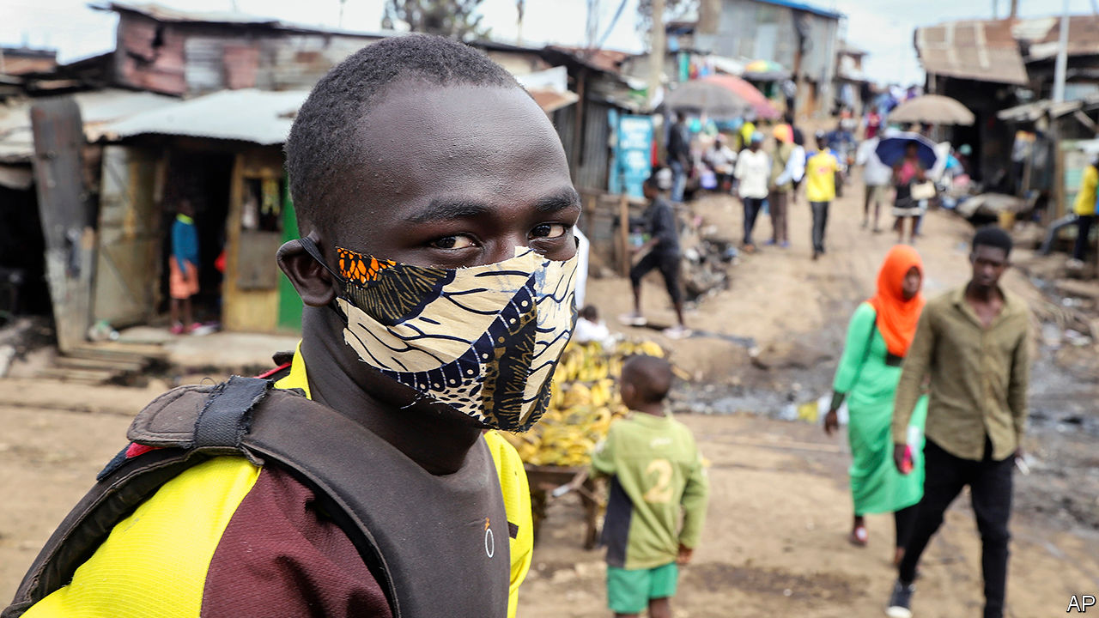

Editor’s note: The Economist is making some of its most important coverage of the covid-19 pandemic freely available to readers of The Economist Today, our daily newsletter. To receive it, register [here](https://www.economist.com/newslettersignup). For more coverage, see our coronavirus [hub](https://www.economist.com/coronavirus)

“IN THE TOWNSHIP people are not worried at all,” says Lesedi Kgasago, a student from Soweto, Johannesburg. Among his friends “corona” is seen either as something that afflicts white people or a fiction. When life is a struggle it is hard to worry about a threat you cannot see.

Besides, asks Mr Kgasago, what can Sowetans do about it? “Self-isolation is just not practical in the ’hood.” Most of the township is poor and crowded. Just 55% of households have piped water. “There is a mentality of if we die, we die, but we’re going to have a good time,” he says.

That may now be more difficult. On March 23rd Cyril Ramaphosa, South Africa’s president, announced a nationwide lockdown. The number of recorded cases in the country is the highest in Africa, at 709 as of March 25th. The rate of increase is similar to that of Italy at the same stage.

Other countries in Africa could be just days behind. Most of its 54 states have confirmed infections. Some hope that hot and humid weather may slow the spread of the virus. But the evidence for that is inconclusive and any effect will be “modest”, reckons Marc Lipsitch of Harvard University. “We don’t know what it will do in Africa,” notes David Heymann of the London School of Hygiene & Tropical Medicine. But there is no reason to think it would be different from anywhere else, he says.

It could be worse. Most rich countries have struggled to respond to the outbreak. African ones have fewer medics and less kit. Social distancing is far harder in overcrowded slums. Lockdowns could increase poverty and hunger. Nor do most African countries have the money to tide people and companies over.

Africa has some advantages. It is a young continent facing a virus that mainly kills the old. There are an estimated 47m Africans over 65 and 6m over 80, out of a population of 1.3bn. In Europe the figures are 143m and 40m out of 750m people.

Africa has also had more time to prepare. Governments have closed borders and restricted air travel. Many have banned large gatherings. The vast majority of children are no longer at school. These steps have been taken sooner in the course of the disease than elsewhere. Uganda, for instance, closed schools before it had any confirmed infections. South Africa’s lockdown was announced before Britain’s, though Britain had more than 16 times as many known cases. Sierra Leone has declared a 12-month state of emergency despite not having a single confirmed case.

Advance warning has also allowed Africa to boost testing capacity. Today more than 40 countries can test for covid-19, up from just Senegal and South Africa in early February. Although they have many fewer testing kits than richer countries do, more are on the way. Jack Ma, the founder of Alibaba and perhaps China’s richest man, has donated 20,000 testing kits, 100,000 masks and 1,000 protective suits to each African country.

Experience in dealing with other infectious diseases may prove useful. Roughly one in three deaths in Africa every year is from an infectious or parasitic disease, compared with one in 50 in Europe. Recent Ebola outbreaks, across west Africa in 2014-16 and in eastern Congo in 2018-20, have taught policymakers vital lessons.

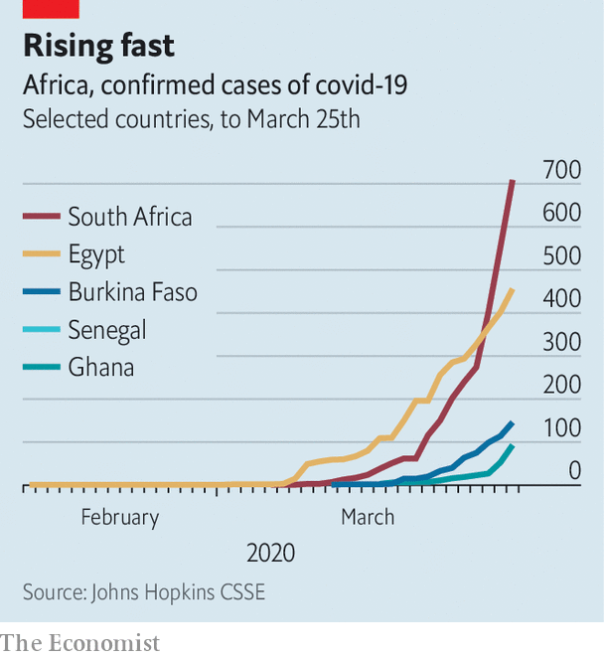

People who have dealt with Ebola, such as David Nabarro, a special envoy for covid-19 to the World Health Organisation, say it is essential to win over communities. One sign of success in Sierra Leone was when Ebola became known in the Mende language as “bonda wote”, literally “family turn round”—a sign that people were changing behaviour. “I am absolutely convinced that African countries can get on top of this quicker than European countries,” says Dr Nabarro.

Experts also urge vigilance. “We are veterans of outbreaks,” says Monica Musenero, a Ugandan epidemiologist. The country has contained regular flare-ups of diseases such as Ebola and Marburg virus. Whereas Ebola always “announces itself”, covid-19 spreads quickly and quietly, she says. As doctors find cases of the new virus, they may be only “catching the tail”.

That is the worry across Africa, where outbreaks could rapidly overwhelm health systems. Sub-Saharan Africa has about one doctor for every 5,000 people, compared with one per 300 in Europe. Data are patchy, but the average American hospital may have more intensive-care beds than most African countries. Kenya has 130; Uganda 55; and Malawi about 25. In Zimbabwe there are probably even fewer in the public system, and doctors and nurses are on strike. Ventilators are scarce: Mali and Mozambique may have one per 1m people. Given the lack of capacity, the disease could be “horrific”, says Tom Frieden, a former head of the Centres for Disease Control and Prevention in America.

The underlying health of Africans may not help either. Doctors do not know if the more than 25m Africans infected with HIV are at greater risk from covid-19. Some speculate that anti-retroviral drugs may help fight the new virus, though early studies suggest otherwise. Even if this were the case, notes Denis Chopera, a Durban-based virologist, only about 60% of South Africans with HIV regularly take their pills.

The burden on health-care systems from covid-19 could impede treatment of other diseases. Studies of the Ebola outbreak in west Africa suggest that about as many people died because they could not get treatment for malaria, HIV and tuberculosis as from Ebola itself. Others died from being unable to give birth safely. Suppressing outbreaks of Lassa fever in Nigeria and measles in Congo could be hampered by the diversion of resources to covid-19.

Governments may also have a hard time convincing their citizens to take the new virus seriously. Fake news is one reason. Dodgy cures and conspiracy theories are spreading on WhatsApp groups, which typically have more members in Africa than elsewhere. In Congo the virus is seen as a “mzungu” (white person) disease. Some Ethiopians see their country as blessed and therefore protected. More than a quarter of Nigerians say they are immune, most commonly because they are “a child of God”.

Religion may be doing more to spread the disease than stop it. Senegal was slow to stop pilgrims from travelling to the holy city of Touba, despite an outbreak. A Christian gathering in South Africa has been linked to another outbreak. Thousands still attend megachurches in Nigeria. Although many pastors and imams are spreading the gospel of handwashing, others are talking nonsense. Orthodox Christians in Ethiopia have promoted quack “cures” involving garlic, lemon and ginger. Prices of these foodstuffs have risen by more than 200%, and fights have broken out in markets over them.

Many African leaders have been swift to ban religious meetings. Some churches are streaming services online. But this is not the case in Tanzania, where President John Magufuli has refused to close churches, saying: “That’s where there is true healing. Corona is the devil and it cannot survive in the body of Jesus.”

African governments face practical as well as spiritual obstacles. The state’s ability to enforce social distancing and lockdowns is questionable in cities, where two in every five Africans live. More than half of city-dwellers are in crowded slums (see map). In Alexandra, a slum in Johannesburg, there are more than 9,000 households per square km, compared with fewer than 700 in neighbouring Sandton, a posh suburb. In Kampala 71% of households sleep in a single room. Frequent handwashing with soap is difficult. In Makoko, a huge slum in Lagos, less than 20% of households have piped water. Conditions in refugee camps are often worse.

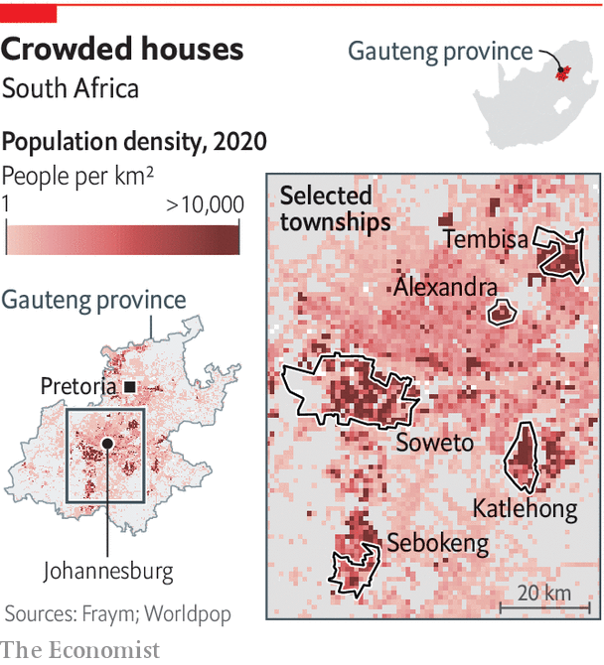

Persuading slum-dwellers to stay in one-room shacks with many relatives will be tougher than getting people in New York or London to stay on the sofa watching Netflix. And few can work from home. Six in ten Ugandan workers are either self-employed or help out in a family business. If people do not work they do not eat, says Steven Agaba, who lives in a poor part of Kampala, Uganda’s capital. He gestures at a man selling fruit from a tarpaulin spread across the muddy ground. “It will not be the coronavirus to kill us, but the hunger.” It may also send the poor back to their villages, further spreading the disease.

The precariousness of everyday life means that the economic effects of covid-19 in African countries will be both colossal and different from the rich world. The welfare of a billion people depends on how governments balance saving lives from the virus while minimising economic damage in a continent where more than 400m people live on the equivalent of less than $1.90 a day. It is not at all clear how this Gordian knot can be untied.

The hit to economies was already apparent even before the first case of covid-19 was reported in Africa. More than 80% of its exports go to the rest of the world, the highest share of any big region save Australasia. About half of these are raw materials. As commodity prices have plunged, so have forecasts for growth and tax receipts.

Other industries have been hammered too. Tourism, which employs more than 1m people in each of Kenya, Tanzania, Ethiopia and South Africa, has collapsed. In Kenya and Ethiopia, both exporters of flowers, bulbs are being fed to cows and roses are rotting in heaps. Manufacturing is stricken. Orders have dried up for clothes exporters in Ethiopia, Ghana and Lesotho.

Trade is at a trickle. Dozens of scheduled ships are either not turning up at Mombasa port, in Kenya, or arriving partly empty. Remittances could soon dry up—a disaster for the 13 African countries where that money is worth more than 5% of GDP. (In Lesotho remittances equate to 23%.) The overall effect is “more serious than 2008”, says Albert Zeufack, the chief economist for Africa at the World Bank.

In some countries such as Malawi, where most people subsist by growing their own food, the economic impact of covid-19 may be relatively small. But in many others, the clampdowns on economic life are adding to the pain. Restrictions on movement and commerce will be especially harmful to workers in the informal economy—that is, most of the African labour force. Roughly 85% of workers do not receive a regular reported wage.

On March 21st Rwanda closed its border with Congo. The livelihoods of petty traders who buy food in one country and sell it in the other are in peril. In Goma, on the Congolese side, Naomi Sifa sits with a pile of bananas a few metres from the desolate frontier. By selling them in Rwanda she would normally make 3,000 francs ($1.77) each day, just enough to feed her family. No longer. “If they keep the border closed, they will kill people with hunger,” she says.

The economic consequences of covid-19 have not escaped African epidemiologists. For John Nkengasong, director of Africa CDC, a public-health body, the virus could be a “national-security crisis first, an economic crisis second, and a health crisis third”, if the responses are not calibrated appropriately. That does not mean letting the disease rip, but it does mean “community engagement” and careful monitoring of knock-on effects on poverty and the treatment of other diseases.

African authorities will probably struggle to shut down cities to the extent seen in Europe, never mind China. For the moment, though, they are trying to combine restrictions on movement with some steps to ease the economic pain. The Seychelles, for example, has pledged salary guarantees for private-sector employees for three months. South Africa has announced a tax holiday for businesses to encourage them to keep paying workers, and its central bank is extending credit lines to keep firms afloat. Senegal aims to spend about 6% of GDP feeding people and helping firms, but it must appeal for funds to do so.

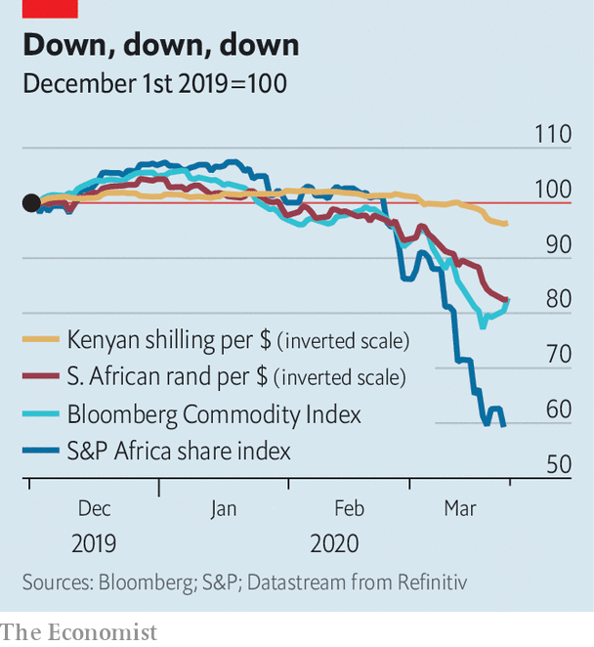

No country is able to match the sums being spent in the West. Social safety nets, where they exist, tend to support old people and mothers, not the jobless. Cash transfers would be the quickest and most efficient response to avert mass poverty. So far, in response to the covid-19 crisis, 69 countries globally have introduced, adapted or expanded social-protection schemes. Yet in sub-Saharan Africa only South Africa and Kenya have done so.

The lack of action is in large part because African countries do not have enough money to do more. Between 2010 and 2018 average public debt in sub-Saharan Africa rose from 40% to 59% of GDP, the fastest increase of any developing region. More than half of African countries are above the IMF’s recommended limit for public debt. The World Bank says that 29 out of 47 African countries need to tax more than they spend just to keep their debt constant as a share of the economy. But their tax revenues are about to plummet and the cost of borrowing is soaring as investors flee to safety.

A fiscal response on the scale seen in the rich world would require outside help. Abiy Ahmed, Ethiopia’s prime minister, has asked the G20 for an emergency package worth $150bn to boost health spending, shore up foreign reserves and patch up social safety nets. He wants the World Bank’s investment arm to tide over African companies hit by disruptions to global supply chains, for the IMF to increase its lending to poor countries and for existing debt to be rolled over or forgiven.

The West’s response may determine its relationships with African countries for decades. If the rich world declines to help more, China will probably dominate the response. Mr Ma’s gift may soon be followed by economic assistance, which could cement China’s position as the main partner for many African countries.

Other political consequences of covid-19 will soon become clear. One may be a rise in xenophobia. Ethiopia and Cameroon, among others, have seen attacks on foreigners or their property. Autocrats such as Uganda’s Yoweri Museveni or Mr Magufuli may take advantage of a distracted world, and find covid-19 a convenient reason to delay elections or arrest dissidents.

What will ultimately determine the fate of leaders on the continent, though, is how they combine their direct response to the virus with mitigating its vast indirect costs. Mr Ramaphosa has largely been open, decisive and bold. But even he will struggle to maintain public support as he tries to enforce a long lockdown. African countries face an unenviable task, which they cannot address alone. In trying to “flatten the curve” of the number of infected, they risk crushing their people. ■

Dig deeper:  
For our latest coverage of the covid-19 pandemic, register for The Economist Today, our daily [newsletter](https://www.economist.com/newslettersignup), or visit our [coronavirus hub](https://www.economist.com/coronavirus)

This article was downloaded by calibre from <https://www.economist.com/middle-east-and-africa/2020/03/26/africa-is-woefully-ill-equipped-to-cope-with-covid-19>

|  |  |  |  |
| --- | --- | --- | --- |
|  | Articles | Sections | Next |

|  |  |  |  |
| --- | --- | --- | --- |
| Previous | Articles | Sections | Next |

#### An even tighter grip

# As covid-19 spreads, Arab states are clamping down

Security services spy a chance to extend their powers

Mar 26th 2020 |

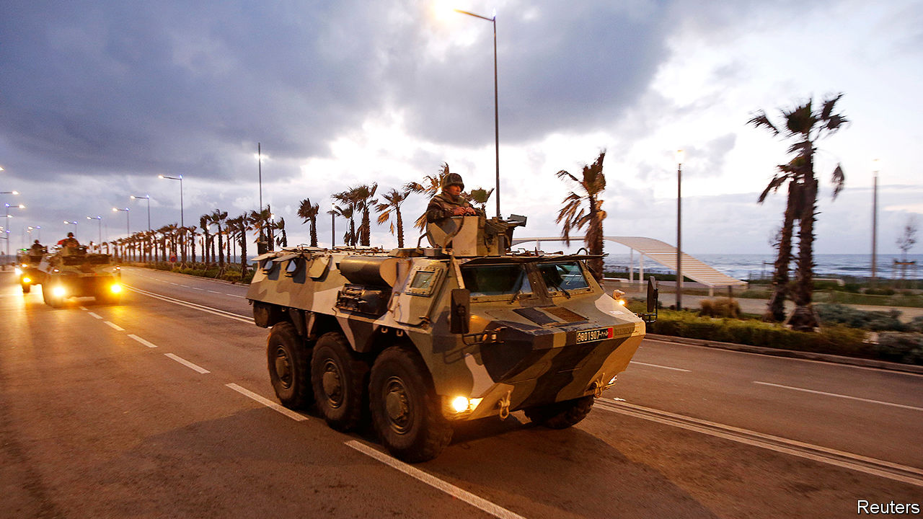

Editor’s note: The Economist is making some of its most important coverage of the covid-19 pandemic freely available to readers of The Economist Today, our daily newsletter. To receive it, register [here](https://www.economist.com/newslettersignup). For more coverage, see our coronavirus [hub](https://www.economist.com/coronavirus)

IF YOU BELIEVE the official numbers, covid-19 has not yet hit the Middle East and north Africa as hard as the rest of the world. Excluding Iran, where an outbreak is raging, the virus has killed around 100 people in the region, compared with thousands in Europe (which has more people). Nevertheless, Arab leaders are taking drastic steps to curb its spread, imposing curfews, closing businesses and quarantining cities. This is wise: countries such as Italy and Iran delayed action and were overwhelmed. It is also troubling. The region’s regimes have long played on people’s fears to justify their authoritarian rule.

Many governments have declared states of emergency, allowing leaders to rule by decree (as many do anyway) and deploy the armed forces. In Egypt, for example, the army has been sent out to disinfect areas. In Jordan it now guards public squares and helps enforce a ban on people leaving their homes. With the civilian authorities in Iran unable to cope, the Revolutionary Guards have sought more power and pushed for virus-related restrictions. In some Western countries, too, the army is out in the streets. But regimes in the Middle East and north Africa are less likely to loosen their grip on society once the crisis recedes.

They are also clamping down in ways not seen in the West. Morocco has detained people for rumour-mongering. “Those spreading fake news will be pursued,” says Abdelmadjid Tebboune, Algeria’s president. Jordan limited the number of journalists allowed to report outside, even before it recorded any deaths from the virus. Egypt banned a correspondent from the Guardian, a British newspaper, after she cited Canadian epidemiologists who think the outbreak in Egypt is worse than the government says. Arabs increasingly rely on state broadcasters, which deliver slanted news and questionable data alongside public-health announcements.

Even in the region’s freest country, Israel, there is concern that the government is overstepping. Binyamin Netanyahu, the prime minister, has ordered his spooks to use phone surveillance technology to track Israeli citizens in an effort to curb the spread of the virus. Some Israelis worry that this power will be abused. Mr Netanyahu and his allies are also accused of using the outbreak to delay his trial on corruption charges and keep him in office, as negotiations over a new government continue. “He is doing his utmost to exploit the opportunity the coronavirus introduced,” says Yohanan Plesner of the Israel Democracy Institute, a think-tank.

Elsewhere, though, draconian measures have been greeted with praise. As the virus spread, the hashtag “declare a state of emergency” trended on Twitter in the region. According to Ipsos, a pollster, 98% of Jordanians think their government is doing a “good” or “very good” job. They are seemingly happy with a new law that allows the king to seize private property, detain anyone who threatens public order and screen all media before publication. Even anti-government activists are sounding supportive. “Sometimes human rights and public-health needs clash,” says one in Morocco, which is under lockdown.

Social distancing has meant that the large anti-government protests rocking countries such as Algeria, Lebanon and Iraq have fizzled away for now. Opponents in the region are getting along better, too. Israel and the Palestinians are co-operating, to an extent, in the face of a common enemy. The United Arab Emirates and Kuwait have offered aid to Iran.

The calm may not last, though. The pandemic has hit the region’s economic mainstays, such as tourism and remittances, while a collapse in the price of oil has cut into government revenues, putting public-sector jobs at risk. Meanwhile, the WHO is casting doubt on the outbreak data coming from governments in the region. Insufficient testing means the number of infected people is undoubtedly higher than the official tallies. Most health systems are not equipped to deal with a large outbreak. As more people fall ill, the region’s authoritarians may regret having long spent more on their armies and security services than on hospitals and medical supplies. ■

Dig deeper:  
For our latest coverage of the covid-19 pandemic, register for The Economist Today, our daily [newsletter](https://www.economist.com/newslettersignup), or visit our [coronavirus hub](https://www.economist.com/coronavirus)

This article was downloaded by calibre from <https://www.economist.com/middle-east-and-africa/2020/03/26/as-covid-19-spreads-arab-states-are-clamping-down>

|  |  |  |  |
| --- | --- | --- | --- |
| Previous | Articles | Sections | Next |

|  |  |  |  |
| --- | --- | --- | --- |
| Previous | Articles | Sections | Next |

#### A double lockdown

# Gaza, already under siege, imposes quarantine

Residents respond with dark humour

Mar 26th 2020 | BEIRUT

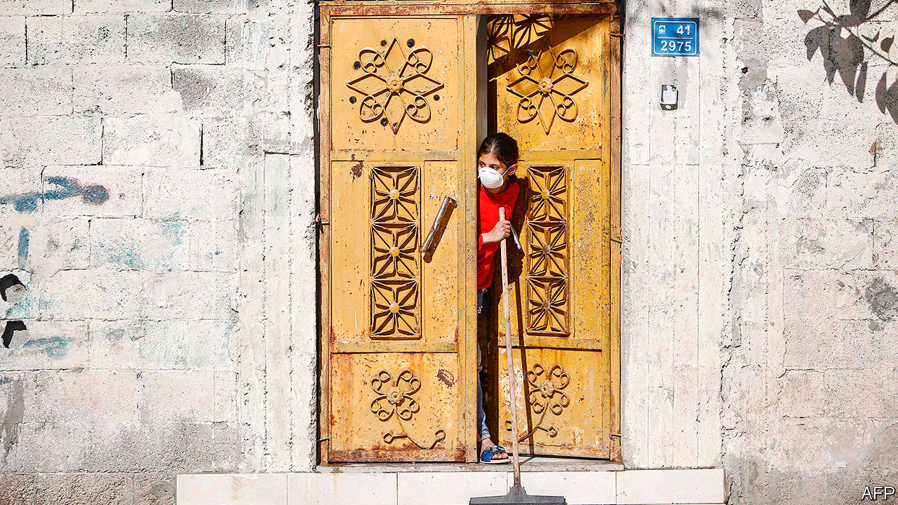

Editor’s note: The Economist is making some of its most important coverage of the covid-19 pandemic freely available to readers of The Economist Today, our daily newsletter. To receive it, register [here](https://www.economist.com/newslettersignup). For more coverage, see our coronavirus [hub](https://www.economist.com/coronavirus)

AS BORDERS CLOSE, businesses shut and much of the world adjusts to being locked down, residents of Gaza can only look on with grim amusement. Isolation is nothing new for the territory’s 2m Palestinians. They have been under blockade since 2007, when Hamas, a militant group, seized power after winning a majority in legislative elections. Israel and Egypt have largely cut off the movement of goods and people in and out of Gaza.

It is not a total lockdown: Gazans are free to move about their sliver of land, which measures 365 square kilometres (140 square miles). But few can venture any farther. Last year, on average, just 740 people were able to leave Gaza each day.

“Fourteen days of isolation? Welcome to our last 14 years,” goes one joke making the rounds on messaging apps. An unemployed graduate, desperate to emigrate, quips that his Palestinian passport is at last worth the same as a European one. Another laughs at videos of Westerners panic-buying the wrong goods—perishable food, incomprehensible amounts of toilet roll—and jokes about starting an online course to teach proper stockpiling.

As the virus swept through Israel and the occupied West Bank, though, the restrictions turned Gaza into a reverse cordon sanitaire. Residents wondered, with a sort of bitter optimism, whether their plight would spare them from a crisis that has paralysed much of the world.

No longer. On March 21st the health ministry announced the territory’s first two cases of covid-19. The patients had returned two days earlier from Pakistan, via the Rafah crossing with Egypt. Days later another seven cases were confirmed, all members of the security forces who had met the returnees. Officials said all the patients were isolated. Still, they took no chances. Restaurants and cafés have been closed and Friday prayers cancelled.

An outbreak would be catastrophic. Gaza is one of the world’s most densely populated places. The health-care system, shattered by the long blockade, would be unable to cope. Even in normal times, basic items like antibiotics are often in short supply. The territory has just 62 ventilators, or three for every 100,000 people. At least a quarter of them are already in use. Beds in intensive-care wards are similarly scarce. So are doctors, because scores of them have emigrated recently.

The virus has begun to pop up in other ravaged corners of the Middle East as well. For weeks Syria insisted that it had been spared the scourge of covid-19. Few Syrians believed this, given the number of people travelling back and forth to Iran, home to one of the world’s worst outbreaks. But on March 22nd the government logged the country’s first official case. It stopped public transport and imposed a curfew. Worse still would be an epidemic in Idlib, the last big rebel-held pocket, where 3m people live in dire conditions. Libya announced its first case of covid-19 on March 24th.

These countries may never know the full extent of their outbreaks. Doctors in Gaza say they received only about 200 kits to test for the virus. Most have already been used. They are pleading with Israel and the WHO to send more, but it is unclear when, or if, they will. More than 1,400 people, many of them recently returned from abroad, have been crammed into schools turned makeshift isolation centres, sleeping six or eight to a classroom—a quarantine within an open-air jail. ■

Dig deeper:  
For our latest coverage of the covid-19 pandemic, register for The Economist Today, our daily [newsletter](https://www.economist.com/newslettersignup), or visit our [coronavirus hub](https://www.economist.com/coronavirus)

This article was downloaded by calibre from <https://www.economist.com/middle-east-and-africa/2020/03/26/gaza-already-under-siege-imposes-quarantine>

|  |  |  |  |
| --- | --- | --- | --- |
| Previous | Articles | Sections | Next |

|  |  |  |
| --- | --- | --- |
| Middle East and ... | Sections | Britain |

Europe

Spain: The emergency room

.

Italy, Germany and the virus: A numbers game

.

Coronanomics: Money for all

.

Swearing: Dutch disease

.

Russia’s economy: Isolationomics

.

Charlemagne: Aesop’s euro zone

.

|  |  |  |
| --- | --- | --- |
| Middle East and ... | Sections | Britain |

|  |  |  |  |
| --- | --- | --- | --- |
|  | Articles | Sections | Next |

#### The emergency room

# Spain has suffered more covid-19 deaths than any country save Italy

A crucial week in a stricken and shuttered country

Mar 26th 2020 | MADRID

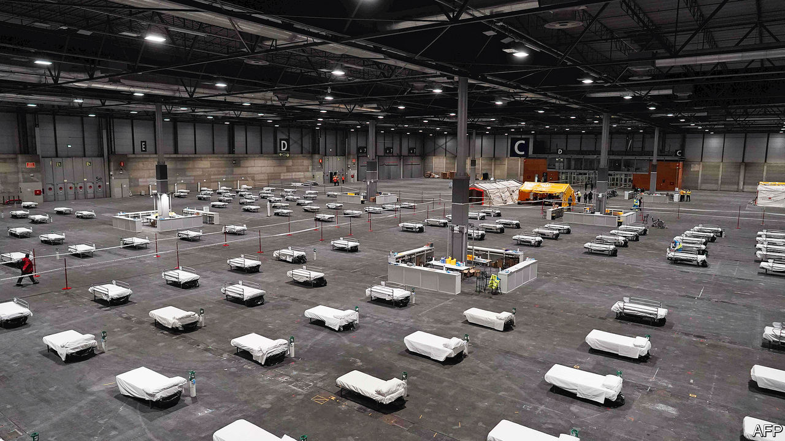

Editor’s note: The Economist is making some of its most important coverage of the covid-19 pandemic freely available to readers of The Economist Today, our daily newsletter. To receive it, register [here](https://www.economist.com/newslettersignup). For more coverage, see our coronavirus [hub](https://www.economist.com/coronavirus)

WITH ITS carefully spaced empty white beds laid across the dark floor, the pavilion of Madrid’s exhibition centre looked like an installation left over from last month’s contemporary art fair. In fact it is a field hospital, set up by the army in 18 hours on March 22nd. Three days later it housed more than 300 coronavirus patients, and was being expanded to take up to 5,500. It is the front line in what Spain’s Socialist prime minister, Pedro Sánchez, has called “the most serious situation the country has faced since the civil war”.

After Italy, Spain is the country worst hit by covid-19, with 49,515 cases and 3,647 dead as of March 26th, with both numbers still rising steeply. It has now overtaken China on the death count. Officials see this week as crucial. With the health system in Madrid, the centre of the outbreak, close to breaking point, the government hopes that a state of emergency and lockdown imposed on March 14th will ensure that the peak of infection will pass by the end of the month. Whatever happens, Spain’s economy is heading for deep recession. Its prized health system faces criticism; its politics may be changed.

This week a spectral parliament agreed to extend the state of emergency until Easter. Mr Sánchez has rejected calls from some regional governments to tighten the lockdown further. This already confines most Spaniards to their homes, with no outdoor exercise allowed. It has shut most shops and all bars, restaurants and hotels, but allows factories, farms and building sites to continue. The prime minister notes the restrictions are among the most severe in Europe; tightening them would have an even bigger impact on livelihoods.

The priority now is to get through the health crisis. There are several pressure points. Hospitals and their intensive-care beds in the capital are all but full. As well as the new field hospital, the government has commandeered a dozen hotels for patients with milder symptoms and has ordered private hospitals to admit patients from the public system. The army is ferrying others to quieter areas.

Spain’s outbreak has several peculiarities. The high death rate is partly because the virus has cut a swathe through nursing homes, many of which lack medical staff. Spaniards are more tactile than north Europeans and interact much more with older and more vulnerable relatives. It is also because the government and health services, which are decentralised to regional administrations, were slow to react, with almost no testing until long after the virus had gained a hold. Only now have 650,000 test kits arrived, with another 1m on the way. “The lockdown is very important, but not enough,” says Daniel López-Acuña, a former official at the World Health Organisation. “It has to be backed up with testing.”

Lack of readiness showed itself too in the infection of many health workers (14% of total cases), who lacked protective gear. Spaniards have hailed their steadfastness with nightly applause from balconies. The government hopes to recruit some 50,000 retired or former health workers. Lastly, the virus is now spreading rapidly around the country (faster than in Italy), with Catalonia now accounting for around 20% of cases, behind only Madrid (around a third).

The next worry is the economy. It depends heavily on tourism and the car industry, both of which have shut down completely. Economists are forecasting that GDP will shrink by up to 15%, depending on how long the emergency lasts. Much of that will not be recovered. “Tourists who come later on won’t eat two dinners a night,” says Toni Roldán of Esade-EcPol, a think-tank.

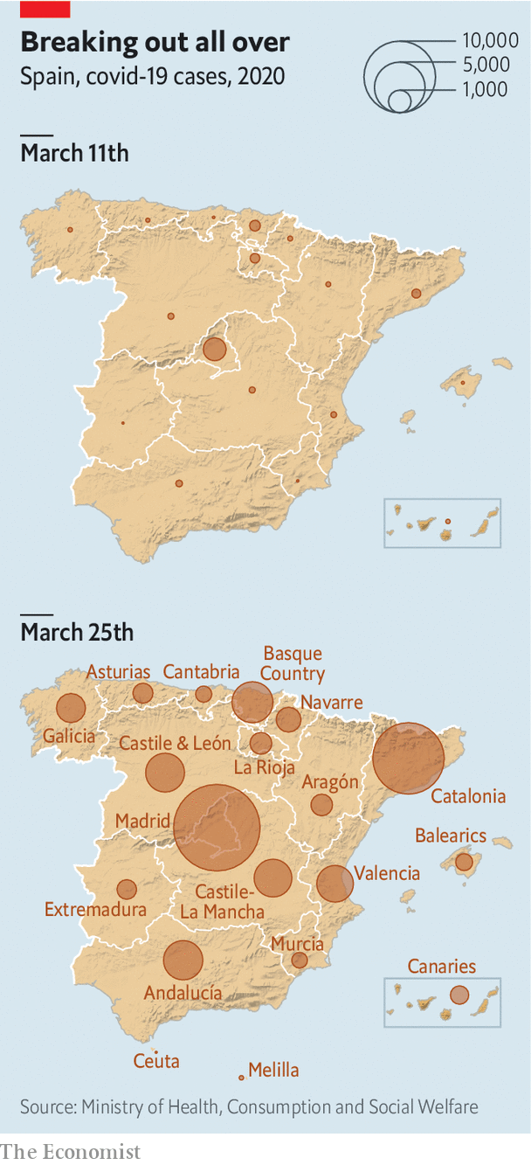

The government has unveiled an aid package worth up to €200bn (around 16.5% of GDP), half in credit guarantees and €17bn in extra spending on health services and income support. It has guaranteed that workers temporarily laid off (some 1.5m so far) will get unemployment benefit. That will not help the 2.5m workers on short-term contracts or the 3.7m self-employed. Officials say they are working on measures for these groups. “The key issue is immediacy,” says Mr Roldán.

How is all this to be paid for? The fiscal deficit could swell to 10% of GDP this year, and, with interest costs rising, push public debt to 120%. No wonder Mr Sánchez is pushing hard for the EU to help out, such as by issuing “coronabonds”.

By common consent the government, an inexperienced and uneasy coalition between the Socialists and far-left Podemos, erred in its tardy reaction to the virus. In what now seems another world, ministers were fixated on healing their divisions with a big feminist demonstration on March 8th. But since the start of the state of emergency, which centralised policing and health services, Mr Sánchez has seemed more sure-footed.

His critics have their own difficulties. The conservative People’s Party (PP) has oscillated between loyalty and sniping. It runs the Madrid regional government, which was more aggressive than others in cutting health spending and privatising some provision. Quim Torra, the separatist head of the Catalan government, called for the “total confinement” of his region, but has failed to handle the virus well. In a poll this month his was the only region where respondents gave higher marks to the central government than their local one.

Mr Sánchez has made verbose and repetitious televised speeches, much mocked by opponents. But many Spaniards like the fact that he is engaging with the problem and with them, says Charles Powell of the Elcano Royal Institute, a think-tank. Spaniards have generally been more disciplined than other Europeans in observing the lockdown. “There’s an element of Spanish patriotism, not nationalism, in this,” says Mr Powell. “My prediction is that Sánchez will come out of it looking stronger.” ■

Dig deeper:  
For our latest coverage of the covid-19 pandemic, register for The Economist Today, our daily [newsletter](https://www.economist.com/newslettersignup), or visit our [coronavirus hub](https://www.economist.com/coronavirus)

This article was downloaded by calibre from <https://www.economist.com/europe/2020/03/26/spain-has-suffered-more-covid-19-deaths-than-any-country-save-italy>

|  |  |  |  |
| --- | --- | --- | --- |
|  | Articles | Sections | Next |

|  |  |  |  |
| --- | --- | --- | --- |
| Previous | Articles | Sections | Next |

#### Covid comparisons

# Why does Germany’s death rate look better than Italy’s?

The data may deceive

Mar 26th 2020 | BERLIN

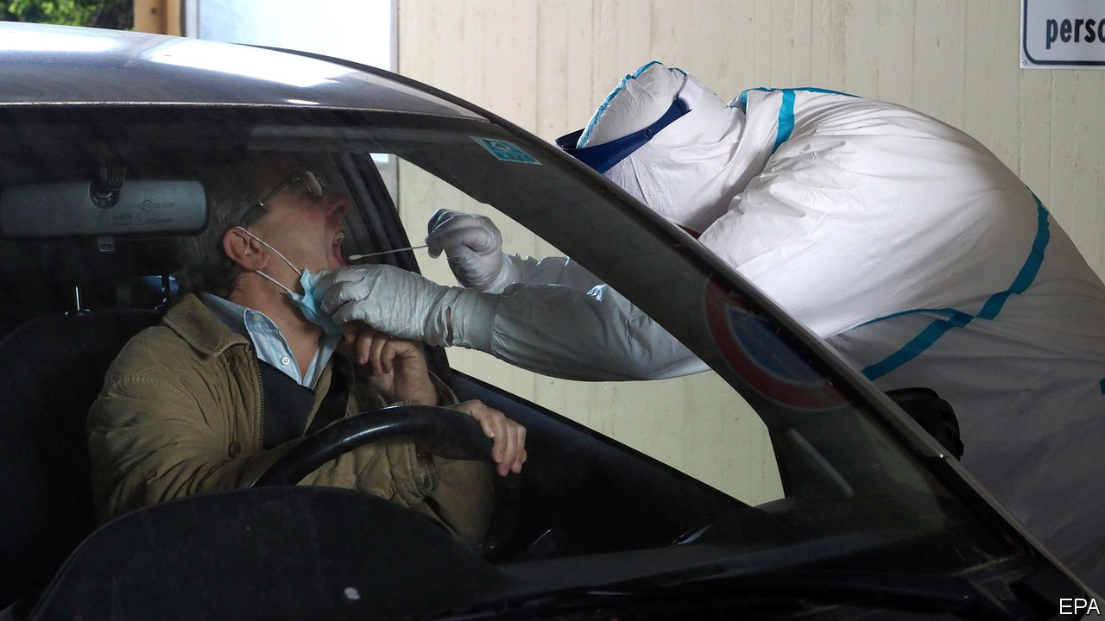

Editor’s note: The Economist is making some of its most important coverage of the covid-19 pandemic freely available to readers of The Economist Today, our daily newsletter. To receive it, register [here](https://www.economist.com/newslettersignup). For more coverage, see our coronavirus [hub](https://www.economist.com/coronavirus)

A NEW PASTIME has emerged among people stuck at home: obsessively tracking how their country’s covid-19 death toll compares with those of their neighbours. Some divide the deaths by the number of reported cases of the disease to get a supposed fatality rate. That, in turn, often leads to the premature conclusion that some European countries are spectacularly better than others at keeping people with covid-19 alive.

Take Italy and Germany. On March 25th Italy had recorded 74,386 cases of covid-19 and 7,503 deaths, the highest number in the world. Germany’s tally that day stood at 37,323 cases and just 206 deaths. Going by these figures, the fatality rate would seem to be around 20 times higher in Italy than in Germany. In fact, this is a spurious number, for several reasons.

First, in any country the number of confirmed covid-19 cases is an unknown fraction of the actual number of cases. Both Italy and Germany have been testing lots of people. In Germany, where different doctors and regions have different practices as to whom they test, accurate national figures on the number of tests done are hard to verify. That makes comparing the two countries tricky. But the broad consensus seems to be that there has been a greater degree of testing in Germany, meaning that it is spotting more mild cases of the disease than Italy. Severe ones end up in hospital, where they are obviously easy to count.

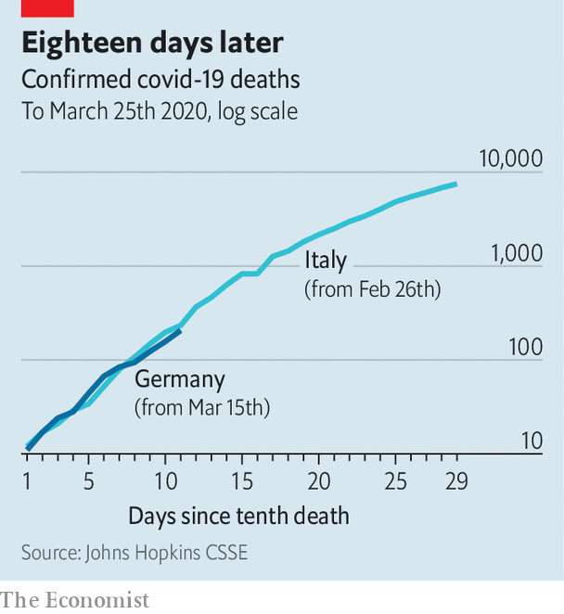

What is clearer is that the first wave of covid-19 infections in Italy was predominantly among older people, who are far more likely to die than younger people, even with the best of care. The median age of those diagnosed with covid-19 in Italy is 63 years, compared with 47 in Germany. The two countries have a similar share of older people in the general population. But only 20% of cases reported in Germany are people aged over 60, compared with 56% of those in Italy. The early German cases seem to have contracted the disease at carnivals and ski-resorts, which explains why the initial profile is so young.

Another reason why Italy’s death rate looks much higher is that its epidemic began earlier. Covid-19 deaths lag behind infections by several weeks. That means that for quite a time the disease can spread unnoticed. Italy’s first deaths were on February 22nd, Germany’s two weeks later. So a large number of Germans who are already infected will become sicker and die in the coming days and weeks. That is starting to happen. On March 23rd Germany’s cumulative number of covid-19 deaths jumped by 56%; the next day’s increase was 33%.

Lastly, Italy’s deaths would not be so numerous if its covid-19 patients had not overwhelmed its hospitals. The country’s epidemic has been concentrated in the Lombardy region, whereas Germany’s cases have been distributed more broadly across several hotspots. As the disease spreads in both countries, it will become clearer whether the German health system really is so much better than Italy’s at keeping covid-19 patients alive. ■

Dig deeper:  
For our latest coverage of the covid-19 pandemic, register for The Economist Today, our daily [newsletter](https://www.economist.com/newslettersignup), or visit our [coronavirus hub](https://www.economist.com/coronavirus)

This article was downloaded by calibre from <https://www.economist.com/europe/2020/03/26/why-does-germanys-death-rate-look-better-than-italys>

|  |  |  |  |
| --- | --- | --- | --- |
| Previous | Articles | Sections | Next |

|  |  |  |  |
| --- | --- | --- | --- |
| Previous | Articles | Sections | Next |

#### Desperate times

# Germany offers cash for everyone

Spending big to offset the corona crunch

Mar 26th 2020 | BERLIN

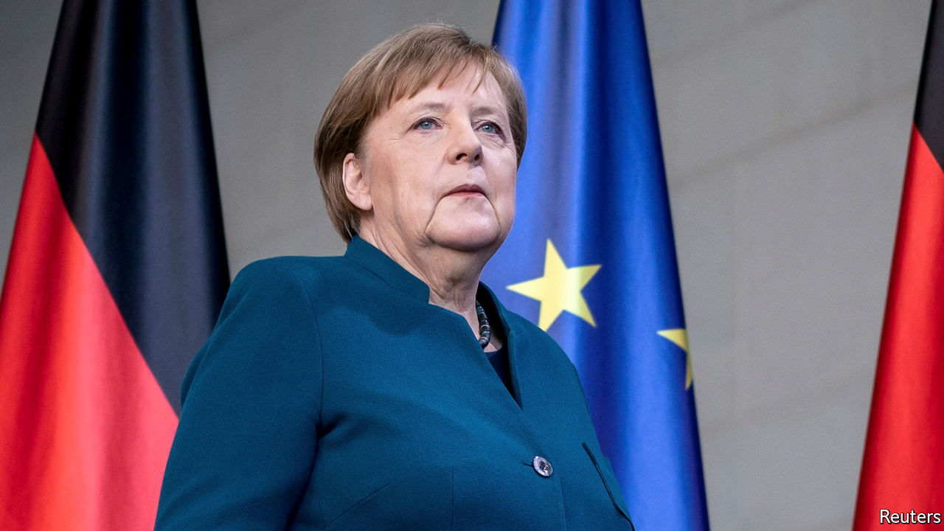

IT WAS SHAPING up to be a bumper year for the Hotel Esplanade in Dortmund. On February 13th its owners threw a big party to celebrate a €2.5m ($2.7m) extension, and to mark the moment that Katja Kortmann took over as manager from her retiring father. Two weeks later the cancellations began: first a trickle, then a tidal wave of up to 300 a day. On March 27th the Esplanade will close its doors to guests and send its 40 staff home. The plan is to reopen on April 19th, but Ms Kortmann doubts that will happen. “It’s just tragic,” she says.

Desperate times, desperate measures. On March 25th Germany’s MPs—sitting the requisite two metres apart in the Bundestag—backed an extraordinary set of policies designed to shield the country’s workers and companies from the worst ravages of the virus. Even sceptical observers have been surprised by the government’s speed and boldness. Its package, the most comprehensive in Europe, includes several elements, some of them dusted off from previous crises.

Chief among them is an expansion of Kurzarbeit (short-time work), under which the state pays 60-67% of the forgone wages of workers whose hours are cut. The scheme, copied across Europe, helped Germany avoid mass lay-offs in 2008-09, but Ms Kortmann’s experience shows how things will differ this time. In the previous crisis, notes Sebastian Dullien of the IMK research institute, manufacturers that faced declining orders used Kurzarbeit to reduce the hours of shift workers. Now the scheme will have to bolster consumer-facing outfits whose customers evaporated overnight. Almost all the Esplanade’s staff, including Ms Kortmann, will be on zero hours once the hotel shuts. The government is planning for Kurzarbeit to extend to 2.15m workers—5% of those with jobs—at a cost of €10bn for a year.

Larger firms can avail themselves of €400bn in liquidity guarantees issued by a new Economic Stabilisation Fund, modelled on a bank bail-out fund from 2008. Another €100bn may be reserved for direct equity stakes in companies, including “strategic” firms at risk of takeover, and the same amount can be provided to the state development bank, which Olaf Scholz, the finance minister, has promised will lend in unlimited quantities to troubled firms. Germany’s 3m small companies and freelancers, meanwhile, can receive grants of €9,000-15,000 to cover fixed costs like rent as long as they can prove that they have been hurt by the pandemic, which should not be hard. Along with various other measures the package amounts to a cool €750bn (though the full sum is unlikely to be used). Several German states are offering further help and Mr Scholz has hinted at a separate post-crisis stimulus.

Germany has had to slaughter several sacred cows to get here. The government’s supplementary budget foresees borrowing of €156bn this year, around 4% of GDP, which means the hallowed schwarze Null (“black zero”) no-deficit policy, in force since 2014, is history. The Bundestag had to invoke an emergency clause in the constitutional debt brake, which normally limits borrowing to 0.35% of GDP. A rotating cast of international financial institutions has long urged Germany to loosen its purse-strings. It took covid-19 to do what the IMF and European Central Bank could not.

For now the measures will cushion the worst of the blow. But for smaller firms with thin cash reserves, the help will only go so far. Alexander Zimmer, who runs the Marienburg Monheim Manor, a conference centre near Dusseldorf, is one example. His workers will receive Kurzarbeitergeld, but he will top it up to a full salary to make life easier for them. He thinks he can do that for three months at most.

At the European level there has been some cross-border solidarity: several German states have accepted patients from overloaded French and Italian hospitals. But the German government is unwilling to heed requests to back jointly guaranteed euro-zone debt (see article). “If we’re declaring war on the virus, eurobonds should be the instrument of choice, but I’m not hopeful,” says Moritz Schularick, an economics professor at the University of Bonn. The pandemic has changed a lot in Germany. But not everything. ■

This article was downloaded by calibre from <https://www.economist.com/europe/2020/03/26/germany-offers-cash-for-everyone>

|  |  |  |  |
| --- | --- | --- | --- |
| Previous | Articles | Sections | Next |

|  |  |  |  |
| --- | --- | --- | --- |
| Previous | Articles | Sections | Next |

#### Typhus off!

# Why Dutch swear words are so poxy

English insults often refer to sex; Dutch ones, to disease

Mar 26th 2020 | AMSTERDAM

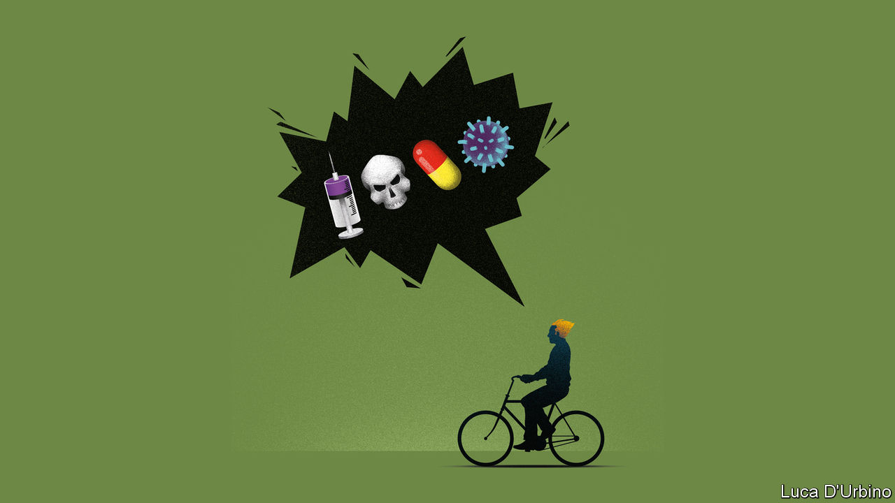

IN MOST LANGUAGES, if someone said you had cancer, it would be a diagnosis. In Dutch, it is more likely to be an insult. Kankerlijer (“cancer-sufferer”) is one of a long list of Dutch profanities and expletives derived from diseases. An undesirable person might be told to “typhus off” (optyfussen) or “get consumption” (krijg de tering). If in (American) English you laugh your ass off, in Dutch you might “laugh yourself the pleurisy” (lachen je de pleuris). No one in England has been called a “poxy bitch” for centuries, but in the Netherlands you can still call someone a pokkenteef. A damned long way is a klereneind (“cholera-end”). And so on.

Because expletives are based on social taboos, in most cultures they are linked to sex, excrement or religion. Many Dutch swear words are as well, but they often feel weaker than the medical ones. Schijt is less like its English cognate and more like the gentler French merde. Mierenneuker (“ant-fucker”) is an anodyne expression for someone who fusses over details. “Whore” is an insult in Dutch too, but when the rapper Lil’ Kleine had a beef with pop singer Anouk last autumn, he went with the harsher kankerhoer (“cancer-whore”).

Scholars are not sure why the Dutch swear with illnesses. One theory links it to Calvinism, the puritanical strain of Protestantism that caught on here in the 16th century, which holds that the virtue of those destined for heaven will show itself in worldly prosperity, health and hygiene. “There was a shift in focus from the afterlife to this life, which, for example, diminished the strength of ‘God damn it’,” says Marten van der Meulen, a Dutch linguist and author of a book on swearing. On this theory, “a curse might be stronger if you used something in actual life, like a disease.”

However, there is also what linguists call the frequency hypothesis: the Dutch may curse with diseases simply because it caught on. Language, as Laurie Anderson said, is a virus. Perhaps someday Dutch kids will savage each other on the playground with cries of coronalijer.

This article was downloaded by calibre from <https://www.economist.com/europe/2020/03/26/why-dutch-swear-words-are-so-poxy>

|  |  |  |  |
| --- | --- | --- | --- |
| Previous | Articles | Sections | Next |

|  |  |  |  |
| --- | --- | --- | --- |
| Previous | Articles | Sections | Next |

#### Fortress Russia

# Russia’s economy is isolated from the global rout

For now

Mar 26th 2020 | MOSCOW

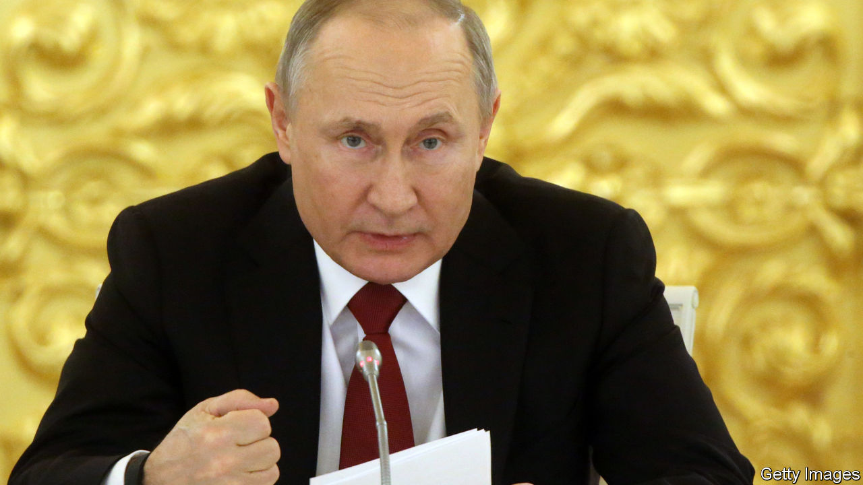

VLADIMIR PUTIN is no doubt feeling smug. The Russian economy ought to be in crisis, but it is not. Covid-19 is causing a global meltdown. The price of oil has slumped below $30 a barrel, half what it was two months ago. Oil and gas traditionally account for two-thirds of Russian exports. That has sent the rouble sliding. The currency has lost nearly a third of its value since early January.

Yet even as the world’s richest countries are in turmoil, taking on vast sums of debt to cushion the blow, Russia’s economy shows few signs of panic. This is not because Russia has diversified, defeated corruption, protected property rights, or boosted competition, investment or growth. It has done none of those things. Rather, the Russian economy is less sensitive to the shock because it has already been self-isolating for the past six years. Ever since Mr Putin illegally annexed Crimea and fomented war in Ukraine, the West has imposed sanctions on Russia and Russia has imposed sanctions on the West.

Since then, the aim of Russia’s macroeconomic policy has been not to foster growth but rather to build a fortress economy that could withstand a severe shock. Underpinning this policy was a fiscal rule in 2017 that required the budget to balance with an oil price slightly over $40 a barrel. Anything above that figure was funnelled into a rainy-day fund which had reached 7.3% of GDP on March 1st.

As a result, Russia now sits on one of the world’s largest gold and foreign-exchange reserves, worth nearly $570bn. Oleg Vyugin, a former official at the central bank and the finance ministry, explains the thinking: “We’re protected against external shocks and foreign enemies because we have modern weapons and rockets, but also because we have gold and reserves.” Russia has also raised its pension age and VAT rate, and has boosted its tax take through digital technology. Mikhail Mishustin, the tax-collector-in-chief, was recently promoted to prime minister.

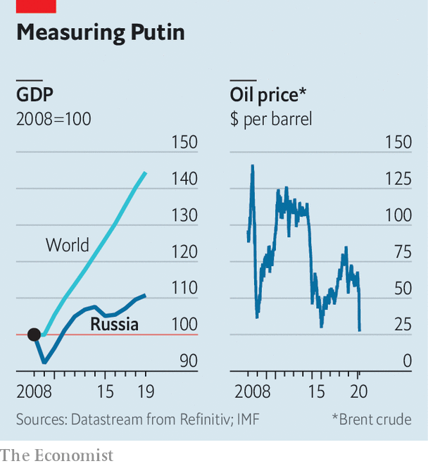

To be sure, the Russian economy remains highly dependent on energy and commodity prices. The dramatic fall in the oil price, partly induced by Russia’s own decision to break out of its deal with OPEC producers, could deprive the government of about 2trn roubles ($25bn) this year. Russia’s risky bet that it could increase its market share and drive American shale firms out of business may backfire spectacularly if America decides to strike its own deal with Saudi Arabia at Russia’s expense, argues Kirill Rogov, an independent analyst. But for now, Russia has more than enough reserves to see it through the next few years. The decline in the value of the rouble has limited the damage to its public finances caused by the falling oil price. Western sanctions have also made it irrelevant, in many cases, that foreign goods now cost more in roubles.

Cut off from international capital markets since 2014, Russian firms have had no choice but to deleverage. Whereas Western firms took advantage of low interest rates and loaded up on debt, Russia’s corporate debt as a share of GDP has fallen to below 50%, while the state debt-to-GDP ratio is well under 20%. Given that most of Russia’s exports are basic, it is also less vulnerable to disruptions in complex global supply chains. “If you are travelling on a horse, you don’t have to worry about running out of petrol,” observes Natalia Orlova, chief economist at Alfa Bank.

Russia has also become more self-reliant. Its counter-sanctions imposed on food imports from the EU have boosted domestic agriculture, driving down the share of food that is imported by a third in the past five years, to just 24%.

Life in isolation has its downside, as many people outside Russia have discovered since covid-19 struck. Russia is poorer than it should be. Its average annual growth rate since 2014 has been a dismal 0.6%, which is a fifth of the global average. Small- and medium-sized private businesses have shrunk. Quasi-state firms controlled by Mr Putin’s cronies have expanded. Rent-seeking is rampant, which means that opportunities for the honest or diligent are frustratingly meagre.

The economic impact of the new coronavirus, which may be more widespread than the government claims, is only likely to deepen Russia’s structural problems. On March 25th Mr Putin announced his own response to the virus, a pale imitation of the vast economic packages announced by western governments. It largely transfers the cost of the adjustment to Russia’s middle class.

Instead of a lockdown, Mr Putin declared a week-long holiday in Russia. In return, small- and medium-sized businesses are to get a corporate-tax holiday for six months (VAT must still be paid). The social taxes businesses pay on behalf of their employees are to be halved, to 15%.

The president’s welfare-support measures were relatively modest. The government is going to increase child benefits by 5,000 roubles a month ($63) and unemployment benefits by a third to 12,000 roubles. Those who fall sick and lose more than 30% of their income will be able to delay repayments of mortgages and certain other loans.

To compensate for the hit to the national budget, Mr Putin increased the tax on dividends received from offshore holdings from 2% to 15%, effectively levying a new tax on the rich. What this package demonstrates all too vividly is that Mr Putin cares a lot more about bolstering the state than about preserving Russia’s market economy, such as it is.

As Ruben Enikolopov of Moscow’s New Economic School argues, the biggest risk that confronts Russia is not an economic collapse but a social one, with millions of people losing their livelihoods and beleaguered private firms shrinking yet further. Mr Putin has long talked about restoring a Soviet-style socially oriented state. The crisis risks exposing that what he has built instead is a corporatist state that cares little about its private citizens. ■

This article was downloaded by calibre from <https://www.economist.com/europe/2020/03/26/russias-economy-is-isolated-from-the-global-rout>

|  |  |  |  |
| --- | --- | --- | --- |
| Previous | Articles | Sections | Next |

|  |  |  |  |
| --- | --- | --- | --- |
| Previous | Articles | Sections | Next |

#### Charlemagne

# How grasshoppers triumphed over ants in Europe

The old fiscal rules are no more

Mar 26th 2020 |

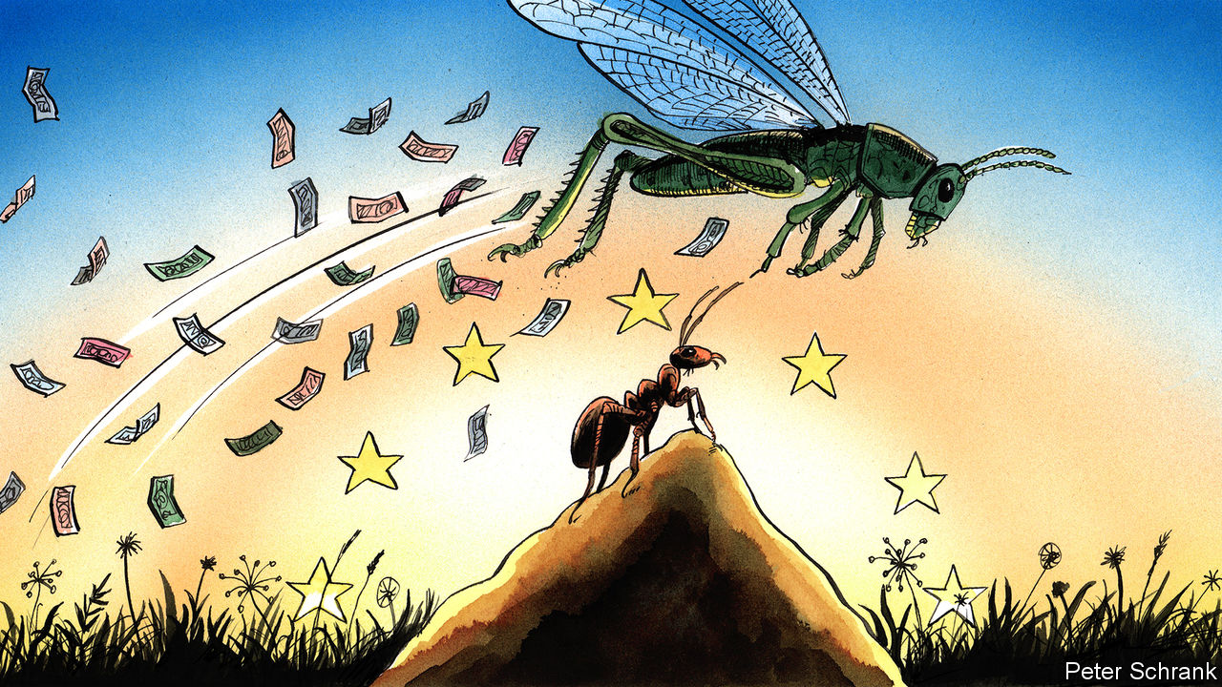

TO EXPLAIN A complicated story, it helps to have a fable. Those who watched the last euro-zone crisis often turned to Aesop’s story of the ant, who worked hard all summer ahead of the coming winter, and the grasshopper, who lazed about during warm weather only to come begging for a handout when the cold arrived. The euro zone, in this simplistic telling, was split between ants and grasshoppers. On the one side were rich, northern countries such as Germany that reformed their economies and spent little during the long summer of the 2000s. On the other were profligate grasshoppers, such as Greece and Italy, that ran up chunky deficits or left their inefficient economies untouched, causing misery when the financial crisis hit. For the ants, this was vindication. When the grasshoppers came begging, they were forced to live like ants, with strict rules on spending and often painful economic reform. Chirps of complaint were ignored. Ants ruled.

Less than a decade later and the grasshoppers are in the ascendant. EU member states have agreed to rip up spending rules to cope with the economic wreckage caused by covid-19. Governments have gorged themselves at a fiscal buffet. Spain launched a stimulus worth 3% of GDP. France put out extra spending amounting to 2% of GDP. Even Germany, the queen of the ant colony, has joined in. Berlin burst through its “black zero” rule, which insists on a balanced federal budget, with a stimulus package worth 4% of GDP. It will even borrow €156bn ($170bn) to pay for it. “There are no rules,” says Claus Vistesen, an economist at Pantheon Macroeconomics, summing up the new mood. “Why not go big?”

In fact, the grasshoppers have been quietly gaining ground for years. Grumbles about fiscal rules beloved by the ants—which supposedly limit government deficits to 3% of GDP and national debt to 60% of GDP—have been growing. “Flexibility” has been the preferred euphemism for a concerted effort to water down the rules, which gave the European Commission finger-wagging rights over the individual budgets of member states. Other efforts to introduce a special carve-out for spending on environmental policy, which will be an increasingly large chunk of government spending in the coming decades, were gaining ground. An ideological breeze was already blowing in favour of those who wanted looser spending. The novel coronavirus has turned it into a hurricane.

Ants were once backed at the highest levels of Europe’s institutions. But austerity’s main advocates have moved on. The commission has become steadily more relaxed about spending. At the start of the last decade, the European Central Bank was among the loudest voices for austerity. Jean-Claude Trichet, the then president of the bank, implored countries to rein in spending or face ruin. By the end of the decade, Mr Trichet’s successor, Mario Draghi, was practically begging countries to spend more—a call that his successor, Christine Lagarde, has matched. Different leaders now sit round Europe’s top table. Only two veterans of the original euro-zone crisis remain in charge of their countries: the Dutch prime minister, Mark Rutte, and Germany’s Chancellor, Angela Merkel. It is little surprise that Mr Rutte and Mrs Merkel nod to the orthodoxies of a previous era they helped shape. Elsewhere, fresh blood has led to fresh thinking.

The ant mentality is still strong in some countries. Olaf Scholz, the German finance minister, boasts that it was only previous fiscal rectitude that has allowed such a large response to the crisis “without batting an eyelid”. It is an argument repeated by Dutch officials, who justify their decision to unbuckle their fiscal belts with reference to their previously strict diet. Such a claim is undermined by the fact that countries with flabbier finances now have the same capability to borrow and spend themselves out of trouble. Paris has promised to splurge in response to the crisis. Despite running a deficit every year for the past two decades, the French government’s borrowing cost is only fractionally higher than that of the Netherlands, which has run a surplus since 2016.

The scale of the covid-19 crisis offers a nihilistic twist to Aesop’s fable. Sometimes a winter is so harsh that previous behaviour becomes irrelevant. The coming crisis will trash the finances of EU countries whether they were previously parsimonious or gluttonous. The Netherlands has squirrelled away about €30bn in surpluses since 2016. But this is dwarfed by the €90bn it may now have to borrow. Practically every country will exit the crisis with bloated debts and a heaving deficit. Bragging about having slightly healthier finances against such a backdrop would be like boasting about having the cleanest face at a mud-wrestling contest.

## Hopping mad

Grasshoppers do not have everything their way. On March 25th, Paris and Rome led a group of nine countries demanding the EU issue mutually guaranteed debt in response to the crisis. This idea is dismissed in Berlin and The Hague. A compromise where countries struggling to pay for the covid-19 response can access bail-out funds without overly strict conditions is more likely. At the start of the decade, the grasshoppers would have leapt at such a deal; now they fume that the ants have not capitulated further.

In this way, the grasshoppers are repeating a mistake of the ants’. Rather than building a fiscal policy that worked for both camps, ants forced grasshoppers to adopt ant ways. As a consequence, resentment festered and populists thrived in southern Europe, which snapped back to its fiscal instincts as soon as the opportunity arose. Similarly, a bout of profligacy in response to a crisis will not compel the likes of Germany to adopt a loose fiscal policy for ever. Already, the ants in Brussels and national capitals mutter that fiscal discipline will be needed to bring order to public finances once this crisis has passed. Both sides must recognise they are stuck together. Rather than triumphant chirping, a compromise between ant and grasshopper is in order. A lasting peace trumps temporary hegemony every time. ■

This article was downloaded by calibre from <https://www.economist.com/europe/2020/03/26/how-grasshoppers-triumphed-over-ants-in-europe>

|  |  |  |  |
| --- | --- | --- | --- |
| Previous | Articles | Sections | Next |

|  |  |  |
| --- | --- | --- |
| Europe | Sections | International |

Britain

Covid-19 and inequality: The great divider

.

Politics: Slow starter

.

Drugs: Stay in, drop out

.

Health care: National Covid Service

.

Village England: The Swan takes flight

.

Community life in London: Alone, together

.

Saving jobs: Furlough maintenance

.

Scottish politics: Leaping Salmond

.

Bagehot: The new politics

.

|  |  |  |
| --- | --- | --- |
| Europe | Sections | International |

|  |  |  |  |
| --- | --- | --- | --- |
|  | Articles | Sections | Next |

#### Dealing with the virus

# How covid-19 exacerbates inequality

Boris Johnson wants to “level up” Britain; covid-19 is doing the opposite

Mar 26th 2020 |

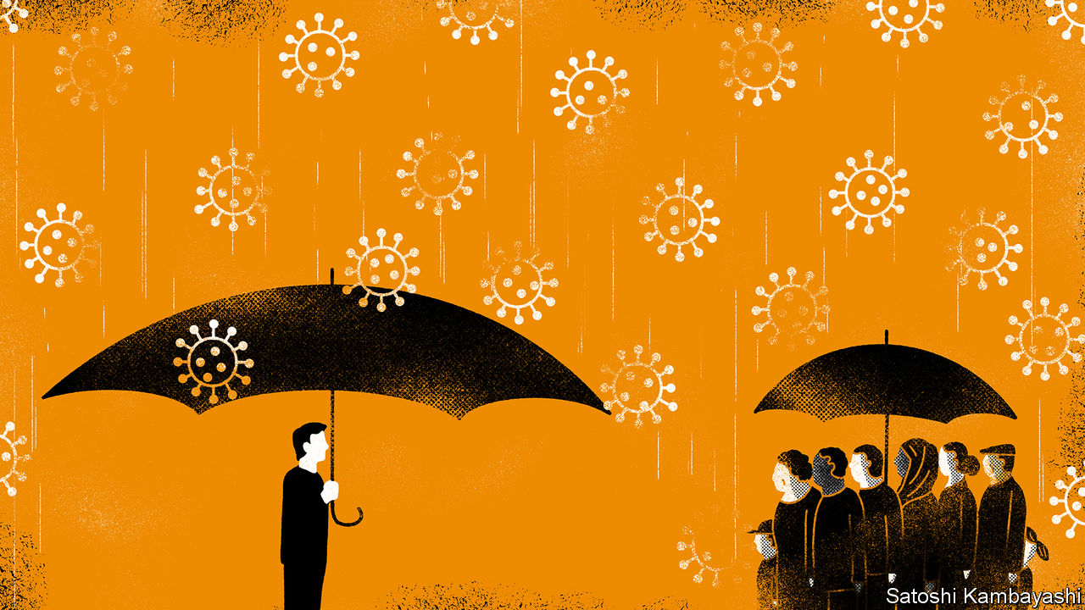

Editor’s note: The Economist is making some of its most important coverage of the covid-19 pandemic freely available to readers of The Economist Today, our daily newsletter. To receive it, register [here](https://www.economist.com/newslettersignup). For more coverage, see our coronavirus [hub](https://www.economist.com/coronavirus)

IN SOME WAYS, Britain is more united than it has been for a long time. Bickering over Brexit has been shelved. Party politics is all but suspended, after Parliament voted to shut itself down on March 25th to minimise the risk of transmission of covid-19. Ministers are marshalling an army of volunteers to help the health service. And the virus itself is no respecter of rank: Prince Charles is among those it has infected.

Yet the fallout from the pandemic threatens to expose—and widen—inequality in brutal fashion. As Torsten Bell of the Resolution Foundation, a think-tank, puts it, “the virus doesn’t discriminate between people but the accompanying economic shock certainly does.” Before covid-19 hit, Boris Johnson’s plan was to “level up” poorer communities. The opposite is happening. Young and old, north and south, and rich and poor all have markedly different capacities to bear the burden of lockdown, social isolation and a sharp drop in economic activity.

The first divide is geographic. Differences in the structure of local labour markets may lead to vastly different outcomes across the country (see map). Some parts of the country are stuffed with professionals who can weather travel restrictions by working from home; others are full of factory workers who can hardly set up assembly lines in their living rooms. Prosperous places like Reading and Brighton have plenty of potential home-workers, according to analysis by the Centre for Cities, another think-tank. Less well-to-do cities like Middlesbrough and Hull do not.

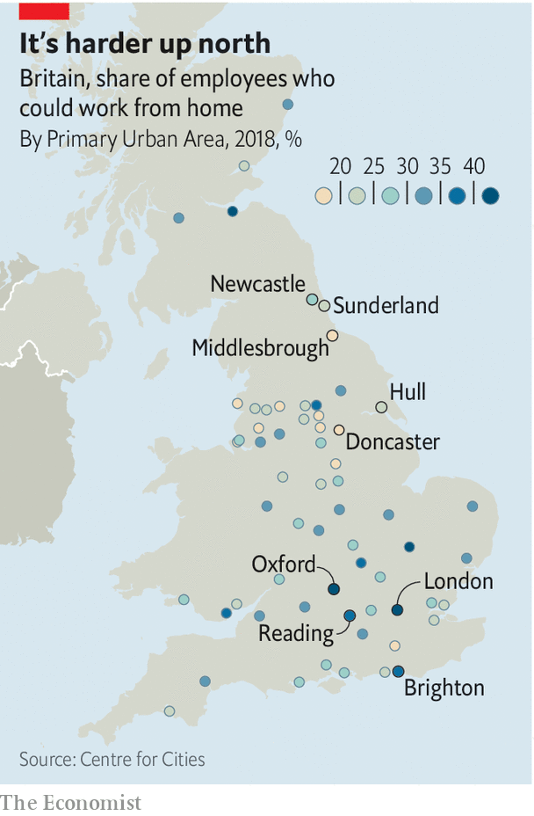

The south-east of England, the region with the highest share of white-collar jobs, is best placed for business as usual. More than a third of journalists, for example, work in London. The Economist has been entirely written and edited from journalists’ homes, most of them in the south-east. Even within regions, differences are stark. Newcastle will cope better than neighbouring Sunderland. The map echoes geographic divides in support for Brexit. The thriving areas that voted Remain are more likely to be packed with video-conferencers today than are the so-called left-behind places that voted to leave the EU.

The second disparity is economic. The most flexible workers tend to be higher earners. The Resolution Foundation reckons about half of Britain’s highest-paid employees can work from home, but less than 10% of those in the four lowest-paid deciles can. Hospitality and retail workers, who will bear the brunt of closures, are already among the lowest-paid in Britain (see chart). Nor can they fall back on reserves: more than half of poorer households have no savings.

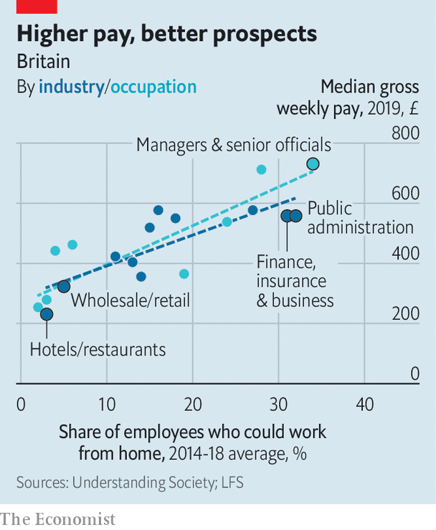

The government will do its best to even things out. It will bear 80% of the wage bills of employees furloughed due to the crisis and is offering firms tax breaks and soft loans. But though it promises some relief for the self-employed, these measures had not been announced as The Economist went to press. And the lower-paid may struggle disproportionately to cope without a fifth of their wages, and with the cramped conditions in which many poorer Britons live.

That is not a problem for Nicholas Coleridge, chairman of the Victoria and Albert museum. He has turned his country pile into something he says resembles an outpost of WeWork, the co-working firm. Four of his children are working from home; the family’s garden folly could come in handy for self-isolation. More space and a higher level of education will make it easier for the better-off to teach their children, who will therefore return to school even further ahead of their peers. According to Teacher Tapp, an app which surveys teachers, 27% of private secondary-school teachers communicated with pupils via video on the first day schools were shut, compared with 2% of those in state schools.

Others are less able to adapt. Families in which both parents work may not be able to supervise their children’s education. James Donovan, a self-employed carpenter in Bath, was working on a barn conversion before the government advised people to stay at home. “When Boris said ‘lockdown’, I was told not to come to work,” he says. So far, he has struggled to apply for benefits. “You’ll be waiting years to get through to anyone on the phone.” The government is redeploying thousands of staff to process applications, 477,000 of which were made in the nine days to March 24th.

Even if they can stay at home, poor families are more likely to be packed together in a small space, helping spread the disease. According to an analysis of government data by the Joseph Rowntree Foundation, a charity, 7% of English people in the poorest fifth of households live in houses without enough bedrooms, compared with less than 0.5% of the richest fifth. Ethnic minorities are also more likely to live in crowded houses. Nearly a third of Bangladeshi households have fewer bedrooms than they need. The comparable rate for white British households is 2%.

The final disparity is age. As well as being more vulnerable to covid-19, the elderly are more likely to live alone. About half of the 8m Britons who live alone are aged 65 or older. For some, the lockdown will compound feelings of loneliness. Many struggle to use the internet. Only 44% of retired Britons say they have good internet skills, compared with 95% of students.

One elderly Londoner is grappling with online shopping for the first time after her goddaughter helped her create an account. “The website kept crashing,” she says. “I’ve discovered if you do it at three or four o’clock in the morning it’s easier to get on.” They are, however, a hardy bunch. Several have told anxious grandchildren to stop worrying, since they experienced far worse during the second world war.

That experience brought the country together, and perhaps this one will too. But some fissures may deepen.■

Dig deeper:  
For our latest coverage of the covid-19 pandemic, register for The Economist Today, our daily [newsletter](https://www.economist.com/newslettersignup), or visit our [coronavirus hub](https://www.economist.com/coronavirus)

This article was downloaded by calibre from <https://www.economist.com/britain/2020/03/26/how-covid-19-exacerbates-inequality>

|  |  |  |  |
| --- | --- | --- | --- |
|  | Articles | Sections | Next |

|  |  |  |  |
| --- | --- | --- | --- |
| Previous | Articles | Sections | Next |

#### Politics

# Boris Johnson’s belated lockdown

Slow off the mark, Britain may have a worse plague than it needed to

Mar 26th 2020 |

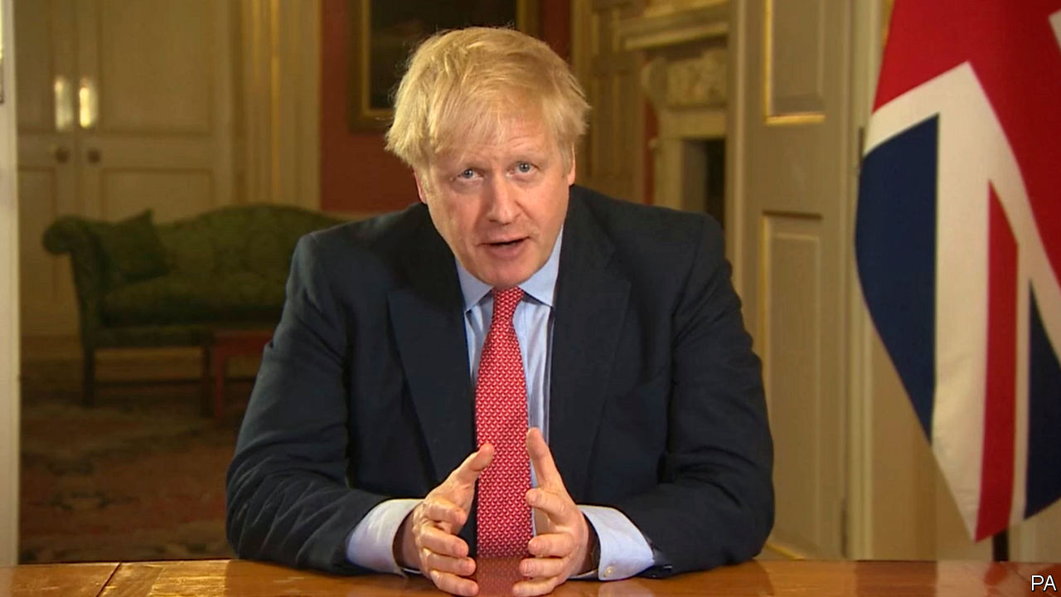

Editor’s note: The Economist is making some of its most important coverage of the covid-19 pandemic freely available to readers of The Economist Today, our daily newsletter. To receive it, register [here](https://www.economist.com/newslettersignup). For more coverage, see our coronavirus [hub](https://www.economist.com/coronavirus)

WHEN BORIS JOHNSON announced a partial lockdown in a sombre prime-time broadcast on March 23rd, polls put popular support for his decision at 93%. Criticism was less of the severity of the measure (though the Daily Telegraph headlined the news “End of Freedom”) than that it came so late, long after most of the rest of Europe.

Mr Johnson held his first meeting on covid-19 only in early March. Initially, the advice to the public was little more than to wash their hands regularly. There was even talk of not slowing the virus down too vigorously, so as to achieve “herd immunity”. What threw this idea overboard was a study by Imperial College London, suggesting that letting the virus spread uncontrolled might mean as many as 250,000 deaths, primarily among older people.

Even when the decision was made to do more to stop the disease, disagreement persisted over tactics. Mr Johnson’s instinctive liberalism sat ill with a compulsory lockdown enforced by the police. Accordingly, he chose to rely on moral suasion, not compulsion, to get people to work from home and avoid socialising. The government ordered the closure of pubs and restaurants only on March 20th, weeks after the rest of Europe.

But the government’s polite requests were widely ignored. The pub closures were treated by many as an excuse for gigantic final street parties. London saw much smaller falls in road and rail usage than most other European cities.

What forced Mr Johnson’s lockdown decision was that the weekend of March 21st-22nd was the first properly warm one of the year. Thousands of people visited the seaside, Snowdonia and other recreational places, clogging the roads. Big crowds thronged into many of London’s parks. Efforts to remain two metres apart, as the prime minister urged, were notable mainly for their absence.

That has changed since the lockdown. According to data from Citymapper, a navigation app, in the week before the lockdown, Londoners were moving around about half as much as they usually do; the day after, the figure was 15%. That evening, Kings Cross was spookily still. The few trains moving in and out had hardly any passengers, and most of the handful of people on its vast forecourt were beggars.

There are still holes. People who cannot do their jobs from home are supposed to go to work, so long as employers can keep them far enough apart, which is often tricky. The Tube remains a source of contagion: service reductions mean that rush-hour trains seem fuller than ever. Enforcement of the new rules is spotty: the police talk of small fines, but also suggest that their effort would be largely persuasive, not coercive.

Mr Johnson is also under fire for not investing enough in testing equipment, not least from Jeremy Hunt, a former health secretary and his erstwhile leadership rival, who believes extensive testing and tracing were key to South Korea’s containment of covid-19. But the NHS is mobilising resources swiftly, from within the service, from the private sector and from the army, which may give it the breathing space it needs to cope with covid-19.

The prime minister must certainly hope so. His premiership was meant to be defined by Brexit, the issue that brought it about. But it now seems more likely to rest on the fight against covid-19 and its aftermath. And even if he wins this war, his future is not guaranteed: after his hero, Winston Churchill, beat the Nazis, he lost the 1945 election to a revitalised Labour Party by a record margin. ■

Dig deeper:  
For our latest coverage of the covid-19 pandemic, register for The Economist Today, our daily [newsletter](https://www.economist.com/newslettersignup), or visit our [coronavirus hub](https://www.economist.com/coronavirus)

This article was downloaded by calibre from <https://www.economist.com/britain/2020/03/26/boris-johnsons-belated-lockdown>

|  |  |  |  |
| --- | --- | --- | --- |
| Previous | Articles | Sections | Next |

|  |  |  |  |
| --- | --- | --- | --- |
| Previous | Articles | Sections | Next |

#### Drugs

# Coke is out, weed is in

The pandemic is shifting demand in the drugs market

Mar 26th 2020 |

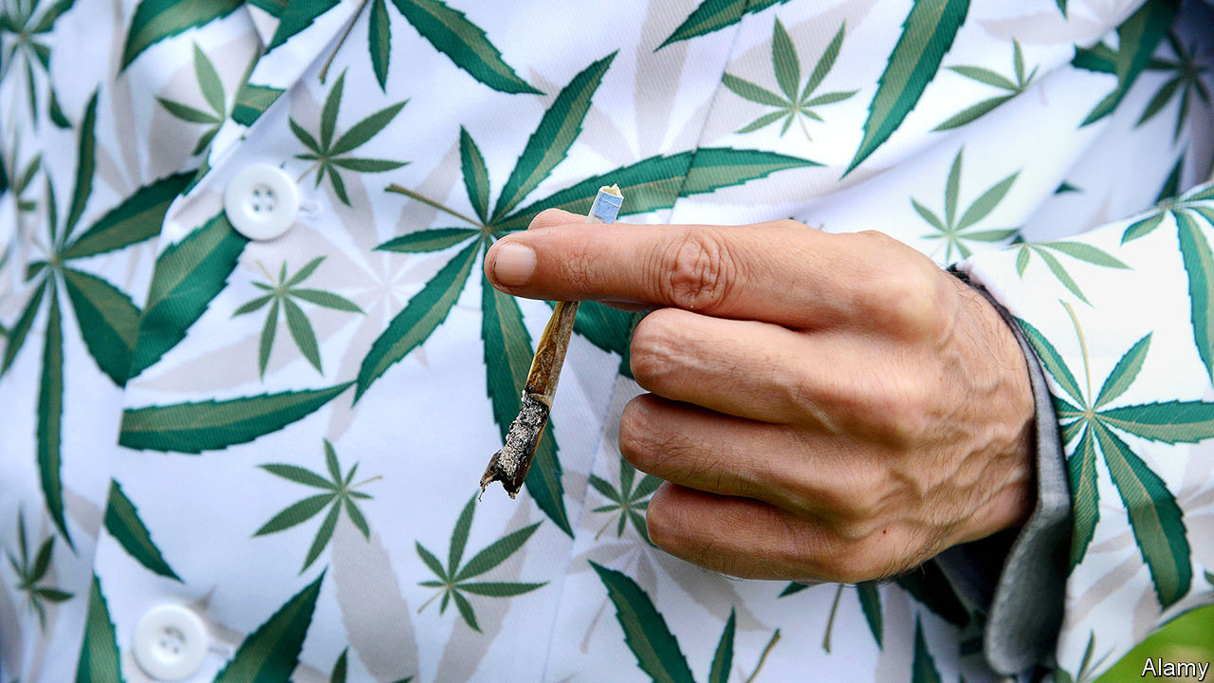

Editor’s note: The Economist is making some of its most important coverage of the covid-19 pandemic freely available to readers of The Economist Today, our daily newsletter. To receive it, register [here](https://www.economist.com/newslettersignup). For more coverage, see our coronavirus [hub](https://www.economist.com/coronavirus)

“NOBODY IS BUYING the party drugs,” laments an east London drug dealer, as he drops two quarter-ounce bags of cannabis onto a customer’s coffee table. Pulling off his protective gloves, he lights up a spliff and settles down for a short break. Outside, ambulances sweep past, their sirens spoiling the hazed ambience. His customer is more than satisfied. “It locks me down—physically and mentally,” he says. “It helps me filter out all this drama.”

The covid-19 pandemic is making Britain’s dealers jittery. As nightclubs and pubs began emptying out, cocaine pushers sent out a flurry of increasingly concerned text messages. “To avoid being affected by delays or disappointment, pre-order NOW!!” went one. Others imposed minimum orders of two or three grams, desperate to shift their stock in a shrinking market. A regular user was unpersuaded. “Imagine being on a comedown during the apocalypse.”

Demand for at least one drug is booming. Large quantities of cannabis are being sold to those preparing for a chilled-out lockdown. “I’ve had so many calls from people asking for ounces who usually buy smaller bits,” one dealer boasts. “Everyone is stockpiling weed,” says the east London dealer. “They just want to blaze their way through the lockdown.” In some parts of the country, the price of weed jumped by half.

The lockdown is also affecting supply. A south London dealer messaged his customers after it was announced, urging them to order quickly “as there will now be limits to time and delivery”. As if he were the boss of a supermarket reassuring customers about the supply chain, another told worried users that he had been on a recruiting spree to provide a more efficient service day and night.

These shifts may also play out on the streets. If revenue dwindles, gangs are likely to battle it out for the remaining custom, according to a report published on March 22nd by Policy Exchange, a think-tank. Turf has already been more closely contested in recent years, thanks to a saturated market and the growth of online suppliers.

Richard Walton, a former senior cop who co-wrote the report, predicts that some gangs will be emboldened if police are distracted by helping to deal with the pandemic. “Some street-level criminals may try to exploit an absence of police presence,” he says.

Still, some dealers have temporarily retired from the trade altogether. “I’m not going outside for a while,” says one. “I don’t want to be taking any cash that has had all those dirty hands on it.”

Dig deeper:  
For our latest coverage of the covid-19 pandemic, register for The Economist Today, our daily [newsletter](https://www.economist.com/newslettersignup), or visit our [coronavirus hub](https://www.economist.com/coronavirus)

This article was downloaded by calibre from <https://www.economist.com/britain/2020/03/26/coke-is-out-weed-is-in>

|  |  |  |  |
| --- | --- | --- | --- |
| Previous | Articles | Sections | Next |

|  |  |  |  |
| --- | --- | --- | --- |
| Previous | Articles | Sections | Next |

#### Health care

# How the National Health Service is transforming itself

A vast, sprawling health service turns its attention to one task

Mar 26th 2020 |

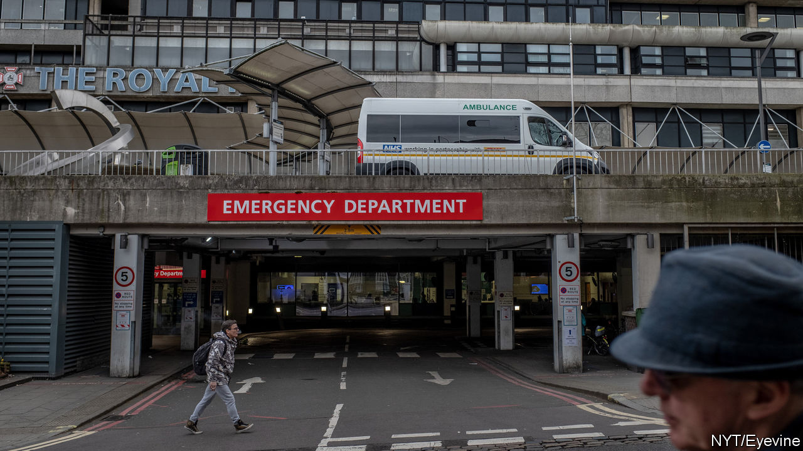

Editor’s note: The Economist is making some of its most important coverage of the covid-19 pandemic freely available to readers of The Economist Today, our daily newsletter. To receive it, register [here](https://www.economist.com/newslettersignup). For more coverage, see our coronavirus [hub](https://www.economist.com/coronavirus)

OVER THE past few weeks, the National Health Service has undergone extraordinary, wrenching changes as it prepares for the coming storm. They involve the mass redeployment of staff, the rapid procurement of equipment and even the creation of an entirely new hospital—the NHS Nightingale—with 4,000 beds in London’s Excel Centre, which had been due to host the World Spa and Wellness Convention. But they also involve smaller adjustments. Communication from NHS England, which runs the health service, has become noticeably terser so as to save time. That is an impressive feat, notes one insider: “Doctors love nothing more than the sound of their own keyboards.”

Britain is now on its way up a steep curve. As The Economist went to press, there were 9,640 confirmed cases of covid-19 and 466 deaths. Numbers are rising fastest in the capital, which is home to more than a third of confirmed cases. In an attempt to suppress the growth, the government has now aligned with much of Europe, instructing people to leave the house only to buy essentials and to exercise once a day. In a short statement announcing the rules, Boris Johnson invoked the need to protect the NHS four times.

The aim is to avoid a Lombardy-style collapse. To do this, the NHS is restructuring on a scale without precedent in its 72-year history. To begin with, its leaders hope to free up 30,000 of its 100,000 beds by postponing elective surgery and urgently discharging inpatients. So that hospitals can focus on preparations, all inspections have been halted. The usual “payment-by-results” mechanism, by which the health service’s internal market operates, will cease on April 1st. As Sir Simon Stevens, the NHS’s chief executive, has written: “Financial constraints...will not stand in the way of taking immediate and necessary action.” The chancellor has announced an extra £5bn ($5.9bn) for the health service, with more to come if needed.

Putting this cash to use, the NHS has struck a deal with private hospitals to acquire 8,000 beds, 1,200 ventilators and 20,000 workers. They will be joined by almost 12,000 retired NHS staff, 5,500 final-year medics, 18,700 final-year student nurses and a volunteer army, who will deliver medicine and check on the vulnerable. The call went out for 250,000 volunteers; within 24 hours, 405,000 had signed up.

The 23 royal medical colleges have identified what can be trimmed from regular practice, allowing specialists to be redeployed. Most outpatient and general-practice consultations are now happening by videolink or phone. In London, at least one hospital has been set aside for non-covid surgery; others will deal solely with those suffering from the virus. Experienced observers are staggered by the pace of change. “Stuff that normally takes a couple of years has been done in 72 hours,” says one.

Whether that is fast enough remains to be seen. Hospital chiefs in London are concerned that the extra capacity is already filling up quickly. Across the country they worry about shortages of protective equipment and testing, which are forcing staff with only minor symptoms to go into quarantine. The government is desperately trying to buy more ventilators.

Some influential voices are nevertheless hopeful. Speaking to a House of Commons committee on March 25th, Neil Ferguson of Imperial College London, whose modelling prompted the government to enforce a lockdown, said that although there would be “hotspots” where the NHS is overwhelmed, his calculations suggest that overall demand will now be within the system’s increased capacity. It will soon be clear whether he is right.■

Dig deeper:  
For our latest coverage of the covid-19 pandemic, register for The Economist Today, our daily [newsletter](https://www.economist.com/newslettersignup), or visit our [coronavirus hub](https://www.economist.com/coronavirus)

This article was downloaded by calibre from <https://www.economist.com/britain/2020/03/26/how-the-national-health-service-is-transforming-itself>

|  |  |  |  |
| --- | --- | --- | --- |
| Previous | Articles | Sections | Next |

|  |  |  |  |
| --- | --- | --- | --- |
| Previous | Articles | Sections | Next |

#### Rural England

# Village life under lockdown

Covid-19 has brought a retail revolution to a small corner of Wiltshire

Mar 26th 2020 | WILTON



Editor’s note: The Economist is making some of its most important coverage of the covid-19 pandemic freely available to readers of The Economist Today, our daily newsletter. To receive it, register [here](https://www.economist.com/newslettersignup). For more coverage, see our coronavirus [hub](https://www.economist.com/coronavirus)

THE PRACTICALITIES of living under lockdown can be especially hard in a small village. Broadband reception in Wilton, in the south-west of England, is patchy so working from home can be tricky. Other than a pond furnished with the requisite number of ducks, the village has few amenities even in healthy times. And now The Swan, the local pub and only village institution (there is no church), has been forced to close.

Yet these Wiltshire villagers are not complaining. Covid-19 is more prevalent in London than in rural England. Locals want to keep it that way, so they are quite happy with the reduction in train services. A new local WhatsApp group is flooded with messages offering to pick up food or prescriptions for the elderly or to walk other people’s dogs and news bulletins: loo paper available in Tesco in Marlborough, potatoes now for sale on the market stall, newspaper deliveries still happening intermittently.

What’s more, covid-19 has brought about a retail revolution. Bill Clemence, The Swan’s landlord, has turned the saloon bar into a pop-up shop selling vegetables, fruit, milk, bread and even (wonders!) local eggs. Wine is priced at a flat £10 a bottle. For the first few days he worried he might be breaking the rules, but he has since been reassured. He allows only two people inside at once and insists that all payments must be contactless, but his service has fast become indispensable. The pub is also selling plenty of take-out family meals to help those who find themselves stuck at home with schoolchildren.

Glorious spring sunshine is helping keep spirits up. The daffodils are out and the first mowing of the year is under way. The biggest local farmer is upbeat, as the uncertainty that covid-19 has brought has pushed up demand for wheat, allowing him to forward sell a much bigger chunk of his spring crop than he would have expected at this stage.

Much as in the rest of the country, covid-19 is bringing the village closer despite (or perhaps because of) lost social amenities. More walkers and cyclists appear to be on the roads, just as fewer cars are driving into nearby towns. And although social distancing is being carefully maintained, the greetings that are exchanged seem cheerier than usual.

Dig deeper:  
For our latest coverage of the covid-19 pandemic, register for The Economist Today, our daily [newsletter](https://www.economist.com/newslettersignup), or visit our [coronavirus hub](https://www.economist.com/coronavirus)

This article was downloaded by calibre from <https://www.economist.com/britain/2020/03/26/village-life-under-lockdown>

|  |  |  |  |
| --- | --- | --- | --- |
| Previous | Articles | Sections | Next |

|  |  |  |  |
| --- | --- | --- | --- |
| Previous | Articles | Sections | Next |

#### Community

# How covid-19 is playing out on a London street

Alone, together in a street under lockdown

Mar 26th 2020 |

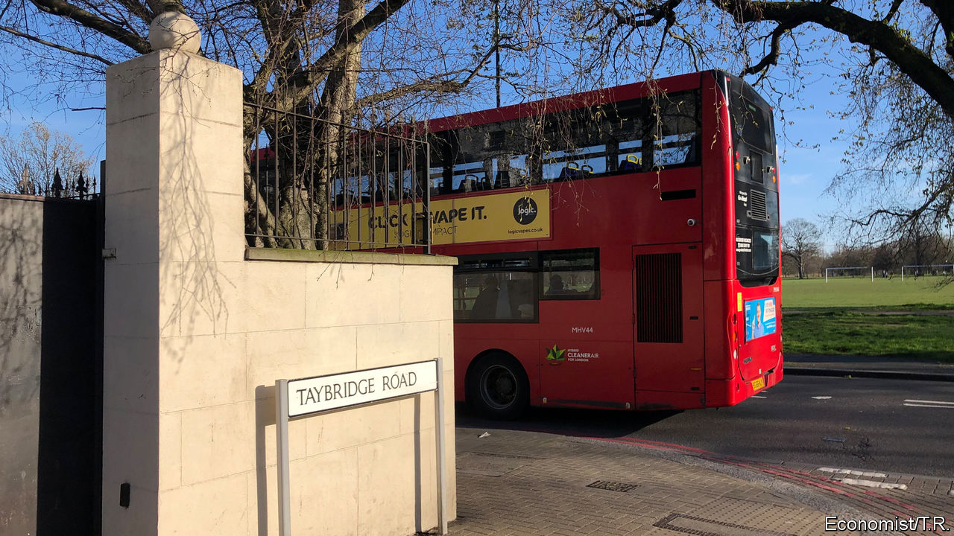

Editor’s note: The Economist is making some of its most important coverage of the covid-19 pandemic freely available to readers of The Economist Today, our daily newsletter. To receive it, register [here](https://www.economist.com/newslettersignup). For more coverage, see our coronavirus [hub](https://www.economist.com/coronavirus)

LEAN OUT of any of the sash windows on Taybridge Road in Clapham, and there’s always something to listen to. From the early hours, jet engines thrum through the sky, delivering passengers to Heathrow in time for work. Then there’s the rapid footsteps of commuters hurrying for the Tube and the laughter of children scooting to a private school round the corner. Tradesmen begin their hammering and drilling soon afterwards, converting lofts and digging out basements. On Friday nights the clunk of car doors reverberates, as Ubers ferry residents back from parties. The next morning abandoned chicken-shop boxes pay testament to the evening’s jollity.

That is, until this week. Now, like much of the capital, this meandering street of late-Victorian houses has fallen quiet. Planes are grounded, offices and schools are shut. Nobody is throwing parties. Yet behind its neatly-painted front doors, Taybridge Road is busier than ever. In ways big and small, every household is adjusting to life under lockdown.

The pandemic has already put some out of work. One is a freelance photographer, whose bookings have dried up; another is a location scout for feature films, who was given two weeks’ notice after only a day’s filming on her latest project. At the other end of the street, Noelle Woosley has been hit particularly hard. She and her partner run their own recording studio and perform at weddings as a cello-and-guitar duo. “All of our weddings this summer have been cancelled,” she says. “People who were going to be recording in the studio have pulled out.” Her sister, who shares their flat, has also lost her job as a waitress. Others are off sick, with suspected cases of covid-19. In one family, the parents and three children are all showing symptoms.

Many of those still in work are struggling to keep their children occupied and their bosses happy. Zoe Wingfield only started a new job, in human resources, three weeks ago after taking time out to raise her twin daughters, now two. Every day, the pair ask her and her partner, a sales director for a telecoms company, where they are going today, expecting jaunts to museums or perhaps a city farm. “They seem confused when we tell them nowhere,” she says. A few doors down, a French family with four children miss their Dutch au pair, who went home when borders began to close. The father hopes that a previous au pair, who moved to a job in a pub, might return. “She’s not very keen to self-isolate alone,” he says.

Nearly every household has cancelled something. One retiree has had to return 33 concert tickets and negotiate refunds on behalf of five friends for a trip to Germany. Nor will she go to York with her goddaughter to celebrate turning 70. Others have abandoned a house party in Scotland, a family trip to Disneyland in Paris and “granny’s annual Easter egg hunt”.

Every house is seeking new diversions. One couple says “romantic life is more important than ever.” At no 137, the four housemates prefer to settle down to watch the government’s press conference each evening. “It’s the closest we’ll get to wartime,” says one of them, Ed Jones. The three friends who share no 24 are enjoying eating together every evening, rather than waiting for a day when nobody is out. “Now every day’s a Sunday,” says one. Panic buying has made trips to the supermarket a thrilling game of potluck. The couple at no 122 yearn for broccoli. Another resident says she would “love to buy a chicken”, as if hankering after some exotic delicacy.

Once-neglected kitchens are in constant use. One family’s kettle has broken under the strain. Libraries are finally being read. Mr Jones intends to work his way through all the Star Wars and Batman films before turning to every movie made by Marvel, in chronological order: “I think we have time.” Others are finding solace in religion. One says it is a good opportunity to spend more time reading the Bible.

Many say the situation is strengthening their friendships, as people check up on each other. A resident of 44 years’ standing, who has only ever been “on nodding acquaintance” with neighbours, is now on a WhatsApp group, organising support for the elderly. One member of the group has volunteered to lead online workouts. Many are fantasising about the end of the crisis; some are hoping to throw a street party. But even being woken up by a plane would be a welcome glimmer of normality.■

Dig deeper:  
For our latest coverage of the covid-19 pandemic, register for The Economist Today, our daily [newsletter](https://www.economist.com/newslettersignup), or visit our [coronavirus hub](https://www.economist.com/coronavirus)

This article was downloaded by calibre from <https://www.economist.com/britain/2020/03/26/how-covid-19-is-playing-out-on-a-london-street>

|  |  |  |  |
| --- | --- | --- | --- |
| Previous | Articles | Sections | Next |

|  |  |  |  |
| --- | --- | --- | --- |
| Previous | Articles | Sections | Next |

#### Labour market

# The jobs retention scheme’s unintended consequences

Intervention in the jobs market helps workers but makes it harder for businesses to hire

Mar 26th 2020 |

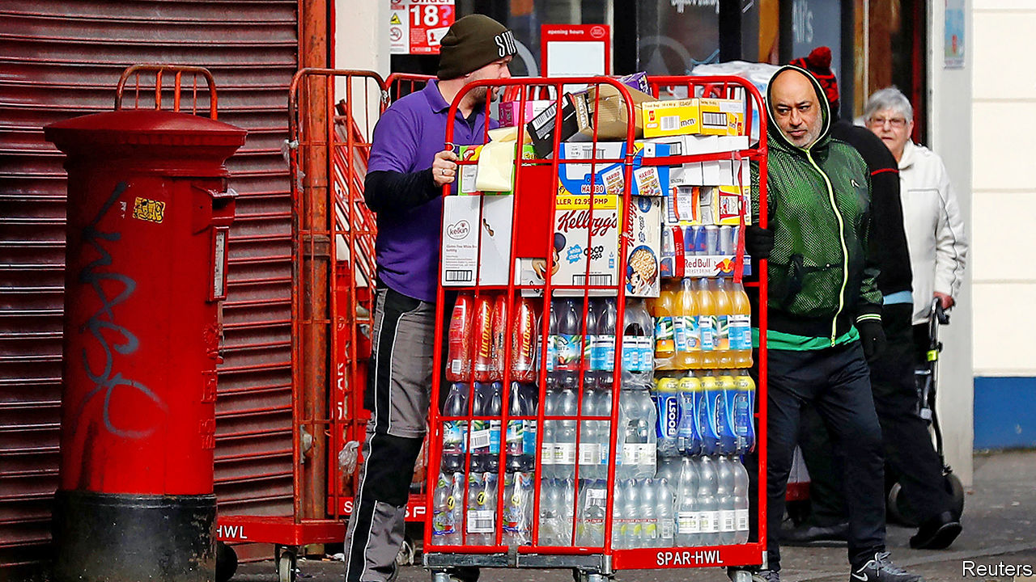

Editor’s note: The Economist is making some of its most important coverage of the covid-19 pandemic freely available to readers of The Economist Today, our daily newsletter. To receive it, register [here](https://www.economist.com/newslettersignup). For more coverage, see our coronavirus [hub](https://www.economist.com/coronavirus)

THERE ARE now stark contrasts on Britain’s high streets. Non-essential stores are closed by government fiat, but supermarkets and food stores continue to experience high demand. Slots for online grocery deliveries now attract the kind of digital queues associated with Glastonbury Festival tickets. The big supermarket chains are on a recruitment drive. Tesco, Britain’s largest, wants to hire 20,000 temporary workers while Morrison’s is looking for 3,500 more workers for its delivery business. Unlike toilet rolls, though, the jobs are not being snapped up quickly.

On March 20th Rishi Sunak, the chancellor, announced an unprecedented intervention in the labour market. Under the Coronavirus Jobs Retention Scheme, firms hit by a sharp fall in demand have the option to furlough their workers instead of sacking them. Those furloughed will receive 80% of their salary, up to a maximum of £2,500 ($2,900) with the bill being picked up by the Treasury. Employees on the scheme will not be allowed to work.

The scheme has been widely welcomed. Capital Economics, a consultancy, reckon that, thanks to the scheme and other measures, unemployment may stay at or under 6% (up from around 4% currently) rather than heading back to the 8% seen during the financial crisis of 2007-2009. But the furloughing scheme, drawn up in a hurry, still has kinks to work out. Under the present rules it is somewhat binary: a firm can either furlough a worker or not furlough them. An employee who, for example, sees their hours cut by half will not be eligible for support. Rather than an all-or-nothing deal, many firms would appreciate being able to cut staff hours, knowing that the government would cushion the blow to employee incomes.

The scheme is also causing issues in the jobs market. Some sectors are still trying to hire, according to Indeed, a recruitment website. Customer-service adverts are up by 3%; security and warehouse jobs are up by 2%. The obvious solution would be for non-essential stores to loan staff to areas in high demand. But that appears unlikely to happen. For many furloughed workers, staying at home on 80% of their previous salary with lower travel and child-care costs, not to mention less risk of infection, is a more attractive option than stacking shelves or loading deliveries.

Xiaowei Xu, an economist at the Institute for Fiscal Studies, a think-tank, argues that “alongside the imperative to protect jobs that will still be viable and productive once the crisis has passed, there is also an urgent need to reallocate some workers in sectors that have temporarily shut down to those facing labour shortages”. That may mean tweaking the retention scheme so that “it is available to furloughed workers who take up temporary work in priority sectors”. So far in this crisis, government policy has done a good job at supporting employment but unless resources are able to shift to where demand is still strong, bottlenecks and disruption will follow.■

Dig deeper:  
For our latest coverage of the covid-19 pandemic, register for The Economist Today, our daily [newsletter](https://www.economist.com/newslettersignup), or visit our [coronavirus hub](https://www.economist.com/coronavirus)

This article was downloaded by calibre from <https://www.economist.com/britain/2020/03/26/the-jobs-retention-schemes-unintended-consequences>

|  |  |  |  |
| --- | --- | --- | --- |
| Previous | Articles | Sections | Next |

|  |  |  |  |
| --- | --- | --- | --- |
| Previous | Articles | Sections | Next |

#### Scottish politics

# Not-guilty verdicts for Alex Salmond

The end of the former SNP leader’s trial is not the end of the story

Mar 26th 2020 |

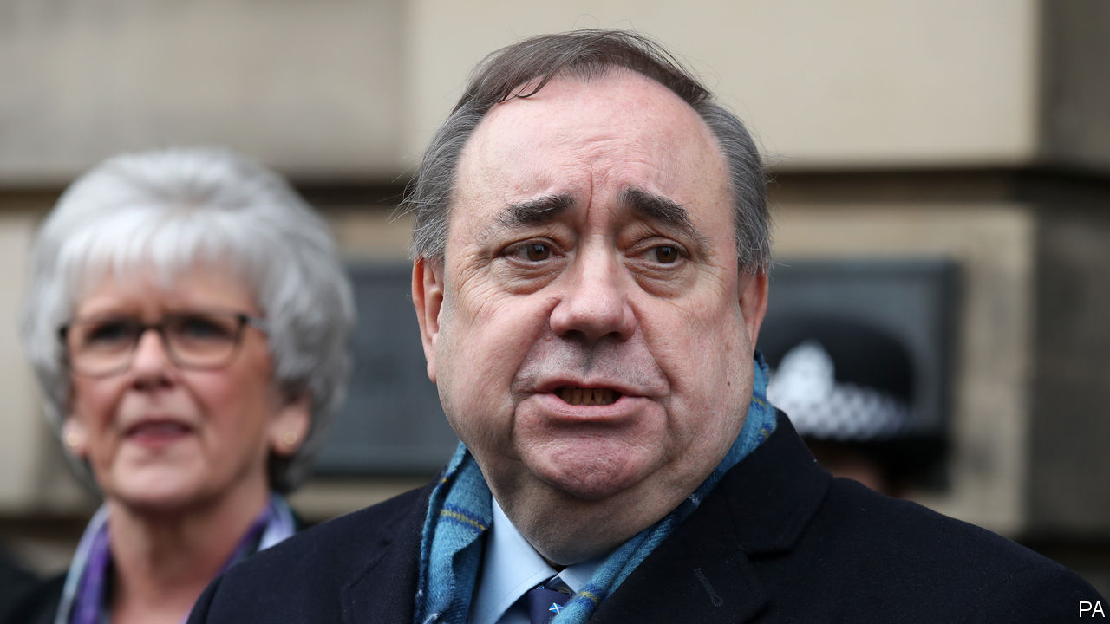

IN OTHER CIRCUMSTANCES, the verdict would have been the Scottish political event of the year. On March 23rd Alex Salmond, Scotland’s former first minister, was found not guilty of 12 charges of sexual assault. The jury found a thirteenth charge to be not proven.

Mr Salmond is a free man. But it is clear that he does not intend to go quietly. He greeted his acquittal with the claim that during the trial his legal team had been unable to produce “certain evidence” but it would now “see the light of day”. During the trial he claimed that the allegations against him—which ranged from indecent assault to attempted rape—had been “deliberate fabrications for political purposes”.

The verdict is an embarrassment for the Crown Office, Scotland’s criminal-prosecution service, and for the Scottish police. Nine women gave evidence and were extensively cross-examined. But the real pressure is on Nicola Sturgeon, Mr Salmond’s successor—both as first minister of Scotland and as leader of the Scottish National Party (SNP). Mr Salmond and his allies in the nationalist ranks are coming after her and her husband, SNP chief executive Peter Murrell.

Mr Salmond and Ms Sturgeon had been growing apart long before he faced criminal charges. Whereas she has approached the independence question cautiously, since 2016 he has called for the country to hold a new referendum quickly. His arrest and trial put a gulf between them. Several of his accusers were close to her and he seems to blame her for his ordeal.

Kenny MacAskill, an SNP Westminster MP and formerly Scotland’s justice minister, said that he was “delighted” for Mr Salmond and that now “some resignations” were “required”. Joanna Cherry, another SNP MP and a staunch Salmond ally who hopes to stand for election to the Scottish Parliament next year, said that she was sure the SNP’s chief executive would welcome an independent review into the Scottish government’s handling of the case. Ms Sturgeon and Mr Murrell may have detected a hint of menace in her remarks.

Compared with spread of covid-19, Mr Salmond’s claims of a conspiracy against him may seem trivial. But when the virus recedes, the former first minister and his supporters will be waiting for the current first minister and her husband. And they will have revenge in their hearts.■

This article was downloaded by calibre from <https://www.economist.com/britain/2020/03/26/not-guilty-verdicts-for-alex-salmond>

|  |  |  |  |
| --- | --- | --- | --- |
| Previous | Articles | Sections | Next |

|  |  |  |  |
| --- | --- | --- | --- |
| Previous | Articles | Sections | Next |

#### Bagehot

# Politics in the time of covid-19

Forget the flummery: politics is now a life or death business

Mar 26th 2020 |

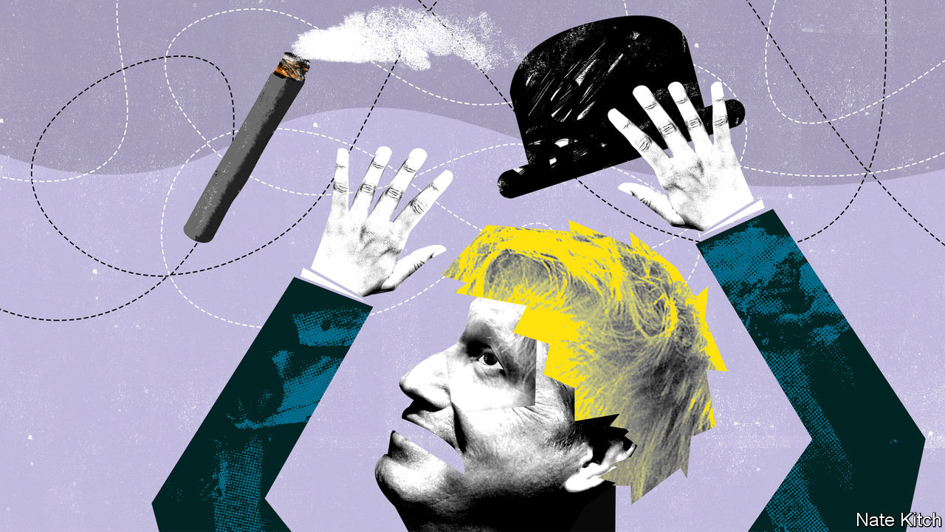

Editor’s note: The Economist is making some of its most important coverage of the covid-19 pandemic freely available to readers of The Economist Today, our daily newsletter. To receive it, register [here](https://www.economist.com/newslettersignup). For more coverage, see our coronavirus [hub](https://www.economist.com/coronavirus)

IN THE PAST few weeks politics has retreated to its core function: protecting the tribe from death and destruction. The government has adopted the slogan “Save lives” along with “Protect the NHS” and “Stay home”. The army is on standby. In the coming weeks thousands of people will die before their time; those who survive may confront a 1930s-style depression.

The atmosphere in the Westminster village reflects these grim facts. Boris Johnson gets through 20-hour days by munching vegan food, perhaps in the belief that plants are good for the immune system. Aides are sleeping on sofas and old camp beds. Having restricted the number of MPs allowed into the chamber so that they could sit two metres apart, the House of Commons has risen early and will remain closed for at least a month. The mother of parliaments is now a sepulchre.

Covid-19 is changing the way Britain governs itself in broader ways, too. Two kinds of politics that have dominated the country for the past decade have vanished. The first is the politics of revolution. Britain has been turned upside down by the successful campaign, driven by activists such as Dominic Cummings, the prime minister’s chief aide, to wrench Britain away from Europe. Since his election victory in December, Mr Johnson has set about implementing his grand ambitions to rewire the country for a post-Brexit future, shifting power from London to the provinces, pouring money into infrastructure and completing Brexit negotiations in double-quick time.

The second is politics as performance or spectacle. Politics has always been performance art to some degree: look at the weekly bear-pit that is prime minister’s questions or the humiliating rituals of general elections. But performance has triumphed over substance in recent years. Leading politicians have become celebrities. Mr Johnson built his political career by appearing on television and turning his first name and blond hair into a global brand. Politics has also been supercharged by the culture wars. Can people with penises reasonably be described as women? Should student groups be allowed to prevent luminaries from voicing controversial opinions at universities? These were the great issues that got people’s blood boiling only a few weeks ago.

The abrupt change of political direction has produced a bad case of whiplash, with Britain adjusting to these new circumstances more slowly than most continental countries, and old habits surviving, discordantly, into the new era. Politics suddenly requires a different sort of person—hence the disappearance of Mr Cummings and the appearance by Mr Johnson’s side of medical and scientific experts. And it requires a different style of presentation from the one that Mr Johnson was comfortable with, focusing on statesmanship rather than celebrity and reassurance rather than disruption.

Downing Street’s communications operation has been particularly slow to adjust: messages have sometimes been confused (Mr Johnson told people to stand two metres apart while obviously standing closer than that to his neighbour) and have been couched in high-falutin’ language about “herd immunity” and “social distancing”. Mr Johnson has also indulged in his natural exuberance by, for example, suggesting that the search for more ventilators should be christened “Operation Last Gasp”. But things are improving. Isaac Levido, the campaigner who won the election for Mr Johnson, has been brought in to impose more discipline in Downing Street “messaging”. The prime minister rose to the seriousness of the occasion in announcing a lockdown to the nation on March 23rd. His address was watched by 27m people.

If Mr Johnson is to come out of this well, he will need to make further changes. There is growing support for creating a national government—a veritable “covid-coalition”—modelled on Winston Churchill’s national government during the second world war, making Sir Keir Starmer deputy prime minister if he wins the Labour leadership as expected and drawing on talented MPs from across the political spectrum. The risk is that the prime minister would sacrifice the tools of party discipline and might find himself presiding over a cabinet of big egos and discordant voices. A national government may be a step too far, but there is a strong case for replacing Mr Johnson’s Brexit government with a One Nation Tory government.

The current cabinet is one of the weakest in post-war history precisely because its members were chosen for their enthusiasm for pushing through the Brexit project. Some of them—such as Dominic Raab, the foreign secretary, and Priti Patel, the home secretary—are far too divisive to command national respect. The fact that Mr Raab, an abrasive Brexit ultra, is currently Mr Johnson’s “designated survivor” should he fall victim to covid-19 is particularly worrying. Others—such as Gavin Williamson, the education secretary, and Liz Truss, the trade secretary—are over-promoted. Mr Johnson needs to draw on all the talents within his party: it is foolish that Jeremy Hunt, Britain’s longest-serving health secretary, doesn’t have a cabinet position. The prime minister also needs to choose a more acceptable figure to replace him if he becomes ill—perhaps the chancellor, Rishi Sunak, whose performance has been exemplary, but who may already have enough on his plate, or perhaps a newly promoted Mr Hunt, who, after all, came second in the Conservative Party leadership race.

Mr Johnson’s career has always been defined by his powerful sense of history (hence his obsession with Churchill) and his ruthlessness in achieving his goals (hence his willingness to break with friends and even family in order to achieve Brexit). He needs to realise that covid-19, not Brexit, will determine how he goes down in history. And he needs to apply the same ruthlessness to clearing out the Brexit cabinet that he applied to clearing out the government that he inherited from Theresa May. He should not try to fight today’s battles with yesterday’s weapons. ■

Dig deeper:  
For our latest coverage of the covid-19 pandemic, register for The Economist Today, our daily [newsletter](https://www.economist.com/newslettersignup), or visit our [coronavirus hub](https://www.economist.com/coronavirus)

This article was downloaded by calibre from <https://www.economist.com/britain/2020/03/26/politics-in-the-time-of-covid-19>

|  |  |  |  |
| --- | --- | --- | --- |
| Previous | Articles | Sections | Next |

|  |  |  |
| --- | --- | --- |
| Britain | Sections | Special report |

International

The pandemic: Stop, collaborate and listen

.

Hospital ventilators: Wind rush

.

|  |  |  |
| --- | --- | --- |
| Britain | Sections | Special report |

|  |  |  |  |
| --- | --- | --- | --- |
|  | Articles | Sections | Next |

#### Stop, collaborate and listen

# Crowdsourcing to fight covid-19

Many trials are under way to find the best treatment

Mar 26th 2020 |

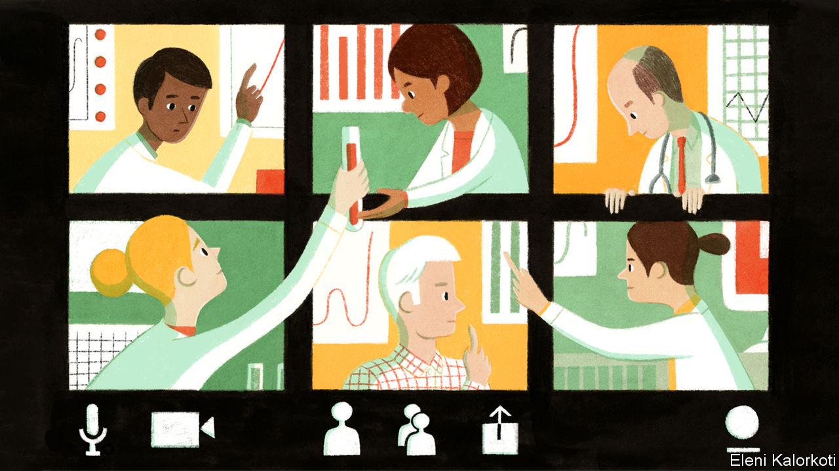

Editor’s note: The Economist is making some of its most important coverage of the covid-19 pandemic freely available to readers of The Economist Today, our daily newsletter. To receive it, register [here](https://www.economist.com/newslettersignup). For more coverage, see our coronavirus [hub](https://www.economist.com/coronavirus)

“WE ARE TRYING to fly the plane while we are building it.” That is how Richard Hunt from America’s department of health described caring for patients seriously ill with covid-19 in a training session on the subject on March 24th. The session was webcast to almost 2,000 people in 39 countries (most were in America). The questions sent in advance filled 25 pages, said Mr Hunt.

The thirst for clinical guidance is desperate. Three months after doctors in the Chinese city of Wuhan encountered the world’s first covid-19 patients, medics in more than 150 countries are treating growing numbers. British scientists reckon that 4.4% of those infected will need hospitalisation; about one in three of those requires treatment in an intensive-care unit (ICU). Doctors in ICUs treat severe pneumonia, the hallmark of a serious case of covid-19, all the time. But with this new disease they do not yet know which changes in a patient’s symptoms, blood tests or vital signs are critical ones. Some may point to improvements, while others suggest deterioration and the need for more intensive care, such as a ventilator.

Knowing when and for how long to put someone on a ventilator is not just crucial for that patient, says Mark Caridi-Scheible of the Emory Critical Care Centre in Atlanta, one of the instructors on the webinar; it is also important for the sake of the next patient who needs the machine. As hospitals around the world brace for more covid-19 patients than they have ventilators for, that question is at the top of their list.

While the disease spreads, the World Health Organisation (WHO) is crowdsourcing what hospitals are learning. It has asked doctors to submit anonymised covid-19 patient records to its global database, listing the drugs prescribed, procedures carried out and outcomes. But it has received fewer contributions than hoped, says Soumya Swaminathan, the WHO’s chief scientist. Talking to doctors directly seems to work better. Clinicians who treat covid-19 patients in 30 countries chime in at a twice-weekly virtual gathering run by the WHO. Their input, plus the clinical studies that are being published at a steady clip, are distilled into the WHO’s standards of care. Knowledge is evolving so quickly that these standards have been revised five times in less than two months.

Meanwhile, veterans from the earliest battles of the pandemic are taking their knowledge to others. On March 12th eight Chinese doctors, led by Liang Zongang, a professor of cardiopulmonary reanimation, arrived in Italy on a charter flight that brought medical equipment supplied by the Chinese Red Cross. They were followed on March 18th by around 300 Chinese intensive-care doctors.

Online learning about covid-19 is gathering speed, especially in developing countries. Around the world, clinicians already gather online to learn and share their experience on such topics as HIV/AIDS, tuberculosis, cancer and mental health. The ECHO Project, based at the University of New Mexico, has trained and supports hundreds of such groups in 39 countries, mostly in Africa and Asia. Many are now using their sessions to learn about covid-19. The experience at hospitals in China, Italy and Spain suggests that is prudent. As critical-care wards in the affected countries were inundated with coronavirus patients, they rapidly had to train doctors and nurses from unrelated specialisms in how to intubate patients and perform other procedures. Dr Caridi-Scheible, whose hospital is already treating more than a dozen covid-19 patients, warns the medics who are standing by for their first cases to “call in every friend and favour you are owed”.

To save the lives of gravely ill patients, doctors are trying many drugs. They are bombarded with suggestions from all kinds of sources online. But as soon as any particular medication is mentioned, everyone rushes to buy or use it, even preventively, despite the lack of evidence, says John Hick from the Hennepin County Medical Centre in Minneapolis. “Until we take the time to figure out what works, throwing the kitchen sink at every patient might actually harm them,” he adds. Steroids were used in the 2003 outbreak of SARS, a respiratory disease caused by another coronavirus, but studies since then suggest they may in fact have caused some harm.

Reliable answers can only come from proper clinical trials. Hundreds are under way. In early March Bruce Aylward, who led the WHO’s fact-finding mission to China in February, said 200 trials had been registered there. But with so many small trials, it was difficult to enroll enough patients. Small trials cannot distinguish a small effect from chance. Such a lack of data may explain why a trial of Kaletra, an HIV drug combination, in patients with severe covid-19 was not conclusive, says Ana Maria Henao Restrepo of the WHO. Trials from China may yet bear fruit. The earliest, in severely ill patients treated with remdesivir, a drug developed to treat Ebola, is due to finish collecting data on April 3rd.

What is really needed is a large, international trial that collects data about lots of drugs from many hospitals. The WHO hopes that a trial it announced on March 20th will do so. It will test four different possibilities: remdesivir, chloroquine, Kaletra, and Kaletra plus interferon beta, the drugs which currently seem to hold most promise. The hope is that medics, even those working under great pressure, will recruit patients. Patients are enrolled through the WHO’s website, which will randomly assign each of them to a trial drug (which will be limited to those that are available at the time).

The trial is “adaptive”, so it will change as results come in. Data will be monitored by an independent board. Ineffective treatments will be dropped and replaced by more promising ones. This will allow the best treatments to be compared swiftly.

After patients are enrolled in the trial, doctors need only record a few data points. When did each patient leave hospital or die? After how long? Did the patient need oxygen or ventilation?

There will be no placebo and doctors will know which treatment has been given to which patient. Those are not features of high-quality clinical trials in normal times. But the design is the best way to find out in the shortest time which of a number of drugs works best. The WHO has not said how long it expects the trial to take. Countries including Argentina, Bahrain, Canada, Iran, Norway, South Africa, Spain, Switzerland and Thailand have already said they will join. Some 3,200 European patients will participate under the co-ordination of a French biomedical research agency. Other international trials are being planned—for example, to determine whether the drugs being tested in patients work to prevent illness when taken by health-care workers. The pace of discovery is unprecedented. But the stakes could hardly be higher. ■

Dig deeper:  
For our latest coverage of the covid-19 pandemic, register for The Economist Today, our daily [newsletter](https://www.economist.com/newslettersignup), or visit our [coronavirus hub](https://www.economist.com/coronavirus)

This article was downloaded by calibre from <https://www.economist.com/international/2020/03/26/crowdsourcing-to-fight-covid-19>

|  |  |  |  |
| --- | --- | --- | --- |
|  | Articles | Sections | Next |

|  |  |  |  |
| --- | --- | --- | --- |
| Previous | Articles | Sections | Next |

#### Wind rush

# Scientists and industry are dashing to make more ventilators

New designs could be assembled by DIY enthusiasts

Mar 26th 2020 |

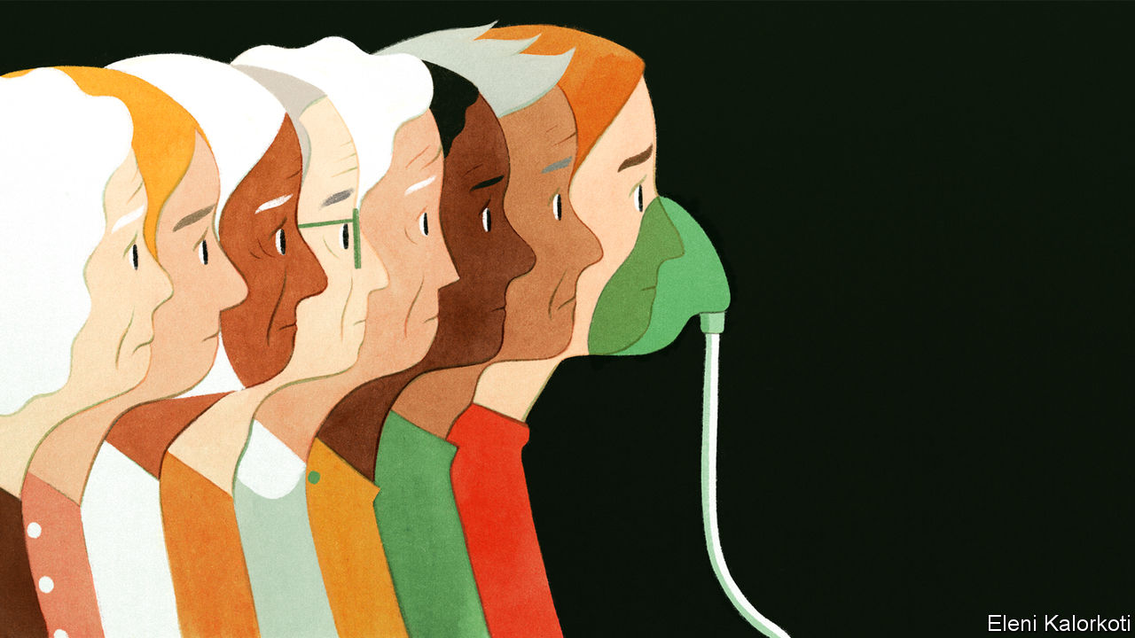

Editor’s note: The Economist is making some of its most important coverage of the covid-19 pandemic freely available to readers of The Economist Today, our daily newsletter. To receive it, register [here](https://www.economist.com/newslettersignup). For more coverage, see our coronavirus [hub](https://www.economist.com/coronavirus)

ONE OF THE most worrying symptoms of covid-19 is the way the coronavirus attacks the lungs of those infected. This means some patients need a ventilator to help them breathe until their lungs recover. But there is a dire shortage of these machines in hospitals, so intensive-care units will be overwhelmed. Urged on by worried governments, ventilator manufacturers are working flat out and forming partnerships with carmakers, aerospace firms and others to boost output as fast as possible.

But their efforts will still be not enough to meet soaring demand. So hope is riding on scores of new projects to develop breathing devices that could be made rapidly by non-specialist companies and small workshops. These are mostly simpler devices; some could even be assembled by DIY enthusiasts. The response to this call to arms is unprecedented.

Yet difficulties and dangers lie ahead. At present ventilation is about the only way doctors have to treat those who are seriously ill from the novel coronavirus, and the shortage of available machines is terrifying. In America the Society of Critical Care Medicine estimates that roughly 200,000 ventilators may be available, though many are older machines that have been in storage and may not be capable of supporting patients with severe respiratory failure. By some estimates, nearly 1m Americans may need mechanical ventilation at the peak of the country’s covid-19 epidemic. And the number of potentially critically ill patients who need ventilating could be much higher. At some point the people needing ventilators will probably far outnumber the machines available. Similar shortages exist in other countries, and in some parts of the world the number of ventilators in a hospital can be counted on one hand.

In their desperation some doctors are trying to connect more than one patient to a single ventilator, even though manufacturers do not recommend this because individual patients need different levels of breathing support.

Ventilators work by pumping air, mixed with additional oxygen as required by the patient, into the lungs. Carbon dioxide is expelled as the lungs contract. The air can be supplied to a patient via a mask. If more breathing support is needed, a tube is inserted down the patient’s trachea and into his or her airways, a process known as intubation. Alternatively, air can be delivered through a tube inserted through an incision in the windpipe.

Ventilators need to be carefully adjusted to suit each patient. This includes setting the number of breaths the machine delivers per minute and the “tidal volume” of air that flows back and forth as the patient breathes in and out.

Ventilators can do other things too, such as helping patients start to breathe on their own. The most sophisticated machines, which can cost up to $50,000, are packed with sensors and patient-care features. But even when used by highly trained staff, ventilators can cause serious complications, such as overinflation of the lungs, in some patients. In the hands of amateurs they could be lethal.

## Faster, faster

So what chance do science and industry have of dramatically ramping up production? The task is formidable. Some groups have little or no experience in the medical field and are trying to cram into a few weeks processes of design, testing, approval and manufacturing that usually take a couple of years.

Yet that does not mean it is impossible. It all depends on the options that are available, says Tim Minshall, head of the Institute for Manufacturing at the University of Cambridge. At one end of the spectrum, he says, existing ventilator producers can be helped to make more machines. In the middle are simpler designs for respirators that might be more easily manufactured and could be built by skilled companies that regulators trust. Then there are newcomers with prototypes but no direct experience in making medical equipment.

Behind all these efforts are companies, groups and well-intentioned individuals keen to make their open-source designs freely available to anyone prepared to start producing them. Hospitals and regulators will, naturally enough, be cautious, wanting to ensure that equipment is safe and reliable, adds Professor Minshall. It is not just the risk to patients and staff they are worried about, but also legal liability. A fast-track approval service, which some countries are planning, would help.

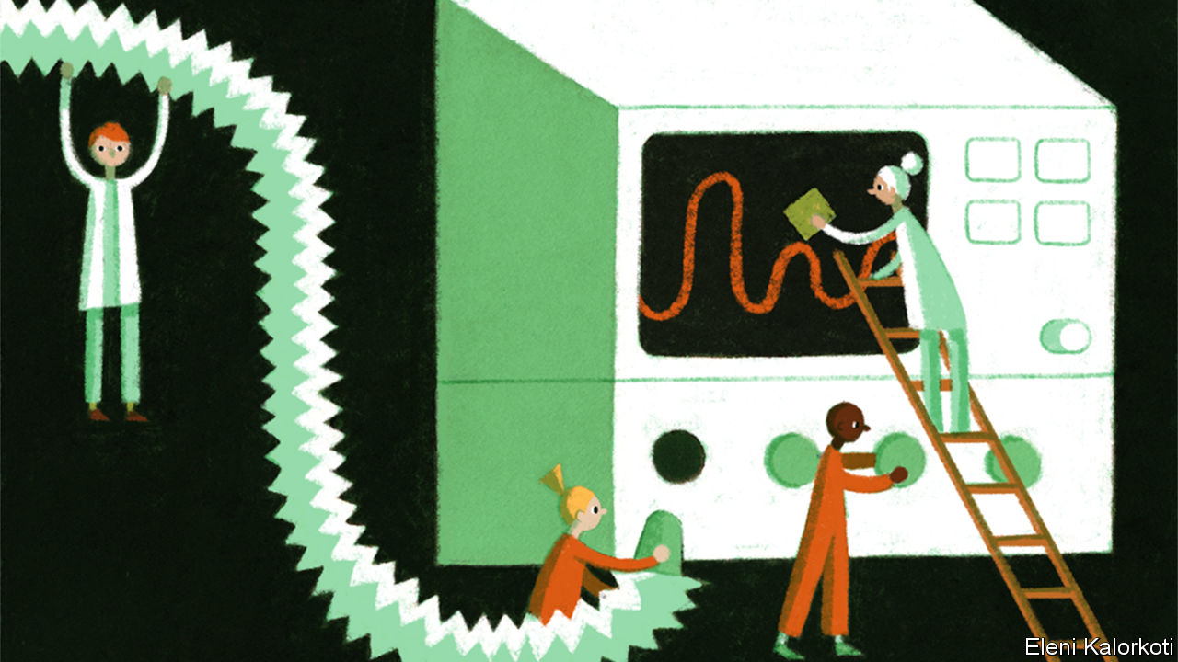

Existing producers are stretching themselves. Hamilton Medical, a Swiss firm that is one of the biggest manufacturers of ventilators, usually turns out 220 machines a week. After moving office workers onto the production line, it hopes to double that by the end of April. Siare Engineering in Italy produces 160 ventilators a month and aims to triple that with the help of army technicians. Medtronic, an American firm with its headquarters in Ireland, plans to more than double its 250 employees making ventilators at its Irish plant and move to round-the-clock production. In America Ventech Life Systems is collaborating with General Motors to scale up ventilator production, and Smiths Group, a British producer, is looking to see if other firms might be able to make its portable machines.

A number of industry groups have got together in response to a request by the British government for 5,000 new ventilators as soon as possible (the country’s National Health Service presently has access to some 8,000), and more later, bringing the total to 30,000. One group is led by Meggitt, an aerospace firm based in Britain that among other things also makes oxygen systems for aircraft. The Meggitt team includes Renishaw, a precision-engineering company that uses 3D printers to make components used in health-care products. Another group is led by McLaren, a supercar-maker that runs a Formula 1 team. Like others involved in motorsport, McLaren is expert at prototyping and manufacturing things rapidly.

Lots of academics are helping. Engineers and doctors from the University of Oxford and King’s College London hope to have prototypes of a simple ventilator that would cost less than £1,000 ($1,177) approved and working in trials at hospitals in London and Oxford in about two weeks. Like some others, the group is mechanising a device widely known as an Ambu (artificial manual breathing unit) bag. This consists of a mask connected to a rubber bag which, when squeezed by hand, pumps air into the lungs. The bag self-inflates when released. Oxygen can also be added to the pumped air through a port in the device. Ambu bags are often used by paramedics to resuscitate people and in emergencies on hospital wards.

The group’s machine, called the OxVent, places the Ambu bag in a sealed perspex box. Compressed air from a hospital airline is fed into the box to squeeze the bag and pump fresh air mixed with additional oxygen into the patient through standard tubing. This allows the device to be controlled by a simple box of electronics with all the essential adjustments needed for patient care, says Mark Thompson, a member of the Oxford team. The next step is to test for reliability and to find ways to manufacture the OxVent quickly. The group has already been in touch with companies eager to help. “It has been absolutely fantastic the support we’ve been offered,” adds Professor Thompson.

A group at University College London rallying ideas for making ventilators has also got a huge response from around the world, says Rebecca Shipley, a professor of health-care engineering. Using proven designs is probably the quickest way to get into production, she reckons. Catherine Holloway, a colleague who leads the Global Disability Innovation Hub, an organisation that promotes technologies to assist disabled people, thinks that “no frills” ventilator designs, already used in some poor countries, might be adopted to boost manufacturing capacity in richer regions.

At a very basic level, some designs could be built at home. Among them is an open-source ventilator developed by a collection of engineers in Barcelona. The oxyGEN machine, as it is called, uses a modified windscreen-wiper motor to squeeze an Ambu bag. Adjustments to the air volume can be made by fitting different-sized parts. But anyone trying to make one should take care. “It is a device designed to avoid life and death situations in emergency triages, not to replace other superior, professional and much safer devices,” the group cautions. Even so, as covid-19 continues to spread, and health-care systems are swamped, some doctors may be so desperate that they take the risk.■

Dig deeper:  
For our latest coverage of the covid-19 pandemic, register for The Economist Today, our daily [newsletter](https://www.economist.com/newslettersignup), or visit our [coronavirus hub](https://www.economist.com/coronavirus)

This article was downloaded by calibre from <https://www.economist.com/international/2020/03/26/scientists-and-industry-are-dashing-to-make-more-ventilators>

|  |  |  |  |
| --- | --- | --- | --- |
| Previous | Articles | Sections | Next |

|  |  |  |
| --- | --- | --- |
| International | Sections | Business |

Special report

Africa: The African century

.

Demography: Sex and education

.

Migration: Young, bright and on the move

.

Fighting the jihadists: The forever wars

.

Food and climate: Feeding another billion

.

Economy: Take-off speed

.

The future: Perchance to dream

.

|  |  |  |
| --- | --- | --- |
| International | Sections | Business |

|  |  |  |  |
| --- | --- | --- | --- |
|  | Articles | Sections | Next |

#### The African century

# Africa is changing so rapidly, it is becoming hard to ignore

Rapid economic and social change will give the continent a bigger role in world affairs, says Jonathan Rosenthal

Mar 26th 2020 |

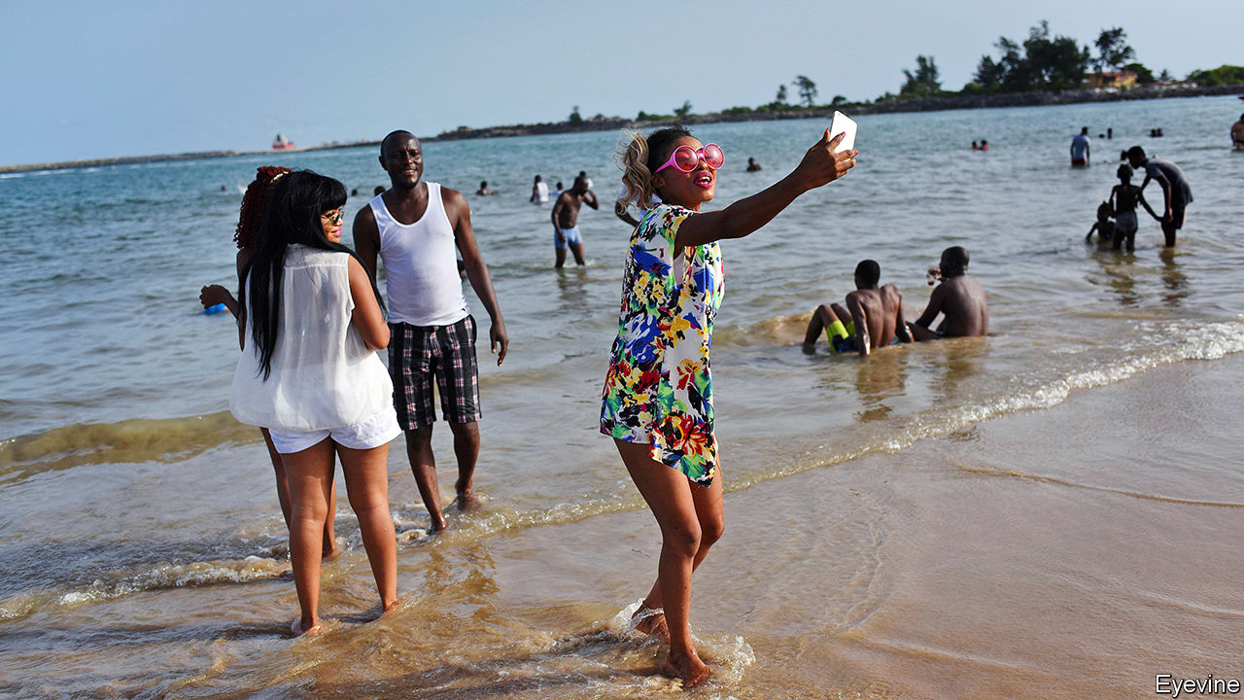

SOMETIMES BRIDGING the gap between success and failure, between finishing high school or dropping out, requires a lot of determination and the cost of a cow. Jack Oyugi grew up as the oldest of 14 children to parents tilling an acre of ground in western Kenya. Their crops usually gave them enough to eat—neighbours would feed them if food ran short—but they had little cash. When Mr Oyugi went to secondary school his father sold his only cow to pay the fees. “The neighbours laughed at him,” he says. Now he is having the last laugh. Mr Oyugi went on to university where he studied biotechnology, and then developed a process to make protein-rich animal feed from water hyacinth, an invasive plant on Lake Victoria. He provides jobs for 30 people. Orders for the feed, which is about 30% cheaper than soyabean protein, are coming from as far away as Thailand. As for his father, “I’ve built him a seven-room house and bought him some cows,” he says proudly.

Mr Oyugi is talented and hard-working. But his jump from village to university, from subsistence farming to founding a thriving business, is also one that encapsulates the change that is sweeping across the world’s youngest continent. Almost half of the 1.3bn Africans alive today were born after the terror attacks on America in 2001—the median age of 19 is less than half that of Europe (43).

In 1885, when the colonial powers carved up Africa, it had fewer than 100m people, or about one-third the number in Europe. Today there are almost two Africans for every European. Some outsiders see this rapidly growing population as a recipe for disaster. Although the poverty rate is falling, about a third of children are still malnourished. This leaves many of them with stunted bodies and diminished mental capacities. Every month about one million Africans enter the job market. Many of them do not have the education or skills they need. More than a third of African children do not finish secondary school. In Mozambique and Madagascar that rate jumps to more than half. Extremists find fertile ground in countries with large numbers of poor, unemployed young people.

Unlike other emerging powers such as China and Brazil, Africa is divided into 54 countries, all with their different problems. Two of its biggest economies, South Africa and Nigeria, are barely treading water. Many are riven by tribal divisions and suffer from poor infrastructure, corruption and the legacies of slavery, colonialism and authoritarian rule. Some are challenged by dangerous religious radicalisation that threatens to turn failing states into failed ones. Climate change will make these challenges tougher. In the short term, so will the spread of covid-19.

The continent has disappointed before. Thabo Mbeki, at his inauguration as president of South Africa in 1999, spoke of entering “the African century”. Even after the global financial crisis, rapid growth in Africa gave hope of sustained progress, albeit from a low base. But that was dampened again from mid-2014, when commodity prices fell and African GDP growth slowed considerably.

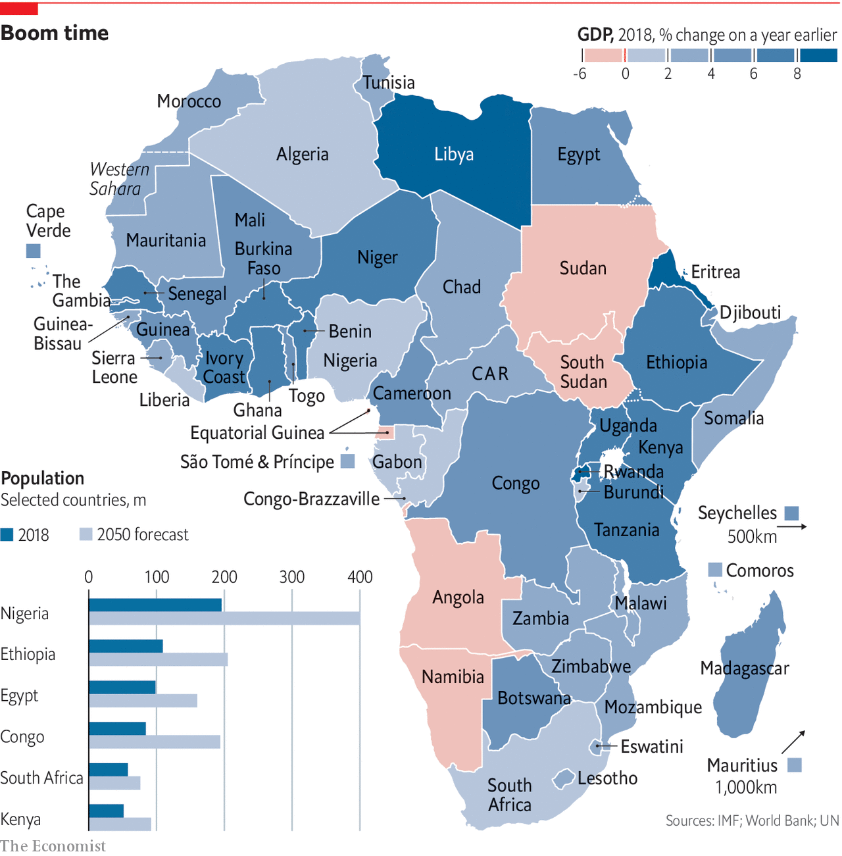

This special report will argue that, in spite of these setbacks and although many of the continent’s problems persist, social, economic and political improvements since the cold war are gathering pace. After centuries on the periphery, Africa is set to play a much more important role in global affairs, the global economy and the global imagination. Asia’s economic and population booms may continue to dominate the first part of this century, but Africa’s weight will grow in the second half.

Demography is a big part of it. Africa’s population will almost certainly double by 2050, giving it more than a quarter of the world’s total. That alone commands attention. But if accompanied by matching growth in GDP, economies such as Nigeria could overtake France or Germany in size (adjusted for purchasing power), according to PwC, an accounting firm. That may not be as far-fetched as it seems at first glance. The Centre for International Development at Harvard University forecasts that seven African countries will be among the 15 to grow fastest until 2027. This will be helped by improving education systems and the most ambitious effort in the world to lower trade barriers in a continent-wide free-trade area. It is not just the movement of goods that is spurring prosperity, but also of people. Migration is likely to enrich and democratise the continent with money, ideas and skills.

This report will argue that progress is not inevitable, nor will it be evenly spread. Much will depend on whether governments continue to become more accountable. Since 2008 there has been an erosion of some democratic gains won since the end of the cold war. Yet the overall optimism is rooted in Africans’ own views of the future. Whereas less than a quarter of German, Japanese and British people think that their living conditions will improve over the next 15 years, two-thirds of Kenyans, Nigerians and Senegalese think life will get better, according to polling by IPSOS. Africa’s new generation is not just full of hope, but is slowly gaining the tools to turn that hope into reality. ■

This article was downloaded by calibre from <https://www.economist.com/special-report/2020/03/26/africa-is-changing-so-rapidly-it-is-becoming-hard-to-ignore>

|  |  |  |  |
| --- | --- | --- | --- |
|  | Articles | Sections | Next |

|  |  |  |  |
| --- | --- | --- | --- |
| Previous | Articles | Sections | Next |

#### Demography

# Africa’s population will double by 2050

But the education of more African girls means it might peak sooner than most people expect

Mar 26th 2020 |

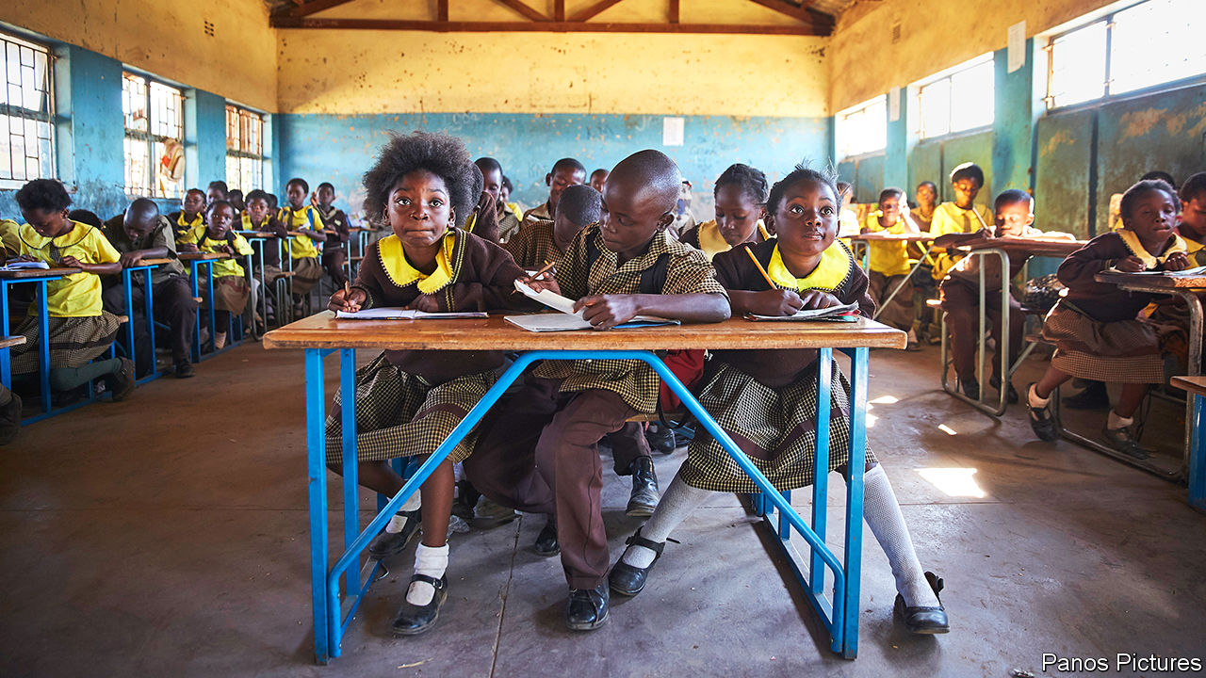

BY 2050, NIGERIA is forecast to have 400m people, meaning it will overtake the United States as the world’s third-most-populous country. The starkness of this fact (its population is currently about 200m) illustrates the degree to which demography will shape Africa’s future. Nigeria’s growth is part of an extraordinary population surge across the continent, but there is controversy about whether it will continue or can be reined in. The answer to that question has serious economic and political implications.

Sub-Saharan Africa’s population is growing at 2.7% a year, which is more than twice as fast as South Asia (1.2%) and Latin America (0.9%). That means Africa is adding the population of France (or Thailand) every two years. Although Asia’s population is four times bigger, almost two children are born each year in Africa for every three in Asia. Most experts agree that, if it continues at its current growth rate, like Nigeria, Africa’s population will double by 2050. That would be 2.5bn people, meaning more than a quarter of the world’s people would be in Africa. Few question those figures because much of the growth is already baked into what demographers term “population momentum”—that is, Africa has so many women of childbearing age that even if most decided to have fewer babies today, the population would keep expanding.

As a result, some doomsayers are dusting off the theories of Thomas Malthus, who argued in 1798 that a growing human population would starve because it would outstrip the supply of food. Among these is Malcolm Potts, a professor at the University of California, Berkeley, who argued in a paper in 2013 that “the Sahel could become the first part of planet Earth that suffers large-scale starvation and escalating conflict as a growing human population outruns diminishing natural resources.”

Yet demographic forecasts of coming decades diverge in a way that could be crucial. The UN expects Africa’s population to double again between 2050 and 2100, to 4.3bn people, or 39% of the world’s total and that fertility rates (the average number of children that women will have over their lives) will fall slowly. It reckons that the rate, which has dropped to about 4.4 from 6.7 in 1980, will take another 30 years to fall below three. But that underestimates the impact of a big jump in the number of girls who are now going to school across large parts of the continent, argues Wolfgang Lutz, a demographer at the International Institute for Applied Systems Analysis near Vienna. It also highlights the urgency of getting even more of them into school.

In the 1970s little more than half of children in sub-Saharan Africa were enrolled in primary school. That share has shot up to almost 100%. The statistic is slightly misleading, since the percentage of children regularly attending schools is lower, though improving. In Ethiopia, for instance, primary-school enrolment has risen to 100% from 65% in 2003, though attendance only stands at 61%. This matters because few things have a stronger influence over fertility rates than education. African women with no formal education have, on average, six or more children. This falls to about four for women who have finished primary school and to about two for those who have finished secondary school.

There is, however, a 20-year lag between changes in education and changes in fertility, so improvements in schooling since the early 2000s are only beginning to be seen (see chart). The change, when it comes, though, may be quick. In Iran women went from having seven children each to fewer than two between the early 1980s and 2006 after a big rise in female education.

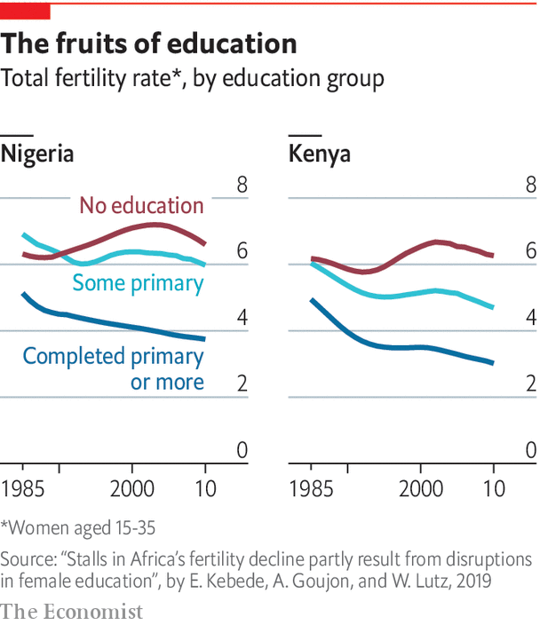

If African countries were rapidly to expand their provision of schooling for girls the continent’s total population might peak around 1.9bn in 2070 before falling to below 1.8bn by the end of the century, according to Mr Lutz.

There are many more reasons to invest in schools than simply to tame population growth. Educated youngsters are more likely to want democratic government, and to reject alternatives such as one-party rule than their uneducated peers. This growing demand for democracy among the young is evident across the continent, whether in the peaceful protests that toppled Omar al-Bashir, the long-standing dictator of Sudan, or that have pushed Ethiopia to abandon one-party rule. Marion Kirabo, a 23-year-old law student in Uganda, helped lead protests against a proposed increase in tuition fees at Makerere University in Kampala last year. The police fired tear gas then hauled them off to a prison cell. “We think we are a different brand,” she says. “We are informed, we are more liberal.”

Falling birth rates, when accompanied by rising literacy, can help kick-start growth, too. Economists reckon that up to a third of East Asia’s economic miracle can be attributed to its “demographic dividend”, or improvement in the ratio between the number of working-age people and that of children and pensioners. Lower fertility can also start a virtuous cycle in which families with fewer children can invest more in educating them and are also able to put aside more in savings. This can have wider economic impacts through lowering the cost of capital.

Morocco, which has one of the lower fertility rates in Africa at 2.4, also has one of the highest rates of saving. Because of this the government is able to borrow at interest rates of 2.25% a year. Nigeria has a fertility rate twice Morocco’s and its national savings as a share of GDP are half the level of Morocco’s.

Nigeria has to pay 13% when issuing local-currency bonds. “What marks China, Mauritius or Morocco apart from Kenya, DR Congo, Nigeria and Zambia, is the fertility rate,” says Charlie Robertson of Renaissance Capital, an investment bank. “The former have fewer children and high savings. The latter have many children, low savings, and high interest rates.”

But it is not enough to simply change the dependency ratio. Skills matter, too. A recent study by the African Development Bank found that the higher the literacy of countries, the more diverse their exports. Put together these various influences can be powerful. David Canning at Harvard University and others reckon that lowering the fertility rate by one child more than forecast in Nigeria would almost double the size of its expected increase in income per head by 2060.

The big problem is continuing to get children into schooling. In Ghana primary-school enrolment jumped from 66% to 89% between 1990 and 2016. But in Nigeria school enrolment has dropped by four percentage points to just 61% since 2003. The situation is even worse in the north-east of the country, where the jihadists of Boko Haram (whose name, in Hausa, means “Western education is forbidden”) have attacked schools and kidnapped schoolgirls. For many families that cannot rely on the state for education, one option is to send someone across the sea. ■

This article was downloaded by calibre from <https://www.economist.com/special-report/2020/03/26/africas-population-will-double-by-2050>

|  |  |  |  |
| --- | --- | --- | --- |
| Previous | Articles | Sections | Next |

|  |  |  |  |
| --- | --- | --- | --- |
| Previous | Articles | Sections | Next |

#### Migration

# Migration is helping Africa in many ways

It is good for development and democracy, as well as helping people improve their lives

Mar 26th 2020 |

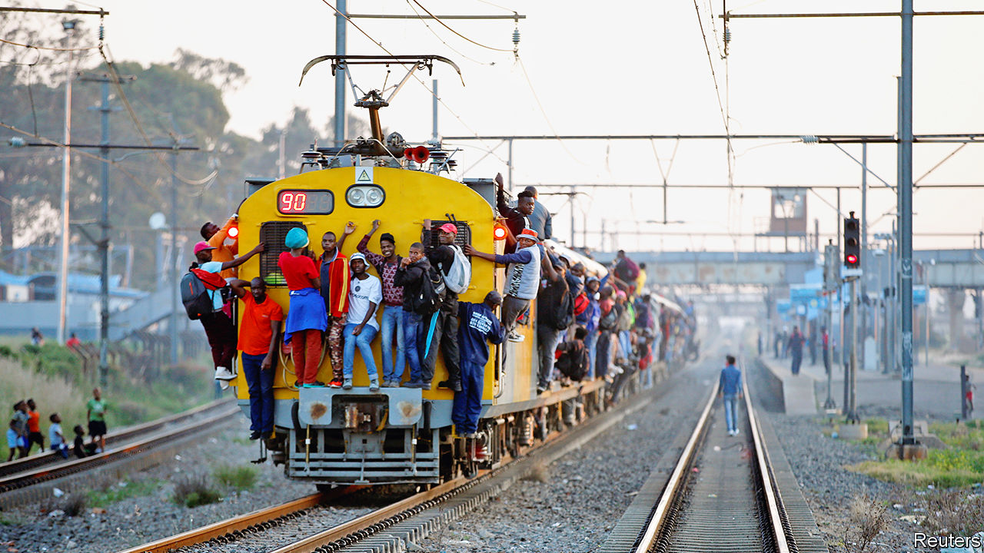

“WHAT’S NIGERIA’S second city?” asks Ngozi Okonjo-Iweala, an irrepressible economist and former finance minister of Nigeria, before chuckling: “London!” She is exaggerating (about 200,000 people who were born in Nigeria live in Britain) but she has a point: one of the most powerful trends shaping Africa, and the wider world, is migration. There are three different types: to the West, within Africa and from countryside to city. All are helping make the continent richer and better educated.

Although many talk about waves of African migrants crossing into Europe, the numbers are still modest. Just 2.5% of Africans, or about 36m people, live abroad, compared with a global average of about 3.4%. Of those, less than half leave the continent.

Even so, African migrants generate a disproportionate share of headlines in rich countries. This is partly because nearly half of those who died crossing the Mediterranean during the height of the “migrant crisis” of 2015 were sub-Saharan Africans. But it is also because populist politicians have stoked fear of migration in many countries. In South Africa, which is home to about 2.2m mostly African migrants, politicians accuse foreigners of taking jobs and committing crimes. This rabble-rousing has led to repeated bouts of anti-foreigner rioting. Matteo Salvini, a former deputy prime minister of Italy, banned rescue ships carrying migrants from Italian waters, and Donald Trump has severely restricted immigration from several African countries including Nigeria.

But it is also because of concerns that the numbers of African migrants will rise dramatically. In 2017 the Pew Research Centre asked people in several African countries whether they would move to another country if they could. About three-quarters in Ghana and Nigeria said they would. So did more than half of Kenyans and South Africans. The reason is simple. The average earnings of African migrants to Europe is $1,020 a month, three times the pay back home, says the UNDP. One reason more people do not move is the high cost charged by people smugglers—on average about $2,400 for men and $3,900 for women—up to 20 times median monthly earnings in the countries they leave. Over the decade to 2017 about 1m Africans migrated to Europe. As Africa grows richer more people will be able to move, and migration will probably increase, argues Sir Paul Collier, a development economist.

Even if Africa’s migration rates were simply to rise to the global average, its fast-growing population would mean tens of millions of people would be on the move. This would be no bad thing. Though more rich countries seem to be putting up barriers, without migration Europe’s population is forecast to fall by about 10% by 2050. It is also ageing: for every 100 people of working age, there would be 118 retirees and children by 2060. Germany alone would need 500,000 migrants a year to offset its demographic decline.

Stephen Smith, who wrote a book on migration, worries that it is draining Africa of its educated young. Yet that overlooks the many benefits of migration, including how it is helping increase skills and education within Africa.

The easiest benefits to measure are the remittances that migrants send home. Nigeria, for instance, got $24.3bn in 2018 from its citizens working abroad, a 24% increase over 2016 and about eight times more than it receives in development aid. That is also more than ten times what Nigeria got in foreign investment in 2018. Senegalese working in Spain send back as much as half of their earnings (helping remittances make up 9% of Senegal’s national income). Not only are such flows far larger than aid, they are also often better spent. A big chunk of aid budgets goes on administration and buying four-wheel-drive cars for aid workers, but most of what migrants send goes directly to recipients (though, scandalously, fees charged by money agents can gobble up to a fifth of the cash). It is also often invested in education, housing and businesses. In Ghana children in families who get help from a relative abroad are 54% more likely to attend secondary school. Lower fees on money transfers could boost private spending on education by about $1bn a year, reckons UNESCO.

Rather than draining the continent of skills, migration shows those at home the benefits of an education, encouraging more people to go to school. About 400,000 Africans study at universities abroad, making up about a tenth of all foreign students worldwide (about the same number as China sent to study abroad in 2005 and about half as many as India does today). In 1960 when the Democratic Republic of Congo gained its independence the whole country had fewer than 30 university graduates. Now it has about 12,000 students studying at foreign universities.

Migrants in democratic societies help promote democracy back home

This means that large numbers of bright youngsters are getting exposed to societies that are often more democratic, less corrupt and with more productive business environments than those they grew up in. Research supports the idea that migrants in democratic societies help promote democracy back home. One study of Senegalese living in America and France found that many were urging their family members to register to vote in elections. Another study, this time in Mali, found that returning migrants were more likely to vote. Their civic-mindedness seems infectious. Voter turnout rises even among non-migrants in neighbourhoods with returnees. The diaspora also provides a haven for the opposition. Oromo activists in America played a key role in the protests that have pushed Ethiopia in a more democratic direction.

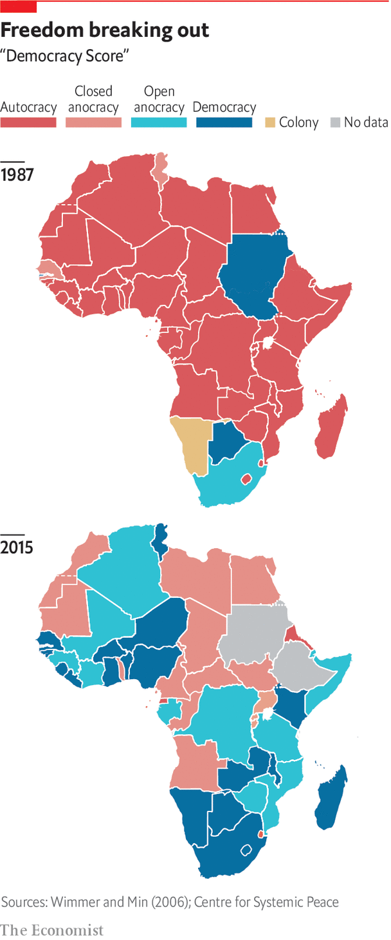

It is not just politics that is being transformed but also business. Some returnees are actual rocket scientists such as Kwami Williams, a Ghanaian-born American who studied aerospace engineering at MIT and was about to take a job at NASA before he changed course and set up a business in Ghana. Or Ikenna Nzewi, a Nigerian-American who studied computer science at Yale before teaming up with two pals from MIT and Duke to set up a business, Releaf, to collect and process palm-oil kernels from smallholder farmers in Nigeria. Rather than migration leading to a “brain drain” or “brain gain”, it is actually circular, with people moving, learning new skills and then moving again, says Stephen Gelb of the Overseas Development Institute (ODI), a London think-tank.

The second big wave of migration is people moving within Africa. More than half of African migrants stay on the continent, most of them travelling along well-established migratory routes such as one that links Burkina Faso and Ivory Coast. There, about 10% of the population are migrants yet they generate close to 20% of its GDP. Migration boosts productivity in many other places. A study by the OECD found that because foreigners working in South Africa brought skills that were missing from the labour market, they did not take jobs from locals. Instead they helped boost employment and wages of South African-born workers, bumping up income per person by as much as 5%.

Countries that send migrants elsewhere in Africa also see many benefits through trade and investment. Lots of people like to eat the food they grew up with, so many end up importing it after they have moved elsewhere, an effect big enough to stand out in trade statistics compiled by UNCTAD. This is also true when they move to the rich world. They are creating a cultural melting-pot of music and film, too. “African youth culture is going to have a fundamental influence on global youth culture,” argues Cobus Van Staden at Wits University. It is exportable because it is open and “deeply in conversation” across cultures, he says, citing as an example how musicians from different African countries collaborate.

The third great migration is the shifting of people from the countryside to cities. Africa’s population is still largely rural, with just 41% living in cities. But this is changing fast. The number of people living in African cities is growing by 3.6% a year, compared with 2.4% in China and India. This rapid growth, a result of both a still-high birth rate and migration, means that Africa’s cities have to accommodate about 20m extra people each year. The UN reckons that over the next decade, all ten of the world’s fastest-growing cities will be in Africa. These include Dar es Salaam in Tanzania, which will almost double to about 11m people.

Many of the benefits of the other two sorts of migration are also seen when people move to cities. In Ghana three-quarters of people who moved from villages to slums sent money to their families back home. Almost nine-tenths thought their lives were better.

Africa is not only urbanising much more quickly than any other continent, it is also doing so at a much lower level of wealth than Asia or South America did. In other parts of the world the movement of people to the cities has generally meant a move into more productive jobs. But in Africa young people often end up hawking vegetables or trinkets on the side of the road. This is because many of the continent’s cities are so sprawling, with narrow jammed roads and poor infrastructure, that people cannot easily get to jobs. Nairobi, for instance, has one of the longest average commuting times anywhere because 41% of people walk to work.

It also costs a lot to transport food to cities, which pushes up prices and in turn forces up wages in factories, making it hard for them to compete on global markets. In short, many have become “consumption cities” with urban economies dominated by low-value services and goods that are consumed locally, rather than tradable goods or services. Better urban planning with denser housing instead of sprawling slums, with wider roads and public transport, would all go a long way to making cities more productive. So would reliable electricity: a study by the Centre for Global Development in Washington, DC, found that one of the biggest obstacles faced by Nigeria’s technology startups was frequent power cuts. “You can’t code in the dark,” says the founder of one firm.

But some of the solutions to urban problems can also be found in the countryside. A good place to start is by helping farmers become more productive. That could reduce food costs in the cities, making them more competitive for manufacturing. Higher incomes in villages could expand markets for goods made in the cities. Sometimes the path to industrialisation starts on the farm.■

This article was downloaded by calibre from <https://www.economist.com/special-report/2020/03/26/migration-is-helping-africa-in-many-ways>

|  |  |  |  |
| --- | --- | --- | --- |
| Previous | Articles | Sections | Next |

|  |  |  |  |
| --- | --- | --- | --- |
| Previous | Articles | Sections | Next |

#### The forever wars

# Parts of Africa will remain unstable for decades

The lack of education and jobs is a major cause

Mar 26th 2020 |

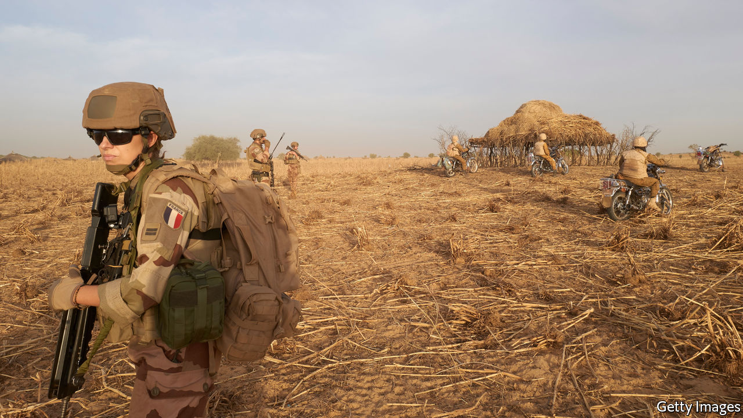

ON THE EDGE of a shallow ravine in the far western corner of Burkina Faso two vehicles bristling with machine guns come to a stop. Several bearded white men lean out, keeping watch for jihadists. Nearby, other Western soldiers are helping their African counterparts stage a mock attack on an insurgent base.

These are some of the special forces from a number of Western countries who have been fighting jihadists in the Sahel for years. Many Western army and intelligence officials see extremists in the region posing a greater danger than the remnants of Islamic State in Syria and Iraq. America has sent about 6,000 troops to Africa, France 5,100 and Germany 1,100. There are almost as many Western troops in Africa as those fighting the Taliban and Islamic State.

Yet most foreign leaders are keeping quiet about it, worried that they will get little public support at home. President Donald Trump has reduced America’s troops in Africa by about 10%, against the wishes of his generals, and is considering a much deeper cut.

That is worrying because the jihadists are getting the upper hand. Last year more than 10,000 people lost their lives in violence related to Islamist groups in Africa. Mali, whose capital almost fell to jihadists in 2012 before French forces stepped in, is at the centre of the turmoil. Much of the countryside in its vast north has fallen, despite a UN peacekeeping force that is 15,000 strong. Now the extremists are spilling out into neighbouring countries. Burkina Faso, which was stable a few years ago, has lost control of the triangle of territory in its north, which borders Niger and Mali.

Western security officials had hoped it could act as a bulwark to stop the insurgents crossing over and destabilising coastal states such as Ghana and Benin. Now they are drawing new lines of defence. François Lecointre, chief of staff of the French armed forces, has said his troops will be in the Sahel “for the next 30 years”. Brigadier-General Dagvin Anderson, who commands American special forces in Africa expects “a generational, multinational effort”.

Stopping the jihadists will require not just troops, but also schools, economic development and accountable governments. Countries in the Sahel are not helped by climate and topography. Their people are poorer, less educated and have stubbornly high fertility rates. Just as countries such as Kenya and Ethiopia are slowing their population growth, women in countries such as Niger continue to have more than seven children each. The region’s rapidly deteriorating security is a warning to the continent as a whole of what may happen if its growing numbers of young people are not educated or are unable to find jobs at home or abroad.

The Islamist jihad has caused more than 1,000 schools to close across west Africa, leaving almost 2m children out of school. In one village of 6,000 people outside the city of Maiduguri in north-eastern Nigeria, near the border with Niger, the only education that the village’s 2,000 children get is learning to recite the Koran. There is not a book in sight, just the rhythmic chanting of children rising into the afternoon heat.

This article was downloaded by calibre from <https://www.economist.com/special-report/2020/03/26/parts-of-africa-will-remain-unstable-for-decades>

|  |  |  |  |
| --- | --- | --- | --- |
| Previous | Articles | Sections | Next |

|  |  |  |  |
| --- | --- | --- | --- |
| Previous | Articles | Sections | Next |

#### Food and climate

# African countries must get smarter with their agriculture

Climate change and continued rural poverty present big challenges

Mar 26th 2020 |

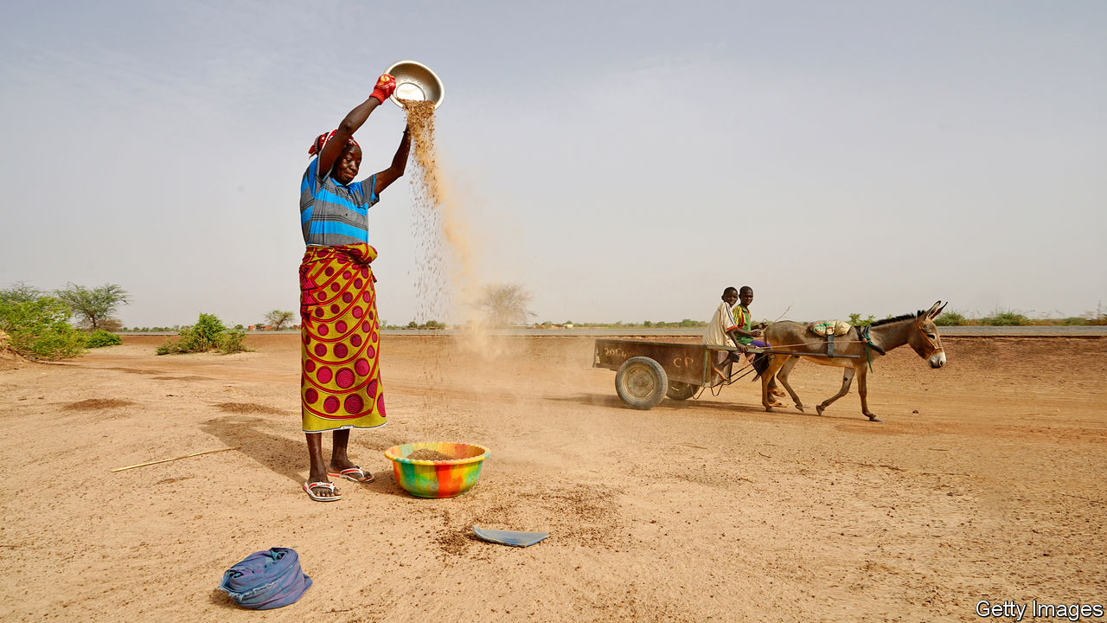

ON THE HILLS of central Kenya, almost lime-green with the shimmer of tea bushes in the sunlight, farmers know all about climate change. “The rainy season is not predictable,” says one. “When it is supposed to rain it doesn’t, then it all comes at once.” Climate change is an issue that will affect everyone on the planet. For Africans its consequences will be particularly bitter: whereas other regions were able to grow rich by burning coal and oil, Africa will pay much of the human price without having enjoyed the benefits. “Africa only represents 2% of global greenhouse-gas emissions but it is the continent that is expected to suffer the most from climate impacts,” says Mafalda Duarte, who runs the $8bn Climate Investment Funds, established by the World Bank.

Although there are huge uncertainties as to the precise impacts of climate change, with large error bars around temperature forecasts, enough is known to say that global warming represents one of the main threats to Africa’s prosperity. Parts of the continent are already warming much more quickly than the average: temperatures in southern Africa have increased by about twice the global rate over the past 50 years. Even if the world were to cut emissions enough to keep global warming below 1.5°C, heatwaves would intensify in Africa and diseases such as malaria would spread to areas that are not currently affected. Farming would also be hit hard. About 40% of the land now used to grow maize would no longer be suitable for it. Overall, it is estimated that maize yields would fall by 18-22%.

Africa is particularly vulnerable, in part because it is already struggling to feed itself and it will have to vastly increase yields and productivity if it is to put food on the plates of a fast-growing population, even without climate change. The UN’s Food and Agriculture Organisation reckons that by 2050 global food production would have to rise by about 70% over its level of 2009 to meet demand from a population that is growing in numbers and appetite. Much of this new demand will be in Africa. Yet the continent already imports about $50bn-worth of food a year and that figure is expected to more than double over the next five years. Self-sufficiency is not Africa’s goal, but the fact that it spends more money importing food than it does buying capital goods suggests it has room for improvement.

Finding out why is not hard. Most farms are tiny, tilled by hand and reliant on rain. More than half of Africa’s people make their living from farming. Although its total harvest has climbed over the past few decades, this is mainly because there are more people farming more land. But in many places there is no spare land to farm. Plots in Rwanda are so small (less than two acres) that you could fit 250 of them onto the average American farm. And although output per worker has improved by little more than half over the past 30 years in Africa, that is still far behind the 2.5 times improvement in Asia. Yields of maize, a staple, are generally less than two tonnes per hectare, a fifth the level in America.

The low productivity of African farmers is reflected both in national economic statistics—despite absorbing so much labour farming generates just 15% of GDP—as well as in their poverty, which is generally concentrated in rural areas. “They can’t even feed their families,” says Jennifer Blanke, a vice-president of the African Development Bank in charge of agriculture. “[Farm] productivity hasn’t improved in many parts of Africa for 100 years.”

One reason is that in the first few decades of independence many African governments neglected farming as they focused on industrialising their economies. Others damaged it by pushing down the prices that state monopolies paid for their crops in order to subsidise workers in cities with cheap food. Ghana taxed cocoa exports so heavily that production collapsed by half between the 1960s and 1980s, despite a jump in the price of cocoa. Yet over the past two decades or so governments and donors have begun to look afresh at farming as a way of providing jobs for the 13m young people entering the workforce each year. Much of the focus has been on getting smallholder farmers to use fertiliser and, more important, better seeds. The results can be impressive. Improved varieties of sorghum, for instance, can produce a crop that is 40% larger than the usual variety. Infrastructure is important. A World Bank irrigation project in Ethiopia helped farmers increase their potato harvest from about 8 tonnes per hectare to 35 tonnes.

Better techniques help, too. Smallholder coffee farmers in Kenya are able to increase their incomes by 40% by following a few simple guidelines on caring for their bushes, such as trimming all but three of their stems. Many of their neighbours do not follow the advice, because it seems counter-intuitive. More stems ought to lead to more coffee beans, they say. Yet after seeing those following the advice get bigger harvests for a season or two, many others start doing the same.

One way of spreading knowledge is to link farms to big buyers of their harvests. When Diageo, a British drinks giant, built a brewery in Kisumu in western Kenya, it wanted to use local crops to make a beer cheap enough to compete with illicit home-brew. It organised farmers into groups, improved supply chains for them to get seeds and fertiliser and then agreed to buy their grain. It now provides a market to about 17,000 farmers. Across the region it has doubled its use of local raw material to about 80% over five years, says John O’Keeffe, who runs its Africa business.

Other industries are also benefiting from technology and capital. Jane Toko, a mother of eight, earned a living for most of her adult life catching fish in Lake Victoria, the world’s third-largest lake. “Long ago the number of fish was high,” she says. “Now they are few.” Dotted along the shore are hundreds of small hamlets, whose residents have fished the lake for generations. This rich source of protein helped the population in the area expand from about 10m in 1960 to more than 40m now, contributing to overfishing. Global warming is also having an impact by reducing the amount of oxygen dissolved in parts of the lake, cutting by 40% the habitat available for fish. Data are sparse but some surveys suggest that the total amount of perch in the lake fell by almost half between 1999 and 2011. Locals say the catch of tilapia, a native freshwater fish that is particularly delicious grilled, has fallen 80%. “There are so many people fishing on the lake, but what comes out is small,” grumbles Maurice Muma, a fish trader.

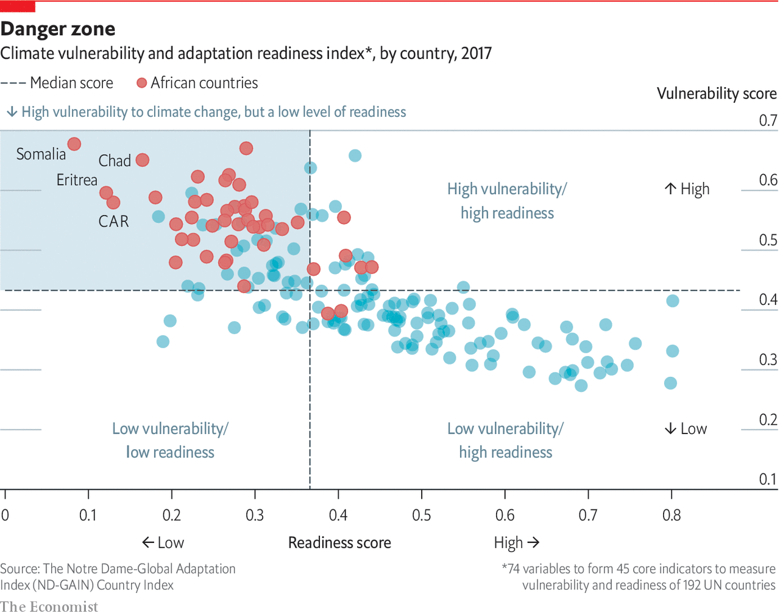

The shrinking fishery has contributed not just to poverty, but also a higher rate of HIV infections by giving fishermen the bargaining power to demand that female traders have sex with them in order to buy their fish. Yet a few kilometres away is part of the solution to the declining catch. Victory Farms, which was founded by two Americans in 2015, has become sub-Saharan Africa’s fastest-growing fish farm. Ponds hold a teeming mass of pregnant fish. Two employees, waist deep in water, sort them and squeeze out the eggs which are hatched in bubbling indoor tanks. Out on the lake floating cages house thousands of growing tilapia. The farm is on track to produce about 10,000 tonnes of fish this year, which is enough to feed about 1m people at Africa’s current rate of fish consumption. The firm hopes to expand to about 60,000 tonnes over the next six years, a figure that would equal more than half of the wild catch in the Kenyan side of the lake. Others are following the example. A recent study by two Kenyan academics found about 4,000 cages in Kenyan waters.

An even more important change is the move from traditional farming to building businesses that can profitably bring technology and investment to smallholder farmers. Taita Ngetich, a young Kenyan, was studying engineering when he wanted to earn a little money on the side. He scraped together 20,000 Kenyan shillings (about $200) to plant tomatoes. Everything went wrong. The crop was attacked by pests. “Then there was a massive flood that swallowed all our capital,” he says. Mr Ngetich persevered by looking into buying a greenhouse to protect his plants from bugs and rain. The cheapest ones cost more than $2,500 each. So he designed his own for half the price. Soon neighbouring farmers started placing orders. His firm, Illuminum Greenhouses, has sold more than 1,400 greenhouses that provide livelihoods to about 6,000 people. The business does not stop there. He also supplies fertiliser, high-quality seedlings and smart sensors that increase yields.

Illuminum’s success shows how technology can help even small farms be more productive. Because such a large share of Africa’s population earns a living from agriculture, even small improvements in productivity can lift the incomes of millions of people. But over the longer run smallholder farming can go only so far, especially in the face of climate change and population pressure.

“If we really want to lift people out of poverty we have to finance projects that will get them an income of at least $100 a month so that they can pay for health care and education,” says Mr Ngetich. “Projects that give them an extra $2 a month from growing beans or maize aren’t going to get them there.” Getting those big jumps will need better jobs in factories and cities. ■

This article was downloaded by calibre from <https://www.economist.com/special-report/2020/03/26/african-countries-must-get-smarter-with-their-agriculture>

|  |  |  |  |
| --- | --- | --- | --- |
| Previous | Articles | Sections | Next |

|  |  |  |  |
| --- | --- | --- | --- |
| Previous | Articles | Sections | Next |

#### Economy

# Many of Africa’s economies are doing well

But there are questions about the best road to long-term growth

Mar 26th 2020 |

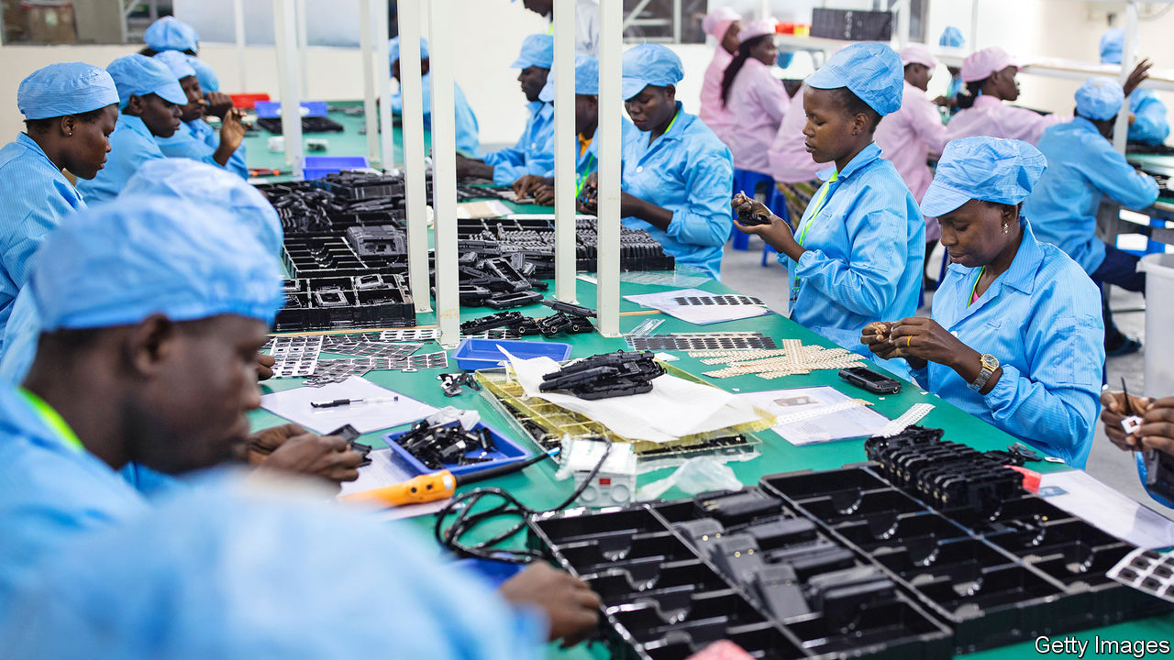

PASSING THROUGH the gate leading into the Hawassa industrial park feels a bit like crossing a boundary between Africa’s past and a vision of its future. On one side three-wheeled tuk-tuks beep their horns as they swerve around pot holes on the main road running through this southern Ethiopian town. On the other side smooth asphalt forms geometric grids around the rows of new factory buildings that represent one of Africa’s boldest attempts to industrialise by following in the footsteps of Asia.

The park opened three years ago, yet it already employs almost 30,000 people and has plans to double. Most of the young women working in it make clothing for companies such as PVH, which owns brands including Tommy Hilfiger and Calvin Klein. Selamawit Malkato, 20, had never seen a factory until she came to Hawassa. But last year she stood with scores of other hopefuls outside the park’s gates. Her sister already had a job inside, stitching shirts. The days are long; the pay low; the bosses strict. Still, Ms Selamawit travelled 60km from her home village looking for work in firms attracted by a supportive government and duty-free access to American markets. “Being a large player in the apparel industry we need to give it a go,” says Vinod Hirdaramani, a Sri Lankan businessman who has opened a garment factory in the park. “It’s one of the last frontiers of apparel making.”

For all the rapid growth in Hawassa and the many other industrial parks that Ethiopia is building, a cloud hangs over its industrialisation strategy. Turnover of employees is high, productivity has been lower than expected and exports are growing more slowly than hoped. To be sure, some of this may just be the high costs of establishing new industries far away from their markets and suppliers and without a ready pool of experienced workers. And the gap between transport costs in Africa and established manufacturing centres is narrowing, argues Dirk Willem te Velde of the ODI, a think-tank in London.

Some of the gloom is over a more fundamental question: will export-led manufacturing play a big role in Africa’s economic growth or has the continent missed its chance because automation will give many manual jobs to machines? The question is important because governments have to decide where to invest scarce resources—in ports and railways to foster manufacturing, for instance, or fast internet cables and film schools.

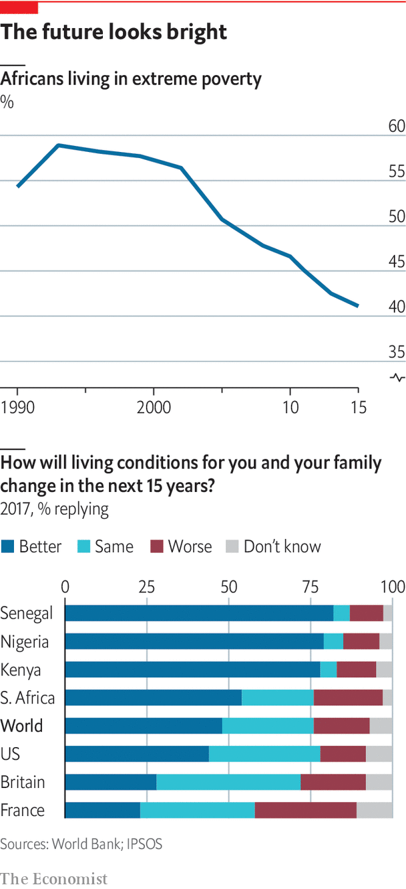

Most successful economies eventually move away from manufacturing towards services. Dani Rodrik, an economist at Harvard, argues that Africa’s are at risk of doing so without first having gone through a phase of industrialisation. The risk is that this “premature de-industrialisation” could leave many African countries unable to produce the good jobs and economic growth needed to catch up with the rich world. Yet such a gloomy outlook seems to be at odds with what is happening on the ground. Although manufacturing’s share of GDP is shrinking in much of the rich world, it has increased in Africa from a low of 9.4% in 2011 to 11% in 2018. Though there are questions about the reliability of those manufacturing data, it is clear that exports are rising sharply. The value of textiles and clothing leaving Ethiopia has jumped about ten times since the early 2000s, and about five times in Kenya and Uganda.

The outlook for Africa’s economies is more nuanced than simply a question of them doing more manufacturing or staying poor. Many countries are expanding into areas that economists are starting to call “industries without smokestacks”. Some, such as flower-exports, may not be classified as manufactured goods in export statistics. But the process of making them looks a lot like factory work and demands many of the same management skills. John Page at the Brookings Institution, a think-tank, argues these industries also deliver many of the benefits of normal manufacturing, including lots of jobs. Kenya’s flower industry employs up to 70,000 people. Horticulture in Ethiopia provides 180,000 jobs. They are also growing quickly. Kenya’s exports of cut flowers to Europe are worth almost $700m a year, up from $134m in 2000.

“Africa has a massive opportunity as a low-cost provider of services”

Moreover, many are starting to export more services, such as running call centres. South Africa, the continent’s most developed industrial economy, sold services worth more than $16bn to the world in 2017, against $10bn worth of car exports that year. Some 40,000 people are employed in South Africa doing back-office work, mostly for foreign companies. Its industry has been growing by more than 20% a year, because it has millions of educated English-speakers and a time zone that makes it easy to work for Europe, Asia and America. Although operating costs are about 50% higher than in India or the Philippines, South Africa is able to provide lawyers or chartered financial analysts who do complex work remotely for law firms or banks, reckons Everest, a consulting firm. “Africa has a massive opportunity as a low-cost provider of services,” says Yasmin Kumi of Africa Foresight Group. Creative industries such as music and film are booming, too, with African musicians filling stadiums in the rich world.

The choice for governments over which path to back is not as stark as it might seem. Faster internet connections are good for the whole of the economy, not just firms employing people doing digital jobs. A study by Jonas Hjort and Jonas Poulsen found big jumps in employment after countries were connected to undersea internet cables. Many of the things that governments should be doing anyway, such as investing in primary-school education or liberalising electricity markets, are good for growth of both sorts, says Stefan Dercon, an economist at Oxford University.

Whichever path Africa ends up taking, its progress will be shaped by two powerful forces: a fast-growing middle class with rising spending power; and the growing integration of Africa’s markets. Start with the middle class. There is plenty of disagreement about how big this group is. The African Development Bank decided that about one-third of Africans were middle-class since they could spend the equivalent of $2-20 a day. Pew used a higher definition ($10-20) in 2015 and decided just 6% of Africans were middle class. Fraym, a data firm, looked at what people own (such as fridges) and how educated they are and concluded that Africa has a “consumer class” of 330m people spending $1.6trn a year.

Whatever the exact number, there is little doubt that it is growing quickly, pulled upward in a group of countries that are growing steadily richer. To see them one needs to first strip out oil producers such as Nigeria and Angola, which have been hit by lower prices. Then one needs to look past South Africa, where growth has been slammed by a decade of on-off power cuts caused by rampant corruption in the state-owned electricity utility. Admittedly this excludes some big countries, but those that are left, which together make up about half of sub-Saharan Africa’s economy, will have notched up average growth rates of 5-6% a year for the past decade. Some, such as Ethiopia, had average growth of more than 10% between 2010 and 2015. Income per person there has jumped 70% between 2010 and 2017.

African firms still face many difficulties catering to this source of home-grown demand. Domestic firms operating in Africa’s fragmented markets are often unable to get economies of scale that competitors in Asia reach. They are also held back by chronic shortages of electricity (some 600m people on the continent are not plugged in), potholed roads and inefficient ports. “The biggest problem is the continent’s inability to develop value chains,” argues Khaled Sherif of the African Development Bank. “Africa exports oil but imports gasoline, it exports cocoa beans and imports chocolate.”

This may begin to change thanks to efforts to make the world’s largest free-trade area, scheduled to come into effect in July. Only 17% of African countries’ trade is with each other, compared with intra-regional trade of 60-70% in Asia and Europe. The United Nations Conference on Trade and Development (UNCTAD) reckons that the elimination of tariffs on trade within Africa would boost GDP by about a percentage point. More importantly as African firms export to neighbouring countries, they can specialise and also learn to become more competitive in global markets as Morocco has done with carmakers and aerospace firms. “Each plane that’s flying now has something from Morocco,” says Mohcine Jazouli, the deputy foreign minister. “Sometimes it’s a piece of an engine, sometimes it’s a piece of the seat, sometimes a cable, but whatever it is, it has been produced in Morocco.”

Another change is the emergence of a startup culture. Last year venture-capital funds invested about $1.3bn in new African firms, an increase of more than 600% over the $200m invested in 2015. It may take a while for economists to work out what building blocks went into this startup boom, but one must be the rising number of educated youngsters—enrolment rates in tertiary institutions across Africa almost tripled to 16% between 2000 and 2016.

Investing in a business anywhere is always a gamble. But in many parts of Africa the risks are needlessly exacerbated by governments. Foreign investors who have seen regular debt crises in many African countries assume that their returns will be diluted by currency devaluations. Many worry about corruption, civil conflict or that their businesses will be expropriated. The big difference between countries that are doing well and those that are not is how well they are governed and how stable they are. ■

This article was downloaded by calibre from <https://www.economist.com/special-report/2020/03/26/many-of-africas-economies-are-doing-well>

|  |  |  |  |
| --- | --- | --- | --- |
| Previous | Articles | Sections | Next |

|  |  |  |  |
| --- | --- | --- | --- |
| Previous | Articles | Sections | Next |

#### The future

# Why are some African countries improving and others not?

Governance and economy policy have a lot to do with it

Mar 26th 2020 |

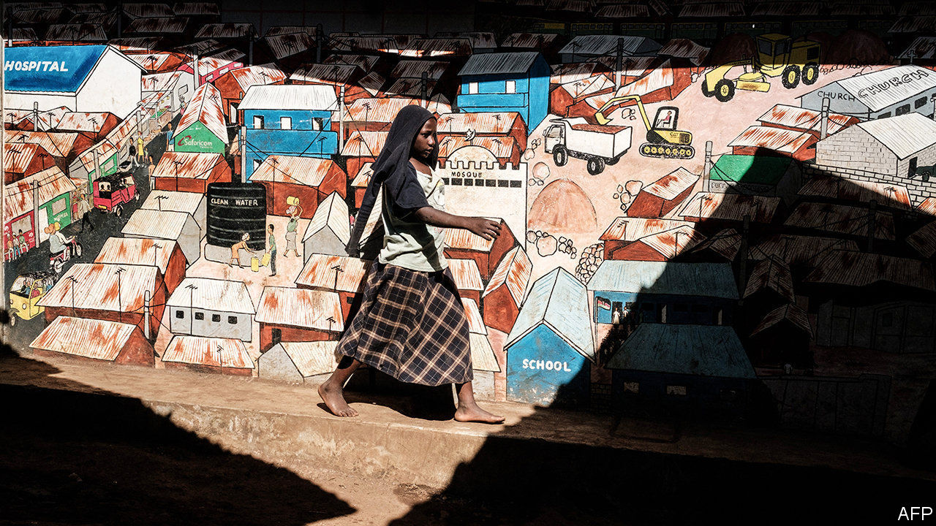

MANY AFRICANS rightly complain that outsiders carelessly lump together its 54 different countries and talk of it as a place that rises or falls as one. Such generalisations are not just lazy but also obscure more than they clarify. The most likely trend over coming decades in Africa will be a clear divergence between how various countries are doing, argues Nic Cheeseman, an expert in African democracies. Some are becoming richer and more democratic even as others stay poor and undemocratic.

This may seem obvious, but many left-wingers generalise that Africa is poor because its former colonial powers want to keep it that way, not because of the choices its leaders are making. Many conservatives, on the other hand, sweepingly say that corruption or bad governance are to blame, without taking account of the obstacles many African countries face. Yet it is in looking at the detail of how otherwise similar countries have taken different paths that lessons can be learned.

The first lesson, about the importance of simply having a state that works, comes from Rwanda and Burundi. Both are small, landlocked and densely populated. Since independence both saw genocides against their Tutsi minorities by their Hutu majorities. In the early 1990s Burundi was almost twice as rich as Rwanda. Yet since then incomes in Rwanda have increased more than three times (adjusted for purchasing power). Those in Burundi have fallen. One big difference between the two is governance. Although neither country is democratic, Rwanda has a functional government and low corruption. The Mo Ibrahim Foundation, which promotes democracy, ranks Rwanda eighth in Africa in its index of governance, which looks at a variety of indicators including the rule of law, infrastructure and sanitation. Burundi comes 43rd.

The second is that economic policies matter. When Kenya and Tanzania gained independence in the early 1960s they had similar economies, dependent on farming, and almost identical incomes per head. Both initially suppressed democracy to run authoritarian one-party states. But they chose very different economic models. Tanzania nationalised big companies and forced people onto collective farms in the name of “African socialism”. Kenya embraced free markets. Today Kenyans are 14% wealthier, adjusted for purchasing power (or 80% wealthier by market exchange rates).

Zimbabwe and Botswana further reinforce this. In the early 1980s Zimbabwe was richer than Botswana before Robert Mugabe destroyed its economy by wantonly printing banknotes and stealing farms for his cronies. Now Botswana is seven times richer.

Perhaps the most striking example of how countries with good policies and robust institutions can climb into a virtuous cycle of development—and how those without can get stuck in cycles of poverty and conflict—is Mauritius, Africa’s most successful economy. In 1961 James Meade, a Nobel laureate in economics, bluntly declared that “the outlook for peaceful development is poor”. Mauritius was small, remote from trading partners and dependent on the export of sugar. Yet, since independence, income per person in Mauritius has increased about six times after inflation, making it Africa’s second-richest country per person. Its success has drawn the interest of big-name economists. Jeffrey Sachs and Andrew Warner decided that Mauritius did well because its economy was open. Paul Romer, another Nobel laureate, attributed its success to foreign investment into its export-processing zones.

Having sensible economic policies is not enough, though. Several other African countries also tried to boost manufacturing by attracting foreign investors to export-processing zones. Only a few, including Ethiopia, Lesotho and South Africa, succeeded. Arvind Subramanian and Devesh Roy, two economists who also looked at Mauritius, concluded that its trade and investment policies accounted for only part of its success. Another important ingredient was the strength of its institutions. Since independence its elections have been peaceful, its government has followed the law, its courts have been honest and corruption has been tolerably low. It regularly comes top in the Ibrahim governance index.

Mauritius is all the more striking when set against its bigger neighbour, Madagascar, which seemed far more likely to succeed because of its richer natural resources and bigger population. In the 1970s, just as Mauritius began attracting foreign investors, Madagascar thought it was a fine idea to send them packing. It expelled the American ambassador and nationalised two American oil companies. While Mauritius was helping find export markets for its sugar farmers, Madagascar began grabbing land from its commercial farmers. It is one of the few countries in the world to have become poorer over the past 50 years, because of disastrous socialist policies and repeated political crises.

Over the longer term, the major trends taking hold are reasons for hope

The most important lesson—and the one that offers the most hope—is that many of these trends are mutually reinforcing. Countries with more capable bureaucracies and more open democracies tend to do better economically and invest more in education. Stronger economies and better schooling, in turn, help slow population growth and improve dependency ratios. Not all countries are in this virtuous cycle. But for those that are, the differences are striking. Kenyan women, for instance, are not just much richer than their cousins in Tanzania, they also each have 1.4 fewer children. Rwanda’s people are not just better off than those in Burundi, their literacy rate is five points higher, too.

Many parts of Africa are still deeply troubled. Nigeria’s economy is not growing quickly enough to keep pace with its population because of inept governance. South Africa, the economic powerhouse, is a laggard that can barely keep its lights on because of corruption and mismanagement. The Sahel is stuck in cycles of violence, high fertility and illiteracy that will take decades to break. Covid-19 is a huge risk to the continent’s people and will disrupt its economies. But, over the longer term, the major trends taking hold—rapid urbanisation; increasing migration and remittances; a rising share of children in school; the hundreds of thousands of students at universities abroad—are reasons for hope. Given a fair wind, these powerful forces promise to bring more democracy and wealth to hundreds of millions of people. ■

This article was downloaded by calibre from <https://www.economist.com/special-report/2020/03/26/why-are-some-african-countries-improving-and-others-not>

|  |  |  |  |
| --- | --- | --- | --- |
| Previous | Articles | Sections | Next |

|  |  |  |
| --- | --- | --- |
| Special report | Sections | Finance and ... |

Business

Business and the virus: Best in show

.

Confinement shopping: Still open

.

Human resources: The importance of people people

.

Bartleby: Diary of a home worker

.

Distributed companies: The nowhere firm

.

Schumpeter: A dispatch from the home front

.

|  |  |  |
| --- | --- | --- |
| Special report | Sections | Finance and ... |

|  |  |  |  |
| --- | --- | --- | --- |
|  | Articles | Sections | Next |

#### Best in show

# The pandemic shock will make big, powerful firms even mightier

And change the societies in which the corporate top dogs operate

Mar 26th 2020 |

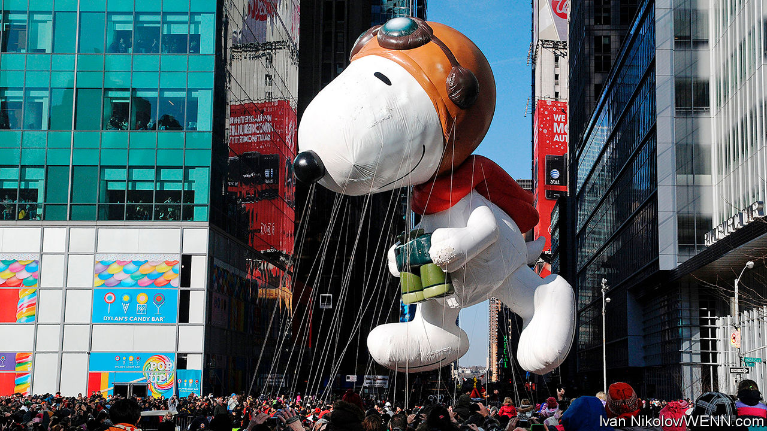

Editor’s note: The Economist is making some of its most important coverage of the covid-19 pandemic freely available to readers of The Economist Today, our daily newsletter. To receive it, register [here](https://www.economist.com/newslettersignup). For more coverage, see our coronavirus [hub](https://www.economist.com/coronavirus)

ACROSS THE rich world, governments and economists are scrambling to work out how costly virus-related lockdowns will be. Will the economy shrink by a tenth or a third? Is the slump going to last for three months, six or more? No one can say with any precision. A similarly unnerving and inexact exercise is happening in boardrooms as firms try to estimate by how much their cashflows will fall and whether they have the resources to survive.

Amid the chaos one thing, at least, is clear: a few powerful firms are set to gain more clout. Already some are a source of financial stability. It costs less to insure Johnson & Johnson’s debt against default than Canada’s. Apple’s gross cash pile of $207bn exceeds most countries’ fiscal stimulus. Unilever is funnelling cash to its army of suppliers (see article). In the long run this group of firms—call them the top dogs—may win market share by investing more heavily than, or buying, enfeebled rivals. The catch is that the post-pandemic world will put these corporate champions on a leash.

Downturns are capitalism’s sorting mechanism, revealing weak business models and stretched balance-sheets. In the past three recessions the share prices of American firms in the top quartile of each of ten sectors rose by 6% on average, while those in the bottom quartile fell by 44%. The drop in sales and profits in 2020 will be much steeper, though hopefully shorter, than in a typical slowdown.

A few firms directly hit by travel and shopping bans have spelled out just how steep. On March 23rd Primark, a fashion retailer, said it was shutting all 376 of its stores in 12 countries, forgoing over $770m in sales per month. It expects to save only half its costs. For most firms the picture is murkier, and perhaps not quite as glum. Some factories are still running and white-collar firms operate remotely. So far companies have announced a flurry of cuts to dividends and share buy-backs. But few have said exactly how much cashflow they expect to burn. For most it will be a lot.

Who, then, are the top dogs? To get a sense of firms’ resilience The Economist has examined the largest 800-odd listed American and European firms. We took their average score on four measures: the cost of insuring their debt against default, operating margins, cash buffers and leverage. Some medium-sized firms score well, but the strongest tend to be bigger, measured by valuation and profits. The 100 hardiest have a median enterprise value nearly twice that of the puniest 100, and median operating profits 17% higher. Their share prices have done better—or less badly—in the past month, falling by a median of 17%, compared with 36% for the 100 frailest.

Silicon Valley and Big Pharma dominate (see chart). Technology firms make up 48 of the top 100. The likes of Microsoft (10th), Apple (13th), Facebook (14th) and Alphabet (18th) operate with big cash buffers. Demand for some of their products is surging: Microsoft’s team-working software, for example. Another 24 are health-care firms. Many have spare cash and a captive market of people in need of drugs. Plenty of the weaklings are in the ailing transport, retail and recreation industries (think Marks & Spencer or American Airlines).

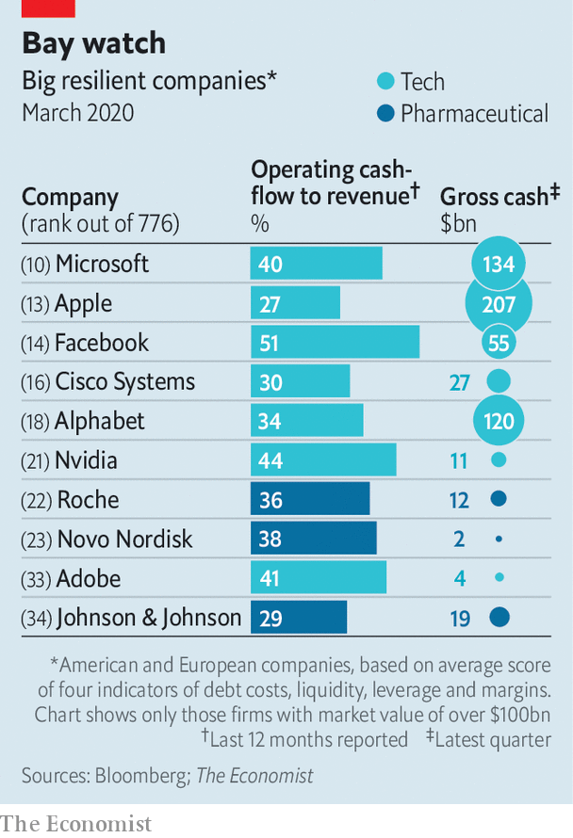

Clear winners and losers are emerging within sectors, too. In tech, Amazon is adding 100,000 workers in America to meet e-commerce demand. Meanwhile SoftBank, a Japanese conglomerate which bet big on flaky startups (including smaller e-merchants), has been forced to announce $41bn in divestments to raise cash, among them, perhaps, the sale of part of its lucrative stake in Alibaba, China’s biggest listed firm. In energy, the shares of giants such as ExxonMobil, Royal Dutch Shell and BP have outperformed smaller firms by a vast margin. Occidental Petroleum, an aggressive medium-sized company that has tried to acquire its way to the big league, now has a hefty $40bn in debt. L’Oréal, a big French personal-care group, has done vastly better than Coty, an American rival. Even among beleaguered aircraft-makers a gap has opened up. On March 23rd Airbus, Europe’s champion, said it had about $32bn of liquid funds available. Debt investors view it as less risky than Boeing, which may seek a bail-out from the American government.

The top dogs’ resilience should eventually translate into an enduring advantage, allowing them to win market share over time. Their cost of capital will be lower. Suppliers will favour them over feebler customers. With higher margins and bigger cash buffers, they will be able to afford higher investment even as other firms cut back. Some will pursue takeovers, encouraged by governments which put the survival of foundering firms (and jobs) ahead of antitrust concerns. As valuations fall and capital gets pricier, the ability of loss-making startups to nibble away at big firms’ profits will recede for a while.

Not everything may go the top dogs’ way. Calls for a new social contract may get louder after the virus passes, with firms pressed to offer vital products for lower prices and to give workers more security. Capitalism may become less Darwinian, as weak firms are propped up by bail-outs and subsidised loans. The amount earmarked for cheap business loans and guarantees by governments in America, Britain, France, Germany and Italy is at least $4trn, or a fifth of their outstanding non-financial corporate debt. Some industries may temporarily be run as officially sanctioned cartels, colluding in order to stabilise prices and production. That will make it harder for strong firms to assert their advantage. Covid-19 won’t only have lasting effects on society and people’s behaviour. It will also alter the structure of global business.■

Dig deeper:  
For our latest coverage of the covid-19 pandemic, register for The Economist Today, our daily [newsletter](https://www.economist.com/newslettersignup), or visit our [coronavirus hub](https://www.economist.com/coronavirus)

This article was downloaded by calibre from <https://www.economist.com/business/2020/03/26/the-pandemic-shock-will-make-big-powerful-firms-even-mightier>

|  |  |  |  |
| --- | --- | --- | --- |
|  | Articles | Sections | Next |

|  |  |  |  |
| --- | --- | --- | --- |
| Previous | Articles | Sections | Next |

#### Still open

# How retailers vie to be considered “essential” in a lockdown

Or not

Mar 26th 2020 | PARIS



Editor’s note: The Economist is making some of its most important coverage of the covid-19 pandemic freely available to readers of The Economist Today, our daily newsletter. To receive it, register [here](https://www.economist.com/newslettersignup). For more coverage, see our coronavirus [hub](https://www.economist.com/coronavirus)

MAN DOES not live by bread alone, even in confinement. Sections of the world’s high streets have been spared from national edicts to shut up shop until covid-19 passes. Supermarkets, pharmacies and banks remain open just about everywhere. Other exemptions reflect which industries politicians feel voters cannot do without.

Is booze a basic need? Not in Pennsylvania or India, where alcohol retailers have been shuttered. France, predictably, has spared its wine merchants. Cavistes had originally been ordered to close, then permitted to stay open even as the French lockdown was tightened (cheesemongers count as food shops, in case you were wondering). Dutch and Californian cannabis dispensaries were also allowed to reopen. Weed sales in California reportedly tripled as tokers pondered life cooped up with their families.

Bookshops remain open in Belgium but not Britain, despite an appeal by James Daunt, boss of Waterstones, a big chain, that they were “no different to a supermarket or pharmacy”. By contrast, when France’s finance minister, Bruno Le Maire, wanted to exempt booksellers, their association beseeched him to keep them closed—but also to stop Amazon and supermarkets from selling books.

Dry cleaners and launderettes have usually remained open, including in New York. But the need to look dapper does not extend to coiffures. Barbers and hairdressers closed in much of Europe (though Germany let them stay open at first). Their trade group, too, pleaded for them to be forced to stay shut, pointing out that hairdressers could scarcely avoid coming into close contact with customers. Also, being closed can help trim expenses by putting staff on government wage-replacement schemes, and perhaps other handouts.

South Korea at no point strictly enforced closure of commerce. But gyms and night clubs that want to stay open must keep a visitor log and enforce distancing rules or be held liable for medical bills of anyone infected on their premises. Non-food establishments from Lucknow to Los Angeles might anyway see few clients even if they kept going. People must juggle child care with remote work. They have lost their income, or are about to; confidence is plummeting. Until it rebounds, shopkeepers may prefer to seek government life-support.

Dig deeper:  
For our latest coverage of the covid-19 pandemic, register for The Economist Today, our daily [newsletter](https://www.economist.com/newslettersignup), or visit our [coronavirus hub](https://www.economist.com/coronavirus)

This article was downloaded by calibre from <https://www.economist.com/business/2020/03/26/how-retailers-vie-to-be-considered-essential-in-a-lockdown>

|  |  |  |  |
| --- | --- | --- | --- |
| Previous | Articles | Sections | Next |

|  |  |  |  |
| --- | --- | --- | --- |
| Previous | Articles | Sections | Next |

#### The importance of people people

# The coronavirus crisis thrusts corporate HR chiefs into the spotlight

In a pandemic, a chief people officer can make or break a company

Mar 26th 2020 | AMSTERDAM

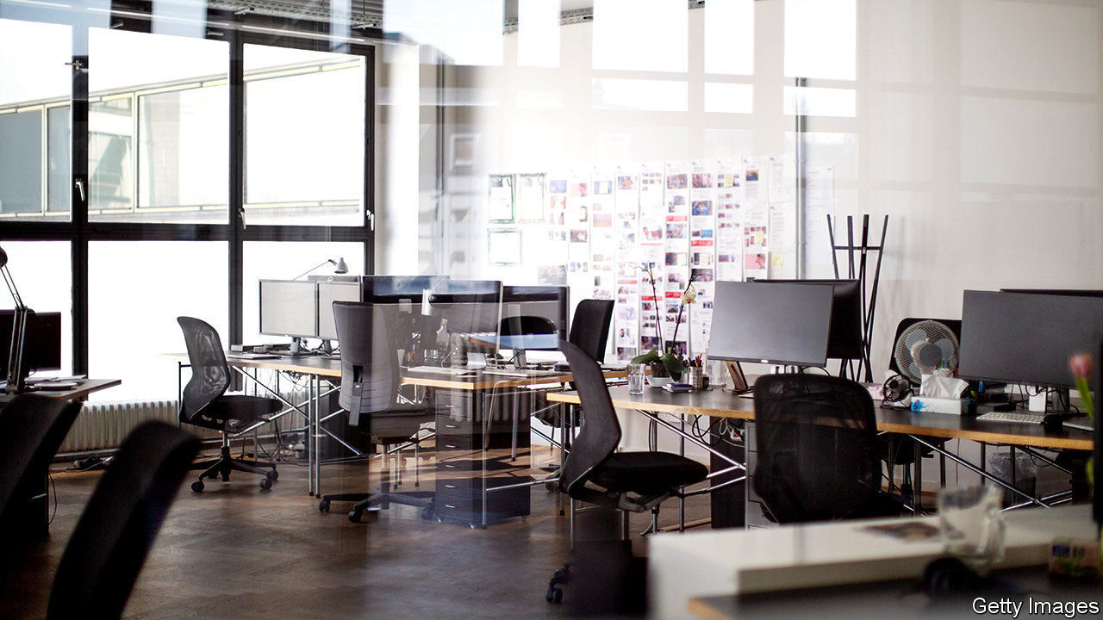

WHEN THE financial crisis rocked the business world in 2007-09, boardrooms turned to corporate finance chiefs. A good CFO could save a company; a bad one might bury it. The covid-19 pandemic presents a different challenge—and highlights the role of another corporate function, often unfairly dismissed as soft. Never have more firms needed a hard-headed HR boss.

The duties of chief people officers, as top human-resources executives are sometimes called, are critical. They must keep employees healthy; maintain morale; oversee a historic remote-working experiment; and consider whether, when and how to lay workers off. Their in-trays are bulging.

Once derided as “pay and parties” managers, by the early 1990s HR chiefs turned to compliance, keeping firms out of the courts (and newspapers). A subsequent string of corporate imbroglios raised their status, notes Patrick Wright of the University of South Carolina. Executive-pay scandals in the 2000s at firms such as WorldCom and Tyco got them more involved in remuneration. A decade later bungled successions at giants like HP, a printer-maker, left them with a bigger say in filling top jobs. More recently they have dealt with firms’ often very public “me too” troubles.

As recruiting and retaining skilled workers became CEOs’ big concern—four-fifths now fret about skill shortages, up from half in 2012—HR heads’ desks moved closer to the corner office. Today many reside right next to the boss. Shareholders are inviting more outside HR chiefs onto boards. In America salaries remain lower than CFOs’ pay but have risen about 20% faster since 2010 (see chart).

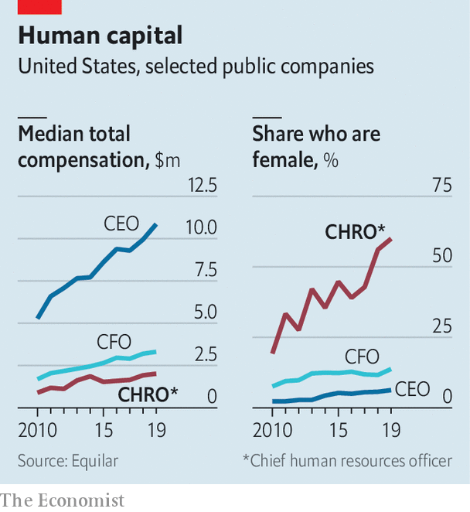

A higher profile entails new expectations. HR was once the domain of history graduates and masters in labour relations; nowadays plenty hold business degrees. Although most firms recruit them from HR jobs, more are choosing outsiders or unconventional candidates. Russell Reynolds Associates, an executive-search firm, found that HR heads appointed to Fortune 100 companies in 2016-19 were around 50% likelier than earlier hires to have worked abroad, in general management or finance.

Before covid-19 tight labour markets and millennial empowerment forced employers to think about getting the most out of workers, says Dane Holmes, a former human-capital head at Goldman Sachs who now runs Eskalera, an HR-analytics firm. Diane Gherson, in charge of HR at IBM, overhauled the computing giant’s performance management with big data. Algorithms challenge managers’ instincts on pay and promotion and alert her team when employees are at risk of fleeing (often before they realise it themselves).

The pandemic makes such “people analytics” more relevant. Beth Galetti, Ms Gherson’s opposite number at Amazon and an engineer with no prior HR experience, oversees 1,000 developers working exclusively on HR tech. The e-commerce titan’s earlier investment in digital induction for new hires is paying off. “We on-boarded 1,700 new corporate employees on Monday [March 16th] alone,” Ms Galetti reports.

Covid-19 may lead more HR chiefs to adopt such systems. Right now most have more pressing problems. Mala Singh, chief people officer at EA, a maker of video games, represents the C-suite in its pandemic-response group. This occupies 60-70% of her (long) day. Her team has been getting desks, computers, even noise-cancelling headphones for home-workers. A bigger concern is balancing jobs with child care. Ms Singh told the caregivers on staff to take as much time as they need to adapt without using up paid leave. She is digitally monitoring employee sentiment, particularly anxiety. In a creative business like EA’s, stress about family “does not enable productive work”, she explains.

Many companies outside the knowledge economy face tougher choices. HR leaders must strike a balance between a firm’s professed purpose, which these days often involves treating staff well, and the bottom line, observes Dan Kaplan of Korn Ferry, a consultancy. The instinct is to cut costs through mass lay-offs. Rather than slash payrolls willy-nilly, says Bill Schaninger of McKinsey, another consultancy, good HR heads can try to reconfigure company work flows: what needs to be done by whom, what can be automated and what requires people to share the same space. Some workers who at first appear redundant may be redeployed or reskilled.

The smartest HR-ers at the doughtiest firms are already gazing beyond the flattened curve. Though not quite recruiting—times are too uncertain—Ms Gherson has begun to groom rivals’ talent. Now that everyone is working from home, she says, no one is listening in on their calls. For an HR chief, “it’s the perfect opportunity.”■

This article was downloaded by calibre from <https://www.economist.com/business/2020/03/26/the-coronavirus-crisis-thrusts-corporate-hr-chiefs-into-the-spotlight>

|  |  |  |  |
| --- | --- | --- | --- |
| Previous | Articles | Sections | Next |

|  |  |  |  |
| --- | --- | --- | --- |
| Previous | Articles | Sections | Next |

#### Bartleby

# Diary of a home worker

The challenges of concentrating during a lockdown

Mar 26th 2020 |

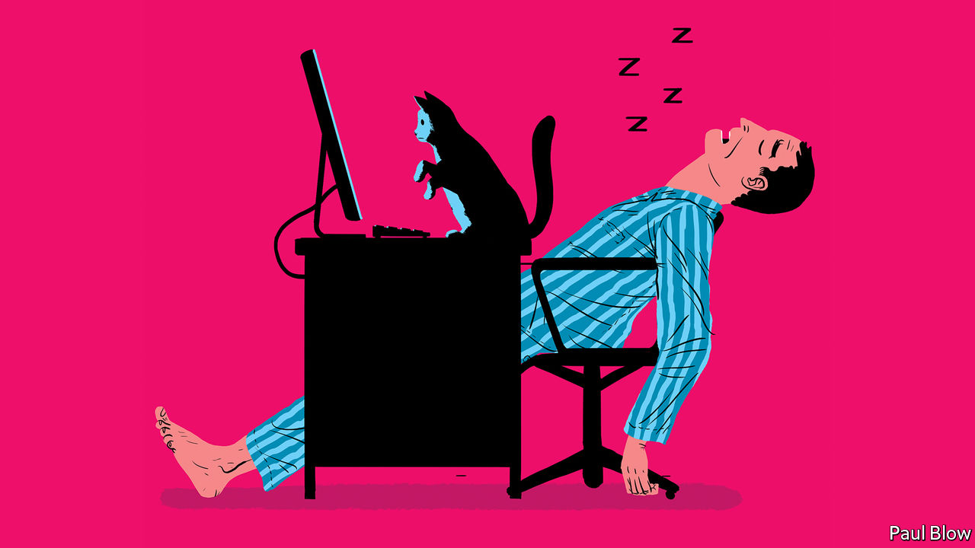

Editor’s note: The Economist is making some of its most important coverage of the covid-19 pandemic freely available to readers of The Economist Today, our daily newsletter. To receive it, register [here](https://www.economist.com/newslettersignup). For more coverage, see our coronavirus [hub](https://www.economist.com/coronavirus)

MORNING: WAKE up at 7am. Listen to radio news full of government restrictions, disease numbers and tales of economic decline. Stop on the way to shower to wake up teenage daughter so she can get ready for school. Daughter tersely points out that her school has been closed for days.

7.20: Breakfast is tricky decision. Is the family closer to running out of milk and cereal, or bread? Realise that cat has only two food sachets left.

7.30: Email inbox consists almost entirely of companies explaining how they are coping with the pandemic. This includes every hotel and restaurant that ever took an online booking.

8.00: Head for supermarket to pick up extra cat food. Shelves resemble scene from zombie apocalypse. Purchase tub of ice cream on grounds that virus posesbigger threat to health than obesity does.

8.30: Attempt to read company’s disaster recovery policy. Hitherto had been more likely to pick up a newly discovered novel by Ayn Rand. Can’t make head nor tail of it. Beg daughter for help as she has actually heard of these apps. Think wistfully of the days when journalism involved a typewriter, carbon paper and the telephone directory.

8.50: Look at academic paper in the hope it will provide column idea. Give up when the abstract turns out to be too, er, abstract. Wish that vital books were not left in the office, seven miles away.

9.00: Check Twitter and news websites for virus developments on grounds this is “research”. Disappear down rabbit hole for 45 minutes.

9.45: Cough briefly. As paranoia sets in, check temperature. All fine but then second thought: what if thermometer is broken? To be safe, wash hands while singing all of “Bohemian Rhapsody”.

10.30: Time to dial into editorial meeting. Realise cannot find phone number or meeting code. Send email to colleague who returns a WhatsApp message with the answer. But that arrives on the phone needed to dial in. Hunt for pen and paper to write down the numbers.

10.35: Finally get through to meeting. Wonder about etiquette for conference calls taken at home. Is it OK to put the kettle on? Eat a biscuit?

10.45: Try to contribute. Realise phone is on mute. After two minutes, work out how to unmute phone. Discussion has moved on. Mute again to avoid embarrassment. Reflect that listening to meeting in which one does not contribute is akin to watching a play performed in a foreign language. Start to miss regular meetings, a concept previously beyond imagination.

11.15: Go for stroll. Have conversation with neighbour who stands a careful two yards away. Wonder whether, like medieval lepers, we will all eventually have to walk down street, ringing bell and shouting, “unclean!”

11.30: Return to house to find cat has sat on laptop, and accidentally opened a whole bunch of tabs and typed random letters. If cat does this long enough, could she write entire column?

11.45: Check Google calendar and find, after cancellations, there are no meetings left for the whole of 2020. Perhaps this is how it is going to be.

11.59: Think of virus-related joke.

Noon: Tweet the joke.

12.01: Realise quip was in terrible taste and hurriedly delete it.

12:15: Lunch dilemma. Eat perishable food before it goes off or non-perishable food which could be out of stock in the supermarket? Settle for ice cream on the grounds that should never have bought it in the first place. Start to watch TV detective series for a few minutes as deserved mental break.

1.30: Suddenly realise the time as detective show ends. Turn off TV.

1.45: Inbox now consists of pitches from two types of PR people. One group wants to highlight products that will make home-working easier and would make great column. The other lot wants to know whether The Economist would like to publish an article from their chief executive praising their own company. Hit delete button multiple times.

2.30: Think about working in Starbucks as a break from the kitchen table. Remember that Starbucks and every other coffee chain has now closed for business indefinitely.

4.00: Consider writing column that is not virus-related but worry it might seem otherworldly. Conduct search of internet for topic that is virus-related but at the same time vaguely cheerful.

5.00: Wonder whether the business editor would accept a column based on a homeworker’s diary. Estimate the odds to be rather long.

Dig deeper:  
For our latest coverage of the covid-19 pandemic, register for The Economist Today, our daily [newsletter](https://www.economist.com/newslettersignup), or visit our [coronavirus hub](https://www.economist.com/coronavirus)

This article was downloaded by calibre from <https://www.economist.com/business/2020/03/26/diary-of-a-home-worker>

|  |  |  |  |
| --- | --- | --- | --- |
| Previous | Articles | Sections | Next |

|  |  |  |  |
| --- | --- | --- | --- |
| Previous | Articles | Sections | Next |

#### The nowhere firm

# How to manage a business without a headquarters

Pandemic lessons for all companies from startups born office-less

Mar 26th 2020 | BERKELEY AND SLACK

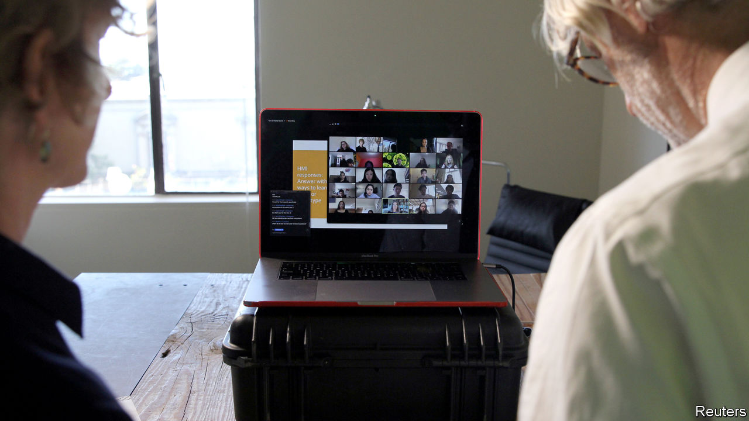

Editor’s note: The Economist is making some of its most important coverage of the covid-19 pandemic freely available to readers of The Economist Today, our daily newsletter. To receive it, register [here](https://www.economist.com/newslettersignup). For more coverage, see our coronavirus [hub](https://www.economist.com/coronavirus)

“WEIRDLY, THINGS haven’t changed much,” says Kyle Mathews as he sprays disinfectant on his hands. At least at work. His startup, Gatsby, helps websites manage content in the cloud. It has no headquarters and its 50-odd employees straddle the world, from Mr Mathews’s home in Berkeley, California, to Siberia.

Such “fully distributed” firms were on the rise before covid-19. As national lockdowns spread, conventional ones are forced into similar arrangements. Those that have grown up this way offer lessons.

Distributed organisations are as old as the internet. Its first users 50 years ago realised how much can be done by swapping emails and digital files. These exchanges led to the development of “open source” software, jointly written by groups of strangers often geographically distant.

Today most distributed startups have open-source roots. Gatsby is one. Nearly all 1,200 employees of another, Automattic, best known for WordPress, software to build websites, work from home. GitHub, which hosts millions of open-source projects (and was acquired by Microsoft in 2018), may be the world’s biggest distributed enterprise. Two-thirds of its 2,000 staff work remotely. Most firms that build blockchains, a type of distributed database, are by their nature dispersed.

Plenty of startups start out distributed to avoid high rents—and so high wages—in Silicon Valley and other tech centres. Many opt to stay that way. Joel Gascoigne, boss of Buffer, which helps customers manage social-media accounts, works remotely in Boulder, Colorado. Stripe, an online-payments firm, has a head office in San Francisco but its new engineering hub is a collection of remote workers.

Distributed startups exist thanks to a panoply of digital tools—most obviously corporate-messaging services such as Slack (chat) and Zoom (videoconferencing), as well as lesser-known firms like Miro (virtual whiteboards for brainstorming) or Donut (which pairs employees to forge personal bonds). Others, like Process Street, Confluence or Trello, help manage work flow and keep track of what goes on in virtual corridors—crucial when people do not share the same physical space. Firms offering organisational scaffolding for distributed firms include Rippling, which manages payroll and employee benefits, grants workers access to corporate services and sets up their devices. Much that is now done in spreadsheets could be turned into a virtual service, predicts Rich Wong of Accel, a venture-capital (VC) firm (and early investor in Slack).

Besides new tools, distributed firms need novel management practices. One rule is not to mix physical and virtual teams. Online participants in mixed meetings often feel excluded. GitHub’s boss, Nat Friedman, has all employees—himself included—log in to meetings virtually, even if they are in the office. Looking over someone’s shoulder to see if they are working (or worse, use software to do it) is another no-no. Remote workers do not slack off, as some managers fear. Trust your team, set clear and, where possible, measurable goals, and let people do their thing, counsels Mr Mathews. To foster camaraderie, Buffer organises an annual in-person retreat (covid-19 will push it online this year).

Trust also requires transparency and explicitness—another reason documentation is key, says Michael Pryor, co-founder of Trello (whose workforce is 80% remote). Discussions that lead to a decision must be captured in writing, he explains, so everyone understands the trade-offs being considered. As a result, distributed firms favour wordsmiths, not good speakers as traditional firms do. Good writing demands clear thinking and discipline, says Mr Friedman, who has been managing distributed teams for 20 years. VCs duly report that distributed startups tend to be better at preparing board meetings.

The pandemic may lead some companies that have outsourced lots of operations to the cloud to go a step further and get rid of at least some offices. “I just don’t think we are going to go back [to business as usual],” says Frank Slootman, boss of Snowflake, a database firm. Even digerati like Twitter plan to turn more virtual.

Still, some businesses suddenly forced into remote work will rue the experience, predicts Mr Gascoigne. Without a learning period they will get all the drawbacks and few of the benefits. Brainstorming and other creative activities are possible online but take practice—and even then feel like an imperfect ersatz of an actual room. Recruiting and breaking in new employees is hard virtually. According to one recent survey of 3,500 remote workers, one in five struggles with loneliness. That is partly why GitHub and Trello operate optional offices.

Most businesses will always have to be located somewhere and need people to work side by side. But as technology improves, swathes of the knowledge economy will gradually move more functions online, thinks Venkatesh Rao of Ribbonfarm, a consultancy. New firms will erect a new virtual floor, which others then inhabit. The coronavirus-fuelled exodus to cyberspace is unlikely to be the last.■

Dig deeper:  
For our latest coverage of the covid-19 pandemic, register for The Economist Today, our daily [newsletter](https://www.economist.com/newslettersignup), or visit our [coronavirus hub](https://www.economist.com/coronavirus)

This article was downloaded by calibre from <https://www.economist.com/business/2020/03/26/how-to-manage-a-business-without-a-headquarters>

|  |  |  |  |
| --- | --- | --- | --- |
| Previous | Articles | Sections | Next |

|  |  |  |  |
| --- | --- | --- | --- |
| Previous | Articles | Sections | Next |

#### Schumpeter

# How Alan Jope runs Unilever from his study

A dispatch from the home front

Mar 26th 2020 |

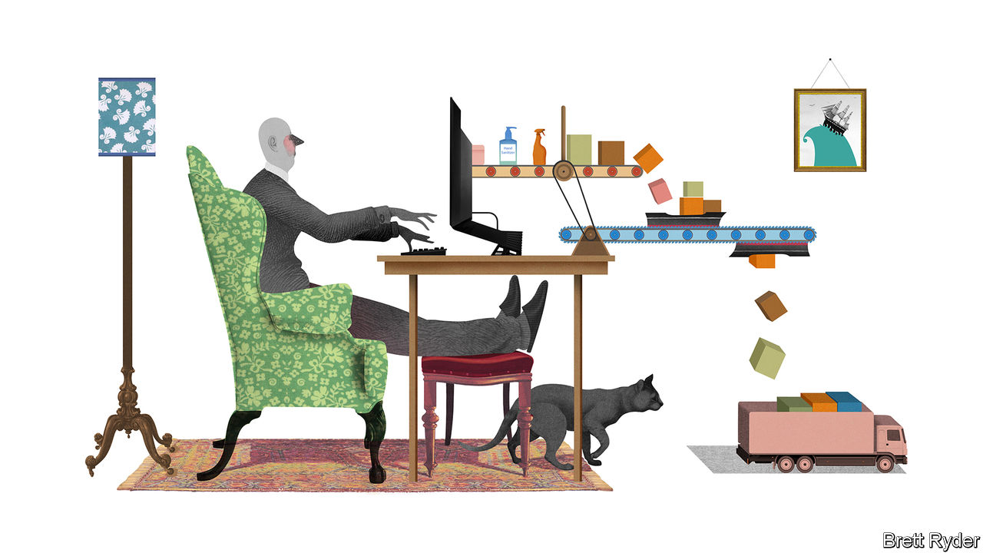

Editor’s note: The Economist is making some of its most important coverage of the covid-19 pandemic freely available to readers of The Economist Today, our daily newsletter. To receive it, register [here](https://www.economist.com/newslettersignup). For more coverage, see our coronavirus [hub](https://www.economist.com/coronavirus)

ON MARCH 13TH Alan Jope, boss of Unilever, a consumer-goods conglomerate that makes everything from Dove soap to Knorr soup, ordered the firm’s 60,000 office workers in all countries bar China to work from home. The 56-year-old Scot took a train to Edinburgh where he joined his family. Sitting in his study, he recently spoke to Schumpeter via an online video-chat that he uses to run a business empire. In a world gone awry, it all felt rather normal. Mr Jope, in his habitual casual garb, looked relaxed. Despite the gravity of the covid-19 pandemic, remote working is “dead easy”, he says; without commuting, he has more time to liaise with underlings around the world.

That is good news, and not just for Unilever. Since January the company has been on the front line of the covid-19 outbreak. As one of the world’s biggest consumer-goods firms, it sells food, hygiene products and other more or less essential staples to 2.5bn customers in 190 countries. Without continued availability of its wares the pandemic’s toll would almost certainly be even greater.

Listening to Mr Jope it becomes clear how many rules of business the pandemic has shattered. The impact on production, consumption and generation of profit is even greater than on office work. The nature of the top job, which he has held since January 2019, has changed, too. In the past the hallmark of a good boss was a strategic mind. The covid era is all about the here and now.

Like many a boss, Mr Jope thinks in categories. For his firm, the pandemic has come in three waves. It began with the lockdown in China. The stoppages then spread to northern Italy, the rest of Europe and America. Now they have reached poor places such as the Philippines, India and Africa. He has four guiding principles: look after people; look after supply; look after demand; look after cash.

First, people. Unilever is trying to safeguard the physical and financial well-being of its 155,000-strong workforce. Besides sending office staff home, factories are operating in “Fort Knox mode” to prevent the spread of infection, he says. Sales teams are ordered to contact customers virtually. Unilever will maintain pay levels for up to three months for all who work for it either directly or, like cleaning and catering staff, through contractors.

Second, production. For Unilever, China and Italy have been laboratories. They offered valuable insights into dealing with lockdowns and “deep cleaning” of factories. When the authorities locked down Lombardy, they at first banned lorry transit. After companies warned of the risk this posed for the supply of food and basic necessities, the order was relaxed. Countries are realising how important it is to keep products moving across borders and within them, Mr Jope says. The firm is not too exposed to cross-border snags. Almost all its products are made from ingredients sourced in the country of production. It scarcely uses air freight, and seaports mostly remain open. Mr Jope says he has so far seen limited disruption at the base of the supply chain, among farmers or packaging firms (but concedes this may change if lockdowns last for months). The biggest bottleneck in many places, he says, is a shortage of lorry drivers, who are “critical”.

As for consumers, his third priority, they have been forced to shop less in all. Moreover, the sheer scale of panic buying in some places in recent weeks has led Unilever to turn monthly sales forecasts into weekly ones. Consumption patterns are not uniform. America and Europe have witnessed shelves stripped, mostly in big supermarkets. In developing countries people flock to neighbourhood shops. Demand is shifting online just about everywhere, but internet shopping is “totally overwhelmed”.

Cash is the fourth concern. Unilever is in decent shape. Its debt is moderate, at less than two times EBITDA. It notched up €52bn ($58bn) in sales last year. Most important at a time of a corporate cash crunch, it had €6.1bn in free cashflow. Like other consumer-goods giants Unilever bolstered it over the past decade by being robust with suppliers. It is not alone. The payables (roughly, what is owed to suppliers) of eight big consumer-goods multinationals, including Unilever, has risen from a median of 9% of sales in the 2000s to 16% last year, in part thanks to longer payment periods.

Now Mr Jope is giving some of it back. On March 24th the firm said it would extend €500m of cashflow relief to suppliers and customers, by speeding up payment to small and medium-sized vendors, and offering credit to small retailers that rely on Unilever. The chief executive says that if many other big companies pay their suppliers more quickly, it would considerably ease the financial strains felt by the small fry. Unilever’s relief up and down its supply chain presents a big shift in a business model of wringing efficiencies through ultra-lean production and distribution. But it has little choice. Although sales of some products may get a boost from panic buying, overall Unilever will not benefit as self-isolating consumers shop less, he thinks.

Apart from changing Unilever’s business, covid-19 is also reshaping its boss’s role. For decades, CEOs have fancied themselves as grand strategists, like generals who believe strategy is to war what plot is to the play. Reputations were burnished with bold, cunning moves, such as mergers and acquisitions or spin-offs. The running of day-to-day operations, including supply chains and staff, were about as glamorous as stage management.

## Strategic retreat

No longer. Mr Jope says that right now strategy is not the main priority. His “operational brains”—the HR, supply-chain and operations chiefs—are more important than ever. His country heads are crucial to running businesses on the ground, including negotiations with panicky governments. Internal communication is critical. One day strategic opportunities will resurface. But right now is not the time for distractions. At least most of them: before saying goodbye he lets slip, slightly bashfully, that his next appointment is a virtual party organised by some of his younger employees. ■

Dig deeper:  
For our latest coverage of the covid-19 pandemic, register for The Economist Today, our daily [newsletter](https://www.economist.com/newslettersignup), or visit our [coronavirus hub](https://www.economist.com/coronavirus)

This article was downloaded by calibre from <https://www.economist.com/business/2020/03/26/how-alan-jope-runs-unilever-from-his-study>

|  |  |  |  |
| --- | --- | --- | --- |
| Previous | Articles | Sections | Next |

|  |  |  |
| --- | --- | --- |
| Business | Sections | Science and ... |

Finance and economics

World trade: Trucks, queues and blues

.

On shaky ground: America’s mortgage market sickens

.

The dollar: The Zoom accord

.

The euro zone: Ripping up the rules

.

Commodities: Buyer beware

.

Buttonwood: Bridges to somewhere

.

Free exchange: How to pay for the pandemic

.

|  |  |  |
| --- | --- | --- |
| Business | Sections | Science and ... |

|  |  |  |  |
| --- | --- | --- | --- |
|  | Articles | Sections | Next |

#### Trucks, queues and blues

# If you thought the trade war was bad for global commerce...

The disruption from the pandemic will be much worse

Mar 26th 2020 | WASHINGTON, DC

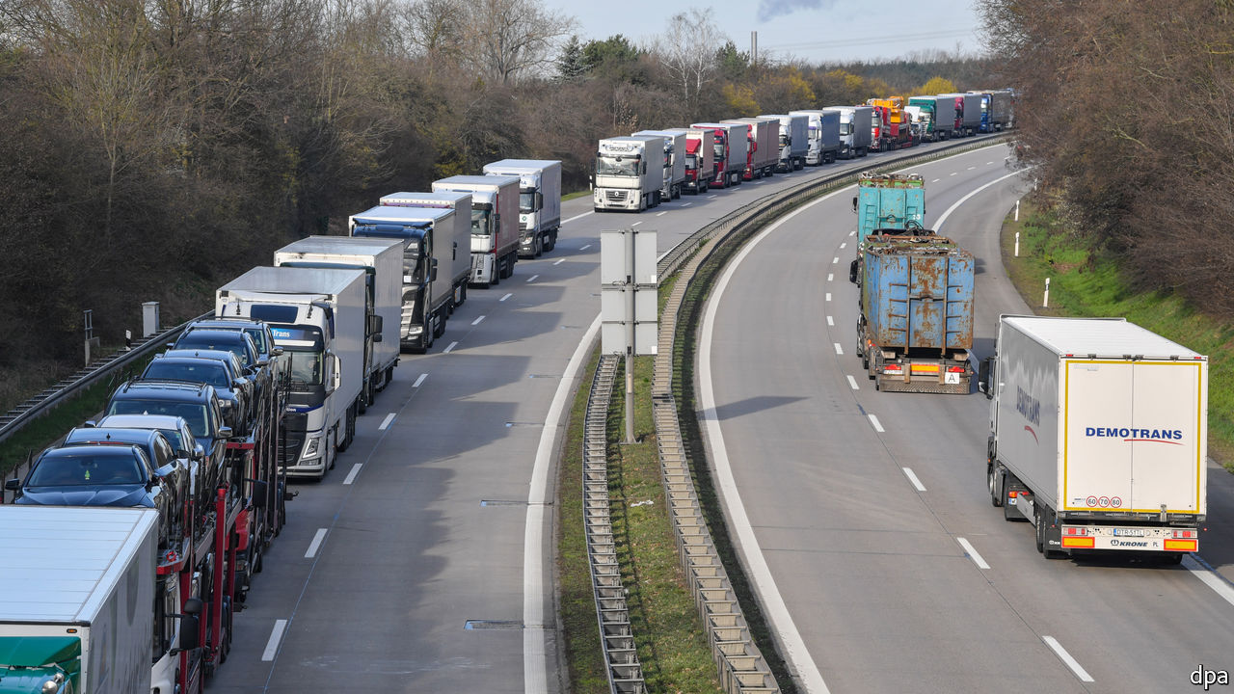

CONTAINER-SHIP navigators, box-ticking customs officials, logistics wizards, truck drivers and warehouse nightwatchmen: all are familiar with dealing with glitches involving international trade, from strikes to trade wars. But with forecasters predicting a slump in global GDP this year, even their most creative thinking cannot keep $25trn of goods and services flowing around the world.

Trade is the conduit through which economic pain passes from one country to another. Even simple products rely on elaborate supply chains: a humble cup of coffee requires 29 firms to collaborate across 18 countries, according to one estimate. Shocks convulse in either direction. A port closure or customs delay can cripple production elsewhere. If consumers stop buying cars and phones, manufacturers and workers in distant lands feel the pinch.

When world output, at purchasing-power parity, fell by 0.1% in 2009, trade volumes collapsed by a whopping 13%. Quarterly volumes fell by even more (see chart). Weaker demand in America and the European Union rippled along trade routes to Canada, China, emerging Asia, Japan and Mexico. One study finds that 27% of the decline in American demand and 18% of that in the European Union was borne by foreign producers.

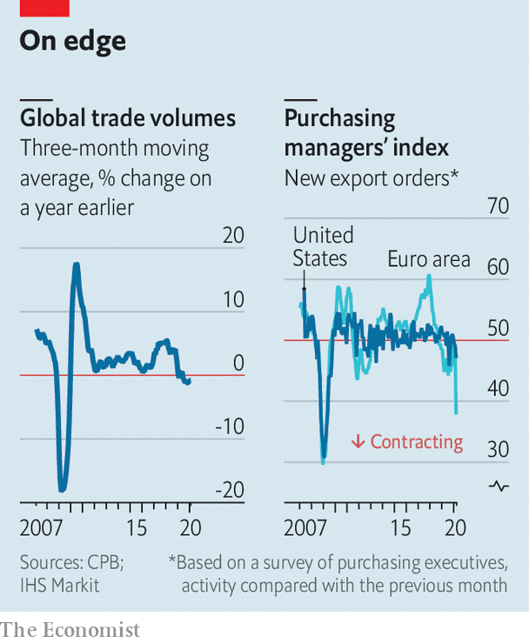

The shock coming this year threatens to be far more brutal. When one of the world’s economic giants sneezes, the rest of the world catches cold. Now everyone is coughing. Factory closures are being exacerbated by a rise in trade barriers. And global demand is plummeting as households’ incomes dry up and cash-strapped firms put their investment plans on ice.

At first the virus infected manufacturing in China, which typically supplies nearly 10% of the world’s intermediate-goods trade. The dollar value of Chinese exports in January and February was 17% below what it was a year earlier (though American tariffs may also have contributed to the weakness). As delivery times stretched out for longer and longer, companies had to pause production for lack of components.

Now factories across Europe, North America and Asia must cope not only with uncertain supplies of parts from China but also with sick workers and a dizzying array of local and national shutdowns. Audrey Ross of Orchard International, a company based in Canada that trades products including mascara and bath sponges, says planning has become a nightmare. One customer in Germany is closed; another in France is open. Warehouses in America have shorter opening hours. Diversifying away from China had at first seemed like a sensible strategy. Now nowhere is safe.

To make matters worse, barriers to trade are going up. More than 50 governments have restricted exports of medical supplies, 33 of which acted after the beginning of March. Tourism has been crushed—it accounts for 8% of global services trade. Flight cancellations have seen the cost of air freight, much of which goes in the belly of passenger jets, soar. Vaughn Moore of AIT Worldwide Logistics, a freight-forwarding company, reports that rates have risen from $2-3 per kilo to $9-11, which for some goods is prohibitively expensive.

Land borders are becoming harder to cross too. Countries from America to Armenia have placed new restrictions on free movement. In almost all cases there are meant to be exceptions for people transporting goods. But haphazard implementation has led to queues that stretch for miles. On March 15th the Italian transport minister had to call her Hungarian counterpart to request that a blockade be removed. Restricted border crossings have in some cases made it hard for drivers to get to work. “Everybody wants to do their own thing,” grumbles Umberto de Pretto of the International Road Transport Union. “If road transport stops the world stops.”

Bunged-up borders mean that it gets harder to refill empty supermarket shelves as people stockpile food, and to meet rocketing demand for medical equipment. Mario Aronovich, a customs broker in Mexico, remembers receiving calls when the crisis started about whether it was possible to export medical masks from Mexico to China. Now he is getting calls about trade in the opposite direction.

So just how big will the drop in overall trade be? In 2009 declining demand accounted for over two-thirds of the crash in trade, a far bigger share than the 15-20% caused by the credit crunch. The extent of the pandemic-induced slowdown in consumer spending and investment is already becoming clear. And it has already dented trade activity badly—a survey of factory bosses in March suggests sharp falls in export orders in advanced countries. Simon Macadam of Capital Economics, a consultancy, has pencilled in a 20% drop in trade volumes this year. That is bigger than in 2009. The drop in trade could be worse if the most pessimistic forecasts of jaw-dropping double-digit year-on-year declines in GDP in some rich countries over the next quarter or two come true.

A lesson from 2009 is that trade bounces back. Some of the precipitous drop then reflected companies drawing down their inventories; that reversed quickly enough when things returned to normal. Gloomier types point out the colossal uncertainty about when the rebound might come. Trade thrives on trust and predictability. Today, with supply chains buckling and borders closing, both are in short supply. ■

This article was downloaded by calibre from <https://www.economist.com/finance-and-economics/2020/03/26/if-you-thought-the-trade-war-was-bad-for-global-commerce>

|  |  |  |  |
| --- | --- | --- | --- |
|  | Articles | Sections | Next |

|  |  |  |  |
| --- | --- | --- | --- |
| Previous | Articles | Sections | Next |

#### On shaky ground

# America’s mortgage market sickens

Mar 26th 2020 |

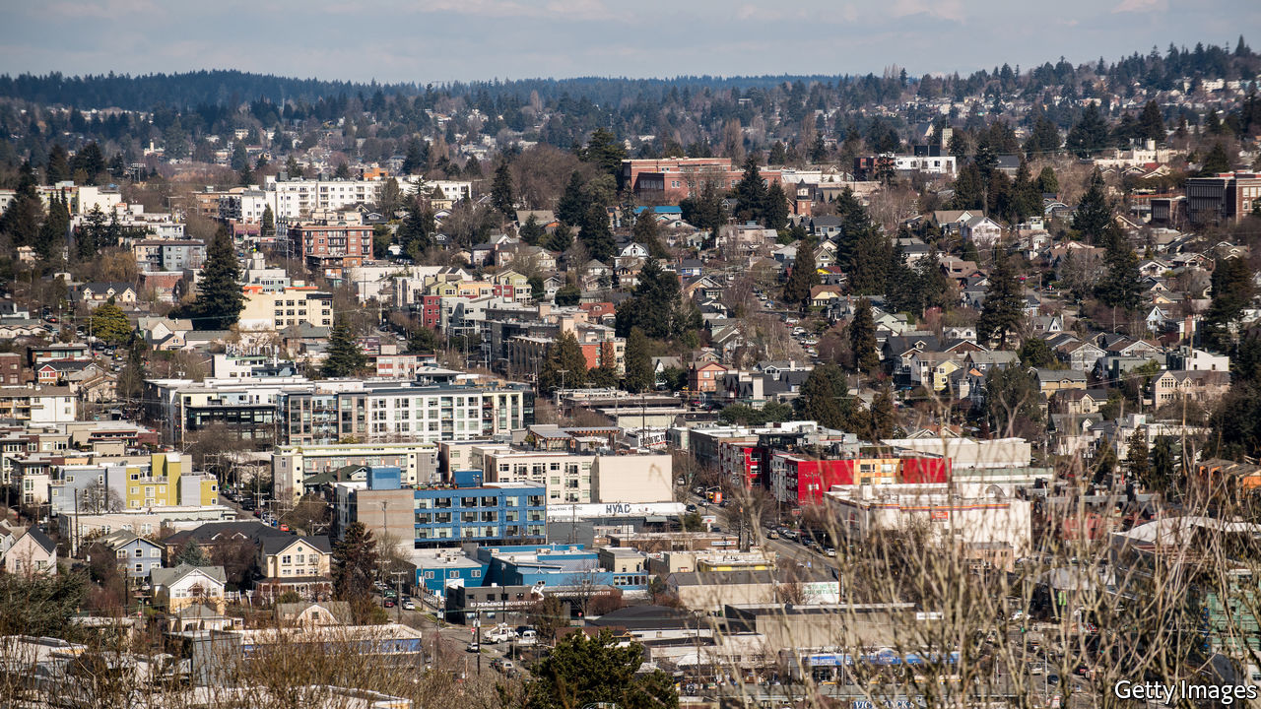

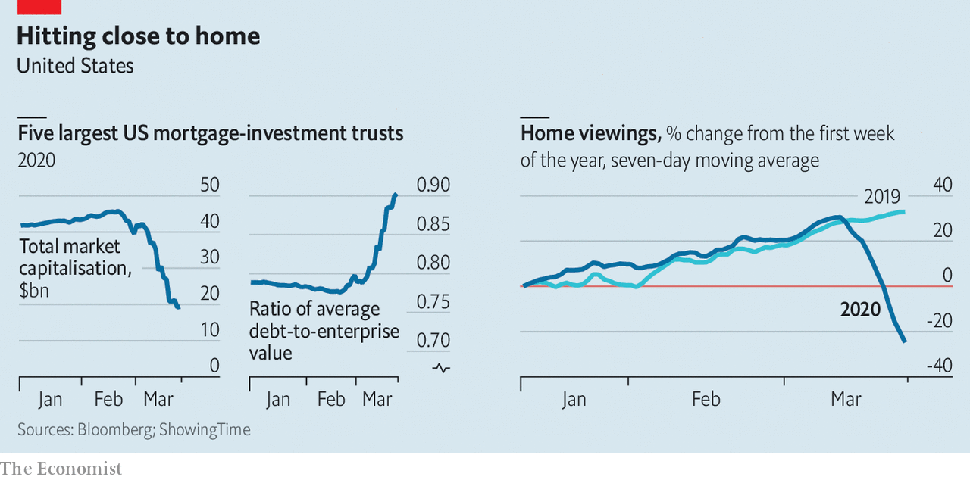

AMERICA'S $19trn commercial and residential mortgage market is jittery as investors begin to fear that laid-off workers and shut-down firms will struggle to repay their debts. Plenty of investors—such as real-estate investment trusts—are highly leveraged. As the value of mortgage-backed securities has dropped sharply they have begun to face margin calls on their debt from their bankers. Some have warned investors that they are unable to meet cash calls. Demand for new residential mortgages is likely to suffer, too. Lockdowns and economic uncertainty have stopped homebuyers looking.■

This article was downloaded by calibre from <https://www.economist.com/finance-and-economics/2020/03/26/americas-mortgage-market-sickens>

|  |  |  |  |
| --- | --- | --- | --- |
| Previous | Articles | Sections | Next |

|  |  |  |  |
| --- | --- | --- | --- |
| Previous | Articles | Sections | Next |

#### The Zoom accord

# America’s central bank is not the only one doling out greenbacks

Central banks in emerging markets are conducting auctions

Mar 26th 2020 | HONG KONG

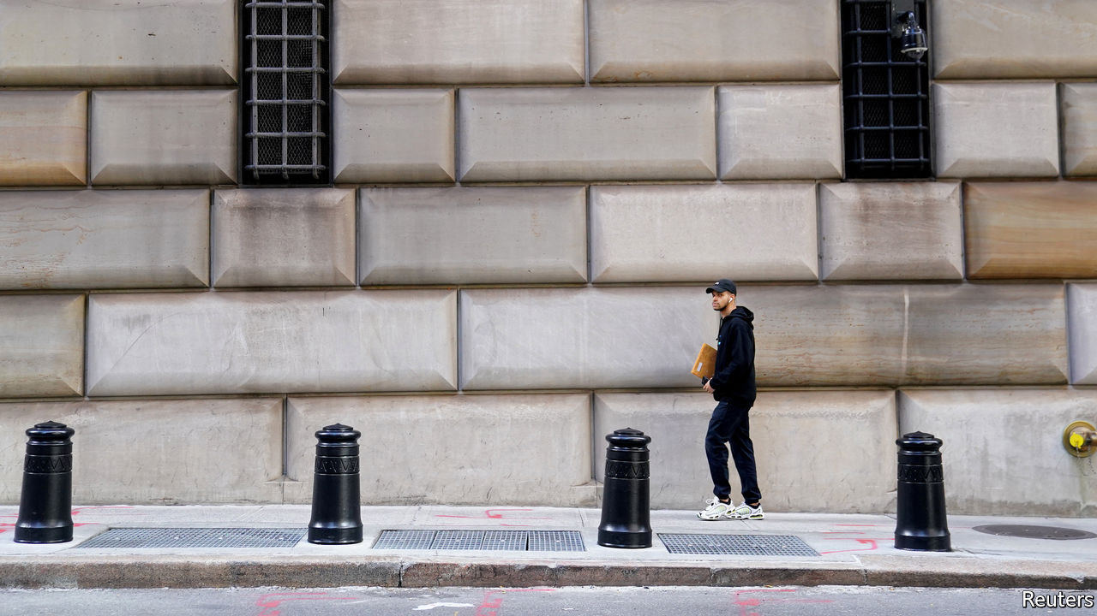

Editor’s note: The Economist is making some of its most important coverage of the covid-19 pandemic freely available to readers of The Economist Today, our daily newsletter. To receive it, register [here](https://www.economist.com/newslettersignup). For more coverage, see our coronavirus [hub](https://www.economist.com/coronavirus)

WHEN AMERICA and its allies wanted to cheapen the dollar in 1985, their officials met in the Plaza Hotel in New York. When they sought to stabilise the currency two years later, they gathered in the Louvre Palace in Paris, conversing over turbot soufflé cardinale washed down with Puligny Montrachet, according to Funabashi Yoichi, a former journalist. The dollar is again a cause of international concern, strengthening from March 9th to 20th, as companies, banks and countries scrambled for the world’s dominant currency, before falling a little this week. But if the world’s policymakers wish to tame it again, where will they meet? In a time of lockdowns, any successor to the Plaza and Louvre accords will have a less resonant name.

America’s Federal Reserve has already tried to alleviate dollar scarcity by reviving a network of swap lines, which allow other central banks to borrow dollars in exchange for the equivalent amount in their own currencies, swapping them back again up to three months later. The Fed eased the terms of its existing lines with Britain, Canada, the euro area, Japan and Switzerland. It then reintroduced lines with nine other central banks, including those of Australia, Brazil, Mexico, New Zealand, Singapore and South Korea.

Many of these central banks are now busily furnishing dollars to banks at home. The Bank of Japan has offered over $156bn since March 17th. Its counterparts in the euro area, Britain and Switzerland have lent over $182bn combined. On March 18th Brazil’s central bank began offering dollar loans to financial institutions that could provide Brazilian government bonds, issued in global markets, as collateral. The Bank of Mexico said it would begin dollar auctions. Earlier this month, the Reserve Bank of India (RBI), which does not have a Fed swap line, but does have almost $482bn of its own foreign-exchange reserves, offered $2bn to its banks. It received bids worth over $4.6bn, prompting it to offer another $2bn auction on March 23rd.

Could the Fed extend these lines further? It has no appetite for assessing which countries warrant its help, or bearing the risk that it might not get its dollars back. Some have therefore suggested it should team up with the IMF. In 2015 Randall Henning of the American University in Washington, DC, proposed that the fund could decide confidentially which of its members has the “very strong” policies and institutions required to qualify for its own precautionary, strings-free loans. These countries would then also become eligible for a Fed swap line. If ever they could not repay, the fund would lend them the money to do so. Mr Henning calculated that, in addition to Mexico and South Korea, another seven emerging markets might qualify, including Chile and Malaysia.

If the dollar resumes its upward march, America’s Treasury could also help weaken it by buying other currencies, points out Zach Pandl of Goldman Sachs. But what to buy? The traditional choices would be the euro and the yen. But both Japan and the euro area fear the deflationary impact of a stronger currency. A better bet, Mr Pandl argues, might be Mexico’s peso or Brazil’s real. It’s just a pity officials cannot share a meal and a bottle of fine wine before they tuck in to each other’s currencies. ■

Dig deeper:  
For our latest coverage of the covid-19 pandemic, register for The Economist Today, our daily [newsletter](https://www.economist.com/newslettersignup), or visit our [coronavirus hub](https://www.economist.com/coronavirus)

This article was downloaded by calibre from <https://www.economist.com/finance-and-economics/2020/03/26/americas-central-bank-is-not-the-only-one-doling-out-greenbacks>

|  |  |  |  |
| --- | --- | --- | --- |
| Previous | Articles | Sections | Next |

|  |  |  |  |
| --- | --- | --- | --- |
| Previous | Articles | Sections | Next |

#### Ripping up the rules

# The ECB breaks its self-imposed rules

But will its latest salvo alone ensure a healthy expansion?

Mar 26th 2020 |

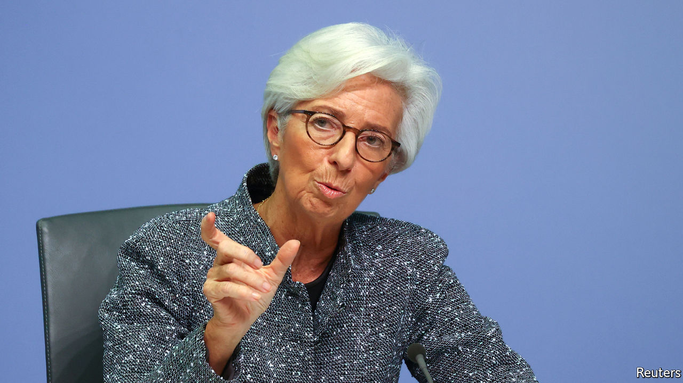

Editor’s note: The Economist is making some of its most important coverage of the covid-19 pandemic freely available to readers of The Economist Today, our daily newsletter. To receive it, register [here](https://www.economist.com/newslettersignup). For more coverage, see our coronavirus [hub](https://www.economist.com/coronavirus)

CHRISTINE LAGARDE took over as the president of the European Central Bank (ECB) in November intent on peacemaking. The bank’s negative interest rates and bond-buying were reviled in the euro area’s northern countries. In order to heal the rift Ms Lagarde launched a year-long review of the ECB’s strategy. Few investors expected policy to change much in 2020.

Covid-19 upended all that. On March 18th the ECB announced an emergency asset-purchase scheme that would buy €750bn ($809bn) in government and corporate bonds. With its existing programmes, the bank will hoover up over €1trn in assets this year—equivalent to 9% of euro-area GDP. But even this might not be enough to gin up the economy.

The severity of the pandemic means that the ECB has been bolder and considerably more flexible than economists would have thought possible a few months ago, says Piet Christiansen of Danske Bank. In large part that is because the ECB is amending some of the rules that have until now governed its asset purchases.

One self-imposed rule concerns the composition of purchases. The ECB generally tries to buy government bonds in proportion to the capital each member state puts into it (or its “capital key”), which is roughly in line with the size of its economy. This time the bank will be more flexible. It could, for example, buy more Italian and Spanish bonds, even though these together account for around a quarter of the capital key. As the virus spread across the south of the euro zone, investors had begun to demand a higher premium for holding southern states’ bonds—and Ms Lagarde did not help when she remarked that she did not consider it the ECB’s job to close yield spreads. The announcement of the emergency bond purchases helped to calm those nerves.

More controversially, the ECB says its emergency purchases will not be bound by its self-imposed “issuer limit”, which had meant that it could not hold more than a third of a member’s sovereign debt. Its holdings of German and Dutch bonds have been fast approaching the cap. The decision could raise heckles in Germany, where the rule is seen as ensuring that the ECB’s purchases do not monetise national debt.

The ECB is breaking more of its own rules. It is expanding the range of assets it will buy. The new scheme will cover Greek sovereign bonds; they had previously been deemed ineligible because of their low credit rating. And the ECB will start to buy assets with maturities of less than a year. That has a happy interaction with recent fiscal easing. On March 23rd the German government said that it would borrow €156bn in order to support its economy (see article). Much of Germany’s borrowing will take the form of short-term bills, says Frederik Ducrozet of Pictet, an asset manager.

Even with all this flexibility, there is still a question of whether the stimulus is sufficient. The extent of the economic damage done by the virus is slowly becoming clear. On March 24th a survey of purchasing managers indicated the steepest drop in activity in its 22-year history. Investors’ medium-term inflation expectations, as measured by the five-year forward swap rate, have fallen to 0.8%, well below the bank’s target of inflation close to, but below 2%. That suggests that investors think more easing is needed to ensure a healthy expansion after the epidemic ends.

One reason for investors’ gloom may be that governments are still doing too little. Even after Germany’s splurge, new spending across the euro zone amounts to only 2% of GDP. Economists at Citibank estimate that something nearer 5% is warranted. Leaders were set to consider whether to make cheap credit lines available to governments through the zone’s bail-out fund after The Economist went to press. Such talks tend to become mired in arguments over what type of strings should be attached to the cash. The pandemic means that a deal looks likelier than ever. But central bankers are also well aware of another, less happy, link between monetary and co-ordinated fiscal policy. The more the ECB does, the less governments feel they need to take action. ■

Dig deeper:  
For our latest coverage of the covid-19 pandemic, register for The Economist Today, our daily [newsletter](https://www.economist.com/newslettersignup), or visit our [coronavirus hub](https://www.economist.com/coronavirus)

This article was downloaded by calibre from <https://www.economist.com/finance-and-economics/2020/03/26/the-ecb-breaks-its-self-imposed-rules>

|  |  |  |  |
| --- | --- | --- | --- |
| Previous | Articles | Sections | Next |

|  |  |  |  |
| --- | --- | --- | --- |
| Previous | Articles | Sections | Next |

#### Buyer beware

# Saudi Arabia stopped trying to support oil prices. Enter America

But a supply agreement can do little in the face of a huge demand shock

Mar 26th 2020 | NEW YORK

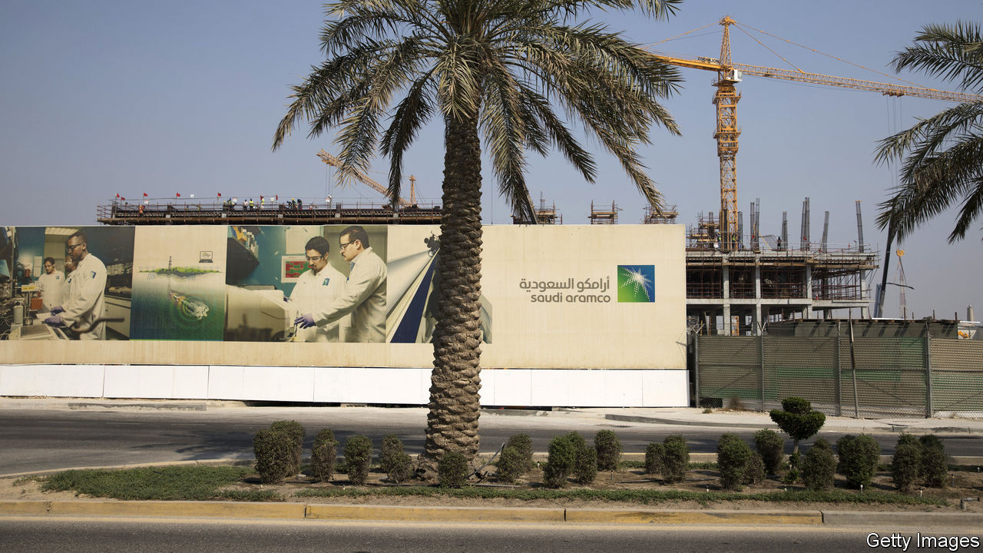

EARLY IN MARCH the oil market’s central banker seemed to go berserk. Saudi Arabia, the most powerful member of the Organisation of the Petroleum Exporting Countries (OPEC), has long adjusted its supply to help stabilise the price of crude. Russia had teamed up with OPEC since 2016, but as covid-19 drove demand relentlessly down, it refused OPEC’s plea to cut production. Saudi Arabia retaliated, declaring its intent to flood global markets. The price of Brent crude halved between March 5th and 18th, to $25 a barrel.

America is stepping in. On March 19th its Department of Energy said it would buy 77m barrels of American crude to store in its strategic stockpile. Ryan Sitton, a Texas oil regulator, is mulling restrictions on his state’s output, which accounts for 41% of America’s total. “The world is in an extraordinary time,” he says. “We need to consider extraordinary solutions.” News on March 23rd that President Donald Trump had appointed an energy envoy to Saudi Arabia raised hopes that America might broker a truce between the kingdom and Russia.

America is not a newcomer to oil-market meddling. The formation of OPEC was inspired in part by the Texas Railroad Commission (on which Mr Sitton now serves). In the 1930s, when the price of oil wallowed below $1 a barrel, troopers fanned across Texas to enforce the commission’s production limits. As America’s oil imports rose, attention shifted to securing supply. The Strategic Petroleum Reserve was created in 1975, after the Arab oil embargo.

Now that shale has transformed America into the world’s biggest oil producer, the country has renewed interest in propping up the price of crude. Mr Sitton maintains that production cuts may be necessary to ensure that America’s shale industry survives covid-19. But America will find OPEC’s mantle an awkward fit.

The vast salt caverns along America’s Gulf coast that contain the strategic reserve are already about 90% full, so they cannot store enough excess supply. Texan regulators have not tried to curb output for decades. Any attempt would surely meet legal and practical hurdles. A grand supply agreement between America, Saudi Arabia and Russia might boost the oil price, but only temporarily.

“The price war has become largely irrelevant,” says Ben Luckock of Trafigura, a trading company. Saudi production now seems far less important, he argues, than the pandemic’s historic destruction of oil demand. Covid-19 is obliterating this at such an astonishing rate that analysts cannot adjust their models quickly enough. Bernstein, a research firm, estimates that demand in the first half of the year may be 10%, or even 20%, below what it was in 2019. In the past 35 years demand has only twice been lower than in the preceding year—in 2008 and 2009.

Yet production has been slow to respond. That is only in part because of the price war. Once a shale well is drilled, there are only marginal savings from stopping production. Many oil companies are hedged and continue pumping in the hope prices will rise. Even when firms slash spending, output may not drop quickly. On March 24th Chevron, an American supermajor, said that it would cut capital spending by 20% this year, but that production in 2020 would roughly match that in 2019.

It looks possible that supply will not just exceed demand for oil now but fill the capacity to store it. Bernstein reckons that there could be over 735m barrels of extra crude this year, and only about 500m barrels of storage available in the OECD, a club of mainly rich countries, and oil tankers.

In the face of such a demand shock, “a production cut that takes a month or two to implement won’t do much,” argues Damien Courvalin of Goldman Sachs, a bank. He contends that a production limit in Texas would slow the consolidation that America’s shale industry needs to be competitive in the long term. Government stimulus might help to boost demand. But the essential fix to bring the market back into balance, reckons Mr Luckock, is a painful one: even lower oil prices. ■

This article was downloaded by calibre from <https://www.economist.com/finance-and-economics/2020/03/26/saudi-arabia-stopped-trying-to-support-oil-prices-enter-america>

|  |  |  |  |
| --- | --- | --- | --- |
| Previous | Articles | Sections | Next |

|  |  |  |  |
| --- | --- | --- | --- |
| Previous | Articles | Sections | Next |

#### Buttonwood

# An imaginative template for dealing with the cash crunch

The world of distressed lending offers a guide

Mar 26th 2020 |

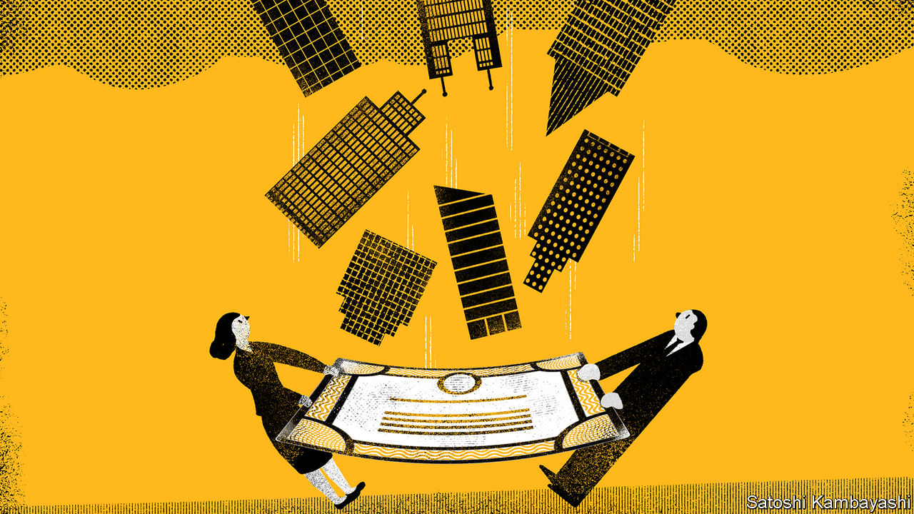

Editor’s note: The Economist is making some of its most important coverage of the covid-19 pandemic freely available to readers of The Economist Today, our daily newsletter. To receive it, register here. For more coverage, see our coronavirus hub

TAKE YOURSELF back, if you can manage it, to a more tranquil time—January, say. Imagine a smallish restaurant chain that had a bad Christmas. Its owner borrowed heavily to expand only to find its new outlets were slow to attract customers. The chain cannot meet its interest and other costs. A consultancy says $10m is needed to tide the firm over until its problems are fixed. The bank says it will forgo interest payments worth $5m, if the owner kicks in $5m of equity capital. A deal is struck.

Fast-forward a few weeks and imagine a similar chain that is temporarily shut down because of the covid-19 virus. The firm has no revenue, but it still has fixed costs. The hypothetical January deal is a template for dealing with the problem. But in a broader crisis, things are always trickier. The bank’s balance-sheet is stretched to the limit. The stockmarket crash has taken a bite from the owner’s wealth. And she is reluctant to sell a stake in the business.

An alternative is to turn to specialist private-credit funds. These are vehicles backed by long-term investors, such as insurance firms, sovereign-wealth funds and university endowments, which lend directly to companies, much as a bank would. Some will have discrete distressed-lending or “special-situation” arms. Many more are prepared to put up capital when others won’t. And everything is a special situation now. So the mindset and methods of these specialists will need to be broadly applied.

What might they offer our hypothetical restaurant chain? One option is a payment-in-kind (or PIK) loan. This affords the borrower flexibility. If the shutdown is protracted, it can roll up missed interest payments into the outstanding debt (ie, pay them in kind). Once the business gets back to normal, it can make interest payments in cash again. A PIK loan has two advantages, according to Mark Attanasio and Jean-Marc Chapus of Crescent Capital, a private-credit firm. It gives immediate relief, and it leaves the capital structure largely intact, so the owner retains control. The lender, in essence, says to the borrower “you take a spring break on interest payments; we believe in your recovery.”

Of course, the interest on any loan granted in a distressed situation will be steep. The opportunity cost to a lender is the double-digit yields now on offer in the high-yield bond market. A way to reduce the risk to the lender, and thus the cost to the borrower, is to secure a loan on fixed assets. Last week United Airlines agreed a one-year loan with banks backed by aircraft and other collateral, according to Bloomberg News. Part of the loan was then sold on to Apollo, a leading private-capital firm. More deals like this seem likely.

Not every business in need is a big airline. A lot of medium-sized firms, like our hypothetical restaurant chain, do not have many tangible assets. Property and equipment are leased. The firm’s worth is in intangibles, such as its brand. There is no value for a lender to recover if the company is liquidated. And in complex situations, such as this one, it is difficult to estimate the severity of the short-term damage and how quickly a business will recover. The ideal solution is an injection of equity capital. But shareholders are reluctant to issue equity in recessions, when stock values are depressed, as it dilutes the value of their stake. Convertible loans offer a way around this. These carry a lower rate of interest than a conventional loan, but give the lender the possibility of converting it into equity when things—revenues, profits, asset values—return to normal.

In our ideal world, there is one lender and one owner. The real world is messier. Lenders to firms in distress expect to be paid back before other creditors. But the company may have covenants on its existing debt that rule out a new lender pushing to the front of the queue. A unique situation calls for flexibility. “The right paradigm is a natural disaster,” says Jonathan Lavine of Bain Capital. “More than ever, banks, shareholders and other lenders will have to work together.”

The goal should be to keep healthy firms intact. There are some specialists that buy the debts of troubled companies in the expectation they will be forced into bankruptcy, wiping the shareholders out and leaving the debt-holders as owners. A change at the top is sometimes necessary. But in general, it makes sense only if the management has screwed up. That does not apply to the vast majority of companies now in distress. It will need a lot of ingenuity and capital to tide them over. It will also need a fair bit of goodwill.

Dig deeper:  
For our latest coverage of the covid-19 pandemic, register for The Economist Today, our daily [newsletter](https://www.economist.com/newslettersignup), or visit our [coronavirus hub](https://www.economist.com/coronavirus)

This article was downloaded by calibre from <https://www.economist.com/finance-and-economics/2020/03/26/an-imaginative-template-for-dealing-with-the-cash-crunch>

|  |  |  |  |
| --- | --- | --- | --- |
| Previous | Articles | Sections | Next |

|  |  |  |  |
| --- | --- | --- | --- |
| Previous | Articles | Sections | Next |

#### Free exchange

# How to pay for the pandemic

Covid-19 could usher in a new era of sovereign-debt management

Mar 25th 2020 |

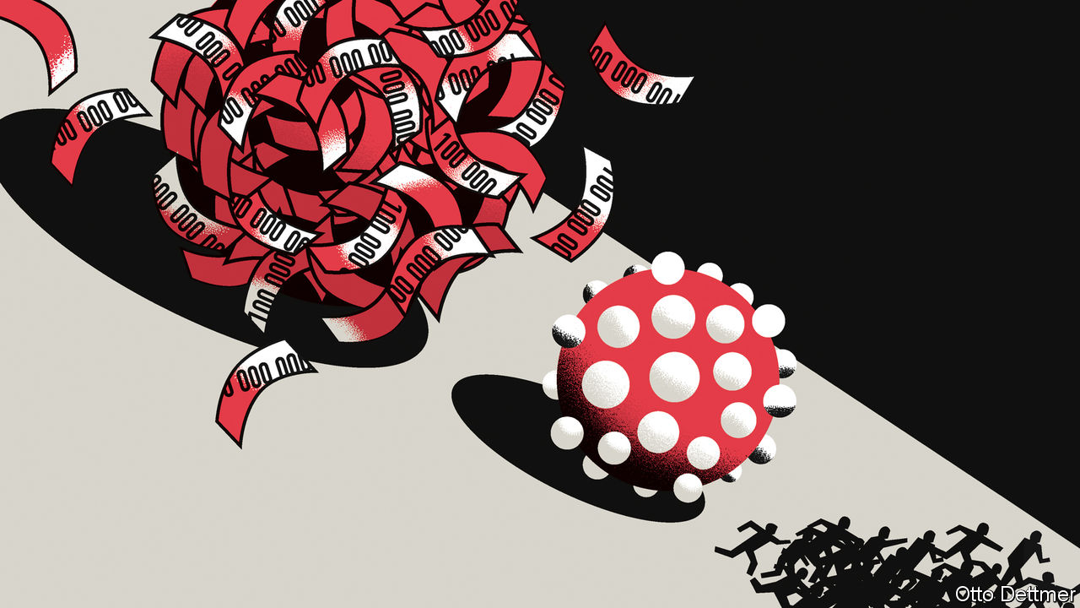

Editor’s note: The Economist is making some of its most important coverage of the covid-19 pandemic freely available to readers of The Economist Today, our daily newsletter. To receive it, register [here](https://www.economist.com/newslettersignup). For more coverage, see our coronavirus [hub](https://www.economist.com/coronavirus)

THIS IS NO time to fret about government debt. While cases of covid-19 soar and economic activity grinds to a halt, governments are right to throw all the resources they can at efforts to limit the pandemic’s human and economic costs. This urgency notwithstanding, the crisis will push sovereign-debt burdens into new territory. Over the past century, major global crises have often led both to large-scale borrowing by governments and to changes—often radical—in the way they handle their creditors. The battle against covid-19 is unlikely to prove an exception. Economic rescue plans now being drawn up are likely to outstrip those employed during the financial crisis; America’s may be worth around 10% of GDP. The blow to output and to tax revenues could also be larger. At least a few economies are likely to find themselves with debt loads well in excess of 150% of GDP.

The history of government borrowing over the past hundred years or so can be divided into three periods. Between the start of the first world war and that of the second, conflict, rebuilding and the Great Depression all placed enormous demands on government balance-sheets. During this tumultuous period, governments were often at the mercy of market sentiment. Britain sought to maintain market confidence by reducing debt—which rose to 140% of GDP immediately after the first world war—through painful austerity. The government ran a primary-budget surplus (ie, net of interest expenses) of 7% of GDP throughout the 1920s.

The results were disastrous. Austerity undercut economic growth: output in 1928 remained below that in 1918. As a consequence, debt continued to rise, reaching 170% of GDP in 1930. Remarking on the bitter experience, John Maynard Keynes noted that “assuredly it does not pay to be good.” Other economies, forced into more desperate measures, fared even worse. Germany, weakened by war and unable to meet its debt obligations, sank into hyperinflation. The destruction of the currency’s value reduced its debt burden as a share of GDP by a huge 129 percentage points, albeit at enormous social and economic cost. Default was also common. In 1933 countries making up nearly half of global GDP were in some form of default or debt restructuring.

During and after the second world war, the governments of advanced economies tried a different approach. After the trauma of the previous 30 years, austerity was no longer a politically tenable means of dealing with the debts built up over the period. Some countries defaulted or experienced post-war hyperinflations. Other governments turned to financial repression—ie, forcing creditors to lend to them on unattractive terms. Many of the tools of repression had been deployed during the war to pay for the conflict. In America, for instance, the Federal Reserve bought Treasuries to prevent yields from rising above a set level. The government also capped the interest rates banks could charge borrowers or pay depositors, and restricted bank lending. Capital controls prevented savers from seeking better returns abroad.

The effect was to force domestic institutions and households to lend to the government at below-market rates. As wartime price controls were relaxed, inflation rose to relatively modest levels and the rate of interest on government debt, adjusted for inflation, turned negative, and remained so for much of the ensuing decades. According to work by Carmen Reinhart of Harvard University and Belen Sbrancia of the IMF, real interest rates across advanced economies were negative roughly half the time between 1945 and 1980. The British government paid an average real interest rate over the period of just -1.7%; the French, -6.6%. The effect was powerful. Between 1946 and 1961 America’s debt-to-GDP ratio dropped by 68 percentage points. In the 1970s debt to GDP across all advanced economies sank to a low of 25%.

A third era began in the 1970s. Governments of advanced economies loosened their grip over capital flows and financial systems, placing themselves once more at the mercy of global capital markets. Though bond markets occasionally pushed politicians around in the 1980s and 1990s, they slowly lost their power to instil fear. Global financial integration has coincided with a rise in desired saving relative to investment, and a hearty appetite for the safety provided by the bonds of rich countries with stable currencies. Borrowing costs have fallen steadily, even as debt loads have grown. The global financial crisis only reinforced this trend. Public debt in rich countries rose from 59% of GDP in 2007 to 91% in 2013. Yet rich-world governments have been able to borrow at near-zero or negative rates over the past decade.

## Money printer go brrr

Covid-19 means there is more red ink to come. A new era of sovereign-debt management could be about to begin. What this period may bring is not yet clear. The post-pandemic debt regime might resemble that of the immediate post-war era. The trials of this crisis could inspire a new wave of investment in technology and infrastructure, leading to fierce competition for available savings and higher government-borrowing costs. Repression would allow governments to manage the surge, especially if barriers to goods and capital go up in the aftermath of national lockdowns.

Alternatively, growth may prove difficult to restart as the pandemic ebbs. Central banks, in an effort to provide relief to troubled economies, are already buying up large quantities of government debt. The Fed is purchasing unlimited amounts of Treasuries; the European Central Bank recently announced a €750bn ($809bn) bond-buying scheme. A weak recovery could push central banks to finance large fiscal deficits with freshly printed cash on an ongoing basis. The experience of Japan, once considered an economic oddity, will be repeated more widely. Money-financed borrowing on that scale, with no inflationary consequences, would turn popular ideas about the limits to debt on their head. It would not be the first time a crisis rewrites the rule book. ■

Dig deeper:  
For our latest coverage of the covid-19 pandemic, register for The Economist Today, our daily [newsletter](https://www.economist.com/newslettersignup), or visit our [coronavirus hub](https://www.economist.com/coronavirus)

This article was downloaded by calibre from <https://www.economist.com/finance-and-economics/2020/03/25/how-to-pay-for-the-pandemic>

|  |  |  |  |
| --- | --- | --- | --- |
| Previous | Articles | Sections | Next |

|  |  |  |
| --- | --- | --- |
| Finance and ... | Sections | Books and arts |

Science and technology

Covid-19 and climate change: Clear thinking required

.

Covid-19 and pollution: Heat and dust

.

Detecting elevated body temperatures: And now here is the fever forecast

.

|  |  |  |
| --- | --- | --- |
| Finance and ... | Sections | Books and arts |

|  |  |  |  |
| --- | --- | --- | --- |
|  | Articles | Sections | Next |

#### Covid-19 and climate change

# The epidemic provides a chance to do good by the climate

The chances are, though, that it will not be taken

Mar 26th 2020 |

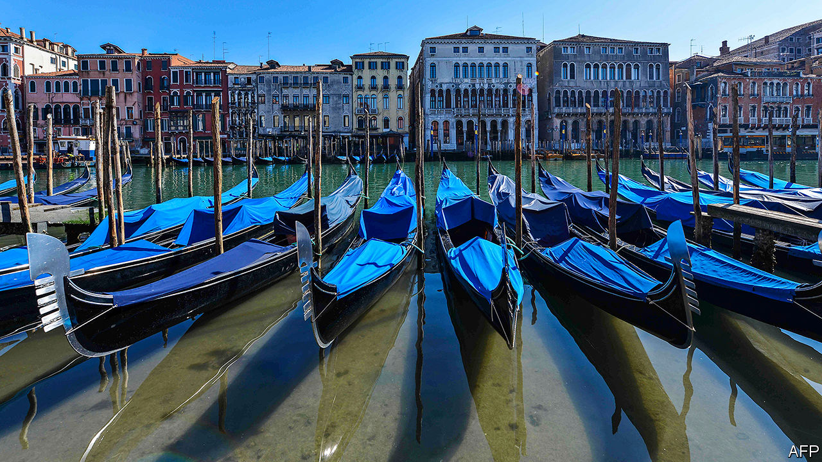

Editor’s note: The Economist is making some of its most important coverage of the covid-19 pandemic freely available to readers of The Economist Today, our daily newsletter. To receive it, register [here](https://www.economist.com/newslettersignup). For more coverage, see our coronavirus [hub](https://www.economist.com/coronavirus)

IN VENICE, WATER in the canals is running clear, offering glimpses of fish swimming against the current. As human activity grinds to a halt, natural rhythms resume. A similar, less visible story is being played out in the skies. Around the world, levels of toxic air pollutants are dropping as places go into lockdown in an attempt to curb the spread of SARS-CoV-2, the virus causing a pandemic of a new disease called covid-19. Emissions of greenhouse gases are following a similar pattern.

One example of pollution falling is that satellites looking down on China’s large cities have witnessed a dramatic drop since January in levels of nitrogen dioxide, a gas generated by machinery such as internal-combustion engines. This fall coincides with the imposition of a countrywide quarantine, travel restrictions, and the shutting down of power stations and factories. Nitrogen dioxide causes respiratory problems. A drop in its levels therefore brings benefits. The concentration of another pulmonary irritant—fine soot particles—was also lower in those cities, by 20-30%, in February of this year compared with levels in the previous three years.

## Clearing the air

Similar patterns have shown up elsewhere, as the virus spreads and lockdowns follow. Satellite data from Italy reveal a marked decline in nitrogen-dioxide concentrations, particularly in the Po valley, the original focus (see article) of the country’s epidemic, and where Italy’s shelter-at-home rules were first imposed. South Korea also saw a drop, starting in mid-February. And in New York City, data collected by TomTom, a GPS-navigation firm, show peak-hour traffic down between 13.5% and 26%. Not surprisingly, carbon-monoxide levels in the city are half those during the corresponding period last year, according to researchers at Columbia University.

Drops like these, in pollutants that are directly harmful to human health, would be expected to be matched by falling emissions of those more-subtly harmful pollutants, the greenhouse gases produced by human activity. And the team at Columbia did indeed find that carbon-dioxide concentrations over New York have fallen. They dropped by 8-10% this month compared with March 2019. In China, meanwhile, industrial shutdowns are estimated to have caused a 25% drop in emissions of CO2 in February, compared with the same month in 2019.

An optimist might see these changes as a silver lining to what is an extremely dark cloud. But that would depend on their being sustained when things return to normal. As François Gemenne of the University of Liège, in Belgium, puts it, “the climate needs a sustained drop in greenhouse-gas emissions, not a year off”. Unfortunately, not only is that unlikely to happen, but the response to the crisis could easily make things worse.

The short-term amelioration of CO2 emission is likely to be real. On March 16th Glen Peters of Norway’s Centre for International Climate Research published estimates suggesting that if, as forecast by the Organisation for Economic Co-operation and Development (OECD) at the beginning of the month, the world’s GDP were to grow by 1.5% this year (a halving of its pre-pandemic estimate), this would lead to a 1.2% decline in carbon-dioxide emissions. This decline, even though the economy would still be growing, would be because of the increasing carbon-efficiency of economic activity. Since then, the prospects for the global economy have worsened considerably. Most forecasters now expect world GDP to shrink this year, and some predict a contraction of fully 4%—twice the decline seen after the global financial crisis of 2007-09. That will make the fall in emissions even bigger.

But not, perhaps, for long. In 2009, worldwide CO2 emissions from fossil fuels and cement production dropped by 1.4%. A year later, however, they were growing again by 5.8-5.9%—faster than they had done since 2003. By the end of 2010, annual emissions were greater than they had ever been (see chart). Overall, therefore, the financial crisis made little difference to the quantity of CO2 in the atmosphere.

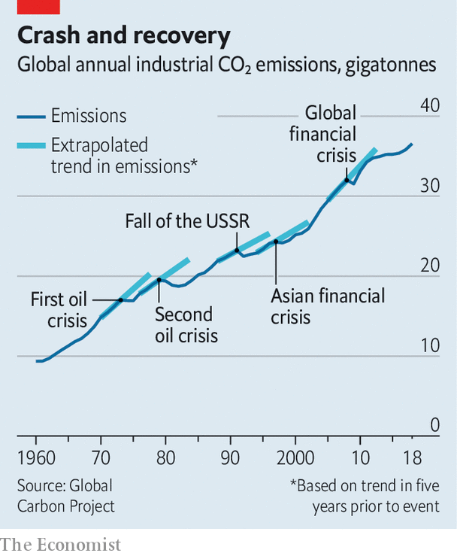

Subsequent analysis has shown that the rise of emissions after the crisis of 2008 was caused especially by rapid growth in certain large emerging economies, notably those of China and India. Low fossil-fuel prices were part of the cause. But there were also stimulus packages deliberately intended to promote carbon-intensive areas of business, such as construction.

Sadly, there are signs of a similar pattern of environmentally inappropriate stimuli happening now. Canada, for instance, is preparing a multibillion-dollar bail-out for its oil and gas industry. Airlines are clamouring for help, too. Several Chinese provinces have announced plans to go on a 25trn yuan ($3.5trn) construction-spending spree. And other ideas that have been floated in China include vouchers to encourage people to buy cars.

Meanwhile, an analysis by BloombergNEF, a clean-energy-research firm, finds that solar power may take a hit, as governments preoccupied with fighting the virus postpone decisions to commission new plants and to agree on targets for the growth of renewable energy. China, indeed, has already deferred an auction for the right to build several huge solar farms. As a result, BloombergNEF suggests, for the first time in decades the amount of solar-energy capacity installed this year could be lower than that in the previous one.

There is also the question of what happens to COP26, the 2020 United Nations Climate Change Conference which is supposed to be held in Glasgow, in November. This was meant to be a moment for the world’s governments to come forward with their most ambitious plans yet to address the problem of rising greenhouse-gas emissions—the first summit of such moment since the one held in Paris in 2015, which agreed to limit global warming to 1.5-2°C above pre-industrial levels. British ministers and UN officials are now discussing whether to shift the meeting into the early months of 2021.

In the shorter term, the focus is on what will happen to an important preparatory meeting scheduled to take place in Bonn, in June. To get agreement at COP26 was already going to be challenging, even without a global pandemic to detract political minds and resolve. Delaying the meeting in Bonn will make things worse.

## A window of opportunity?

There are a few accidental consequences of the epidemic, though, that may have long-term effects which greens would see as positive. One concerns everybody’s favourite environmental whipping boy, the airline industry. Before the crisis, this industry agreed to the launch next year of a scheme called CORSIA, which has the goal of maintaining net global emissions from aeroplanes at the annualised average of the two years 2019 and 2020. Emissions beyond this average would have to be offset by such things as tree-planting projects and schemes to capture methane from landfill sites. Clearly, emissions by airlines in 2020 are going to be abnormally low, which will, if the rules are followed, lower the threshold above which these offsets would be invoked. Whether that happens in practice will depend, though, on whether airlines are willing to continue to be bound to something rather different from what they originally thought they were signing up to.

Ultimately, the outcome of covid-19 for the climate will depend on two unknowns. One is how long the pandemic lasts—something over which politicians have some control, but certainly not as much as they would like. The other is how governments choose to pull their economies out of the hole now being created, which is entirely a matter of politics.

The lazy way, the easy way, to boost countries’ economies in response to the virus would be for governments to throw money at established versions of big industries like energy, transport and construction. They could, though, if they chose to do so, spend the cash instead on encouraging climate-friendly versions of these industries: more solar energy (or even, heaven forfend, nuclear power) instead of bungs to oil and gas; more batteries for cars, and money for research into hydrogen-powered fuel cells; cash prizes for ways of making steel and cement without releasing CO2; and so on.

Fatih Birol, head of the International Energy Agency, an intergovernmental organisation that operates under the aegis of the OECD, has already put out a plea for green stimuli of this sort. Similar calls, though, were made in 2008 and 2009. They fell on deaf ears. Perhaps this time around it will be different.■

Dig deeper:  
For our latest coverage of the covid-19 pandemic, register for The Economist Today, our daily [newsletter](https://www.economist.com/newslettersignup), or visit our [coronavirus hub](https://www.economist.com/coronavirus)

This article was downloaded by calibre from <https://www.economist.com/science-and-technology/2020/03/26/the-epidemic-provides-a-chance-to-do-good-by-the-climate>

|  |  |  |  |
| --- | --- | --- | --- |
|  | Articles | Sections | Next |

|  |  |  |  |
| --- | --- | --- | --- |
| Previous | Articles | Sections | Next |

#### The pandemic

# Airborne particles may be assisting the spread of SARS-CoV-2

Reducing pollution seems to reduce the rate of infection

Mar 26th 2020 |

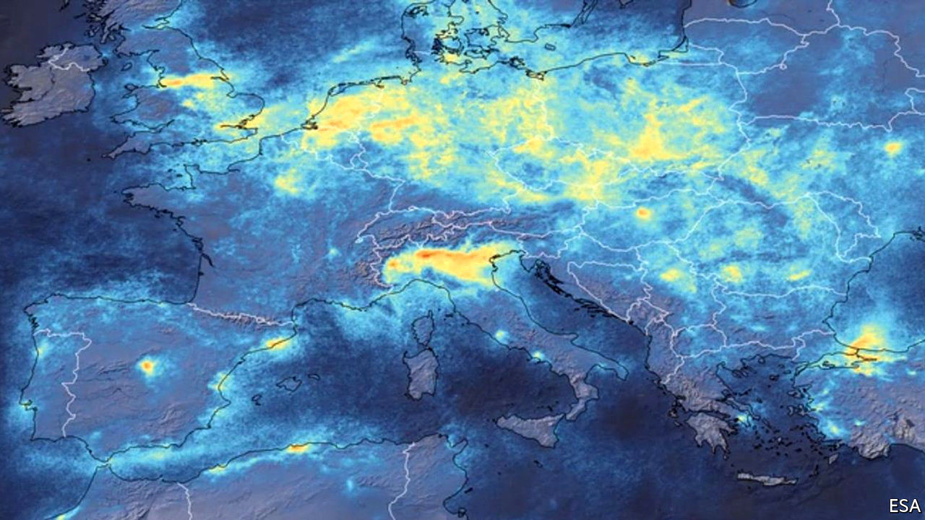

Editor’s note: The Economist is making some of its most important coverage of the covid-19 pandemic freely available to readers of The Economist Today, our daily newsletter. To receive it, register [here](https://www.economist.com/newslettersignup). For more coverage, see our coronavirus [hub](https://www.economist.com/coronavirus)

POLLUTION AND disease have long been associated in people’s minds. The very word “malaria”, for example, means “bad air” in Italian. But the germ theory of infection, developed in the 19th century, knocked on the head the idea that it is the air itself which causes illness. Rather, bad smells indicate sources of pathogens, such as sewage, which are best avoided. A paper just published by a group of Italian researchers does, however, posit the idea that SARS-CoV-2, the virus behind the covid-19 pandemic, might be getting a helping hand from atmospheric pollution.

The paper in question, by Leonardo Setti of the University of Bologna and his colleagues, has not yet been through any process of peer review. Such early releases are, though, becoming commonplace for covid-19-related work, on the assumption that holding ideas back for bureaucratic approval might cost lives. Dr Setti and his associates found themselves wondering why (even allowing for time lags caused by its arrival in different places on different dates) SARS-CoV-2 seemed to spread much faster in Italy’s north—specifically in the wide plain that forms the valley of the Po—than in other parts of the country.

Their hypothesis is that the catalyst was pollution—specifically, small airborne particles that might carry the virus on their surfaces. These are usually far more abundant in the Po valley than elsewhere. In the paper, the researchers cite previous work from other places which suggests that influenza viruses, respiratory syncytial viruses and measles viruses can all spread by hitching lifts on such particles. And they make a good case that, allowing for a 14-day delay caused by SARS-CoV-2’s incubation period, the daily rates of new infections in the Po valley correlate closely with the level of particulate pollution.

An alternative explanation for this correlation might be that, rather than carrying the virus themselves, airborne particles increase susceptibility to infection in those who encounter the pathogen by some other means. Either way, though, a reduction in airborne-particle levels may be a second way, independent of reduced human contact, that lockdowns will help stop the virus spreading around.

Dig deeper:  
For our latest coverage of the covid-19 pandemic, register for The Economist Today, our daily [newsletter](https://www.economist.com/newslettersignup), or visit our [coronavirus hub](https://www.economist.com/coronavirus)

This article was downloaded by calibre from <https://www.economist.com/science-and-technology/2020/03/26/airborne-particles-may-be-assisting-the-spread-of-sars-cov-2>

|  |  |  |  |
| --- | --- | --- | --- |
| Previous | Articles | Sections | Next |

|  |  |  |  |
| --- | --- | --- | --- |
| Previous | Articles | Sections | Next |

#### Detecting elevated body heat

# Taking people’s temperatures can help fight the coronavirus

And now here is the fever forecast

Mar 26th 2020 |

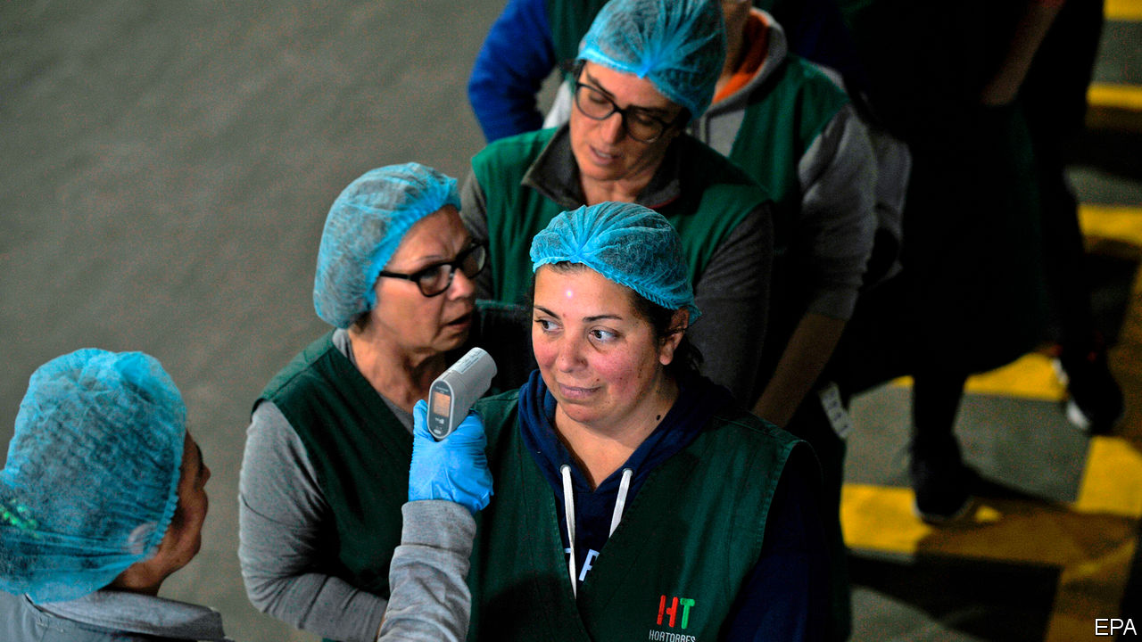

Editor’s note: The Economist is making some of its most important coverage of the covid-19 pandemic freely available to readers of The Economist Today, our daily newsletter. To receive it, register [here](https://www.economist.com/newslettersignup). For more coverage, see our coronavirus [hub](https://www.economist.com/coronavirus)

STICKING A THERMOMETER into an armpit, mouth, ear or other body cavity is the most accurate way to take someone’s temperature. Understandably, though, this cannot be done at airports or checkpoints set up elsewhere to screen the masses for feverish victims of covid-19. So, in a bid to detect the warmth produced by a fever without touching any bodies, officials have opted for alternatives.

The hand-held “thermometer guns” now ubiquitous in China, among other places, are one option. These instruments, known technically as spot pyrometers, use a device called a bolometer to estimate an object’s temperature. A bolometer’s electrical resistance depends on how hot it is. That, in turn, depends on the amount of infrared radiation falling on it from whatever it is pointing at.

Spot pyrometers are used widely in industry to check equipment for signs of overheating, but the infrared signals they rely on can be muddled by dust, moisture, smoke, a change in ambient temperature, a smudge on the device’s lens or even by radio signals. Beyond all this, an official checking a stream of foreheads may, for reasons of personal safety, be reluctant to hold the gun close enough to obtain an accurate reading.

An alternative technology, the thermal camera, is costlier. But it can operate from farther away. Instead of a single bolometer, it has an array of them. These form the pixels which generate the camera’s image, thus building up a heat map of whatever that camera is looking at.

One popular thermal camera, the A320, made by FLIR Systems, an American firm, can detect variations in radiation which correspond to temperature differences within an image of just 0.02°C. But this merely shows whether one part of the object being examined is warmer or cooler than another. When measuring the object’s actual temperature, the A320 is accurate only to about 2°C, says Giovanni Scaglia, FLIR’s head of sales in Italy. For a single reading, this is enough to mistake normal body temperature for a raging fever. In practice, however, the camera’s software looks for deviations from the average temperature of passers-by. Those noticeably hotter than their fellows can then be selected for closer investigation.

Identifying individuals who are infected is important, in order to stop them passing the virus on. But temperature data can also be used to track the epidemic as it spreads. This is the goal of Kinsa Health, a firm in San Francisco that has sold or donated more than 1m smartphone-connected thermometers to households in America. The phones these thermometers are linked to carry an app that transmits back to base each body-temperature recording which its user makes. The app can then give simple medical advice (for example, based on age, sex and so on, does a user with a particular temperature need to see a doctor or not?) The app also provides epidemic information about the neighbourhood, including such things as how badly local schools are affected.

Using its thermometers and apps, Kinsa has built up a trove of data on past fevers in America. Besides being good for public health, this information has commercial value. One American pharmacy chain pays Kinsa for fever data in order to avoid particular stores selling out of things the feverish may wish to purchase.

In the past, Kinsa’s focus has been on influenza. But now the fear is that any elevated body temperature is the result of covid-19. On March 18th the firm began posting relevant data, duly anonymised, but more or less in real time, on a website called Health Weather. In contrast to this “nowcasting”, a government site called FluView, which is run by the Centres for Disease Control and Prevention, relies on sources like hospitals to provide it with data, and tends to lag an epidemic by about two weeks.

Once a fever kicks in, people tend to take their temperature frequently. Kinsa therefore knows a lot about how an epidemic is progressing, and how severe it is, in lots of different places around America. In the past, this has enabled it to make accurate forecasts of disease burden down to the level of individual zip codes. According to Nirav Shah of Stanford University, who advises the firm, such forecasts can look up to 20 weeks into the future for influenza.

Covid-19 is not influenza, of course, and presumably has different patterns of spread. But even before these have been worked out properly, data from Kinsa’s remote thermometers are flagging up useful warnings. As The Economist went to press, atypically high numbers of fevers had popped up in much of peninsular Florida. Time, then, for Floridians to get off the beaches and start keeping their distance from one another.■

Dig deeper:  
For our latest coverage of the covid-19 pandemic, register for The Economist Today, our daily [newsletter](https://www.economist.com/newslettersignup), or visit our [coronavirus hub](https://www.economist.com/coronavirus)

This article was downloaded by calibre from <https://www.economist.com/science-and-technology/2020/03/26/taking-peoples-temperatures-can-help-fight-the-coronavirus>

|  |  |  |  |
| --- | --- | --- | --- |
| Previous | Articles | Sections | Next |

|  |  |  |
| --- | --- | --- |
| Science and ... | Sections | Economic and ... |

Books and arts

Disease and democracy: How to survive a plague

.

Art on the internet: The online of beauty

.

Italian history: Civilisation and barbarism

.

Disappearing acts: Woman overboard

.

Disaster fiction: The yolk of fate

.

|  |  |  |
| --- | --- | --- |
| Science and ... | Sections | Economic and ... |

|  |  |  |  |
| --- | --- | --- | --- |
|  | Articles | Sections | Next |

#### How to survive a plague

# When Athenians feared a disease would wreck their democracy

But it didn’t: mutual trust and free information were a powerful defence

Mar 26th 2020 |

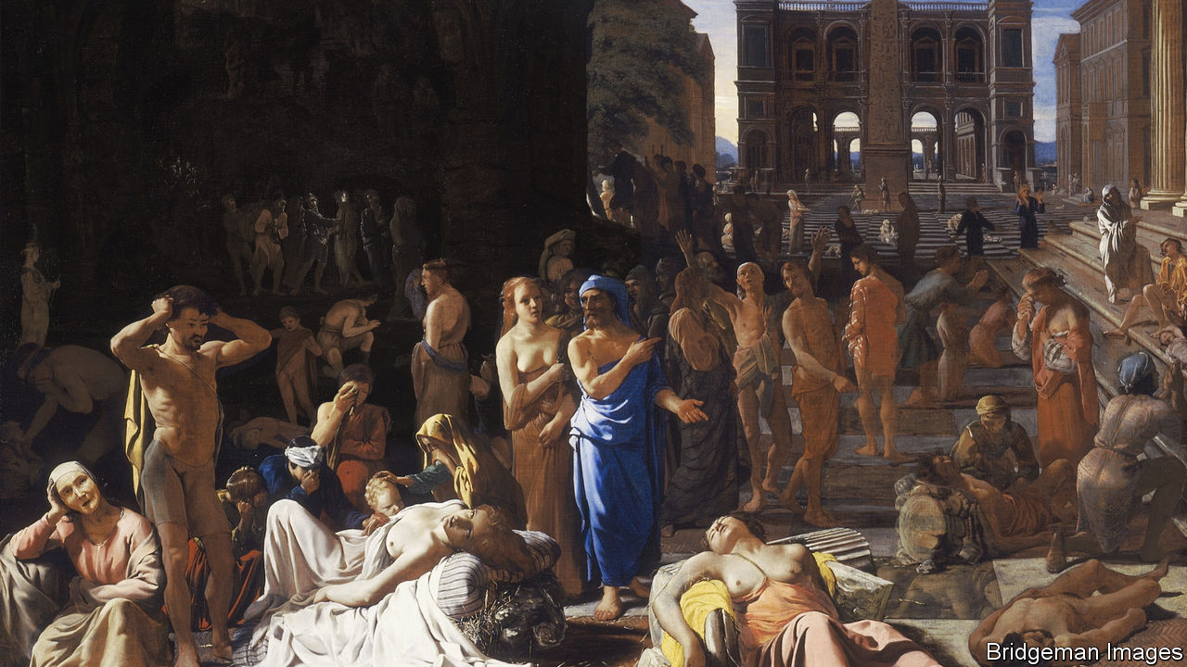

IT IS ONE of the most lurid descriptions in literature of a society collapsing under the shock of a virulent disease. In 430BC, the second year of its war with Sparta, the vibrant city of Athens was struck by a malady that caused panic, despair and a loss of faith in sacred values and institutions. Symptoms included raging fever, retching, convulsions and disfigurement. According to Thucydides, “the catastrophe was so overwhelming that men, not knowing what would happen to them next, became indifferent to every rule of religion or law.”

In his chronicle, Thucydides places ghoulish images of the plague immediately after an oration over the war dead by Pericles—a speech that celebrates the openness and egalitarian optimism of the Athenian state. Perhaps the juxtaposition was meant to emphasise the destruction wrought by the scourge. Consolingly, however, modern research suggests the ancient historian got it the wrong way round: the documentary record is patchy, but these days the crisis is thought to attest to the resilience of Athenian democracy, rather than its fragility.

That record is certainly chastening. Athens, the star among Greek city-states, was profoundly damaged by the disease. The epidemic was the first in a sequence of dire events over three decades: military miscalculations, a rumbling civil war between democrats and oligarchs, violent coups, and surrender to Sparta in 404BC. Anticipating the Bolsheviks, the Spartans sent armed men to close the city’s assembly and impose an authoritarian regime. To anyone witnessing all that first-hand, it must have felt as if the world’s first experiment in rule by the people had ended.

But that feeling would have been premature. The Athenian pestilence and its aftermath were not, in the end, a seismic event comparable to the later plague that began in 540AD, recurred over two centuries and destroyed the late Roman world; or to the Black Death, starting in around 1350, which broke up the feudal society of Europe. In Athens, democracy proved stronger than disease; rather than crumbling, argue Josiah Ober and Federica Carugati of Stanford University in a forthcoming paper, the Athenian system evolved.

True, at least a quarter of the 300,000 or so people who lived in or near the city died—many, writes Ben Akrigg of Toronto University in a recent book, because of disrupted food supplies rather than the disease itself. But there is evidence that Athenian institutions proved robust. Consider the fate of Pericles, who had been elected as one of the city’s ten military commanders in each of the previous 30 years. As anger surged, he was removed in mid-term—but by democratic procedure, not a crazed mob. The next year he was re-elected, only to succumb to the plague himself.

Or take the continuity in the city’s artistic life, including annual drama festivals that required vast, expensive organisation. As Jennifer Roberts of the City College of New York notes, Athenians were presented in 429BC with “Oedipus Rex”, a milestone in world literature. Its portrayal of a king trying to assuage the wrath of Apollo, which took the form of a deadly plague, resonated with audiences who half-suspected that their city had offended the god. Amid the strife of the next 30 years, dramatists went on producing poignant tragedies and rollicking farce.

## Democracy’s virtues

The key to this resilience, thinks Mr Ober, was the “democratic advantage” enjoyed by Athenians, in common with other societies based on free speech and a broad franchise. “We are a democracy,” Angela Merkel reminded Germans last week. “We don’t achieve things by force, but through shared knowledge and co-operation.” Much the same went for ancient Athens, which at its finest cherished truth-telling and held that good information drove out bad.

The things the city did best, such as staging performances, or building and manning ships, required both state funds and voluntary contributions from the rich—what would now be called public-private partnerships. And despite the strain, these activities, and the sense of mutual trust and public service that sustained them, continued in the time of plague. For example, against the odds in 429-428BC the Athenians won a naval battle against a Peloponnesian fleet off the coast of Patras.

These democratic virtues wavered in the post-plague years, dominated as they sometimes were by cynical demagogues; but they did not vanish. It helped that the oligarchs who seized power in 411BC were incompetent and only lasted a few months—and that, after a bout of civil war, the Spartans seemingly lost interest in their vanquished foes’ affairs, whereupon democracy was restored to Athens. To survive, it adapted.

Along with its artistic laurels, the brilliant fifth century BC had seen the apogee of the “demos”, the body of free male citizens that was empowered to steer the city. In the muted fourth century, the demos was balanced by a judicial procedure under which a citizen could be fined, even hypothetically executed, if he took initiatives in the assembly that misled the people or deviated from the constitution. That sounds draconian, but Ms Carugati sees an analogy with later judicial constraints on authority, such as America’s Supreme Court.

After a grim epidemic, the Athenian case suggests, tolerance for reckless decision-making declines. Meanwhile, although the haemorrhage of manpower made it harder to wage war, prudent tactics and canny diplomacy let a reformed Athens claw back influence in the endless contest between Greek states.

The impact of the plague, which flared up again for several years, should not be understated. It was part of a chain reaction which led to the loss of Athens’s empire. But such was the city’s will to live that it rumbled on, more or less democratically, for another eight decades, until its liberties were suppressed by Macedonia in 322BC. Today that endurance is as uplifting a precedent as the glorious Athenian heyday. ■

This article was downloaded by calibre from <https://www.economist.com/books-and-arts/2020/03/26/when-athenians-feared-a-disease-would-wreck-their-democracy>

|  |  |  |  |
| --- | --- | --- | --- |
|  | Articles | Sections | Next |

|  |  |  |  |
| --- | --- | --- | --- |
| Previous | Articles | Sections | Next |

#### The online of beauty

# How art galleries are adapting to the lockdown

Some of the joys of viewing art are hard to replicate on-screen

Mar 26th 2020 |



ART BASEL HONG KONG, Asia’s biggest contemporary-art fair, was cancelled because of covid-19, but anyone who had planned to visit last week could enjoy an experimental alternative: the viewing room. At the click of a keyboard, you could enter a panoramic but private visual salon, without having to brave the airless Hong Kong Convention and Exhibition Centre.

Participating galleries were told that, for a quarter of the original fee, they could have a slot in the online fair. Over 90% of the line-up—231 galleries—gave it a whirl, offering more than 2,000 works worth $270m in total. The viewing room was a telling indication of how art might be shown (and sold) in the future, in a pandemic-stricken era or if travel is otherwise restricted. It offered encouragement—and some lessons on digital engagement.

There, on one webpage, was Jeff Koons riffing on Botticelli’s “Primavera” in a tribute to the history of painting at David Zwirner Gallery. Ota Fine Arts offered one collector the chance to acquire an “infinity room”, one of the most Instagrammed artworks of recent years—the creation of the psychedelic, nonagenarian Japanese artist, Yayoi Kusama. White Cube presented an array of international works by Andreas Gursky (German), Theaster Gates (American) and Beatriz Milhazes (Brazilian).

But not every artist, gallery and form showed to equal advantage in this alternative fair. Not surprisingly, simple two-dimensional works in bright colours came across best. No sculpture or conceptual art was included. Subtle pieces, such as Lucas Arruda’s impressionistic desert-scapes, which seem as much a mood or a state of mind as a physical depiction when you see them in real life, had little impact when viewed remotely.

Besides depth and texture, there are aspects of gallery-hopping that a website is unlikely to replicate. One is serendipity—the sense of wandering between artworks and encountering the unexpected. Another is sociability. Art is a communion between artist and viewer, but galleries and fairs are also places to swap opinions and share enthusiasms.

There are ways to compensate for these inevitable deficiencies. As they shut their physical doors, some of the world’s finest galleries and museums are offering whizzy interactive visits, 360-degree videos and walk-around tours of their collections, all without queues and high ticket prices. One of the best is laid on by the Rijksmuseum in Amsterdam; its tour allows visitors to view its Vermeers and Rembrandts, including the magnificent “Night Watch”, far more closely than would normally be possible. Another standout offering is from the Museu de Arte de São Paulo, which has an even broader collection. On its virtual platform, its paintings, spanning 700 years, appear to be hanging in an open-plan space, seemingly suspended on glass panels, or “crystal easels” as the museum calls them, ideal for close-up inspection.

But such wizardry may be beyond most galleries and artists. For Art Basel, Tracey Emin, a British artist at White Cube, exhibited a heartfelt demand spelled out in icy-blue neon: “Move me” (pictured on previous page). At a distance, that is hard. ■

This article was downloaded by calibre from <https://www.economist.com/books-and-arts/2020/03/26/how-art-galleries-are-adapting-to-the-lockdown>

|  |  |  |  |
| --- | --- | --- | --- |
| Previous | Articles | Sections | Next |

|  |  |  |  |
| --- | --- | --- | --- |
| Previous | Articles | Sections | Next |

#### Civilisation and barbarism

# Art and carnage in the Italian Renaissance

“The Beauty and the Terror” shows the dark side of a fabled era

Mar 26th 2020 |

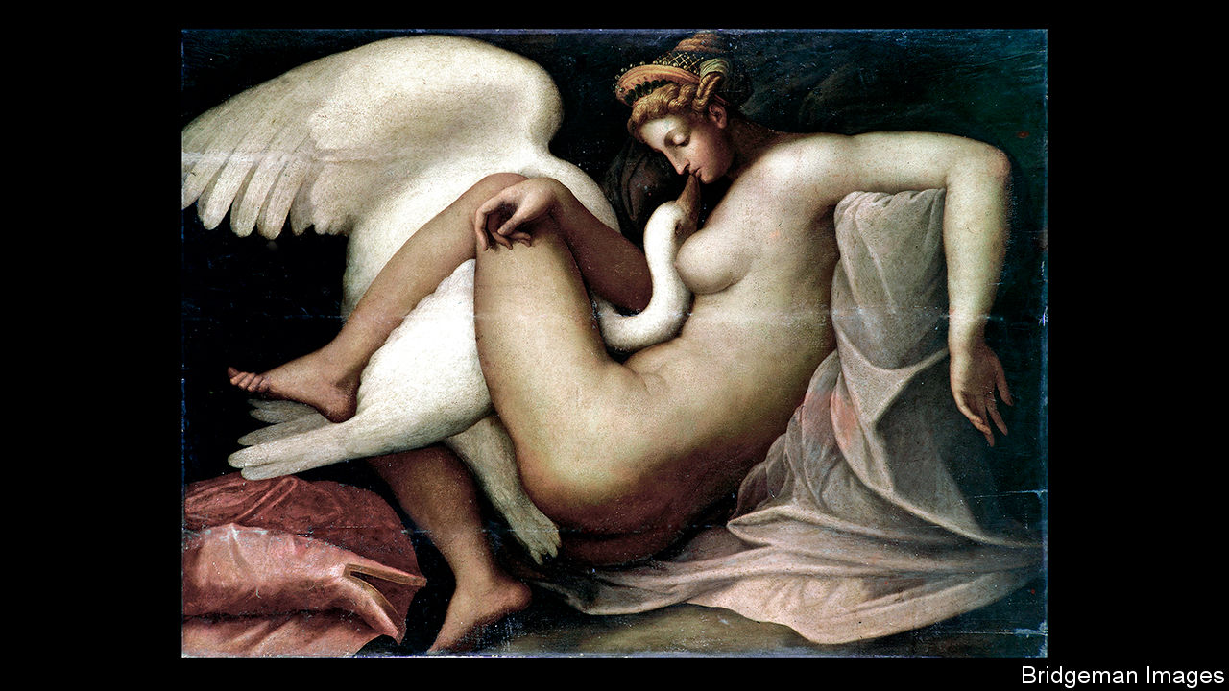

The Beauty and the Terror. By Catherine Fletcher.Oxford University Press; 384 pages; $29.95. Bodley Head; £20.

FOR MOST people, the phrase “High Renaissance” conjures up thoughts of Raphael putting the final touches to the blush of a pensive Madonna; of Michelangelo chipping gingerly at the flawed marble from which he would create his peerless David; of Leonardo da Vinci sketching his latest visionary design for a flying machine. Few reflect, or perhaps even know, that this golden age of creativity was also one of near-continuous warfare in Italy.

The period between 1494, when Charles VIII of France marched across the Alps to press his claim to the Kingdom of Naples, and the Peace of Cateau-Cambrésis in 1559 saw hundreds of thousands of people die in Italy: massacred in battle, starved to death and killed by diseases during sieges, or butchered—often after rape or torture—when the besieged surrendered. Among cities sacked in the so-called Italian Wars were Naples, Brescia, Prato, Pavia and, in perhaps the most frenzied orgy of carnage and looting, Rome in 1527.

Nor was warfare the only source of turbulence. It was in this period that Europeans, including many Italians, began to explore the Americas, and in which they came into mounting conflict with the growing power of the Ottomans in and around the Mediterranean. It was also during these years that the papacy in Rome saw Western Christianity rent in two by the Protestant Reformation.

In her new book, Catherine Fletcher’s aim is to give readers a more nuanced and wide-ranging picture of a singularly tumultuous period in Italian history. The breadth of her reading is remarkable and she uses it to bring alive a huge range of subjects—from ordnance to pornography, and from the remuneration of cardinals to attitudes in Italy towards Jews and Muslims. She is perhaps at her best when teasing out the contributions by women, whether to painting, poetry or politics—or, indeed, warfare. During the siege of Siena, from 1553 to 1555, repairs and improvements to the walls were entrusted to the city’s women, divided into three groups, each led by a woman.

Had this book been written 50 years ago, it would probably have been drily entitled “Italy 1492-1571”; 20 years ago, it might have been called something grandiose like “The World of the High Renaissance”. To tempt contemporary readers, often exposed to history via sensationalising television documentaries, the actual title is “The Beauty and the Terror”. That risks disappointing many who buy Ms Fletcher’s admirable work, for there is not that much of either in it. She devotes just one chapter to those artistic geniuses and does not dwell on the gore. For example, she barely mentions the atrocities committed during the Sack of Rome; in line with modern academic opinion, she resists the temptation to demonise the notorious Borgia dynasty in general, and Lucrezia (probably its most infamous scion) in particular.

More frustratingly, she fails to explore the juxtaposition of the concepts in her title. She recounts the well-known stories of the involvement of da Vinci and Michelangelo in military technology and architecture, yet stops short of looking at what influence that had on their art. Michelangelo must have seen appalling suffering near the end of the siege of Florence. Did it affect him? And how can da Vinci’s apparent pacifism be squared with his enthusiasm for designing war machines and fortifications? The reader comes to the end of Ms Fletcher’s book more fully aware that the beauty and terror co-existed, but still none the wiser as to how they interacted. ■

This article was downloaded by calibre from <https://www.economist.com/books-and-arts/2020/03/26/art-and-carnage-in-the-italian-renaissance>

|  |  |  |  |
| --- | --- | --- | --- |
| Previous | Articles | Sections | Next |

|  |  |  |  |
| --- | --- | --- | --- |
| Previous | Articles | Sections | Next |

#### Women overboard

# People—and money—vanish in “The Glass Hotel”

The author of “Station Eleven” tells a tale of Ponzi schemes and haunting pasts

Mar 26th 2020 |

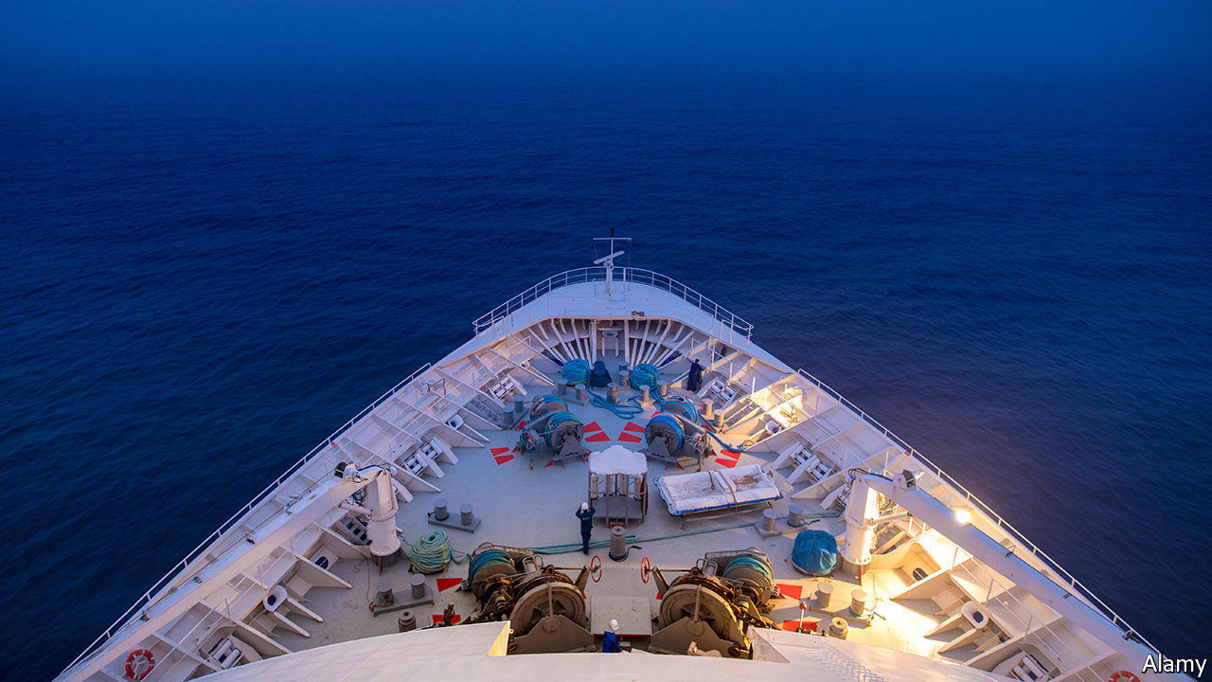

The Glass Hotel. By Emily St John Mandel.Knopf; 320 pages; $26.95. Picador; £14.99.

AFTER PRODUCING three respectable thrillers, the Canadian author Emily St John Mandel raised her profile with her boldly inventive fourth novel. “Station Eleven” (2014) tells of a flu pandemic that devastates the Earth’s population, and follows a group of travelling Shakespearean actors who perform for the survivors 20 years later. The narrative’s before-and-after structure beautifully balances the life and death of a single individual against the fate of civilisation. Beyond its grim dystopia, the story hints at a brave new world founded on hope and humanity.

Today, “Station Eleven” is as timely as a novel can be. Ms Mandel’s new book, “The Glass Hotel”, partly revolves around another catastrophe, only this one is financial and hope is more elusive. Swapping the post-apocalyptic future for the recent past, and charting the chequered fates of a wide cast of characters, she spins a beguiling tale about skewed morals, reckless lives and necessary means of escape.

The main protagonist is Vincent, a young (female) bartender at a swish hotel on Vancouver Island who had a tragic childhood. One night a vicious anonymous message is scrawled on the building: “Why don’t you swallow broken glass.” One of the guests, a shipping executive named Leon Prevant, is disturbed by the graffiti. Vincent herself is shocked and contemplates fleeing, even disappearing. Instead, after serving drinks to the hotel’s owner, Jonathan Alkaitis, she seizes an opportunity and elopes with him to New York.

There she adjusts to her new role as a trophy wife in “the kingdom of money”. Alas, all that glitters turns out to have been fraudulently acquired. Alkaitis is running a multibillion-dollar Ponzi scheme reminiscent of Bernie Madoff’s; its collapse wipes out fortunes and forces Vincent to start afresh, this time as a cook on a container ship. But while at sea she disappears overboard. Leon, one of many investors ruined by Alkaitis, is charged with solving the mystery. Did Vincent fall or was she pushed? And has she washed up on another shore ready to reinvent herself again?

“The Glass Hotel” is a sprawling, immersive book. In places it is disorientating, as the narrative chops between timelines and perspectives. Minor characters, such as Vincent’s half-brother, drift in and out. And yet the novel’s scope and brimming vitality are also its strengths. Vincent’s encounters with the plutocracy are memorably realised; so are Alkaitis’s concoction of a “counterlife” in his prison cell and his employees’ struggles to save their skins.

In the end, all the stories are drawn together by a single question: can you ever escape what you have done in the past, and what has been done to you? “There are so many ways to haunt a person,” the author writes, “or a life.”

This article was downloaded by calibre from <https://www.economist.com/books-and-arts/2020/03/26/people-and-money-vanish-in-the-glass-hotel>

|  |  |  |  |
| --- | --- | --- | --- |
| Previous | Articles | Sections | Next |

|  |  |  |  |
| --- | --- | --- | --- |
| Previous | Articles | Sections | Next |

#### The yolk of fate

# Bulgakov’s biting vision of an avoidable plague

“The Fatal Eggs” is a parable of bureaucratic bungling and drastic countermeasures

Mar 25th 2020 |



Editor’s note: The Economist is making some of its most important coverage of the covid-19 pandemic freely available to readers of The Economist Today, our daily newsletter. To receive it, register [here](https://www.economist.com/newslettersignup). For more coverage, see our coronavirus [hub](https://www.economist.com/coronavirus)

The Fatal Eggs. By Mikhail Bulgakov. Translated by Hugh Aplin.Hesperus Press; 112 pages; £6.99.

WHEN PROFESSOR Vladimir Persikov’s wife runs off with an opera singer, she leaves him a note. “An unbearable shudder of revulsion is aroused in me by your frogs,” she tells him. In “The Fatal Eggs”, a little-known novella by Mikhail Bulgakov, a pestilence spawned by the professor’s zoological research threatens not just his marriage, but civilisation itself.

The scourge in the story—published in 1925 and set three years later—is not a disease, exactly. In their imagination of epidemics, novels such as Mary Shelley’s “The Last Man”, “The Plague” by Albert Camus or José Saramago’s haunting “Blindness” might seem more apposite in the time of covid-19. Nor is this biting tale Bulgakov’s finest work (that is his satirical fantasia, “The Master and Margarita”). But as a parable of bureaucratic bungling, avoidable disaster and drastic countermeasures, it is horribly relevant.

In his laboratory in Moscow, Persikov discovers a “ray of life” that makes amoebae and tadpoles reproduce at speed. Thrilled, he orders extra kit from Germany and exotic eggs from across the Atlantic (like the virus, this is a globalised affair). Foreign powers covet the new technology, but the Soviet state requisitions it to help kick-start poultry production. The apparatchik in charge of the state farm, Alexander Faight, was once a flautist in Odessa; he is carrying his instrument when he encounters a giant serpent, which he tries to pacify with a waltz from “Eugene Onegin”. He fails, and the beast eats his wife.

The Russian author takes digs at the church, heedless carousers in the streets, blinkered scientists—and, naturally, at the Bolsheviks. But his depiction of blasé, incompetent officialdom resonates across the ages and all forms of government. “Honest to God, it’ll work out,” Faight says blithely of the poultry plan, like a president recommending an unproven drug. Disaster ensues because the authorities botch their deliveries, sending the hens’ eggs meant for the farm to Persikov, and his exotic specimens to the farm. Then, after the creatures hatch, the first, all-too familiar response is disbelief and denial. Faight stammers a report to two security agents; one thinks he is hallucinating, the other that a circus animal might have escaped. A newspaper editor dismisses an urgent telegram as a drunkard’s raving.

Before long, though, everyone goes berserk. Martial law is declared in Moscow amid a flood of refugees. Like quarantined Europeans applauding ambulances from their balconies, cowering citizens take to the pavements to salute the cavalrymen on their way to interspecies battle, and the marching gas squadrons “with breathing tubes over their shoulders and with cylinders on straps behind their backs”. Artillery units bombard forests; aeroplanes spray poison. Civilian casualties mount. And, following a perennial instinct, vigilantes hunt for someone to blame.

In the end, the weather intervenes, as some hope it might today. An unseasonable summer frost kills the serpents and freezes the eggs, and a year after the trouble arose, it is all over. Moscow, Bulgakov writes encouragingly, “again began to dance, to burn and to spin with lights”. ■

Dig deeper:  
For our latest coverage of the covid-19 pandemic, register for The Economist Today, our daily [newsletter](https://www.economist.com/newslettersignup), or visit our [coronavirus hub](https://www.economist.com/coronavirus)

This article was downloaded by calibre from <https://www.economist.com/books-and-arts/2020/03/25/bulgakovs-biting-vision-of-an-avoidable-plague>

|  |  |  |  |
| --- | --- | --- | --- |
| Previous | Articles | Sections | Next |

|  |  |  |
| --- | --- | --- |
| Books and arts | Sections | Graphic detail |

Economic and financial indicators

Economic data, commodities and markets

.

|  |  |  |
| --- | --- | --- |
| Books and arts | Sections | Graphic detail |

|  |  |  |  |
| --- | --- | --- | --- |
|  | Articles | Sections | Next |

# Economic data, commodities and markets

Mar 26th 2020 |

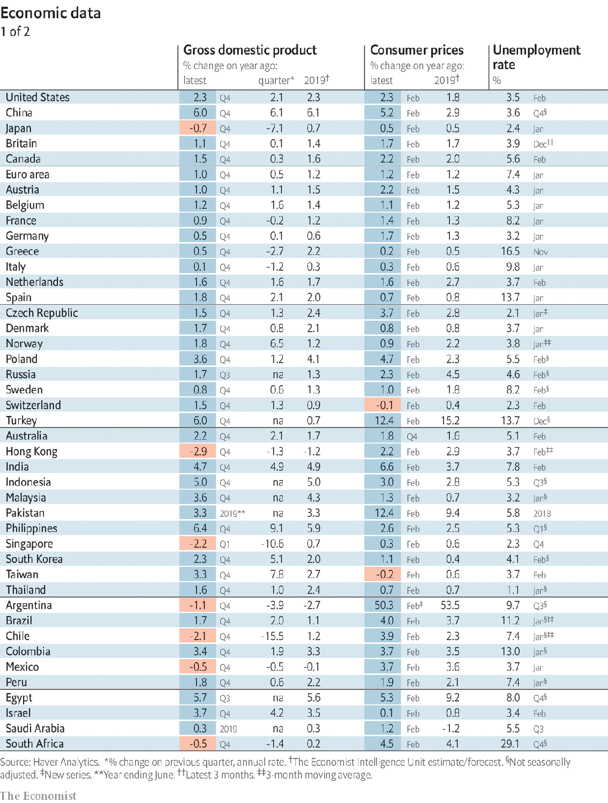

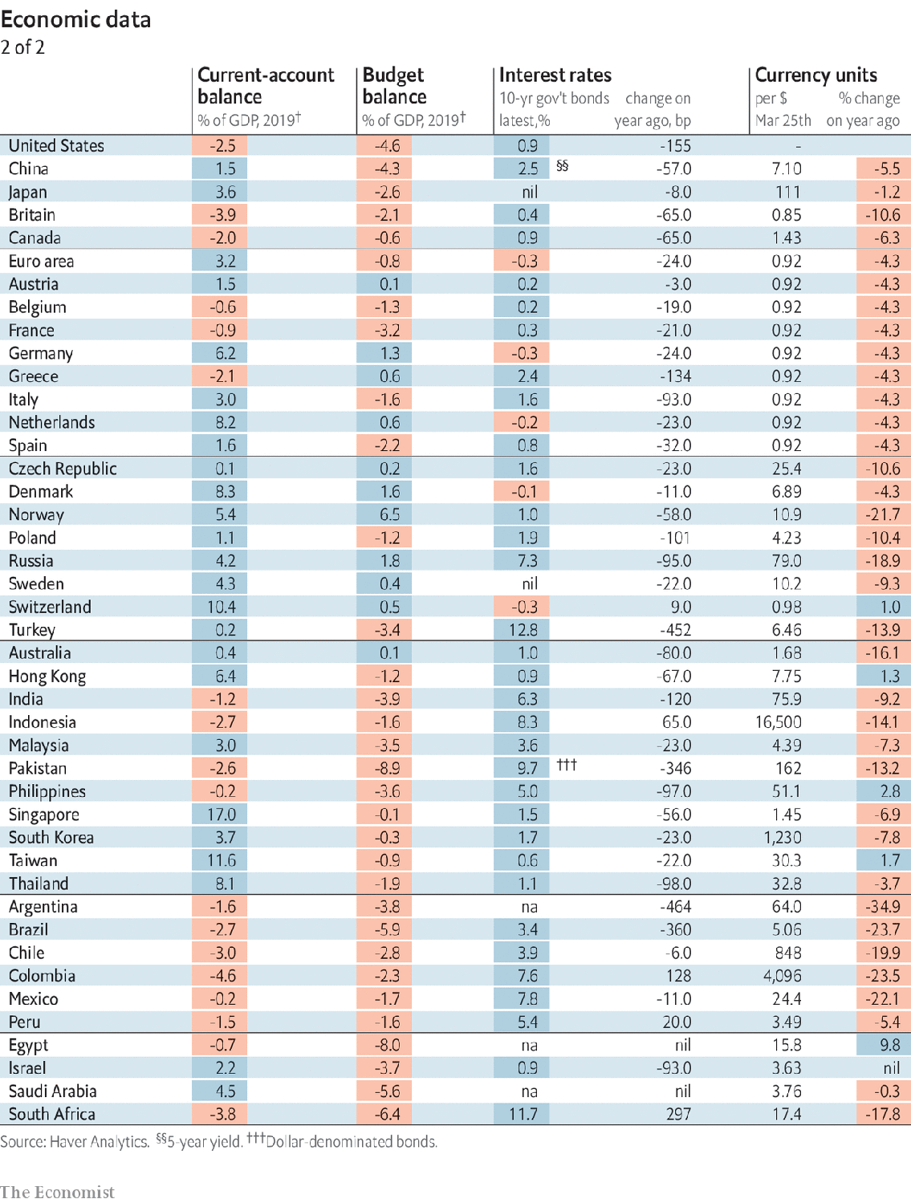

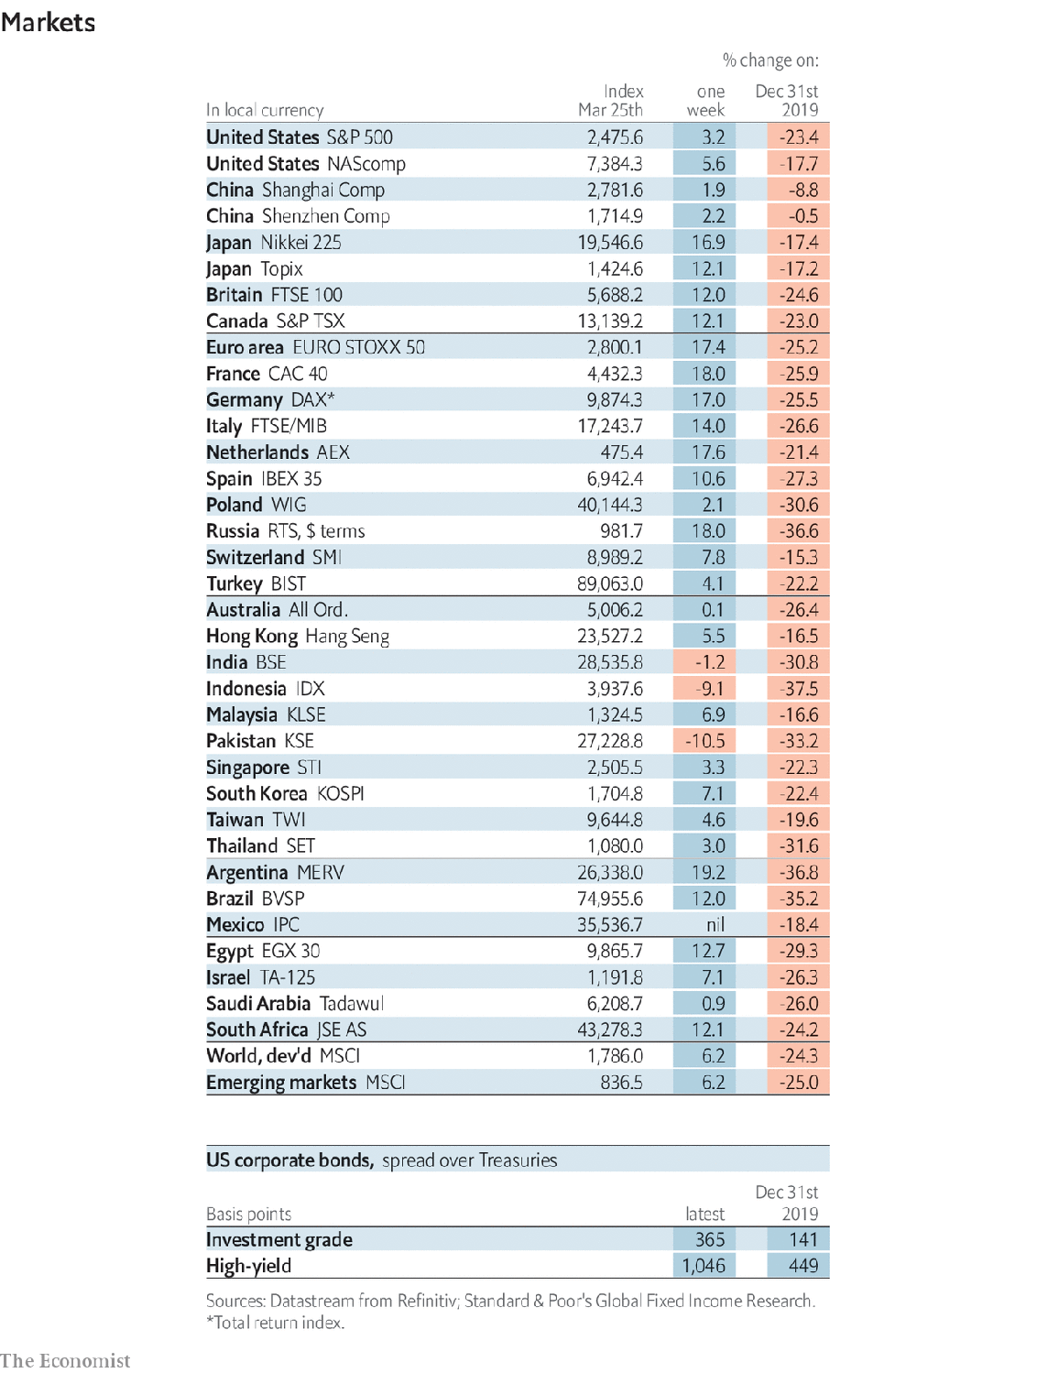

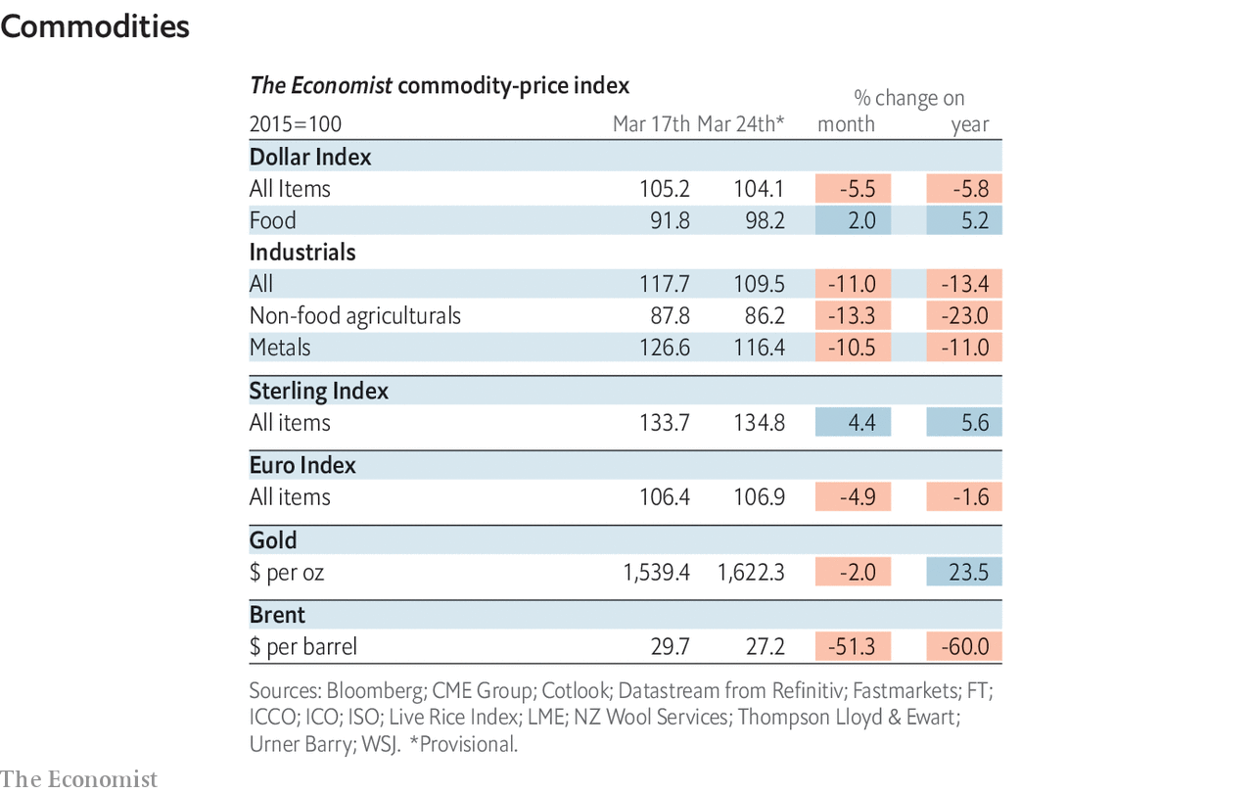

This article was downloaded by calibre from <https://www.economist.com/economic-and-financial-indicators/2020/03/26/economic-data-commodities-and-markets>

|  |  |  |  |
| --- | --- | --- | --- |
|  | Articles | Sections | Next |

|  |  |  |
| --- | --- | --- |
| Economic and ... | Sections | Obituary |

Graphic detail

Climate change: Winter is not coming

.

|  |  |  |
| --- | --- | --- |
| Economic and ... | Sections | Obituary |

|  |  |  |  |
| --- | --- | --- | --- |
|  | Articles | Sections | Next |

#### Winter is not coming

# The northern-hemisphere winter of 2019-20 was the warmest ever on land

Temperatures stayed roughly the same from November to March

Mar 28th 2020 |

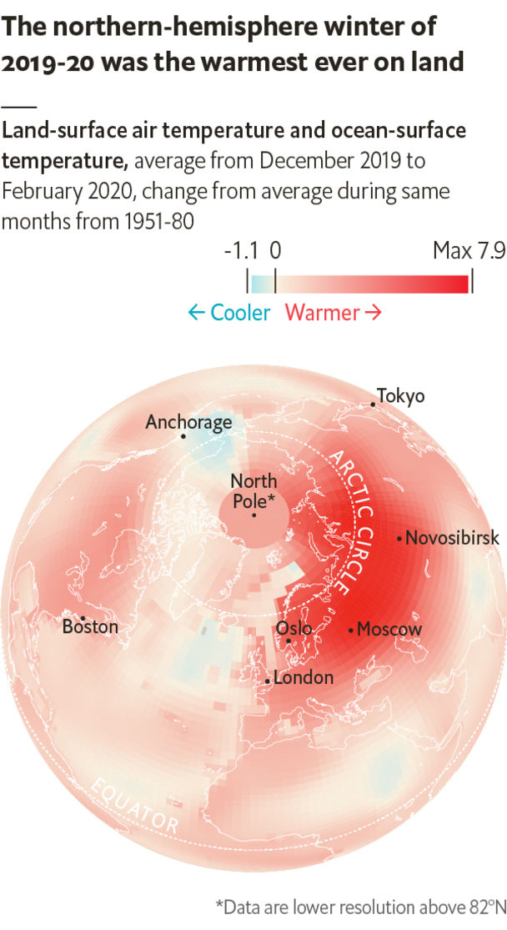

THE MOST commonly cited risks of climate change are natural disasters: fiercer wildfires and hurricanes, bigger floods and longer droughts. But one of the most striking recent effects of global warming has been unusually mild weather in many parts of the world.

The northern-hemisphere winter that ended on March 20th was the second-warmest since records began, and the warmest ever on land. The anomaly was biggest in Europe and Asia, where average temperatures from December to February were 3.2°C (5.8°F) and 3.1°C above the average from 1951-80, and 0.8°C and 0.7°C above those continents’ previous record highs. After a normal autumn, temperatures stayed close to their November levels for months. In Boston, where daily lows in January tend to hover around -6°C, the average minimum this January was 0°C; for Tokyo the figures were 0°C and 5°C. By local standards, the balmiest winter of all was in Russia. Moscow’s average daily low in January was -2°C, far from the customary -13°C.

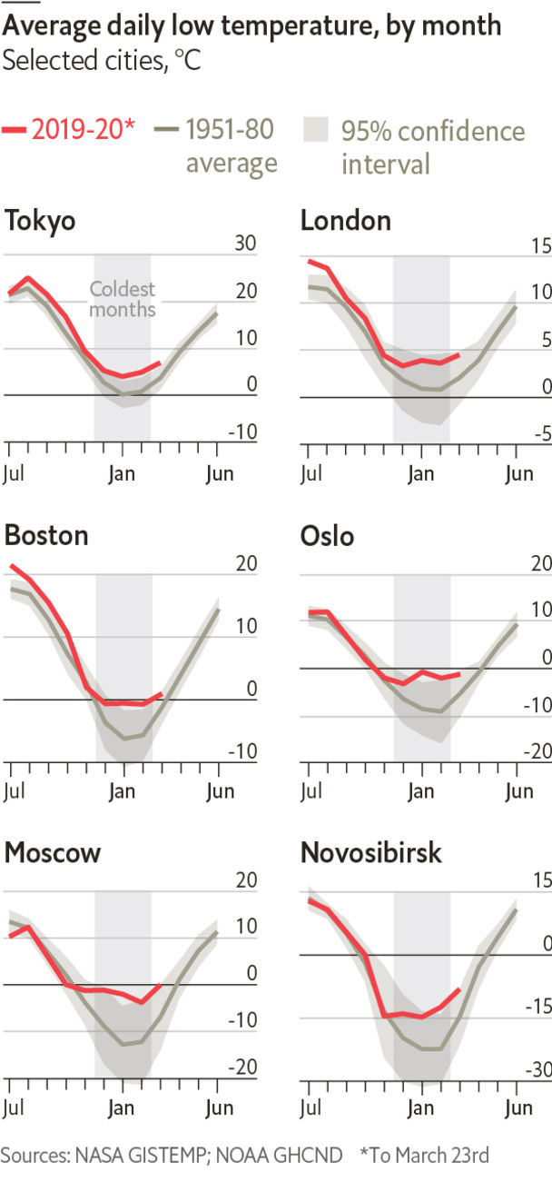

The winter-that-wasn’t of 2019-20 is not yet a new normal. The main factor determining the severity of northern winters is the “Arctic oscillation”: the relative pressure of Arctic and sub-tropical air. When pressure is higher in the Arctic, cold air from the North Pole pushes south, bringing harsh, dry winters to many places. When pressure is higher towards the sub-tropics, warm air pushes northwards, hemming in cold air around the pole. These two patterns flip back and forth irregularly.

For reasons that are not yet clear, pressure in the sub-tropics this year was much stronger than in the Arctic. And researchers have not yet determined how rising temperatures affect the Arctic oscillation. Until a few years ago, climate models tended to show pressure in the Arctic strengthening, reducing the amount of warming during winter at temperate northern latitudes. The latest models find the reverse.

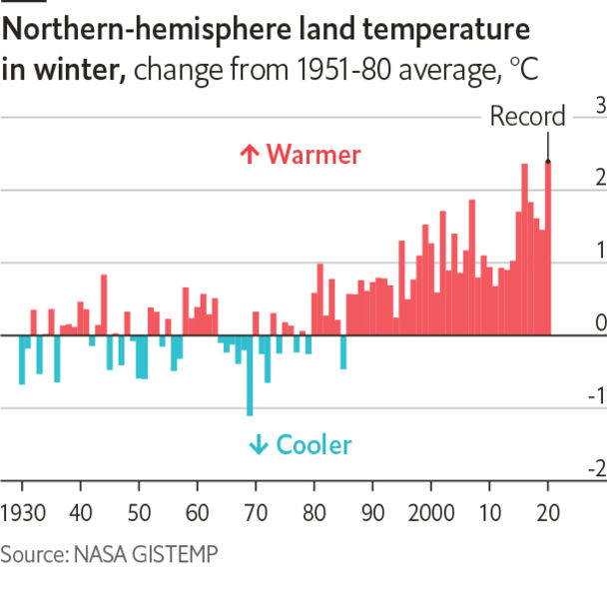

However, climate change is still responsible for anomalies like this one. At the average global temperature in 1950, a winter this mild was all but impossible. In today’s climate, such reprieves from the cold should occur once every 11 years. And if global warming continues on its current trajectory, winters like this year’s could become standard within a few decades.

Mild winters offer benefits. Heating is cheaper, flu seasons are shorter and fewer people die overall. But problems mount as well. Without hard frosts, pests can survive and multiply to attack crops more harshly. Warmer winters are usually wetter, changing snowfall patterns. This can shrink the snowpack that supplies rivers, and cause floods. Even people who bemoan frigid winters may miss them if they vanish. ■

Sources: NASA GISTEMP; NOAA GHCND

This article was downloaded by calibre from <https://www.economist.com/graphic-detail/2020/03/28/the-northern-hemisphere-winter-of-2019-20-was-the-warmest-ever-on-land>

|  |  |  |  |
| --- | --- | --- | --- |
|  | Articles | Sections | Next |

|  |  |  |
| --- | --- | --- |
| Graphic detail | Sections |  |

Obituary

Michel Roux: Cooking with Albert

.

|  |  |  |
| --- | --- | --- |
| Graphic detail | Sections |  |

|  |  |  |  |
| --- | --- | --- | --- |
|  | Articles | Sections | Next |

#### Cooking with Albert

# Michel Roux died on March 11th

The chef and restaurateur who, with his brother, transformed British dining was 78

Mar 26th 2020 |

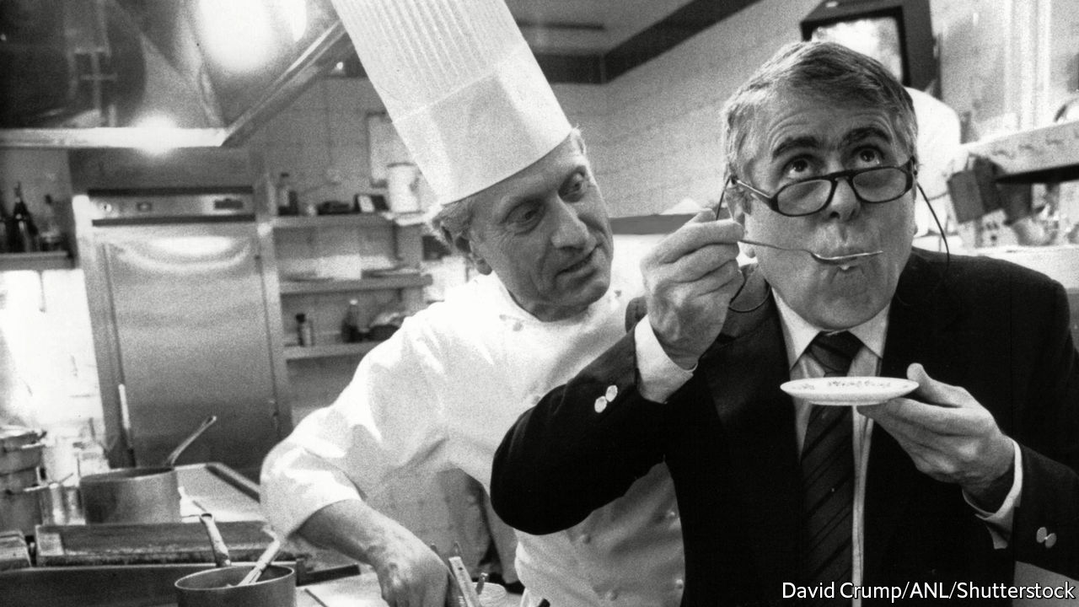

THE SIGHT was so awful that Michel Roux, then only in his 20s and new to London, quickly turned his face away. Through the window of the Lyons Corner House near Marble Arch he could see people eating British peas. The peas were fluorescent, big as quails’ eggs. And there was worse: on each side-plate a piece of sliced bread, limp as a handkerchief and bleached frighteningly white. He realised then that he had come to a land that was still in the culinary Dark Ages. And it was all Albert’s fault.

His older brother had persuaded him to come. He had been working as a chef in London for eight years, and now had plans. Those eventually led to the founding of two restaurants, Le Gavroche in Chelsea and the Waterside Inn at Bray in Berkshire, which transformed fine dining and the whole food scene in Britain. Each venue earned three Michelin stars, something the country had never experienced before. But as Michel stood aghast in the street that day, he was torn between revolutionary fervour and despair.

Despite the fact that Albert was dark, dumpy and short, and he was tall, fair and much handsomer, he had always looked up to him, so to speak. If Albert had been a fireman, he would have been a fireman too. As it was, Albert went young to be apprenticed to a pastry-chef, so at 14 he did the same. There at last he surpassed his brother, becoming so good at pastries and desserts that for many years he held the title of Best Pastrycook in France. No one could make an omelette soufflé Rothschild (succulent with apricots, perfumed with Cointreau, his tour de force when he was Cécile de Rothschild’s chef for nearly six years), the way he could. (Albert was more of a sauce man.) They bickered all the time, doing a TV cookery show later in which they flirted with filleting each other, but they made a good team; so in 1967 they bought their 90-seater restaurant in Lower Sloane Street and shook up London together.

What they offered was classic French-restaurant cuisine, short menus cooked fresh à la minute; not, as was the custom even in high-class British restaurants then, dishes reheated from frozen or cooked far in advance. Every ingredient was fresh too, often sourced from French suppliers whom they knew as friends. (Later, they ordered in almost everything from Rungis market in Paris.) As the business expanded, first with the Waterside Inn, then with two smaller restaurants in London, then with more down-market eateries that plain folk could almost afford, the same philosophy was applied to all of them, and a host of eager young British chefs were trained, some with Roux Scholarships, to run them.

All this made Michel enormously proud, yet it was hardly what he had expected. He had wavered about being a chef. With his looks and his deep voice—in his kitchen, he never needed a microphone—he might have made an opera singer. But love of food ran deep. Growing up as the son of a charcutier, he had learned whether it was Monday or Tuesday from the smell of boudin or andouillettes on the stairs; and his earliest memory was of beating up egg yolks which, as if by magic, thickened in the hot stock into sauce for his mother’s blanquette of veal. To run just one restaurant with Albert would have been good enough. And it was hard work: so hard that he was hardly ever at home, and his first wife divorced him. Though he knew almost no English, he still had to take his turn at front-of-house while Albert was manning the stove. They cooked and played host in alternate weeks, knowing well that if they tried to share service there might be blood.

Both of them came up with ideas, but his strength lay in details. Precision and patience were a pastrycook’s skills. It mattered to him, for instance, that commis waiters should not talk to the customers and that diners should wear ties (he almost refused entry to the Rolling Stones when they turned up without them). Every ingredient had its right place, too, and as each arrived he would taste it, unseasoned, to judge exactly where it might sit within a dish. When he and Albert produced cookery books, spreading the revolution to ordinary British kitchens, he, being a perfectionist, wrote the words, just as on their cookery shows he was the suave and particular main presenter. And in 1986 it made sense to split their interests, so that while his brother went bustling after new business he departed for Bray, to run the whitewashed former pub on the Thames they had opened a decade before.

There, as the Waterside Inn reinforced its reputation (and kept its stars) with quenelles de brochet and his own sublime tarte Tatin, he could make a public virtue of being classic and old-fashioned. The dining rooms were padded deep with chintz. His wine cellar was exclusively French, for he loved his bordeaux and burgundies too well to stray—going to Bordeaux every year to taste the en primeur vintage, and cultivating his own vineyard at his villa near Saint-Tropez. Nouvelle cuisine passed him by: on his menus butter featured everywhere, irreplaceable and indispensable. And bad manners never ceased to infuriate him. The new generation of celebrity chefs struck him as sadly insecure, even unbalanced, using dreadful words and treating their underlings like dirt. He himself was kind to his chefs, and his kitchen was happy. He did not need to blanch their heads in boiling water to make sure he kept them.

Had Britain really changed, then, since his arrival? He sometimes wondered. By 2020 London could boast three three-star Michelin restaurants—but Paris had ten. Britain now offered cuisines from all over the world, but too many new dishes were merely visual, picnic stuff that lacked depth. The best of British cooking was still the afternoon tea, with treacle tart and sponge cake and scones with jam and cream, which he and Albert both loved greedily and which had persuaded them, in the beginning, that there was hope to be found somewhere. But those peas, alas, were not yet right. They had to be fresh-shelled, to start with; cooked in butter, never water; and then, preferably, cut one by one in half before they could ever grace a plate. ■

This article was downloaded by calibre from <https://www.economist.com/obituary/2020/03/26/michel-roux-died-on-march-11th>

|  |  |  |  |
| --- | --- | --- | --- |
|  | Articles | Sections | Next |